Introduction to 1 & 2 Peter

I’d like to introduce you to Peter… Yeah, that Peter

Peter, the apostle, is first found in Scripture in Matthew 4:18-22 (his first mention in each of the other gospels is found in Mark 3:13-19, Luke 5:1-11, John 1:35-43). From these and subsequent accounts, we know that Peter was:

- named ‘Peter’ by Christ, but was also called ‘Simon’ & ‘Cephas’ (Greek: Kephas)
- a fisherman by trade, on the Sea of Galilee, where Christ called him to be a disciple
- known initially for his bold, if unenlightened statements and proclamations
- most prominently portrayed among the twelve disciples in the four Gospels
- ‘credited’ with both great statements about and tragic denials of our Lord
- a leading spokesman among the apostles in the first 15 chapters of Acts
- the apostle who passed on the gospel of salvation to the Gentiles (Acts 10)
- written about by Paul, with whom he spent some time (Galatians 1:18; 2:1-14)

Peter also mentions Paul, and illuminates for us some things about Paul’s letters, too:

2 Peter 3:14-16 (NASU)
Therefore, beloved, since you look for these things, be diligent to be found by Him in peace, spotless and blameless, 15 and regard the patience of our Lord as salvation; just as also our beloved brother Paul, according to the wisdom given him, wrote to you, 16 as also in all his letters, speaking in them of these things, in which are some things hard to understand, which the untaught and unstable distort, as they do also the rest of the Scriptures, to their own destruction.

Whatever happened to…?

Refer to the supplement to this handout (HHBC – 1 & 2 Peter – 01 Introduction to 1 & 2 Peter – Supplement - page 1 of 1) for the historical sources indicating Peter’s presence in Jerusalem, absences from Rome, presence in Antioch, and possible to probable later presence in Rome.
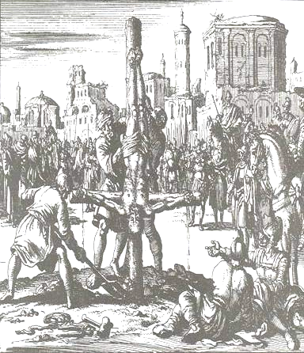
Peter is only mentioned in Scripture as being in Jerusalem, or the vicinity, from the time of Christ’s crucifixion (about 30 AD) to the meeting recorded in Acts 15. External evidences, which admittedly lack the reliability of Scripture, point to Peter’s possible presence outside of the region around Jerusalem from about 47 AD to 66 AD. Historical scholars debate the reliability of the record of Peter’s presence ‘outside of Jerusalem’. The record that indicates Peter’s presence in Rome in his last days also indicates his crucifixion there, upside down, so as not to be crucified in the same way as the Lord.

Who else might be involved in these letters?

In 1 Peter 5:12, we get a clue that Silvanus (aka Silas), an associate of Paul (2 Corinthians 1:19; 1 Thessalonians 1:1; 2 Thessalonians 1:1 ), was assisting Peter with the writing of 1 Peter. Mark (in 1 Peter 5:13; aka John Mark [Acts 12:25], author of the Gospel of Mark, and cousin of Barnabas [Colossians 4:10]) is also mentioned as present at this writing. Because of the rather consistent tracking of 1 Peter with the book of Acts, some have suggested that Luke was associated with the writing of 1 Peter:

- Acts 4:11 > 1 Peter 2:4: Christ as the rejected stone (Ps 118:22)
- Acts 1:22; 5:32; 10:39 > 1 Peter 5:1: Eyewitness of Christ
- Acts 10:34 > 1 Peter 1:17: God as no respecter of persons
- Acts 10:42 > 1 Peter 4:5: God as judge of the living and the dead
- Acts 15:9 > 1 Peter 1:22: The cleansing of the heart

Acts was written a couple years earlier than 1 Peter, so 1 Peter was apparently drawing upon the content of the book of Acts. If that is so, and it appears likely, then this brings more evidence of circulation of New Testament documents among those in the early church.

Now, to whom is he writing?
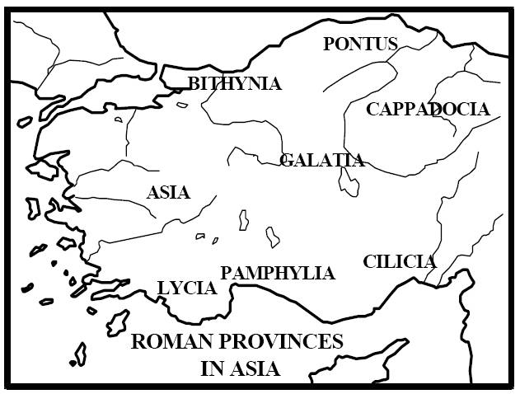
Both 1 and 2 Peter were written to believers, of course. In 1 Peter 1:1, Peter listed the regions where the letter is addressed, “…scattered throughout Pontus, Galatia, Cappadocia, Asia, and Bithynia”. These would have been generally Greek-speaking regions in what is now western, northern and eastern Turkey. Galatia and Asia were areas where Paul had carried out missionary activities, (Map from Dr. Constable's Notes on 1 Peter) alongside others (Acts 13 & 14; Galatians; 2 Timothy 4:10). The believers Peter addressed included a large minority of Jews, who had settled there about two and a half centuries earlier.

2 Peter does not have the same listing of regions, but Peter provided a strong clue that he was writing to the same group of believers:
2 Peter 3:1-2 (NASU)
This is now, beloved, the second letter I am writing to you in which I am stirring up your sincere mind by way of reminder, 2 that you should remember the words spoken beforehand by the holy prophets and the commandment of the Lord and Savior spoken by your apostles.

These believers lived in areas that ranged from port cities, to plains, to mountainous regions, with Roman roads traversing through every one. Asia alone had about 500 cities and towns, including Ephesus, the Roman Empire’s 3rd or 4th largest city. There were both common and unique varieties of agriculture, mining, manufacturing and medicine.

When did Peter write these letters?

It sure would be nice if Peter had written a date on his letters, even just the year ☺, but the system of dating we now have wasn’t in place in New Testament times. By study of the chronology of Peter’s life, the rest of New Testament history, and other historical evidences, conservative biblical scholars estimate the date of Peter’s authorship of these books at:

- 1 Peter: about 63 AD
- 2 Peter: about 66 AD

According to a number of biblical chronologists, 2 Peter was likely written about a year before Peter’s death by martyrdom.

Adapted from: http://www.abu.nb.ca/courses/NTIntro/1Pet.htm.
Ryrie Study Bible, page 1976.

