1 Peter 1:1-5

1 Peter 1:1,2

1 Peter 1:1,2 (NASU)
Peter, an apostle of Jesus Christ,

To those who reside as aliens, scattered throughout Pontus, Galatia, Cappadocia, Asia, and Bithynia, who are chosen 2 according to the foreknowledge of God the Father, by the sanctifying work of the Spirit, to obey Jesus Christ and be sprinkled with His blood: May grace and peace be yours in the fullest measure.

Peter identifies himself by the name that was given him by the Lord:

Mark 3:16 (NASU)
And He [Jesus Christ] appointed the twelve: Simon (to whom He gave the name Peter)

As was mentioned before, besides Simon and Peter (Greek, Petros, meaning stone), he was also called Cephas (Aramaic: Kephas, meaning stone). Peter was an apostle (apostolos: special messenger) of Jesus Christ. An apostle, as a spiritual gift and specific assignment by the Lord Himself, had these characteristics in the New Testament:

- An apostle received his gift and office by the sovereign decision of God: 1 Corinthians 1:1; Ephesians 1:1; Colossians 1:1
- An apostle had to have been an eyewitness of the resurrected Lord: Acts 1:22; 1 Corinthians 9:1; Hebrews 2:3,4; 1 John 1:1-4
- An apostle was endowed with power to perform signs, wonders and miracles: 2 Corinthians 12:12; Hebrews 2:3,4
- An apostle had success in evangelism: 1 Corinthians 9:2; 2 Corinthians 3:1-3; Galatians 2:7-9
- An apostle had the capacity to suffer patiently – to persevere: 2 Corinthians 12:12

Peter wrote this letter as a special messenger of Jesus Christ. Consider Peter’s viewpoint on what he had seen and heard and done and come to know from the day the Lord invited him to be His disciple, then sent him out as one of His apostles. Consider Peter’s listening to the Lord teach, seeing Him perform miracles, as well as Peter doing and saying things both praiseworthy and detestable. Consider also Peter’s apostleship, recorded from the end of the Gospels through Acts 15: how much he had experienced and the Lord had restored and changed him in the almost two decades that span those chapters. Consider finally the three decades that had passed since he saw the Lord ascend into the heavens from the Mount of Olives until the time when Peter wrote this letter we are now reading.

And consider Christ, our Lord with whom we are now seated (Ephesians 2:6; Hebrews 3:1; 12:3), and in whom we are blessed with every spiritual blessing (Ephesians 1:3), being in Him by God’s doing (Romans 6:3; 1 Corinthians 1:30), who is our life (Colossians 3:1-4), and whose coming for us is our blessed hope (Titus 2:11-14).

Peter next tells us about the recipients of his letter, first addressing their spiritual standing while living on planet earth. The words “who reside as aliens” translates the Greek word parepidemos, which has the idea of a resident foreigner (someone residing in a country for a short term purpose while holding citizenship in and allegiance to another country). Peter was saying in one way what Paul said to the believers at Philippi:

Philippians 3:20 (NASU)

For our citizenship is in heaven, from which also we eagerly wait for a Savior, the Lord Jesus Christ;

Peter then names several regions in what is now Turkey (see map on prior week’s handout). He then describes the believers as “chosen, according to the foreknowledge of God the Father.” Now there are those who like to take the words “chosen” and “foreknowledge” in the direction of theological and philosophical argument. Considering the character of Peter’s letter, and the needs of his readers, a more likely intent would be to take these personally and spiritually: being “chosen” by God indicates that the believer is specially cared for and about, and God’s foreknowledge is the basis of comfort and assurance about the believer’s past, present and the future. What is happening with us on earth and eternally is not some cosmic accident or dreaded machine, but is being carried out by a God who acts in our lives intentionally and with full knowledge. It is God the Father. The Holy Spirit’s ministry is making us holy, and set apart for God’s purpose, so to be putting that holiness into practice, and to be purified (the meaning of sprinkling of blood) by Jesus Christ. All three persons of the Trinity are involved in our salvation, including the past, the present and the eternally unfolding outcome.

Peter offers grace (the Greek greeting) and peace (the Jewish greeting) to his readers, both of which go beyond the significance of casual and customary greetings. Grace is God’s infinite character expressed to us in the person of Jesus Christ, and peace describes the character of the relationship between God and saint, the new condition within the saint as the saint is filled with Christ, and between saints, as they share His life.

1 Peter 1:3-5

1 Peter 1:3-5 (NASU)
3 Blessed be the God and Father of our Lord Jesus Christ, who according to His great mercy has caused us to be born again to a living hope through the resurrection of Jesus Christ from the dead, 4 to obtain an inheritance which is imperishable and undefiled and will not fade away, reserved in heaven for you, 5 who are protected by the power of God through faith for a salvation ready to be revealed in the last time.
1 Peter 1:3 starts out virtually identical to the beginning of Ephesians 1:3. The Greek phrase behind our English words “Blessed be the God…” come from the Greek Old Testament in Genesis 14:20, where Melchisedek was speaking to Abraham (see also Daniel 3:28; 2 Corinthians 1:3). From the Father’s abundant mercy (compare Ephesians 2:4, “rich in mercy”), we have been reborn into a living hope by the raising of Jesus Christ from [the] dead ones. Imagine Peter (!), who about three decades before had run to see the empty tomb and had seen our resurrected Lord on multiple occasions. Peter’s offering of this certain hope was not hypothetical, nor was it wishful thinking. Peter had seen the risen Lord for himself and proclaimed that fact boldly and repeatedly (Acts 2:24; 3:15; 5:32; 10:40; 1 Peter 1:21)!

Peter wrote that God the Father is to be credited with our salvation to an inheritance in the heavenlies: an inheritance that doesn’t perish, get defiled or fade away (Ephesians 1:11, 14). What does He mean? Jesus Christ! Him! Notice that when the 24 elders are seen in the heavenlies in Revelation 4-19, they are occupied with Christ, drawn to Him to such a degree that even though they are aware of the unbelievable judgments coming upon earth, it is still Christ who draws their attention. Many of the believers Peter wrote to were going through very difficult times, as we will see. Peter does not deny that fact as he addresses them, but points to the riches in Christ that cannot be threatened by anyone. Our place with Christ is reserved (written as a perfect tense verb: a completed past action with ongoing results into the future, implying permanence), Peter wrote, for us, and the keeping of that inheritance does not depend upon us in any degree, nor upon any other outside force, but on the infinite power of God Himself.

We have been saved in the past from the penalty of sin, in the present from the power of sin, and the future from the presence of sin – when we go to see the Lord of glory face to face (1 John 3:2). It is that future time that Peter points to in verse 5, which is not just a ‘saved from’, but a ‘saved to’: Him – Jesus Christ, our living hope.
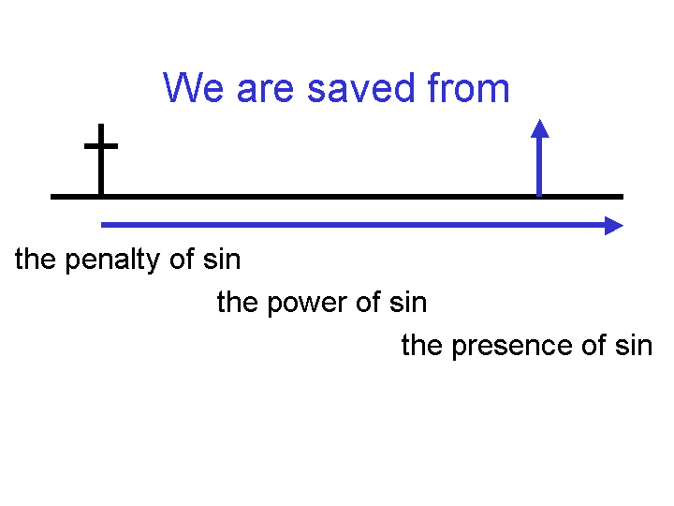

But our salvation to is centered upon the person of Jesus Christ, in whom we are!

Peter was less commonly called ‘Simon’, which may be a contraction for the Hebrew name ‘Simeon’ (Hebrew: Shimeon, meaning hearing). Genesis 29:31-33, “Now the Lord saw that Leah was unloved, and He opened her womb, but Rachel was barren. 32 Leah conceived and bore a son and named him Reuben, for she said, "Because the Lord has seen my affliction; surely now my husband will love me." 33 Then she conceived again and bore a son and said, " Because the Lord has heard that I am unloved, He has therefore given me this son also." So she named him Simeon.”
1 Corinthians 1:7-9 (NASU), “…awaiting eagerly the revelation of our Lord Jesus Christ, 8 who will also confirm you to the end, blameless in the day of our Lord Jesus Christ. 9 God is faithful, through whom you were called into fellowship with His Son, Jesus Christ our Lord.”

