1 Timothy 6:11-21

In this passage the apostle Paul is giving his final instructions to Timothy, his appointed representative in Ephesus. His instructions are in the form of a series of directions (in the imperative) and charges, interspersed with statements of spiritual truth.

1 Timothy 6:11
But flee from these things, you man of God, and pursue [practical] righteousness, godliness, faith, love [agape], perseverance [patience in circumstances] and gentleness.

This is an interesting verse: flee and pursue – what a spiritual strategy!

- What is Timothy to flee from?
- Why does Paul call Timothy “man of God”
- What are the spiritual advantages of pursuing righteousness, godliness, faith, love, perseverance and gentleness.

1 Timothy 6:12
Fight the good fight of faith [compare to 1 Timothy 1:18; 2 Timothy 4:7]; take hold of the eternal life to which you were called [compare to 1 Timothy 6:19], and you made the good confession in the presence of many witnesses [compare to 2 Timothy 2:2].

- It is fascinating that fighting the good fight is a term that Paul uses with Timothy three times, but with nobody else. Why would he do that?
- Paul tells Timothy to take hold of the eternal life to which he has been called. Is that so that Timothy becomes saved, remains saved, or… what does Paul mean anyway?
- Does making a good confession mean that Paul tells a bunch of people all of the things he has been doing wrong – every single one?

Here is Paul’s pattern of charging Timothy:

1 Timothy 5:21
I solemnly charge you in the presence of God and of Christ Jesus and of His chosen angels…

1 Timothy 6:13
I charge you in the presence of God, who gives life to all things, and of Christ Jesus, who testified the good confession before Pontius Pilate…

2 Timothy 4:1
I solemnly charge you in the presence of God and of Christ Jesus, who is to judge the living and the dead, and by His appearing and His kingdom…
- Why would Paul charge Timothy in the presence of God and Jesus Christ every single time? Why Timothy, three times, but not even once for Titus?
- “In the presence of” means literally, “before the face of”. Why is that important, and what does it mean?
- Testifying the good confession before Pontius Pilate means…? Does it have anything to do with the good confession in 1 Timothy 6:12 or is it quite different?

1 Timothy 6:14-16
…that you keep the commandment without stain or reproach until the appearing of our Lord Jesus Christ, 15 which He will bring about at the proper time--He who is the blessed and only Sovereign, the King of kings and Lord of lords, 16 who alone possesses immortality and dwells in unapproachable light [Daniel 2:19, 22], whom no man has seen or can see. To Him be honor and eternal dominion! Amen.

Compare this passage to the start of the same letter:

1 Timothy 1:17-19
Now to the King eternal, immortal, invisible, the only God, be honor and glory forever and ever. Amen. 18 This command I entrust to you, Timothy, my son, in accordance with the prophecies previously made concerning you, that by them you fight the good fight, 19 keeping faith and a good conscience [compare to 1 Timothy 6:12; 2 Timothy 4:7]…

- What ‘commandment’ is Paul writing about?
- Is the ‘appearing’ of Jesus Christ the rapture, when He comes to take His church to their heavenly home, or is it the second coming of Christ to earth?
- From “He who is blessed…” to the end of verse 16 – is that about Christ or about the Father or about God?

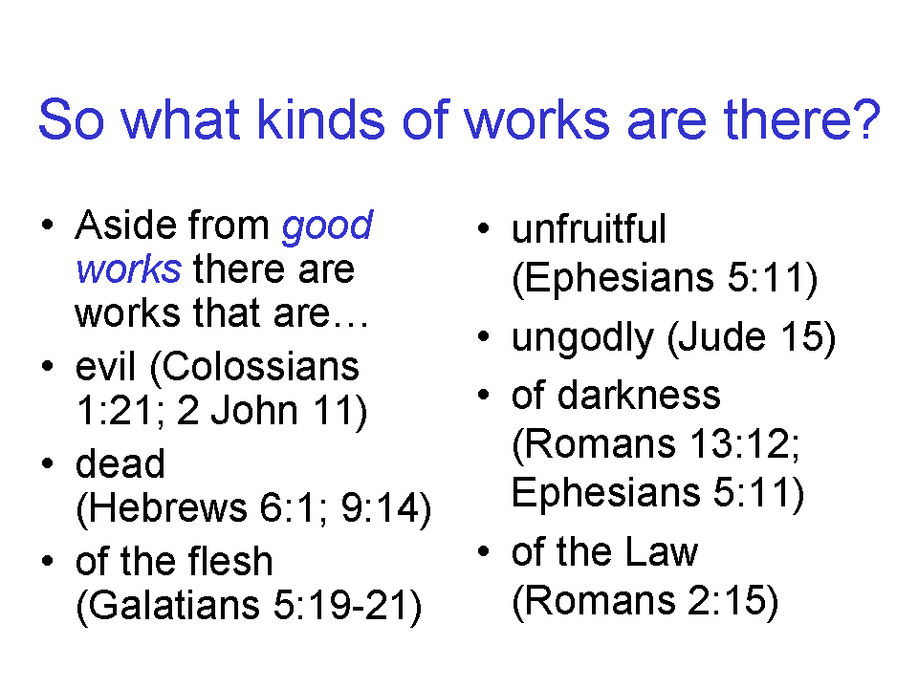
17 Instruct those who are rich in this present world not to be conceited or to fix their hope [compare 1 Peter 1:13] on the uncertainty of riches, but on God, who richly supplies us with all things to enjoy. 18 Instruct them to do good, to be rich in good works, to be generous and ready to share, 19 storing up for themselves the treasure of a good foundation for the future, so that they may take hold [a term used in winning an athletic competition; compare to 1 Timothy 6:12] of that which is life indeed.

- Where should a believer ‘fix one’s hope’?
- Should believers shun and avoid enjoyment?
- So are works good or bad?
- Should the sharing of wealth be legislated so as to enforce Christian principles upon society?
1 Timothy 6:20-22
O Timothy, guard what has been entrusted to you [compare 2 Timothy 1:14], avoiding worldly and empty chatter and the opposing arguments of what is falsely called "knowledge"-- 21 which some have professed and thus gone astray from the faith. 22 Grace be with you.

- What does it mean to be entrusted with something? Why guard it?
- See 1 Timothy 1:11 and Titus 1:3. Has Paul been entrusted or has Timothy been entrusted – which one? Exactly what is being entrusted?
- Aside from Paul and Timothy who else is able to guard what we entrust to Him, and is there a timeframe in mind for that entrusting [2 Timothy 1:12]?
- So is avoiding things just a fearful and phobic way to live, or is there some wisdom in it?
- How does a believer decide what or who to avoid?
- Is all knowledge good – or bad? How does one decide?
- Do things have to be guarded once we get to heaven? Are there hazards in heaven?
- What does Paul mean by ‘the faith’? Should we just make sure we have some kind of faith in something – even just faith in some kind of a ‘higher power’? is that what Paul has in mind?
- What does it mean for grace to be with you? Why would Paul wish this for Timothy?

The words, “man of God” is used dozens of times in the Old Testament, but is used in only two places in the New Testament – once in each letter to Timothy. The next place that Paul writes “man of God” to Timothy is 2 Timothy 3:16, 17.
2 Timothy 2:16, “But avoid worldly and empty chatter, for it will lead to further ungodliness…”; 2 Timothy 3:5, “…holding to a form of godliness, although they have denied its power; avoid such men as these.”; Titus 3:9, “But avoid foolish controversies and genealogies and strife and disputes about the Law, for they are unprofitable and worthless.”

