Titus 2:1-15

Titus 2:1
But as for you, speak the things which are fitting for sound doctrine.

Paul repeatedly used a word with Titus that is translated ‘sound’, from a Greek word from which we derive our English word ‘hygiene’. The original word implies ‘healthy’. He had used it more than once in each of his letters to Timothy. Here are the passages in Paul’s letter to Titus where he uses that word.

Titus 1:9
holding fast the faithful word which is in accordance with the teaching, so that he will be able both to exhort in sound doctrine and to refute those who contradict.

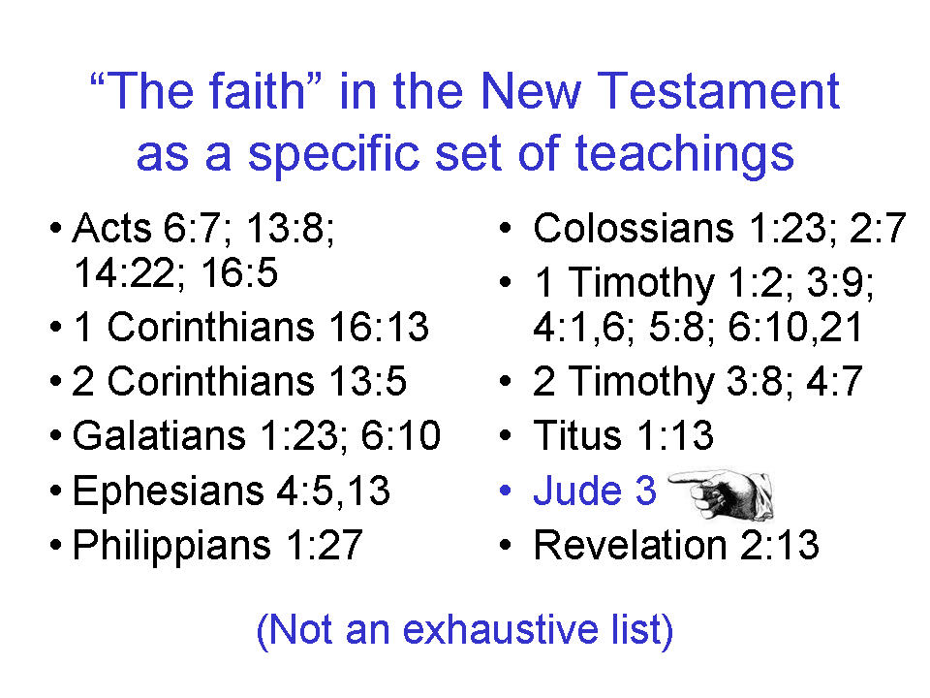
Titus 1:13
This testimony is true. For this reason reprove them severely so that they may be sound in the faith,

Titus 2:1, 2
But as for you, speak the things which are fitting for sound doctrine. 2 Older men are to be temperate, dignified, sensible, sound in [Gk: the] faith, in love, in perseverance.

Titus 2:8
…sound in speech which is beyond reproach, so that the opponent will be put to shame, having nothing bad to say about us.

- Why all the emphasis by repetition on the word ‘sound’?
- What is Paul saying is important to establish and keep as ‘sound’ in these verses?

Titus 2:2-8
Older men [Gk: presbuteros] are to be temperate, dignified, sensible, sound in [Gk: the] faith, in [Gk: the] love, in [Gk: the] perseverance. 3 Older women [Gk: presbuteras] likewise are to be reverent in their behavior, not malicious gossips nor enslaved to much wine, teaching what is good, 4 so that they may encourage the young women to love [phileō: an affectionate attachment] their husbands, to love their children, 5 to be sensible, pure, workers at home, kind, being subject to their own husbands, so that the word of God will not be dishonored. 6 Likewise urge the young men to be sensible; 7 in all things show yourself to be an example of good deeds, with purity in doctrine, dignified, 8 sound in speech which is beyond reproach, so that the opponent will be put to shame, having nothing bad to say about us.
Paul gives instruction on roles and moral and spiritual character according to age and gender (older men, older women, younger women, younger men). Note carefully what Paul says to each group, and how he says it. These points of moral and spiritual character directed believers in ways that stood in contrast to the prevailing secular culture.
Paul also directs Timothy to stand out as an example (Gk: tupos, from which we get our word ‘type’ – see PowerPoint slide set and slides included on page 4 of this handout).

- If ‘in Christ’ there is neither male nor female (Galatians 3:28), why does Paul make male and female distinctions in this passage? Is Paul a chauvinist?
- Should we set aside the contents of this passage as irrelevant in today’s culture?
- If there is neither male nor female (in the earthly sense) in eternity (Matthew 22:30), why should maleness and femaleness make any difference while we are here on earth?
- Are women never to teach in the church or among the body of Christ (see verse 3 above)? Should women be prohibited from learning about spiritual things (1 Corinthians 14:31, 35; Philippians 4:9; 1 Timothy 2:11)?

- Why are women never told to agapeo love their husbands, while husbands are told repeatedly to agapeo love their wives (as in Ephesians 5:21-33)?
- Considering the prior question, why are younger women to be encouraged to phileo love their husbands – and their children?
- Is Paul totally against younger women being single (not being married)?
- How do we know this?

- What is the value of imitating and having examples in the body of Christ?
- How is this different from ‘faking it’, and ‘just acting’?
- What is the value in Paul’s words like, “so that the word of God will not be dishonored”, and, “beyond reproach so that the opponent will be put to shame having nothing bad to say about us.”?
- How is this different from just trying to superficially impress people?

Titus 2:9-10
Urge bondslaves to be subject to their own masters in everything, to be well-pleasing, not argumentative, 10 not pilfering, but showing all good faith so that they will adorn [Gk: kosmos, from which we get our word ‘cosmetics’] the doctrine of God our Savior in every respect.

- Why doesn’t Paul try to rid the society of slavery?
- In view of the presence of this passage in Scripture, shouldn’t we try to reinstitute slavery in our own culture – just not on a racial basis? Why or why not?
- Which parts of the above passage are stated positively, and which are stated negatively? Why are the negative statements there?
- Should we shun a focus on doctrine in the church? Why or why not?
- Are the words, “so that they will adorn the doctrine of God our Savior in every respect.” similar to, “so that the word of God will not be dishonored”, and, “beyond reproach so that the opponent will be put to shame having nothing bad to say about us.”?
- Why does Paul keep harping on how things look to others outside the church?
Titus 2:11-14
For the grace of God has appeared, bringing salvation to all men, 12 instructing us to deny ungodliness and worldly desires and to live sensibly, righteously and godly in the present age, 13 looking for the blessed hope and the appearing of the glory of our great God and Savior, Christ Jesus, 14 who gave Himself for us to redeem us from every lawless deed, and to purify for Himself a people for His own possession, zealous for good deeds.

The words, “our great God and Savior, Jesus Christ” are in a construction in the Greek text that says that God and our Savior Jesus Christ are one in the same.

- How has the grace of God appeared?
- Does verse 11 say that everybody is or will be saved?
- What parts of the above passage are focused upon the past? The present? The future?
- With all of the emphasis on works - deeds – is Paul teaching a doctrine of good works?
- What is the nature of a believer’s hope? Can we have our ‘hopes dashed’?

Titus 2:15
These things speak and exhort and reprove with all authority. Let no one disregard you.

The word ‘Let’ does not mean ‘allow’ anywhere from the book of Acts on to Revelation. Both of these sentences are imperatives in the Greek text.

- Why is what Titus is to teach not to be regarded as mere suggestions, advice, a preferred opinion, or just a personal recommendations?
- Is Titus told to be a church dictator, carrying these things out with absolute dictatorial authority and severe and irresistible enforcement of every point?
- Are Paul’s instructions to Titus loving?
- What is the basis of Titus’ authority?
