The Bible: God’s special progressive revelation

In this Bible Survey elective, we will begin by taking four Sundays to examine the character of the Bible:

Jan No. Topic

5 01 The Bible: God’s special progressive revelation

12 02 The Bible: The inspired, inerrant word of God

19 03 The Bible: The canon of Scripture & how it’s to be interpreted
26 04 The Bible: Alive, powerful & transforming

One of the reasons for taking a look at the Bible as a whole first is because the Bible is not an accident of human history, but God’s deliberate and special revelation to mankind, along with Jesus Christ Himself, both grace-given because He loves us.

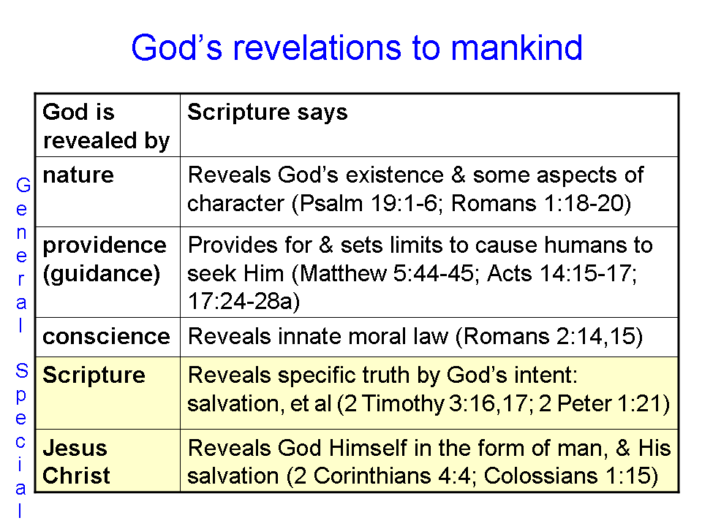

Scripture indicates that God has revealed Himself in five ways: the General Revelations of nature, providence, and conscience, and the Special Revelations of Scripture and Jesus Christ. So the Bible is God’s special revelation in which God intentionally reveals specific truths to us.

The Principles of Progressive Revelation

In summary, the Bible is composed of 66 books, written by about 40 authors, almost all of whom were Jewish, over a period of about 1500 years. It is that last statement that we want to focus upon now. God did not do an instant ‘flash’ revelation where He gave all of what He wished to reveal at one point in time. Instead, God revealed Himself over time, writing through human authors by the instrumentation of the Holy Spirit.

2 Timothy 3:16-17
All Scripture is inspired by God and profitable for teaching, for reproof, for correction, for training in righteousness; 17 so that the man of God may be adequate, equipped for every good work.

2 Peter 1:20-21
But know this first of all, that no prophecy of Scripture is a matter of one's own interpretation, 21 for no prophecy was ever made by an act of human will, but men moved by the Holy Spirit spoke from God.

Principle 1 – What do we know now?

In the two supplements on the Chronology of the Old Testament, and the Chronology of the New Testament, we can see the time and duration of writing of the books of the Bible. As we proceed through the Bible chronologically, we can ask the question at various points in time, “What had God revealed to mankind up to this point?” as well as, “What would God reveal later that is not revealed to mankind up to this point?”

Principle 2 – What do we know about the future?

In parallel with the principle of progressive revelation above there is also a matter of progressive prophesy, which is revealed in Scripture. As we proceed through the Bible chronologically, we can ask the question at various points in past time, “What had God prophesied up to this point?” as well as, “What would God prophesy in the future that is not revealed to mankind up to this point?” and, “What fulfillment of prophesy is revealed in Scripture up to this point?

Principle 3 – What do we know about the past?

Then there is also progressive revelation about the past. We’re told, for example, about Adam and death in the early chapters of Genesis, but we’re not told that all mankind is ‘in Adam’ and therefore all die until 1 Corinthians 15:22. We’re told about Moses leading the Israelites under the cloud and through the sea in Exodus chapters 14 and 15. But we’re not told that the Israelites were baptized into Moses until 1 Corinthians 10:2. The directions about the Passover lamb are given in Exodus 12, but 1 Corinthians 5:7 says explicitly that Christ is our Passover who has been sacrificed. Exodus 17 tells about how God, through Moses, gave the Israelites water from the rock. But 1 Corinthians 10:4 tells us that the rock was Christ.
These principles of progressive revelation are essential insights to properly understand Scripture. And this leads us to the next principle of progressive revelation.

Principle 4 – Revelation is progressive until it is complete.

The Old Testament revelation was progressive until the last prophet wrote, which was Malachi, written about 450 to 430 BC (some would end Malachi at about 400 BC). Any attempt to add to the 39 Old Testament books was false on one or more levels, since the line of prophets had ended. The Apocrypha includes a number of those false revelations.

“From the days of Artaxerxes [465-425 B.C.] to our own time every event has indeed been recorded. But these recent records have not been deemed worthy of equal credit with those which preceded them, because the exact succession of the prophets ceased. But what faith we have placed in our own writings is evident by our conduct; for though so great an interval of time (i.e. since they were written) has now passed, not a soul has ventured either to add, or to remove, or to alter a syllable. But it is instinctive in all Jews at once from their very birth to regard them as commands of God, and to abide by them, and, if need be, willingly to die for them.” - Josephus, writing in ‘Against Apion’ about 90 AD

The New Testament revelation was progressive until the last book was written by the apostle John: The Book of Revelation. Any attempt to add to those 27 books – and there have been many – is false. All of the New Testament books were either written by an apostle (Matthew, John, Paul, etc.) or were sponsored by an apostle (Mark by Peter and Paul, Luke by Paul, James by the apostles in Jerusalem, etc.). Here are the five biblical qualifications of an apostle (a special messenger appointed by Christ):

- Had success in evangelism: 1 Corinthians 9:2; 2 Corinthians 3:1-3; Galatians 2:7-9
- Had the capacity to suffer patiently – to persevere in trial: 2 Corinthians 12:12
- Received his gift & office by a sovereign decision of God: 1 Corinthians 1:1; Ephesians 1:1
- Had to have been an eyewitness of the resurrected Jesus Christ: Acts 1:22; 1 Corinthians 9:1
- Endowed with power to perform signs, wonders & miracles: 2 Corinthians 12:12

God has completed the revealing through His Son and those he elected to serve as contemporary witnesses (Hebrews 1:2). Jude 3, Revelation 22:18, 19, 1 Corinthians 4, Hebrews 2:1-4, Ephesians 2:20 & 3:4, 5 all speak of the finality of apostolic era revelation (among other passages). There are no more apostles, since no others qualify biblically, as outlined above.

So the Bible is God’s love-letter to us, that took 1500 years to complete.

