The Bible: The canon of Scripture & how it’s to be interpreted

The Canon – should we stand in front of it, stand behind it, or stand on it?

Canonization refers to the recognition of which documents were inspired, and not the authoritative declaration of what was inspired. There was a recognition of which documents were inspired and which were to be excluded because of the lack of evidence of inspiration. So canonization is the second link in the four link chain, which assumes the first link of inspiration, without which canonization cannot take place.

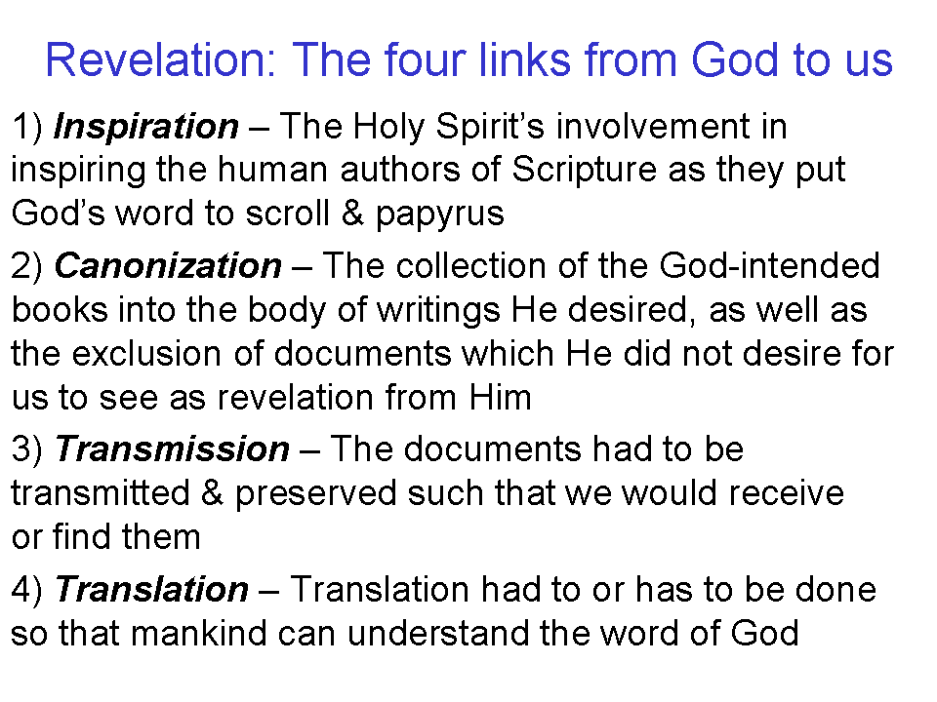
By New Testament times, the canon of the Old Testament had already been well established, although the Sadducees held only to the inspiration of the first five books of the Old Testament. Josephus, writing before the end of the first century, writing from a perspective that did not reflect the view of the minority Sadducees, who had effectively been ended by the Roman destruction of the temple prior to the time of Josephus’ writing:

From the time of Artaxerxes, moreover, until our present period, all occurrences have been written down but they are not regarded as entitled to the like credit with those which precede them, because there was no certain succession of prophets. Fact has shown what confidence we place in our own writings. For although so many ages have passed away, no one has dared to add to them, nor to take anything from, nor to make alterations. In all Jews it is implanted, even from their birth, to regard them as being the instructions of God, and to abide steadfastly by them, and if it be necessary, to die gladly for them.”

Various references in the New Testament to the books of Moses, the Law and the Prophets, and the Psalms, were spoken of as if the books were well recognized (Matthew 5:17; 7:12; Luke 24:44, etc.), there being no discussions recorded in the New Testament debating the Old Testament books among the Pharisees, nor questioning which books were meant.
As is apparent in the New Testament books, the canonizing activities regarding the New Testament books began even while the apostles were on the scene:

• Selecting and verifying of contents (John 20:30; 21:23-24; Luke 1:1-4; 1 John 1:1-4)

• Public reading of Scripture (1 Thessalonians 5:27; 1 Timothy 4:13; Revelation 1:3)

• Circulation of Scripture (Colossians 4:16; 2 Peter 3:15-16; Revelation 1:11)

• Determination of what was in the “canon” and what was not (2 Timothy 2:15; 3:16-17; Hebrews 4:12 – “the word”)

• Quoting of New Testament Scripture (1 Timothy 5:18, Paul quoting from Luke 10:7)

See the accompanying supplemental chart for the acceptance sequence in the early church. The matter of canonicity took final focus when Athanasius (295-373) wrote in 367 AD, listing the present 27 books of the New Testament canon. He was also the first to use the word “canon” in reference to the New Testament. Church councils at Hippo (393 AD) and Carthage (397 and 419 AD) each confirmed the present list of 27 New Testament books. The books recognized as included in the New Testament canon were measured by the following four criteria:

1) Apostolicity: was the book written by an apostle or apostolic associate (requiring also, of course, that the book was of the Apostolic era)?
2) Spirituality: were the contents of a given book of such a spiritual character as to entitle it to this rank?
3) Universality: was the book universally received in the church?
4) Inspiration: did the book give evidence of being divinely inspired?

There are several lines of reasoning that lead to the conclusion that the New Testament canon is now closed:

• God has completed the revealing through His Son & those He elected to serve as contemporary witnesses (Hebrews 1:2).

• Jude 3, Revelation 22:18,19, 1 Corinthians 4, Hebrews 2:1-4, Ephesians 2:20 & 3:4,5 all speak of the finality of apostolic era revelation (among other passages).

• There are no more apostles, since no others qualify biblically (Acts 1:22; 1 Corinthians 1:1; 9:1,2; 12:18; 2 Corinthians 3:1-3; 9:2; 12:12; Galatians 2:7-9; Ephesians 1:1; Colossians 1:1; Hebrews 2:4).

For further reading on the canon of Scripture, you may consult: Introduction to Bibliology, by Hampton Keathley III at www.bible.org; A General Introduction to the Bible, by Geisler & Nix, 1986, pages 21-297; The Canon of Scripture, by F. F. Bruce, 1988; Major Bible Themes, by Chafer & Walvoord, 1974, pages 16-24 (except to note that verbal plenary inspiration is not a theory).
Interpretation of Scripture

Here is the paragraph in the Holly Hills Bible Church doctrinal statement that addresses interpretation:

Dispensational Interpretation – We believe that Scripture is to be interpreted according to its grammatical and historical context, including that God, Who does not change, deals in a different manner with the Gentile nations, the people of Israel, and the God-created body of heavenly saints called “the Church”. We believe that all who are saved of all time are saved entirely by faith in Christ, either looking forward or back to the cross. (John 14:6; Acts 4:12; Romans 11:1, 2; 1 Corinthians 9:17, 10:32; Ephesians 1:10, 2:11-22, 3:2; Colossians 1:25)

Let’s approach these words concept by concept:

Scripture is to be interpreted according to its grammatical and historical context

Each word, verse and passage has a context in which it was written. So a contextual interpretation of Scripture considers the elements of language, history and culture that allow us to understand:

- What did the author intend to convey?
- What did the intended readers of the book of the Bible understand by what the author wrote?
- What did God, the ultimate author of Scripture, intend to convey?

Scripture itself often has the insights into language, history and culture that we need to start with, and then other tools can supplement the essential resource of Scripture.

God, Who does not change, deals in a different manner with the Gentile nations, the people of Israel, and the God-created body of heavenly saints called “the Church”.

God does not change, Scripture says, so He is consistent. In contrast, Open Theism says that God does change, and God does not know the future. As a consequence, prophecy can be fallible, God can change His mind, and God’s promises cannot necessarily be counted upon, because God does not know everything that might impact His promises. So we will reject the Open Theist’s approach to interpretation of Scripture.

The Gentiles first show up in Scripture in Genesis chapter 1. The roots of the people of Israel begin in Genesis chapter 12 and continue through Genesis chapter 50. Though Jesus talked about the church towards the end of each of the gospels, the church began on the day of Pentecost as recorded in Acts chapter 2. Gentiles and Israel are ethnic and earthly distinctions, and some are saved and some are not saved from these two ethnic groups. The church consists only of those who are saved, and who have a heavenly position, and ethnicity is of no consequence. All three groups continue to maintain a separate identity through the end of the present heavens and earth, and on into eternity in the new heavens and new earth.

We believe that all who are saved of all time are saved entirely by faith in Christ, either looking forward or back to the cross.

There are those who will get confused and/or make assumptions, and who think that having three different bodies of people means that we believe that different people are saved by different means. That of course, is not true. Salvation is by faith always, from Adam to the last person born on planet earth.

Blessing, however, can be different from one group to the next:

- Adam and Noah were both blessed by God and both told to be fruitful and multiply.
- Israel, from the time of Moses, was blessed as they obeyed the Law of Moses.
- The church is blessed with every spiritual blessing in the heavenly places in Christ.

The blessings of Adam and Noah and Israel were earthly, and Israel’s blessing under the Law of Moses was conditional. But the blessings of the church are unconditional and heavenly and in Christ.
________________________________________________________________________

For more resources on the canon of Scripture go to:

www.hollyhillsbiblechurch.org
under ‘Archived Series’ select

Bible Backgrounds/Church History 2012
Lesson 30 has audio and a handout on the canon of Scripture

For more on the interpretation of the Bible:

www.hollyhillsbiblechurch.org
under ‘Archived Series’ select
How to Study the Bible 2007
There is a 13 part series of audio files and handouts.

Which is why Jesus responded to their question out of one of the five books that they considered inspired (Matthew 22:23-33).
Contra Apion 1.8 ¶¶38–42; other English translations end the first sentence with, “…the exact succession of the prophets ceased”. See A General Introduction to the Bible, by Geisler & Nix, 1986, pages 205-206.

