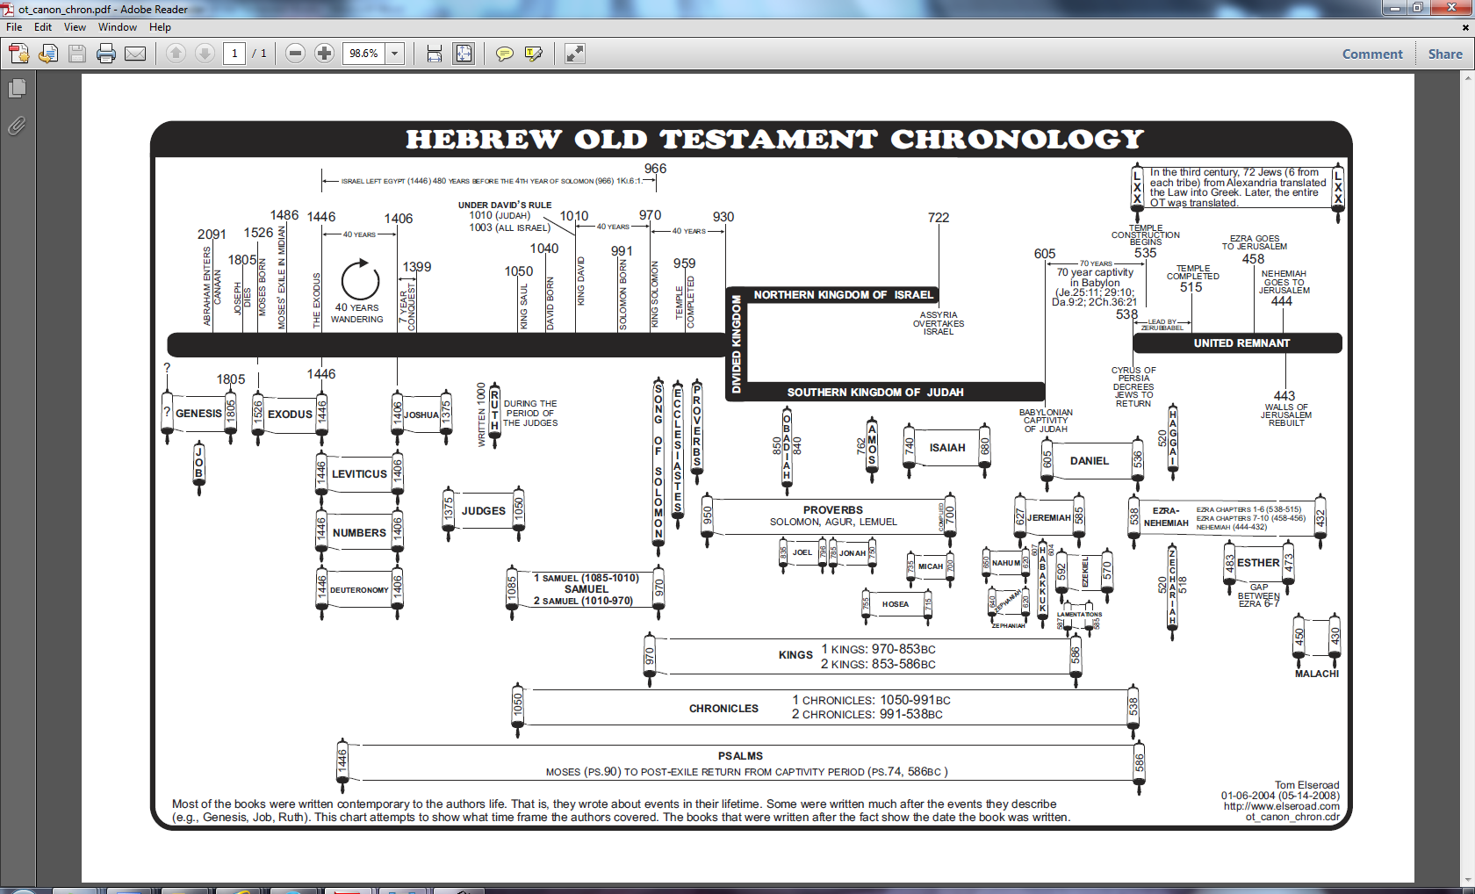
Many of the Psalms can be identified by time & author (e.g., Moses, Psalm 90, 1446 BC)

