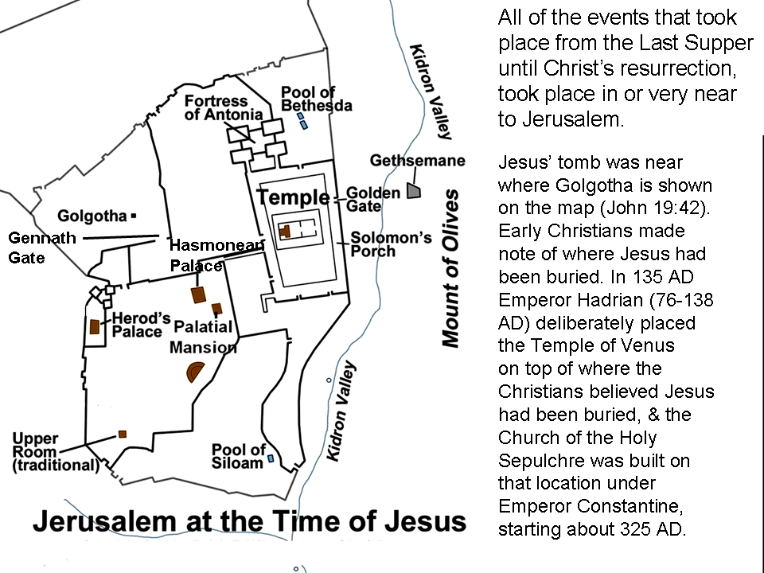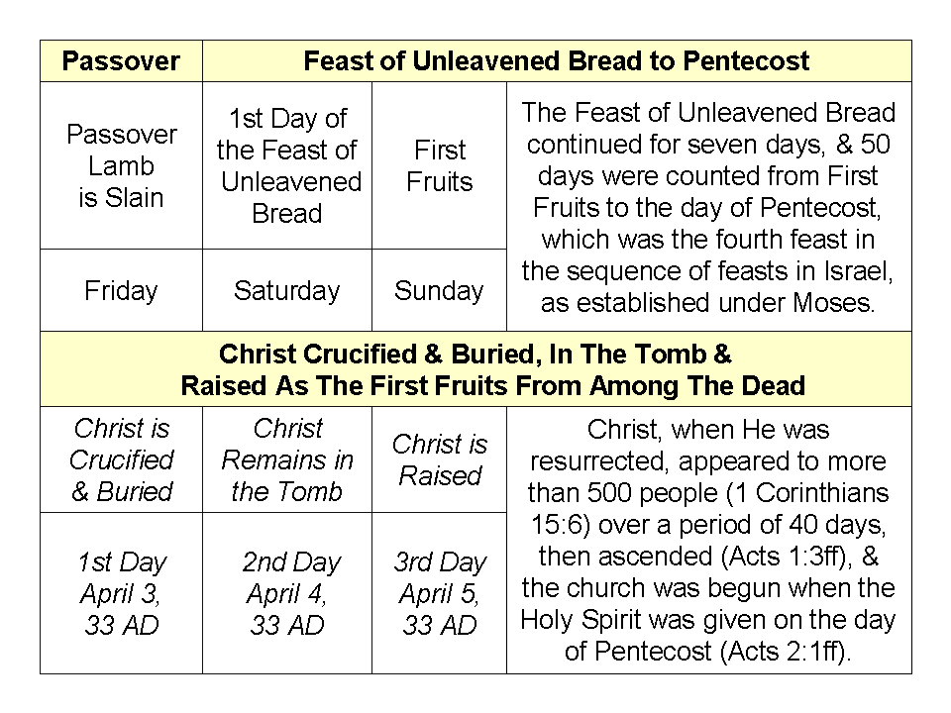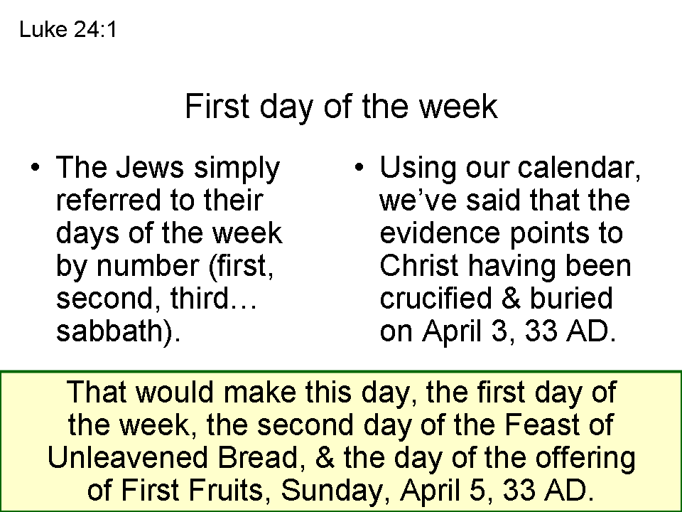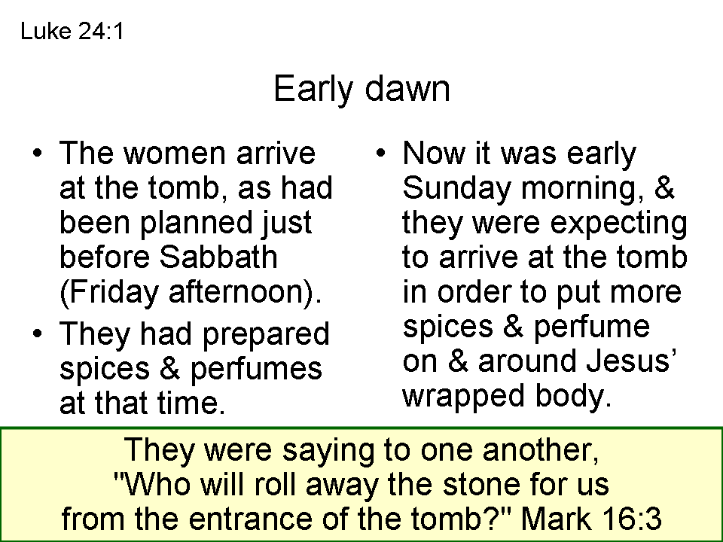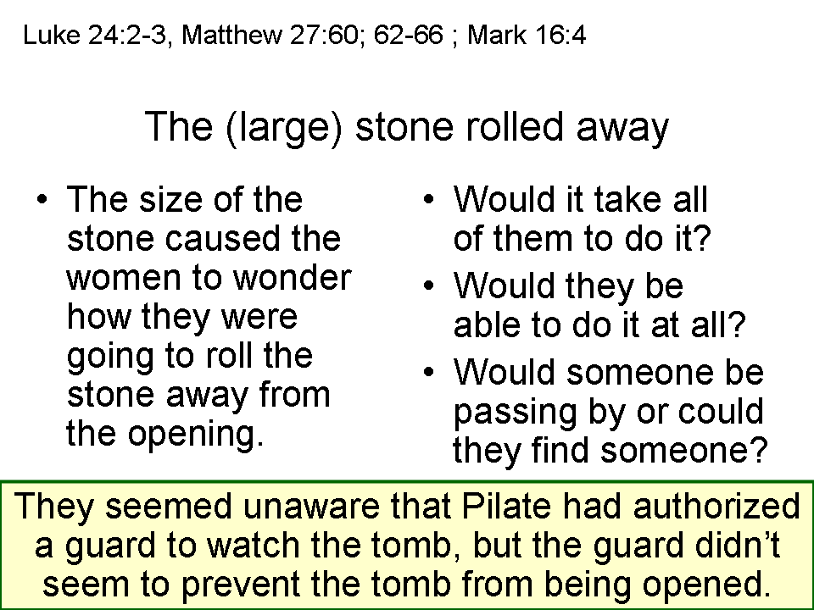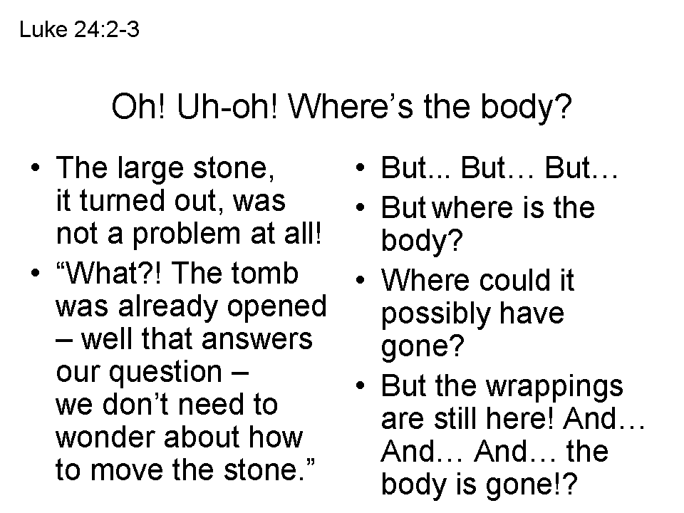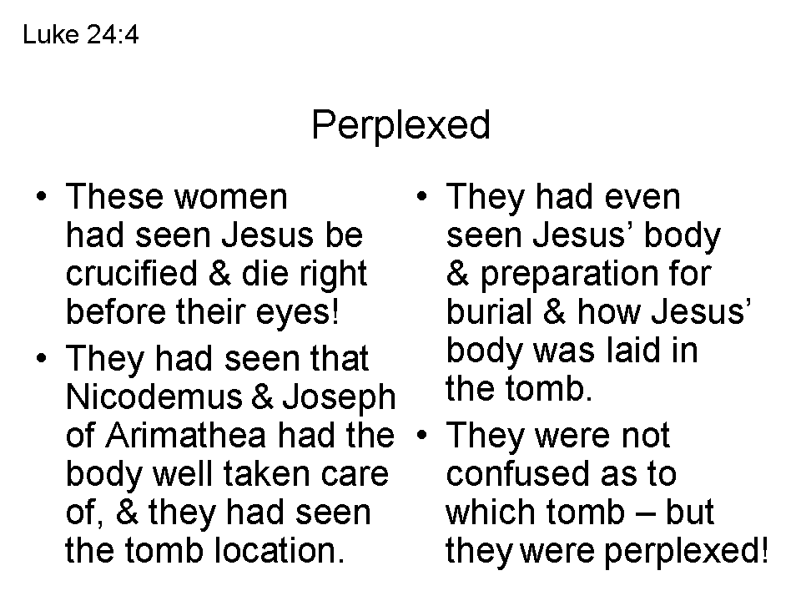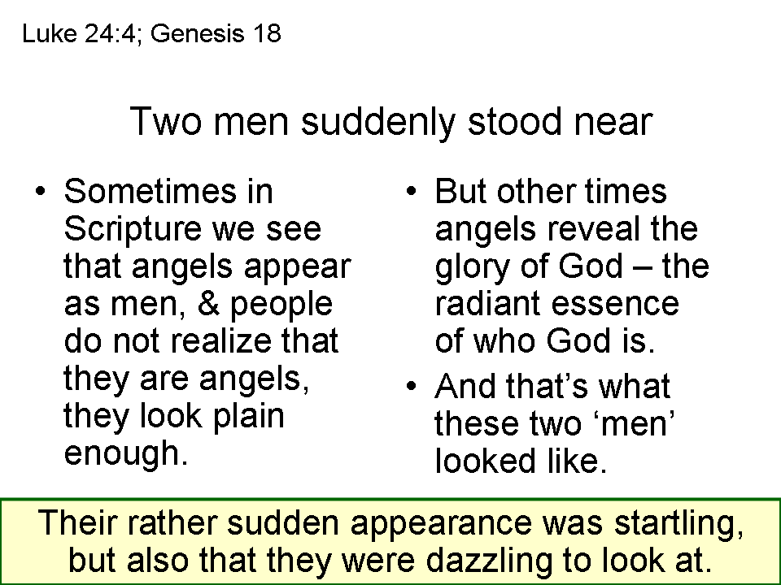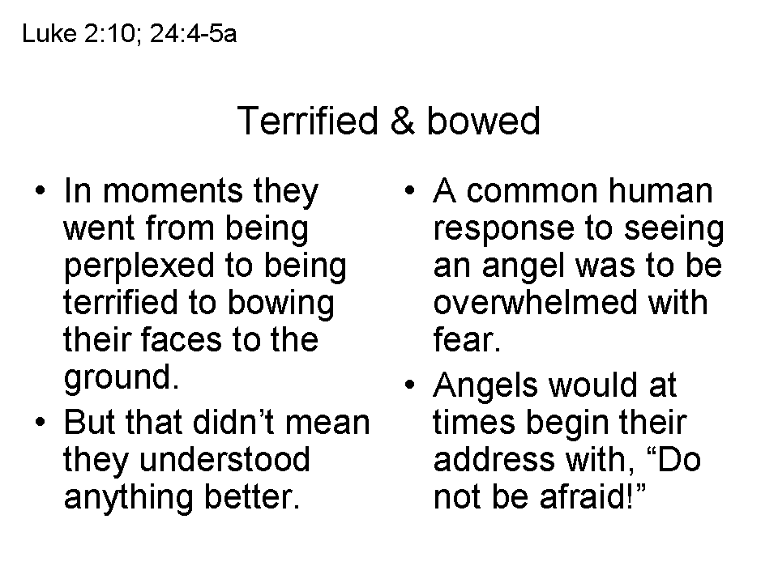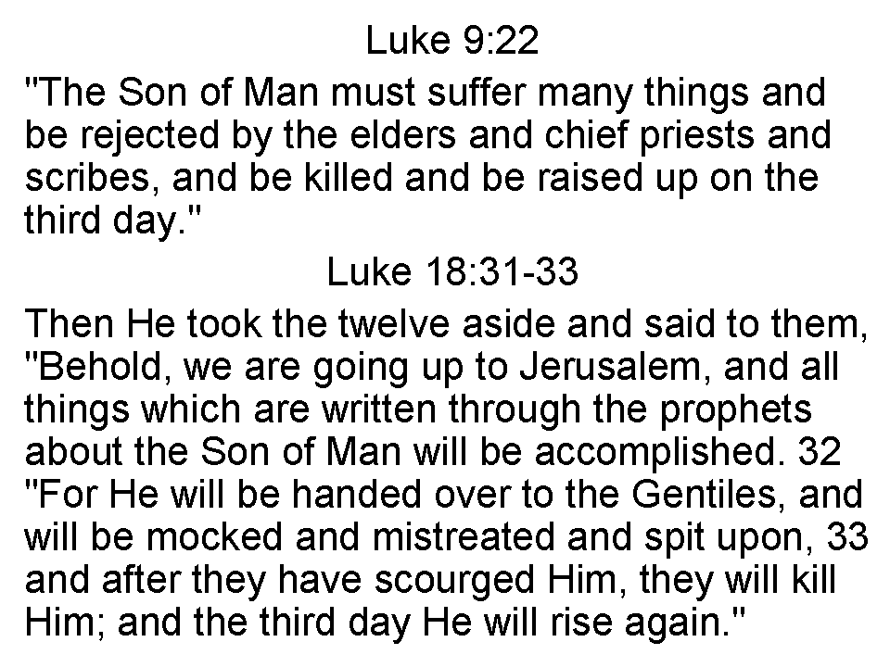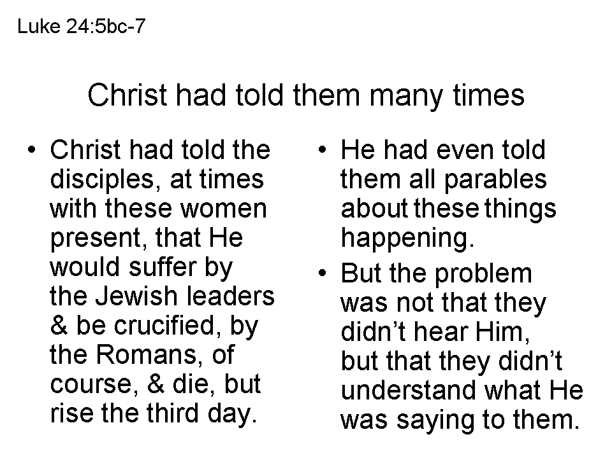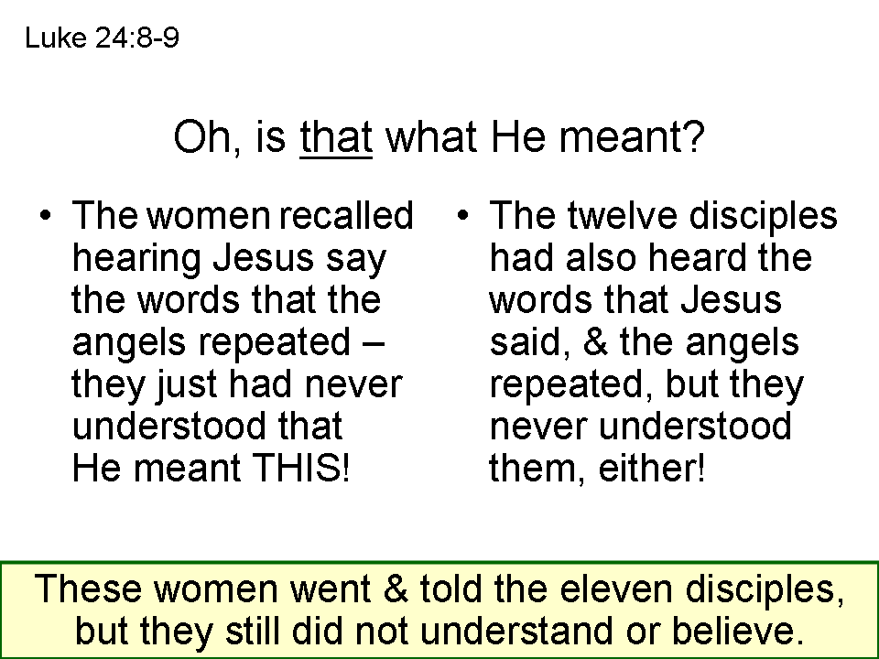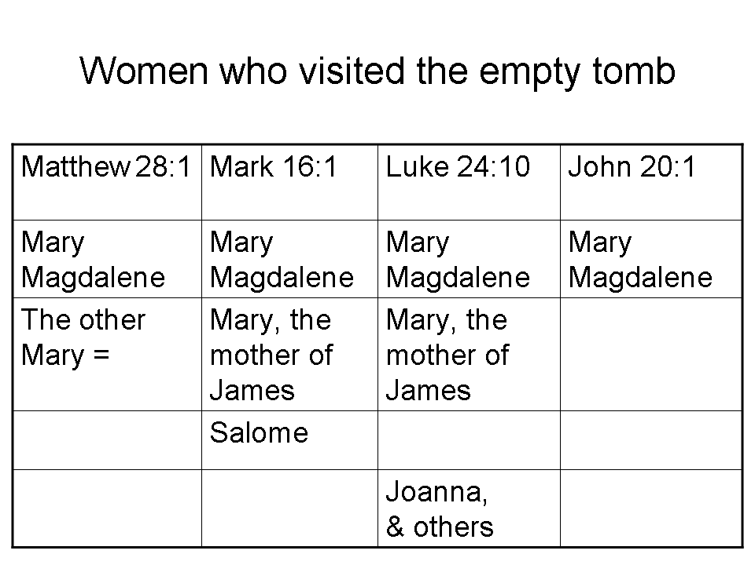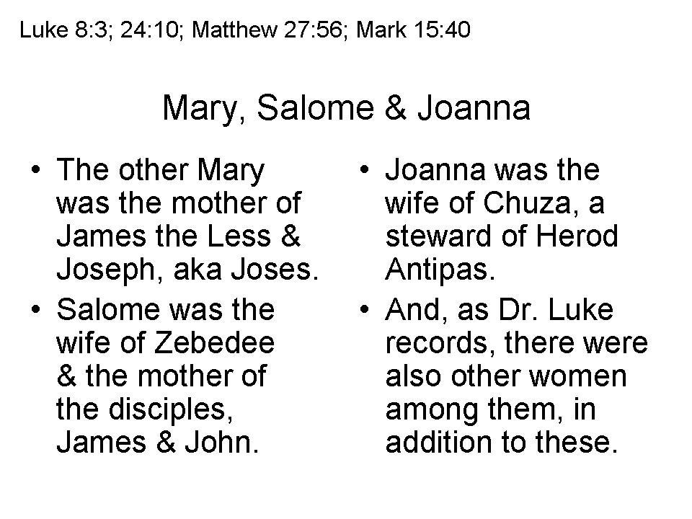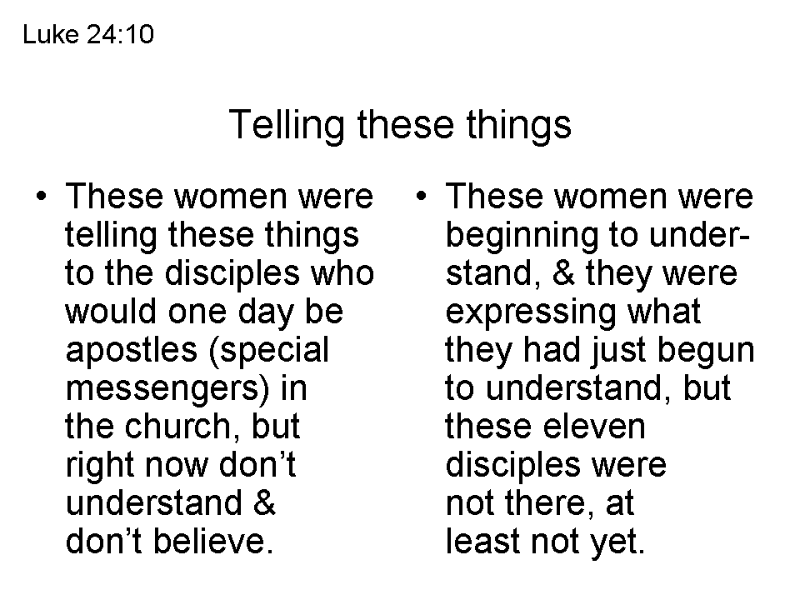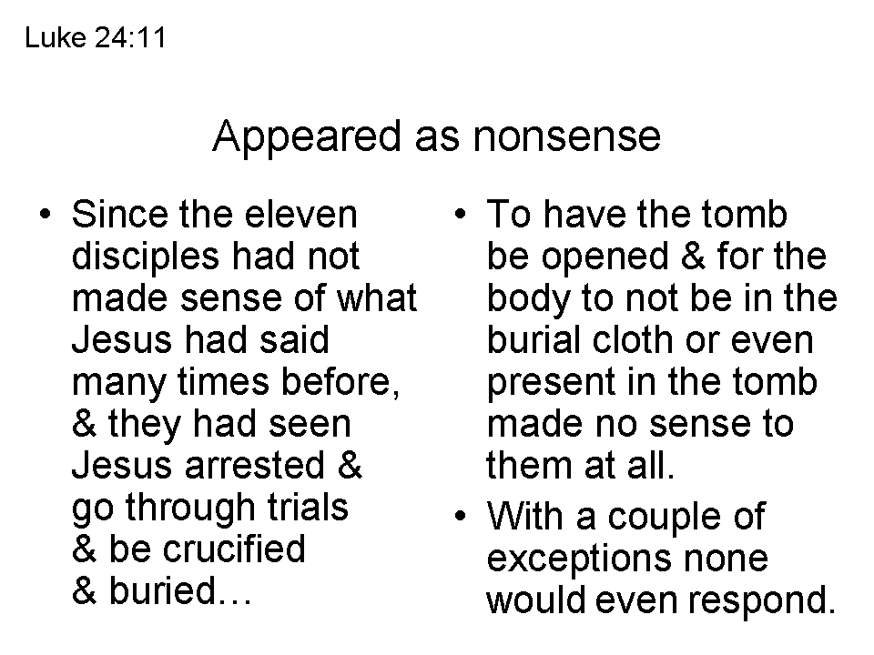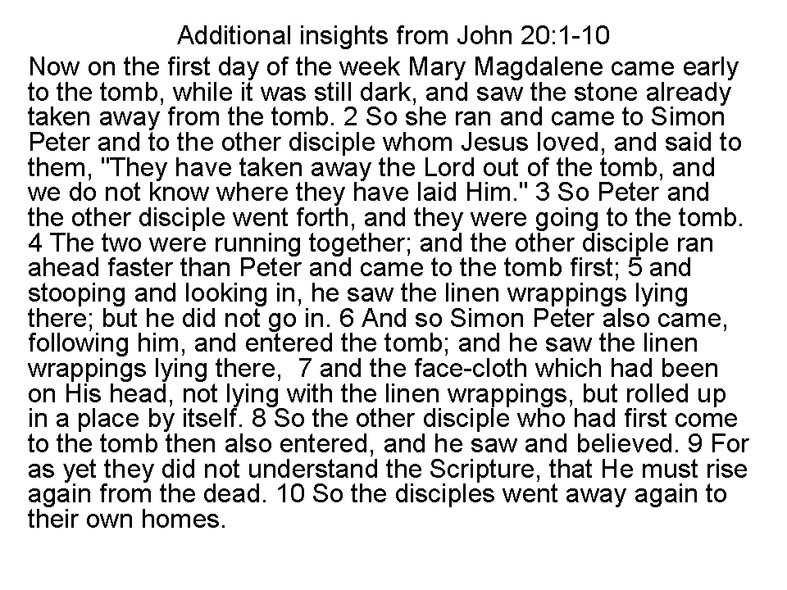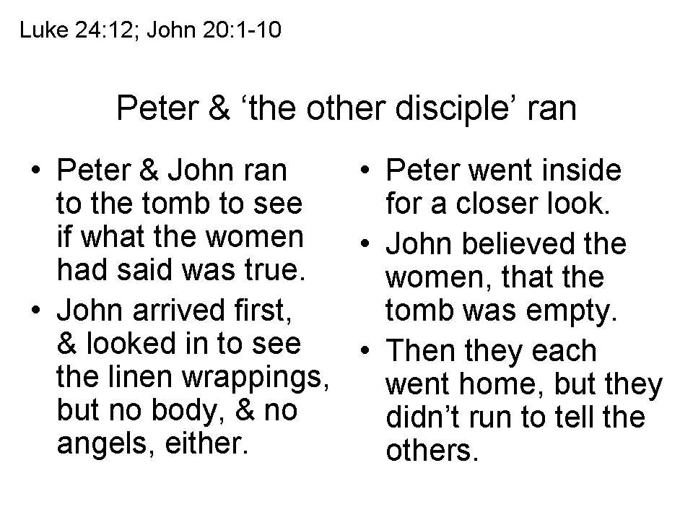
The Resurrection of Christ – A Summary of the Passages

The Empty Tomb
Day | Subject/Other Features | Scriptures
Sunday | The Tomb visited by the women: Mary  Magdalene, Mary the mother of James, Salome | Matthew 28:1; Mark 16:1
Sunday | The stone rolled away, allowing witnesses to  see the empty tomb | Matthew 28:2-4
Sunday | The tomb found empty by the women, at about  the time of sunrise (Luke: early dawn) | Matthew 28:5-8; Mark 16:2-8;  Luke 24:1-8; John 20:1
Sunday | The tomb found empty by Peter & John; grave  clothes arranged consistent with resurrection | Luke 24:9-11, 12; John 20:2-10
Post-Resurrection Appearances
Day | Appearance To Whom & Summary Info | Scriptures
Sunday | Mary Magdalene; Jesus predicts His ascension | Mark 16:9-11; John 20:11-18
Sunday | The other women; instruction to meet in Galilee | Matthew 28:9-10
Sunday | Report of the soldiers to the Jewish authorities;  Sanhedrin’s absurd explanation | Matthew 28:11-15
Sunday | The two disciples traveling to Emmaus who  didn’t believe the report about the empty tomb | Mark 16:12-13; Luke 24:13-32
Sunday | Report of the two disciples to the rest, including  an appearance to Peter; Paul also reported  another appearance to Peter | Luke 24:33-35; 1 Corinthians 15:5a
Sunday | Ten disciples, revealing characteristics of Jesus’ resurrected body | Mark 16:14; Luke 24:36-43;  John 20:19-25
Sunday, a  week later | The eleven disciples, in which Thomas’ doubt  is removed | John 20:26-31  1 Corinthians 15:5b
Some time later | Seven disciples fishing in Galilee; Peter told to  feed & care for His sheep | John 21:1-25
Still later | The eleven in Galilee, then to the 500+; Great  Commission to large number of followers | Matthew 28:16-20; Mark  16:15-18; 1 Corinthians 15:6
Still later | James, Jesus’ brother, who becomes a believer | 1 Corinthians 15:7; John 7:1-5
40 Days after resurrection | The disciples in Jerusalem, who are told to wait  for the coming of the Spirit | Luke 24:44-59; Acts 1:3-8
After His ascension | To Stephen, Saul, later called Paul, & to John | Acts 7:55-56; 9:3-6; 20:24;  22:17-21; 23:11; 26:17; Galatians  1:12, 17; Rev. 1:12-20

To summarize: there were several recorded testimonies to the empty tomb, including multiple instances of simultaneous witnesses, and at least eleven recorded instances of witnessing Christ’s resurrected body in the 40 days after the resurrection, with witnesses numbering from one to over five hundred, and three witnesses to Christ’s resurrection after His ascension. To these we can add the persistent public testimonies to the resurrection, often spoken among other witnesses in the very same locality (Acts 2:24, 32; 3:26; 4:10; 5:30-32; 10:39-42, et al), and the personal testimony of Peter in writing (1 Peter 1:21), who saw the empty tomb right after Christ was resurrected, and saw and spoke to Him in His resurrected body multiple times, up to the day of Christ’s ascension.
