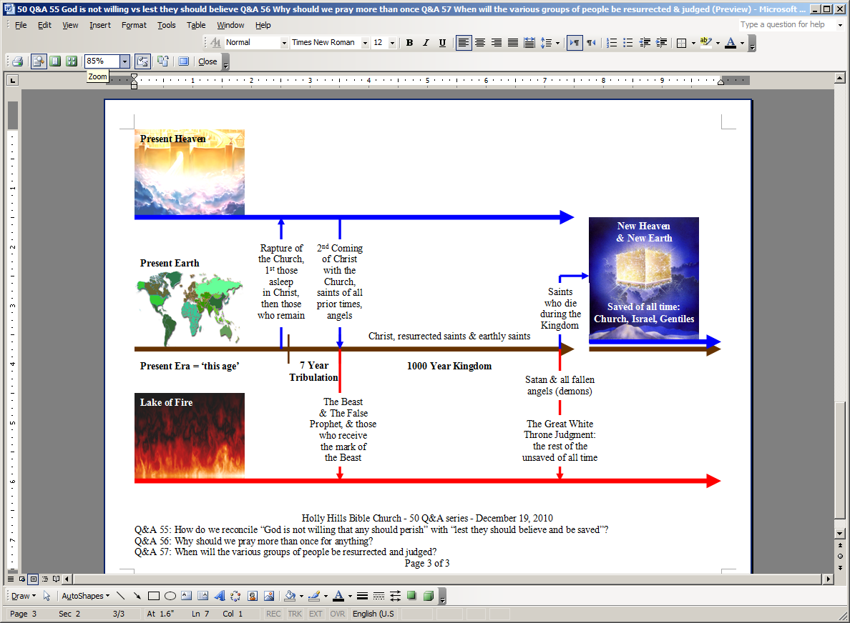
Future Things: Key Places, Events, Resurrections, Judgments & People Groups
Text of ‘New Heaven & New Earth’ is on top of copyrighted artwork by Pat Marvenko Smith. Right to use has been purchased.

