A Biblical Look at Truth

Vocabulary:

- Philosophy – the love of wisdom; the study of the fundamental nature of knowledge, reality, and existence; a particular system of philosophical thought.
- Epistemology – The branch of philosophy that studies the nature of knowledge, its presuppositions and foundations, and its extent and validity
- Wisdom - The ability to discern or judge what is true, right, or lasting
- Logic – The study or use of reason

What is Truth?

Characteristics of the Christian definition of Truth:
- Truth is a characteristic of God Himself.
- Truth exists only because God created it in the universal realm. Truth outside of God Himself cannot exist outside of God’s creation and expression of it.
- Truth is Propositional – can be stated in propositions or ‘true or false statements.’ The Bread is made with wheat. The bread is either made with wheat or not made with wheat.
- Truth is absolute.
- Directly corresponds with the way things are. For example if the Bible says that Christ rose on the third day then His corpse miraculously arose on the third day.

Insightful Passages on Truth

Romans 1:18-25
For the wrath of God is revealed from heaven against all ungodliness and unrighteousness of men who suppress the truth in unrighteousness, 19 because that which is known about God is evident within them; for God made it evident to them. 20 For since the creation of the world His invisible attributes, His eternal power and divine nature, have been clearly seen, being understood through what has been made, so that they are without excuse. 21 For even though they knew God, they did not honor Him as God or give thanks, but they became futile in their speculations, and their foolish heart was darkened. 22 Professing to be wise, they became fools, 23 and exchanged the glory of the incorruptible God for an image in the form of corruptible man and of birds and four-footed animals and crawling creatures.

24 Therefore God gave them over in the lusts of their hearts to impurity, so that their bodies would be dishonored among them. 25 For they exchanged the truth of God for a lie, and worshiped and served the creature rather than the Creator, who is blessed forever. Amen.
- What does this say about the starting point for the non-believer in being able to define and clearly articulate truth?
- What are some of the quality ‘trade-offs’ between God and creation? What characteristics does God have compared to the characteristics of His creation?
- Is there hope for these corrupt people?

Conclusion: Mankind, due to the corruption of sin, is incapable of finding truth on his own. God revealed truth but most of mankind rejected it.

Ephesians 4:11-16
And He gave some as apostles, and some as prophets, and some as evangelists, and some as pastors and teachers, 12 for the equipping of the saints for the work of service, to the building up of the body of Christ; 13 until we all attain to the unity of the faith, and of the knowledge of the Son of God, to a mature man, to the measure of the stature which belongs to the fullness of Christ. 14 As a result, we are no longer to be children, tossed here and there by waves and carried about by every wind of doctrine, by the trickery of men, by craftiness in deceitful scheming; 15 but speaking the truth in love, we are to grow up in all aspects into Him who is the head, even Christ, 16 from whom the whole body, being fitted and held together by what every joint supplies, according to the proper working of each individual part, causes the growth of the body for the building up of itself in love.

Ephesians 4:20-21, 25
But you did not learn Christ in this way, 21 if indeed you have heard Him and have been taught in Him, just as truth is in Jesus, … 25 Therefore, laying aside falsehood, speak truth each one of you with his neighbor, for we are members of one another.

- What has God done to preserve the truth within the Church?
- How are we supposed to deliver the truth?
- What is the result of truth within the body?
- What does this say about denominationalism and separation of believers based on doctrinal differences?

2 Timothy 2:15
Be diligent to present yourself approved to God as a workman who does not need to be ashamed, accurately handling the word of the truth.

- Who is this written to?
- How should this affect the believer when the believer looks for a church home?

2 Timothy 4:3-4
For the time will come when they will not endure sound doctrine; but wanting to have their ears tickled, they will accumulate for themselves teachers in accordance to their own desires, 4 and will turn away their ears from the truth and will turn aside to myths.

- When did/does this ‘time’ come?
- Don’t you feel blessed to have the Bible, preserved and true?

The Four Truth Questions

1) Is there absolute Truth?
Proverbs 22:20, 21; Hebrews 13:8

Yes__ No__

2) Is that Truth singular?
John 14:6; John 18:37

Yes__ No__

3) Has the Truth been given?
Psalm 119:160; John 17:17; Revelation 1:1,2

Yes__ No__

4) Is the (absolute, singular, given) Truth knowable?
John 8:31,32; I John 5:13,20

Yes__ No__

A Critical Truth For The Defense Of The Faith

The word of God teaches that the five senses in the physical realm correspond to five senses in the spiritual realm. The Bible says that those five senses into the spiritual realm:

- Are not ‘switched on’ in the unbeliever
- Are ‘switched on’ in the believer, by God’s doing
- Can have varying degrees of use among believers
- Can and ought to be trained to be discerning in the spiritual realm, among believers
- Can fall into dullness and relative disuse by lack of training, among believers

Below are some slide format graphics and text, followed by several critical principles for our use in the Defense of the Faith and in Discernment.
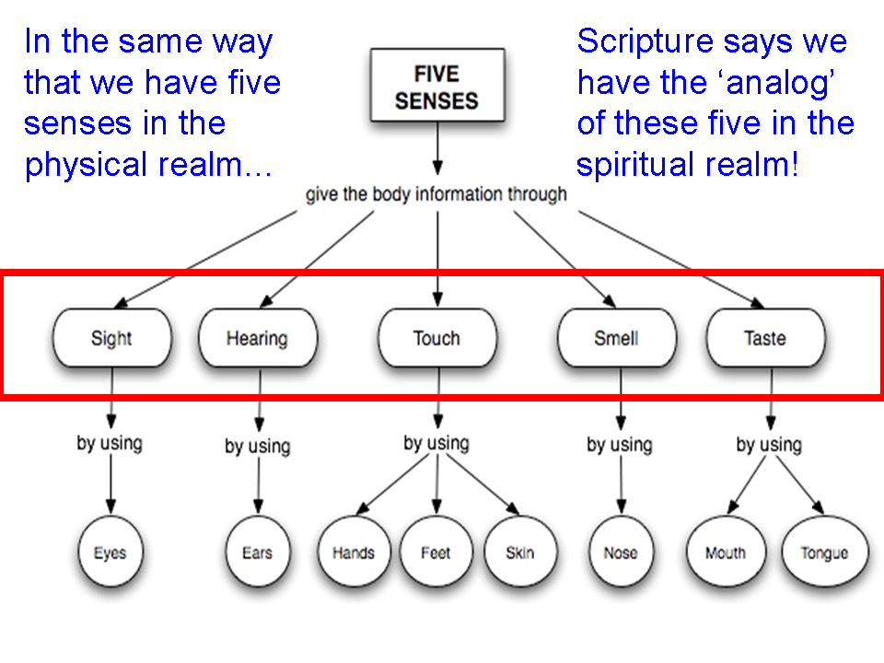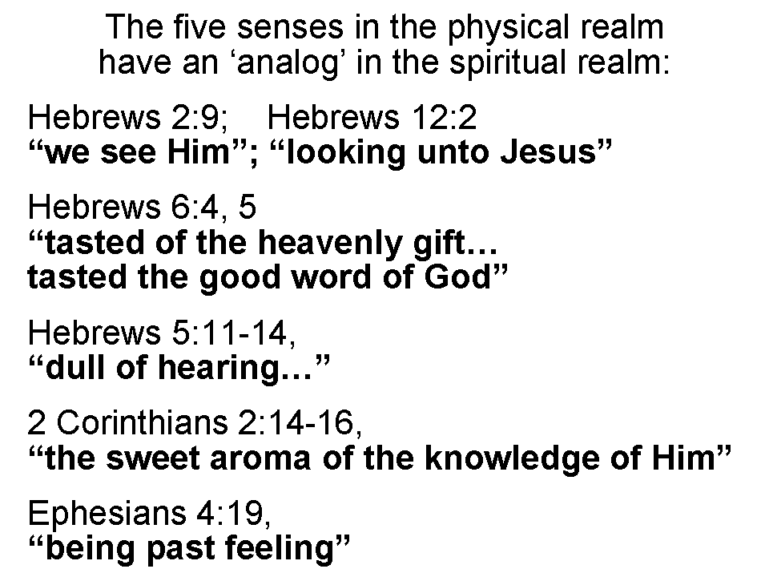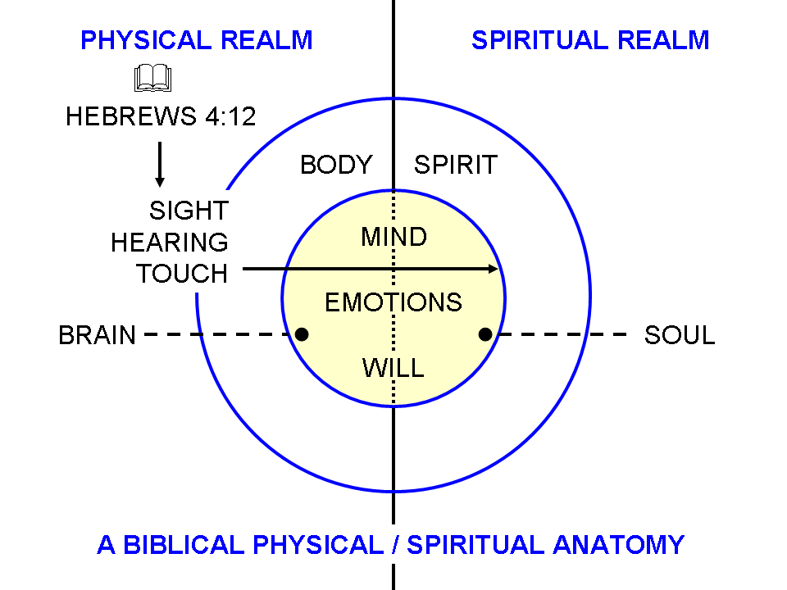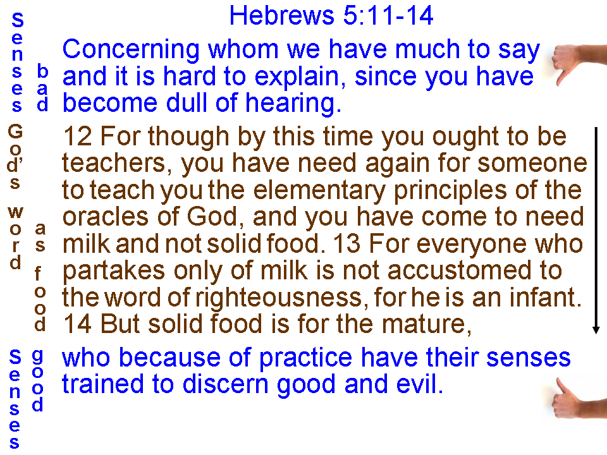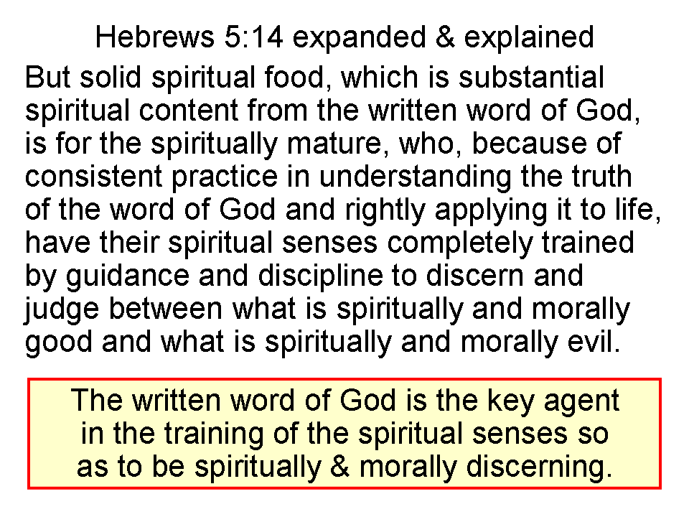
The principles to be drawn from an understanding of the five spiritual senses are:

1) It is important to realize what the unbeliever, of whatever worldview, doesn’t sense in the spiritual realm. It is because of that lack of sensation in the spiritual realm that the unbeliever does not hold the same worldview as the trained and discerning believer.

2) While it is true and helpful to know that the unbeliever cannot sense into the spiritual realm, it will likely not be useful for us to tell him that. The unbeliever is blind to what he is blind to, deaf to what he is deaf to, etc.

3) Believers, having had their senses ‘switched on’, need ongoing training of those senses in order to develop those senses (Hebrews 5:11-14). That training takes place primary through the word of God and the ministries of the body of Christ. Lack of that training is likely to result in little to no development of the spiritual senses, or even in one who has been trained, retrogression.

4) One perspective on the spiritual senses is that we are in this elective offering a solution for the unbeliever, and a growth path, preventive and corrective the believer, in whatever state of spiritual sensation. For the unbeliever who comes to believe, the spiritual senses are ‘switched on’ by God’s doing. For the believer, who has just come to believe, the training of the senses ought to begin right away. For all believers, the training of the spiritual senses ought to continue. For believers who have retrogressed in the use of their spiritual senses, the restoration ought to begin right away.

5) The above points are valuable insights for individual believers who are in the body of Christ, for Christian parents, and for teachers and elders. The understanding of these principles is critical, and the application of these principles is essential to the spiritual health of individual believers, and the church body as a whole.

Summary of Truth entry in Baker Encyclopedia of Christian Apologetics, edited and partially written by Norm Geisler.

