Logic & Worldviews
Vocabulary:
- Inductive Reasoning - reasoning from detailed facts to general principles
- Deductive Reasoning - reasoning from the general to the particular (or from cause to effect)
- Worldview - The way one interprets life, its meaning and how one reacts [or thinks one would react] to scenarios. Ones Paradigm with which they operate.
- Syllogism – A pair of propositions that are used to prove a third proposition.

Logic
Logic is an integral part of our ability to have thoughts and to comprehend words, sentences and ideas.

There are three core rules for logic:
- The Law of non-contradiction. Example: A does not equal Not A. We cannot say that God is God and God is the Devil.
- The law of identity. Example: A is A. Binds names with objects. I cannot be me and I cannot be a chair at the same time. See: Who’s on First.
- The law of excluded middle. Binary, something is A or not A but not in between. This prevents two opposites from being true in their comparison with one another.

One example of logic in action is the place wherein we find that we can argue for the existence of a higher being. Using logic, the existence of a higher being can be argued for, and often someone will confess to knowledge of a higher being. The problem is getting them to have faith in the God of the Bible. That requires the work of the Holy Spirit and logic cannot replace His work in their lives.

Logic is in humor, or humor is where logic often isn’t. One non-laughing matter is how people use logic to interpret their world. Their worldview is critical to their ability to cope with life, and so if they don’t have an understanding of their worldview and are unable to reason through things they can quickly become a mess. This applies to believers as well as non-believers. A believer that doesn’t understand mercy, grace and love will soon reason their way into the Law and become entangled in failure and feeling inadequate.

Worldviews
Last week we looked at Romans 1:18-25, this week we’ll look at the rest of Romans chapter 1 and identify the second worldview we’ll be talking about. If you weren’t here or don’t recall you’ll find that man exchanged the Glory of God for the foolishness of mankind.
Romans 1:26-32
²⁶For this reason God gave them over to degrading passions; for their women exchanged the natural function for that which is unnatural, ²⁷and in the same way also the men abandoned the natural function of the woman and burned in their desire toward one another, men with men committing indecent acts and receiving in their own persons the due penalty of their error. ²⁸And just as they did not see fit to acknowledge God any longer, God gave them over to a depraved mind, to do those things which are not proper, ²⁹being filled with all unrighteousness, wickedness, greed, evil; full of envy, murder, strife, deceit, malice; they are gossips, ³⁰slanderers, haters of God, insolent, arrogant, boastful, inventors of evil, disobedient to parents, ³¹without understanding, untrustworthy, unloving, unmerciful; ³²and although they know the ordinance of God, that those who practice such things are worthy of death, they not only do the same, but also give hearty approval to those who practice them.

Unlike a pessimist or optimist: the glass of the depraved mind is FULL of these things. Any number of these things may be missing or subdued on some level. What is the critical detail missing for them to have victory over these issues which are clearly evil?
How does the secular mind deal with sin?
What are some of the logical assumptions of these immoral attitudes?
Does this look like an upward spiral to you?

How do the following worldviews deal with:
Pain? Trials? Pleasure? Eternity? God? Truth?
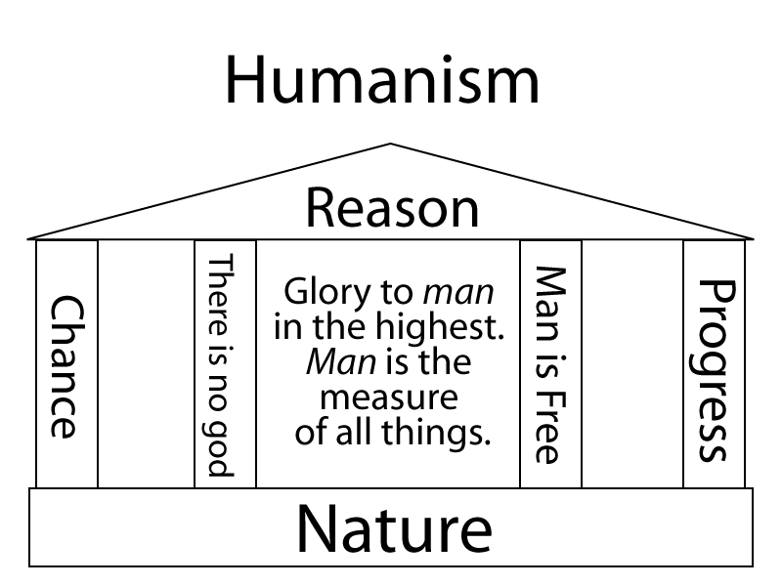
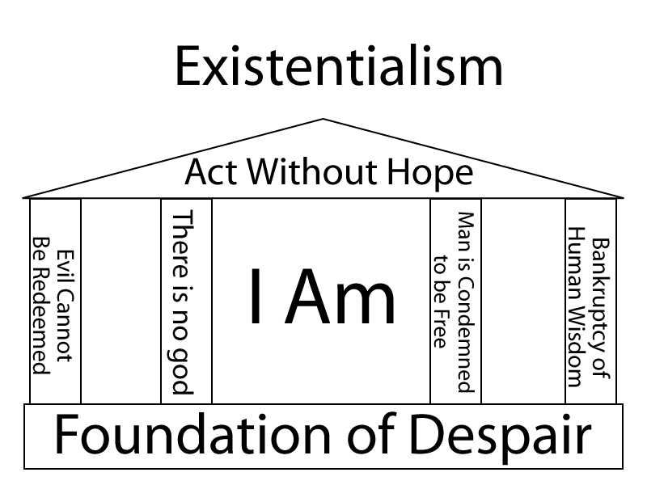
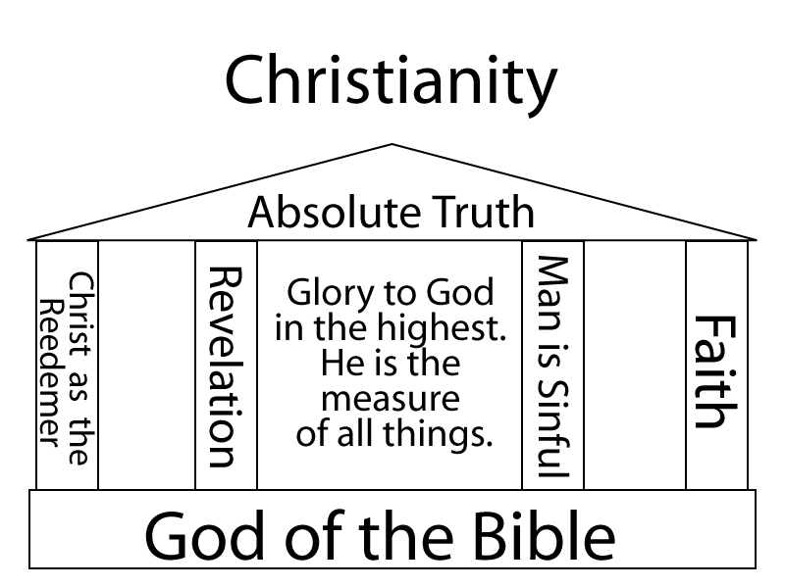

Source: WordNet ® 2.0, © 2003 Princeton University
Source: WordNet ® 2.0, © 2003 Princeton University

