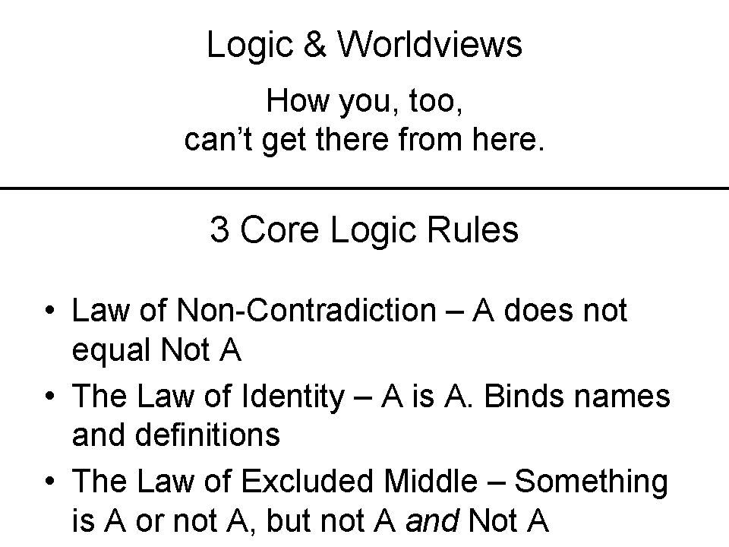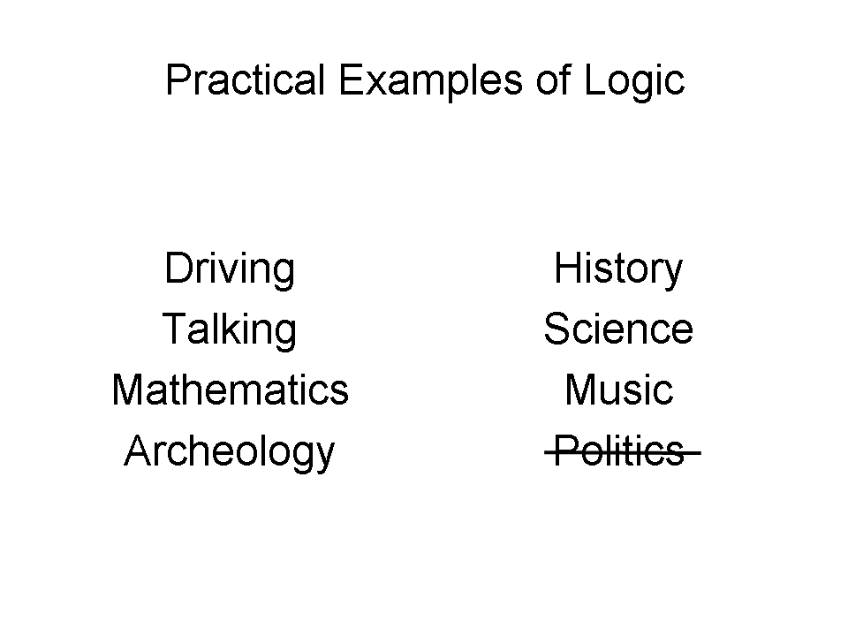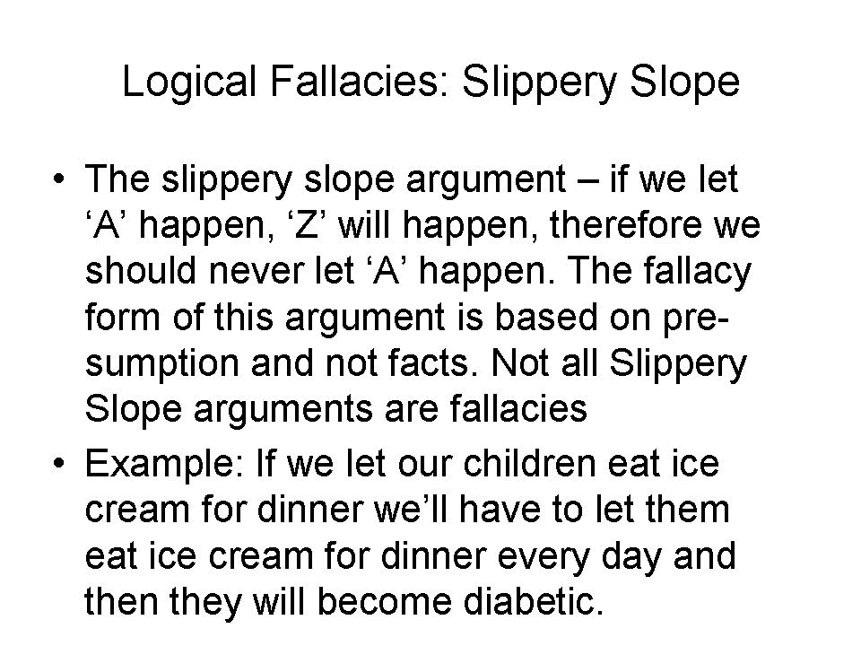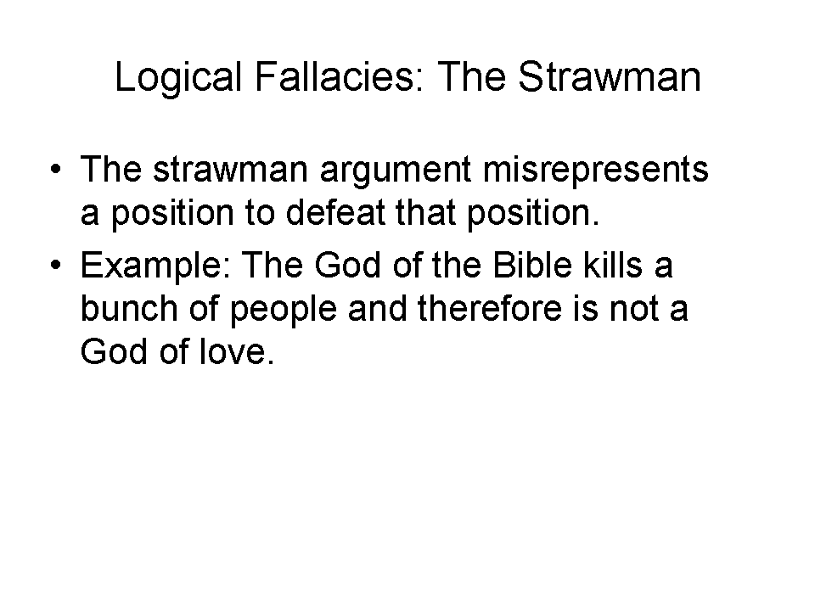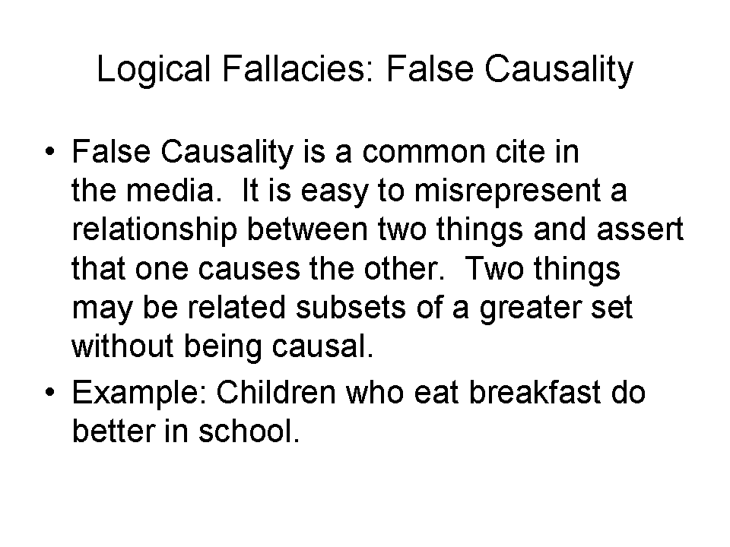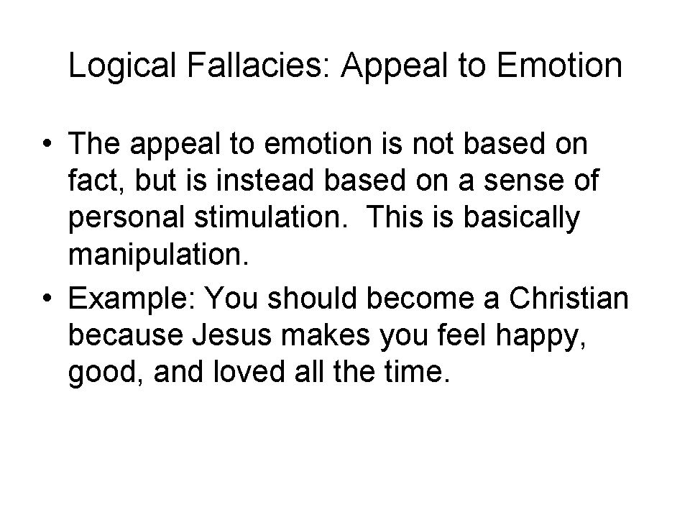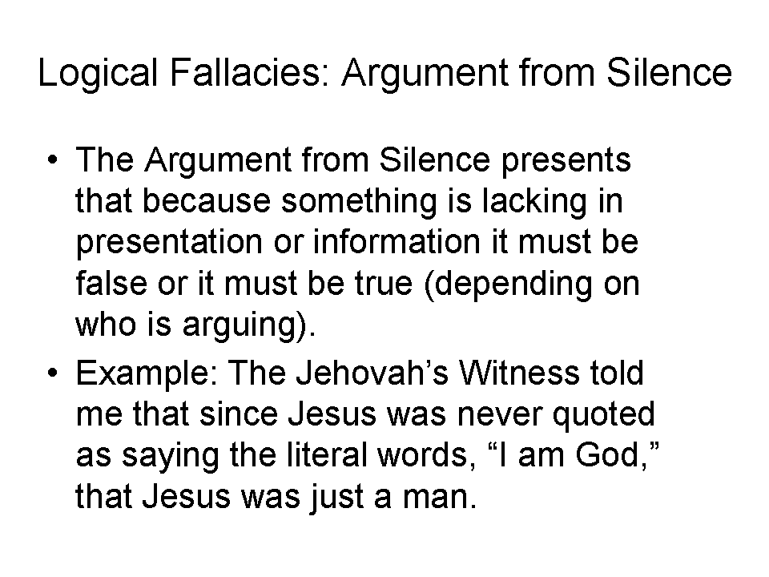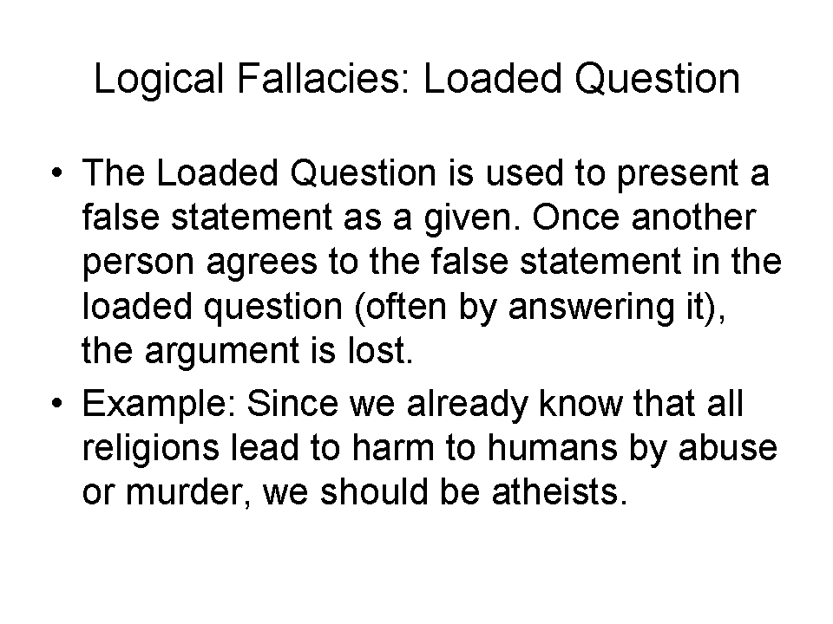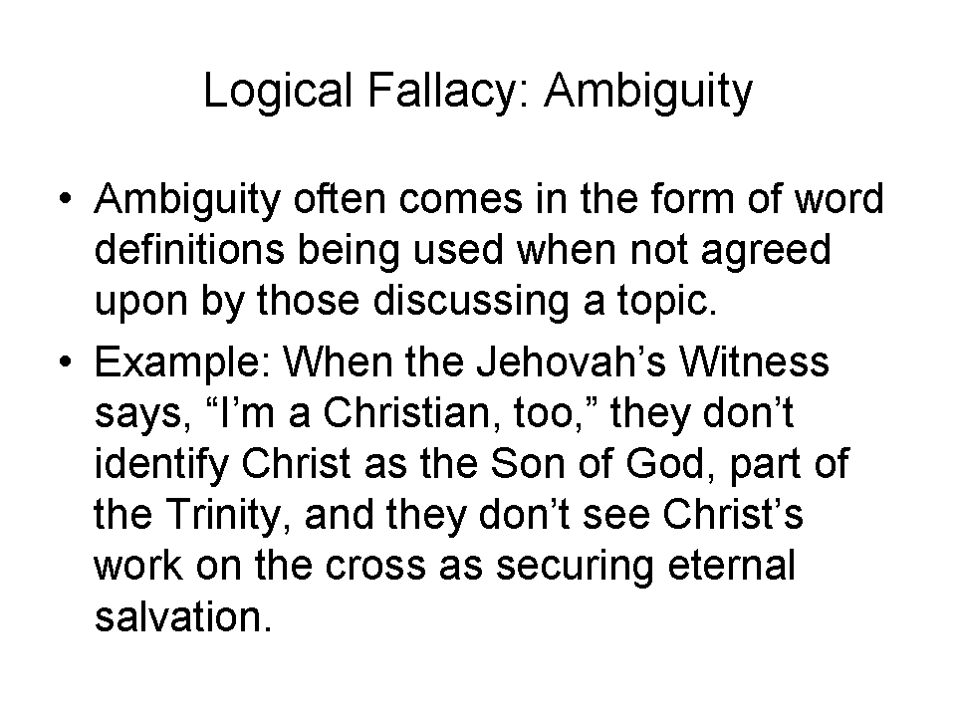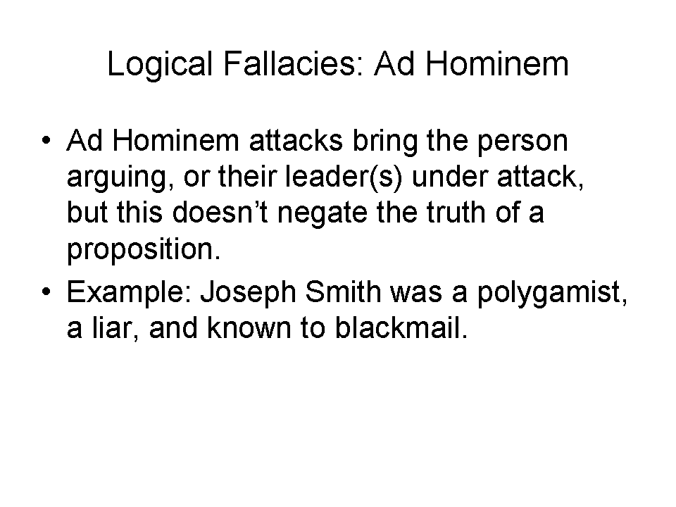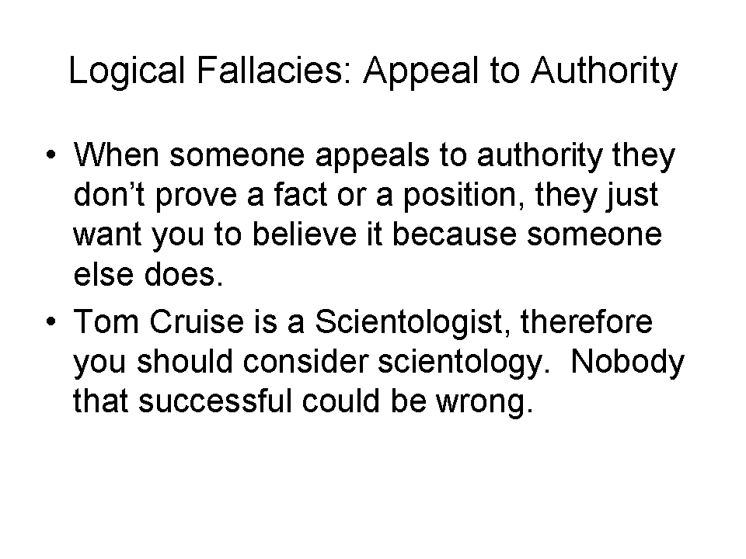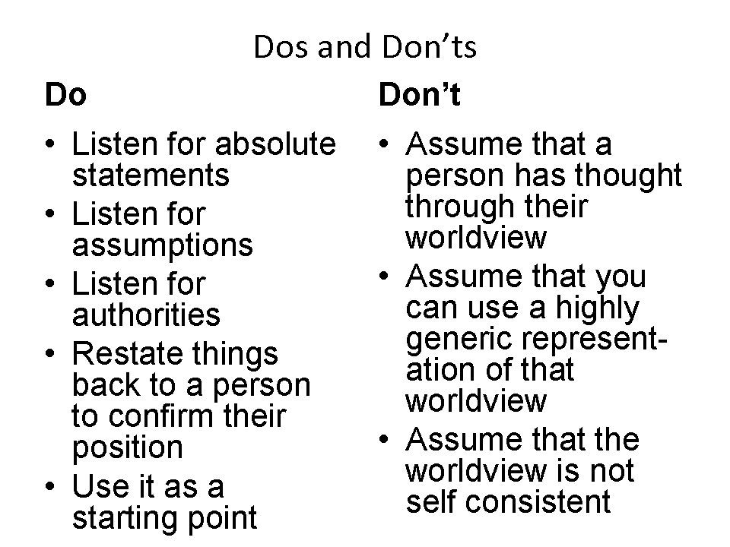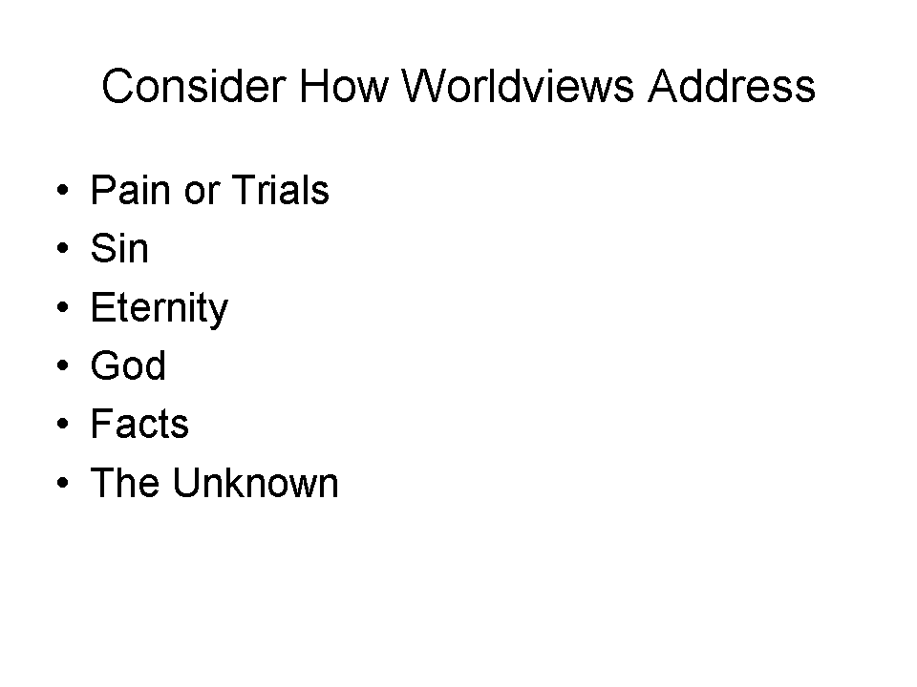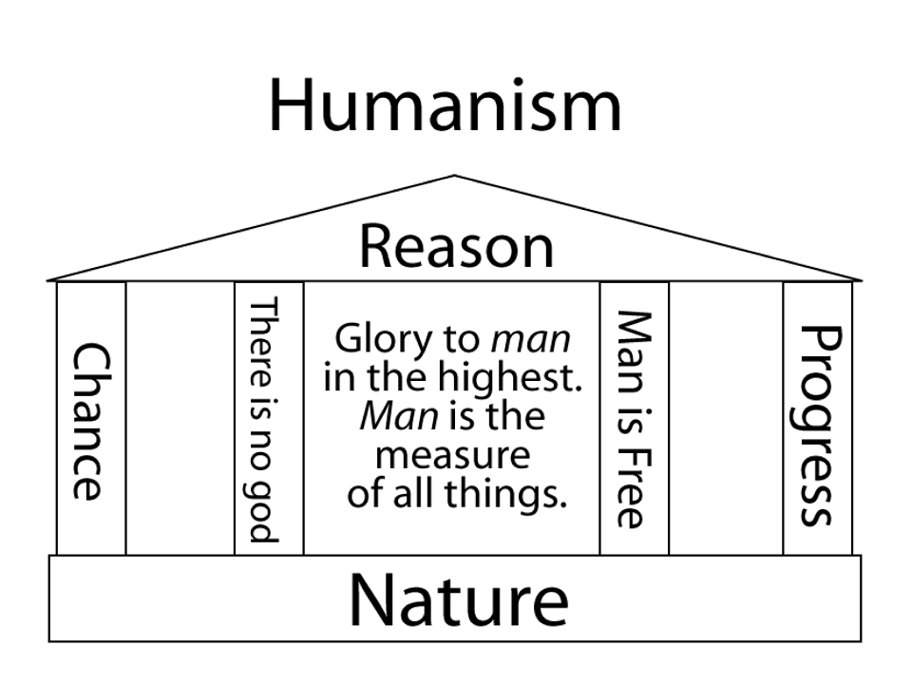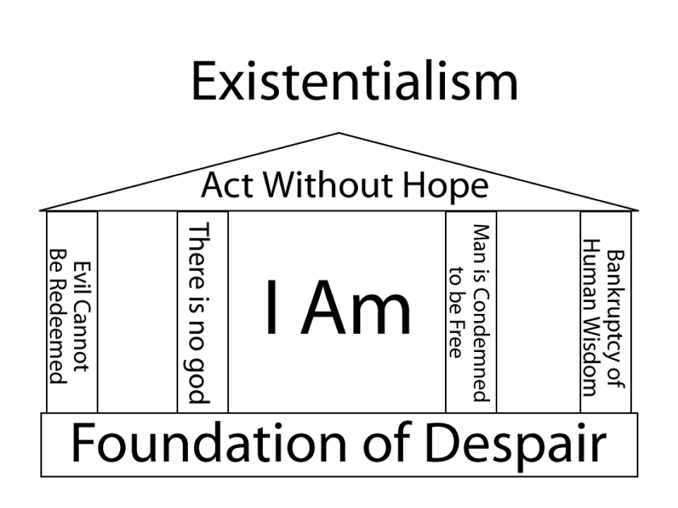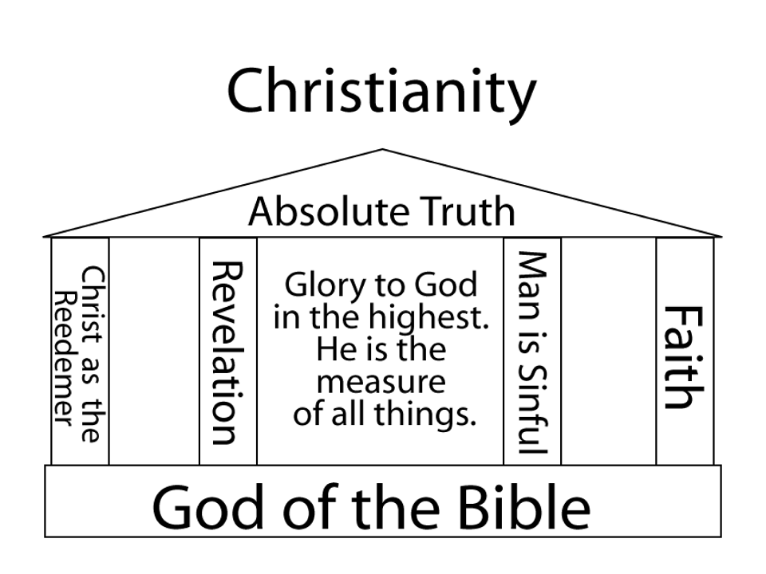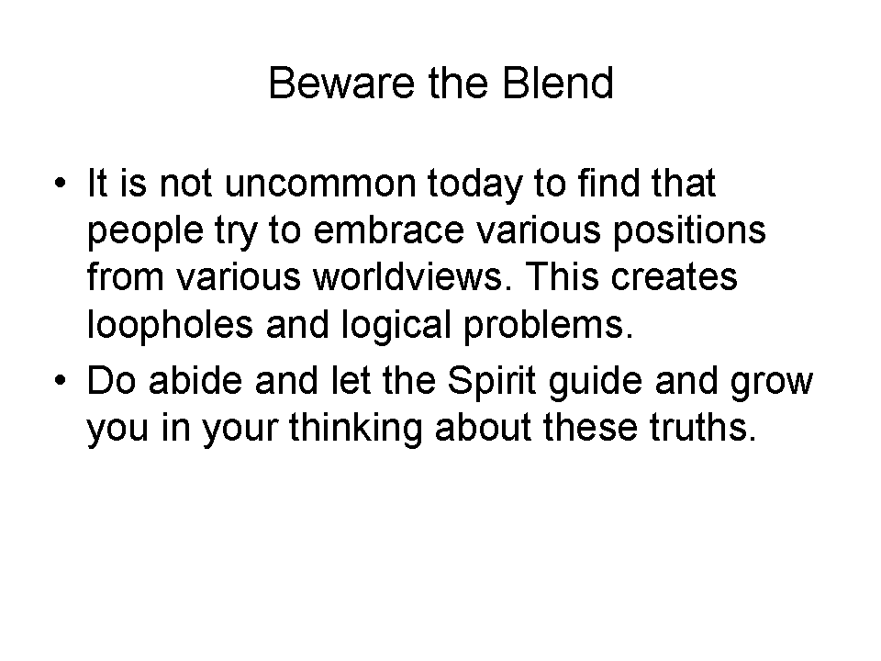
Quotes & Their Logical Fallacies

Below are quotes from various skeptics, agnostics and atheists. What are some of the fallacies (from last week or elsewhere) that are presented in the positions stated?

Skepticism

If you would be a real seeker after truth, it is necessary that at least once in your life you doubt, as far as possible, all things. – René Descartes

Fallacy: ________________________________________________________________

Skepticism: the mark and even the pose of the educated mind. – John Dewey

Fallacy: ________________________________________________________________

I don’t want to believe. I want to know. – Carl Sagan

Fallacy: ________________________________________________________________

Agnosticism

The mystery of the beginning of all things is insoluble by us; and I for one must be content to remain an agnostic. – Charles Darwin

Fallacy: ________________________________________________________________

I am an agnostic; I do not pretend to know what many ignorant men are sure of. – Clarence Darrow

Fallacy: ________________________________________________________________

I deeply believe in pluralism. I believe in the close proximity of multiple systems or agnostic systems. – Ben Nicholson

Fallacy: ________________________________________________________________

Atheism

I am against religion because it teaches us to be satisfied with not understanding the world. – Richard Dawkins

Fallacy: ________________________________________________________________

Faith is the great cop-out, the great excuse to evade the need to think and evaluate evidence. Faith is belief in spite of, even perhaps because of, the lack of evidence. – Richard Dawkins

Fallacy: ________________________________________________________________

All thinking men are atheists. Ernest Hemingway

Fallacy: ________________________________________________________________

Properly read, the Bible is the most potent force for atheism every conceived. – Isaac Asimov

Fallacy: ________________________________________________________________

Conclusion
While secular empiricism on the surface sounds like it is a rational, self-consistent worldview, it also comes with assumptions that are believed (i.e. faith). Given that a person or persons are in charge of truth claims and the understanding of the universe will always be finite in a universe that appears not to be, absolute claims and absolute morality are based on assumptions of consistency across the universe both in time and space.

By using logical fallacies like ambiguity (redefinition of terms), ad hominem attacks on believers, and assuming the critic of Christianity has no faith-system underpinning their worldview, the secularist charges at religion – Christianity for the most part in the US – and wants to pull down the walls of all other worldviews to attempt to unify mankind under humanism.

