Where did modern science come from?

What is modern science?

Definition of Science: The systematized collection of knowledge about nature through using only reason and sense experience in order to discover the underlying laws of nature, which explain how nature is organized and allow future accurate predictions about nature's processes or objects to be made.

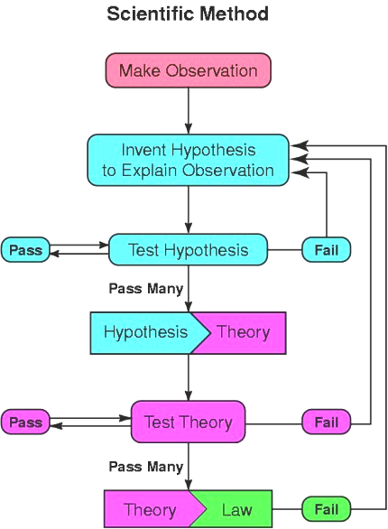
How did modern science begin?

Modern science was originally established by Christians in western Europe. They were not all the same kind of Christians, but they began to found the sciences based on a common Christian worldview, that included:

1) God created the world & it is independent from Himself.

2) God is a God who does not change in His qualities, & He established consistent natural laws that govern the physical universe.

3) By a combination of observation (empirical knowledge) & logic (rational knowledge), discovery of those natural laws allows us predict how nature will behave in the future.

4) God has revealed & is revealing Himself, including through Nature & the Bible.

5) The Bible uses logic, therefore God must have created natural laws in which can be understood by use of logic, & its numerical corollary: mathematics.

6) God is a God of truth, therefore He created truth external to Himself in the created world, & that truth can be known & pursued.

7) Truth is also required when recording & reporting the results of scientific observation.

8) Man was created by God in His image, so that we have the capacity to observe what God created & to think God’s thoughts after Him. God also designed our senses to gather truth.

9) The hard work (rigor and vigor) that is required to conduct repeated observations and maintain the scientific method is encouraged in the Bible. Related to this is the Christian concept of humility, which does not disdain hard work nor seek to exalt oneself at all costs.

10) A linear conception of time, with a concept of past, present and future, so as to see the world in a cause and effect perspective, and also to see the value of predictions based on hypotheses, theories and laws regarding the physical world.

Also contributing to the development of modern science was the invention of moveable type print and the printing press in Europe, about 1439. Communication about scientific endeavors was then much more rapid and consistent.
Other cultures and religions failed to develop modern science

Technological advancements do not equal modern science as the worldview and method are still lacking what is required for a sustainable advance of science within a discipline. Other cultures and religions, though they made technological and/or mathematical contributions, did not develop modern science, because one or more of the above points of worldview were missing:

- The Babylonians contributed our system of angular measurement (360 degrees in a full rotation), but they didn’t believe in most of the points given above. They had a pantheon of gods whom they viewed as influencing nature in many ways.

- The ancient Greeks developed mathematics and logic, philosophy and some technology, but saw repeated observation and experimentation as beneath them. That sort of thing was for slaves. The gods of the Greeks were changeable and capable of deception and worse. The Roman culture and pantheon could be summarized similarly.

- Our numbering system is derived from the one in use by those in India, Persia and the Arab world, and was disseminated into Europe by Leonardo Bonacci (aka Fibonacci; 1170 - 1250). But Islam did not develop modern science, because it was and is taught that Allah is unknowable and that Allah did not reveal himself. Man is therefore not created in Allah’s image. Muhammad (570-632), the founder and prophet of Islam, in the Quran emphasized Allah's will and power, but not Allah’s rationality or consistency. Aristotle’s (384-322 BC) speculative book, On the Heavens, completely hindered Islamic development of science, and it hindered Christian development of science until it was cast off and replaced by Christian presuppositions.

- The Chinese culture was inventive and clever, but did not embrace western logic nor have a concept of God and man that brought about the necessary worldview to serve as the basis for modern science. Further, like Hinduism, centered in India, there is a cyclical perspective of time in ancient Chinese thought (consistent with reincarnation), rather than a linear view of time, required to develop modern science. One Buddhist monk attacked the Christian dogma of creation as follows:

Space, worlds, and beings have no beginning nor end if we consider them not in themselves and individuals but in their totality. They are eternal from this global point of view. They proliferate without end and during incalculable cosmic periods progress through successive stages of formation, stability, degradation and then a return to nothingness.

- Ancient Egypt, though it had an advanced civilization for its time, and did have a level of technology, had about 700 gods, and the gods were looked upon as influencing everything. There were a number of aspects missing from the necessary perspective for developing a sustainable modern science.

The founders of modern science

These are some of the scientists who began working from a Christian worldview, and increasingly rejecting the Greek philosophical worldviews which had been entrenched in the educational systems of Europe.

Nicolas Copernicus (1473-1543) maintained that the sun was at the center of the solar system, not the earth.

Francis Bacon (1561–1626) announced his intention to replace the doctrines of Aristotle’s Organon in his New Organon (1620). He had a Puritan mother who (as mothers tend to do!) influenced him. His emphasis on the utility of scientific discoveries, as opposed to gaining knowledge for its own sake, which was Aristotle's tendency, has a Puritan ring to it.

Galileo Galilei (1564–1642), a Roman Catholic, wrote a book about Two New Sciences (1638). He was a mathematics professor who developed fundamentals of physics.

Johannes Kepler (1571–1630), who had earlier noted that the Paracelsians had invented a new medicine and that the Copernicans had invented a new astronomy, presented a book on his own discoveries which he also saw as A New Astronomy (1609).

Isaac Newton (1642–1727), who developed Newton’s laws of motion and contributed significantly to the understanding of the orbital mechanics of the solar system. After these scientific accomplishments, Newton wrote commentaries on Romans and Daniel.

John Flamsteed (1646-1719) trained for the church, but made fame as first Astronomer Royal, establishing Greenwich observatory and providing Newton with essential data for his calculations. Poorly paid, he nonetheless poured his own money into new tools for the observatory. It was he who brought Greenwich to world-wide fame.

Charles Boyle (1627-1691), the deviser of the namesake law concerning the compression of gases, the English chemist and physicist wrote in his last will and testament: "Wish [the Royal Society, a group of scientists] a happy success in their laudable Attempts, to discover the Nature of the Works of God, and prayer that they and all other Searchers into Physical Truths, may Cordially refer their Attainments to the Glory of the Great Author of Nature, and to the Comfort of Mankind."

John Ray (1627-1705), the great biologist, told a friend that sparing time to investigate nature was good: "What time you have to spare you will do well to spend, as you are doing, in the inquisition and contemplation of the works of God and nature."

Forty-two of the 68 founding members of the Royal Society (starting through meetings in 1645, unofficially), for which their religious background was known, were Puritans.

Christianity: A Cause of Modern Science?, Eric V. Snow, 1997: http://www.rae.org/pdf/jaki.pdf
Some will only say that Christianity helped science along, as a contributing factor, such as Robert K. Merton, the sociologist who wrote Science in Seventeenth Century England, Osiris, Vol. 4. (1938), pp. 360-632. Likely his sociologic approach is where he received this perspective.
Moveable type printing was actually invented by Bi Sheng (990-1051) in China about 1041-1048, using ceramic print faces. But that technology was not transported directly and immediately to Europe.
Christianity: A Cause of Modern Science?, Eric V. Snow, 1997: http://www.rae.org/pdf/jaki.pdf

