Science, Faith & Knowledge

The typical approach of aggressive agnostics, atheists and skeptics is to describe themselves as rational, logical, thinking people, and to describe Christians as relying on pure faith, perhaps even in spite of the facts. That sort of presentation, as we have seen, is often done by expressing logical fallacies. What we will present here is that:

1) All scientists hold to at least ten scientifically unverifiable presuppositions, that is, things that are assumed before collecting any data and before using any logic. These are things that cannot be proven scientifically, yet they are necessary to carry on science.

2) So all scientists, whether they are aware of it or not, and whether they will even admit to it or not, have faith in at least these ten presuppositions.

3) Those scientists who are working in a field outside the optimal domain of science, in the historic and prehistoric past, must make even more assumptions which cannot, by their nature, be scientifically verified.

4) How can we ‘know’ something? The technical term for assessing and addressing this question is ‘epistemology’. Science, it is said, is able to bring us to a knowledge of things in the physical realm. But what kind of knowledge is it? And how certain is that knowledge? And what are its limits?

Faith in the ten scientifically unverifiable presuppositions (1 & 2 of the 4 above)

A presupposition is something that is assumed before using logic and reasoning and before collecting measurements, data, etc. Here are ten of the core presuppositions of modern science

(1) the existence of an external world
(2) the orderly nature of the external world
(3) the knowability of the external world
(4) the existence of truth
(5) the laws of logic
(6) the reliability of our memory, thinking and sensory faculties to serve as truth gatherers and as a source of justified true beliefs
(7) the adequacy of language to describe the world
(8) the existence of values in science (e.g., "test theories fairly & report results honestly")
(9) the uniformity of nature and the continuity of laws inherent in nature into the future
(10) the existence of numbers corresponding to nature in order to measure and model using mathematics
These ten assumptions of modern science are derived from the ten Christian worldview points we presented last Sunday. So modern scientists, whether Christians or not, are carrying out science with elements – we could say, ‘remnants’ - of a Christian worldview. Those ten assumptions are taken on faith. There is no way to prove them. They can be confirmed in practice, but they must be assumed and taken on faith in order to put them into practice. Without them there is no modern science, as we know it.

More faith beyond the ten presuppositions of all scientists (3 of the 4 on page 1)

The optimal domain of science, that is, the domain in which the assumptions of science and the scientific method work best, are in dealing with present processes and events, with things that are smaller in scope and scale.
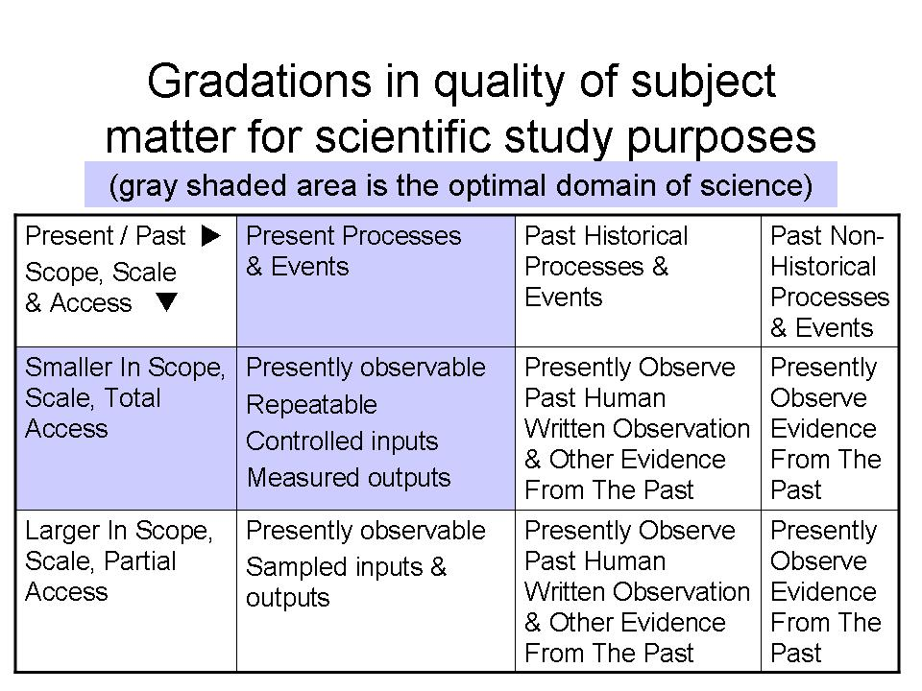

Any scientist who deals with past historical processes and events (at least one person present to record observations of the past processes and/or events), or who deals with past non-historical events (nobody present to record the events) must make additional presuppositions (assumptions made prior to gathering data and using logic) beyond the ten essential assumptions that all scientists make, as listed on page 1.

For example the scientist who attempts to use radioactive decay dating methods must use a set of assumptions about how much material was present originally, and must assume that the recently measured rate of decay can be confidently extrapolated back in time for thousands and millions of years, even though we don’t know why a particular radioactive isotope will decay at the rate it does, or what might impact its rate of decay. We also cannot be sure that none has been added to or taken away from the sample being tested. The scientist must have faith in his assumptions, which can never be objectively verified.
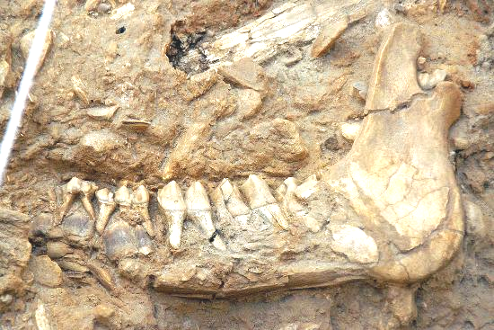
If a paleontologist finds a fossil in the ground, of say, a giraffe, he can make as many observations as he wishes, in the present, and will extend those observations into the past using assumptions. But the paleontologist can never go back in time to verify that any of the assumptions are correct. The paleontologist can, however, put faith in the assumptions that were made, but the assumptions will remain a matter of faith – not science. And the paleontologist will very likely report the observed facts and will report his conclusions as scientific findings, but very likely never disclose the assumptions that were made that were all taken on faith and will never be scientifically verifiable by anybody.

Richard Dawkins wrote about the evolution of giraffes in at least six of his books, and he wrote that giraffes evolved from an okapi-like animal, slowly over millions of years. What he won’t tell you is that there is no fossil evidence for such an evolution, and the fossils would be the only historical evidence that an okapi-like animal evolved into a giraffe – if those fossils existed. So the millions of years and the evolution and the fossils that ought to be there are all a matter of faith in scientifically unverifiable presuppositions – evolution is assumed, not proven by the facts and logic that are required by real science. The case with giraffes applies to a number of animals and plants – the fossils are missing.

In The Greatest Show On Earth Richard Dawkins wrote, “This book is my personal summary of the evidence that the 'theory' of evolution is actually a fact – as incontrovertible a fact as any in science.” That statement is a logical fallacy. The truth: The evolution Dawkins wrote about is not a scientific fact. It is the set of assumptions that he made before he even started anything called science. Additionally, science is not flat and uniform. Part of science is in the optimal domain, and there are parts of it where worldview-based assumptions have to be made before gathering data and drawing logical conclusions. Dawkins’ statement about evolution being a fact is a statement about the worldview-based assumptions - scientifically unverifiable presuppositions - that Richard Dawkins personally has faith in, even where there isn’t any evidence. Dawkins, it turns out, has great faith. But that is probably why he won’t tell his readers that the transitional fossils that ought to be there simply don’t exist. That would reveal his great faith in his unverifiable assumptions, even when there is no actual evidence to support his faith.

Epistemology – how we ‘know’ something (4 of the 4 on page 1)

How is it that we can say that we ‘know’ something? We’ve been talking about science, and the basic presuppositions of science – what we assume before we begin gathering data and drawing conclusions through logic – are the ten listed on –page 1. Using logic and thinking and mathematics leads us to rational knowledge. Making observations using our senses is called empirical knowledge. Science is a combination of these two – rational and empirical knowledge – all of which was arrived at from a Christian worldview. Repeated testing of the hypothesis, theory or law serves as a check on the knowing from the scientific process.
But are there other ways of ‘knowing’ something? The Christian would answer, “Yes.” Aside from rational knowledge and empirical knowledge we can know many things by means of revelation from God. The Bible is one of five ways in which the Bible says, God has revealed Himself.

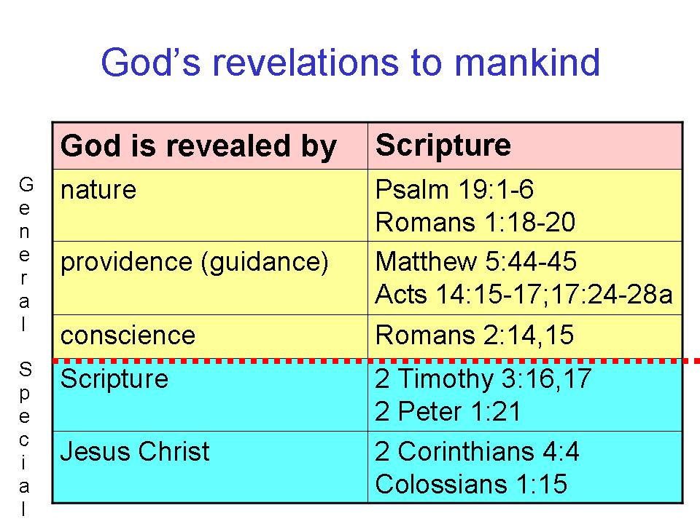

But how do we ‘know’ we can trust the Bible to be God’s revelation?

- That’s one reason why we offer this elective, so that you can know that the Bible is trustworthy, and convey that to others, in support of and in defense of biblical faith.

How can we ‘know’ that we are interpreting it correctly?

- That’s why we offer, “How to Study the Bible” as an elective, in which we examine the elements of language, history and culture.
- That’s why, when we study a book of the Bible, we will often include key principles of interpretation at the beginning and along the way.

The Four Truth Questions & Knowing:

1) Is there absolute Truth? Yes__ No__
Proverbs 22:20, 21; Hebrews 13:8

2) Is that Truth singular? Yes__ No__
John 14:6; 18:37

3) Has the Truth been given? Yes__ No__
Psalms 119:160; John 17:17; Revelation 1:1, 2

4) Is the (absolute, singular, given) Truth knowable? Yes__ No__
John 8:31, 32; I John 5:13, 20

Adapted from: http://www.apologetics315.com/2011/03/ten-presuppositions-of-science.html William Lane Craig & J.P. Moreland, Philosophical Foundations for a Christian Worldview (Downers Grove, IL: InterVarsity Press, 2003), pp. 348.

