History: How do we know what we know? – Part II

Why history matters – a whole lot!

The major reasons why history does matter pivotally are presented throughout Scripture, such that the historical truth or falsehood of these points has sweeping and ultimate eternal consequences – extending outside of the physical realm and beyond the time of individual and global human history on planet earth:

  - Scripture presents that God is sovereign over history in specific ways
  - Scripture presents that God personally entered history in a specific way
  - Scripture testifies on the basis of specific history, claiming to reveal truth progressively throughout history up to the death of the last apostle
  - Scripture bases our eternal identities and destinies upon specific events that took place within history
- Some of those events are subject to specific points of historical verification
- Some of those events are subject to general historical and cultural context confirmation
- Other events or aspects of those events are specifically claimed to be the subject of revelation by God
- Scripture views history as both physical and spiritual, with both physical and spiritual events taking place in parallel. The spiritual realm is presented as the source of the physical realm and the character of the physical aspect of man and nature expresses the spiritual standing of individual and all human beings with God:

Romans 6:3-11 (NASU)
Or do you not know that all of us who have been baptized into Christ Jesus have been baptized into His death? 4 Therefore we have been buried with Him through baptism into death, so that as Christ was raised from the dead through the glory of the Father, so we too might walk in newness of life. 5 For if we have become united with Him in the likeness of His death, certainly we shall also be in the likeness of His resurrection, 6 knowing this, that our old self was crucified with Him, in order that our body of sin might be done away with, so that we would no longer be slaves to sin; 7 for he who has died is freed from sin.

8 Now if we have died with Christ, we believe that we shall also live with Him, 9 knowing that Christ, having been raised from the dead, is never to die again; death no longer is master over Him. 10 For the death that He died, He died to sin once for all; but the life that He lives, He lives to God. 11 Even so consider yourselves to be dead to sin, but alive to God in Christ Jesus.

People view history in various ways, but…

  - Some are ultimately skeptical that we know anything at all about history
  - Some try to make history have the message that they wish it to have
  - Scripture makes claims that are rooted in physical history and are ultimately dependent upon the objective truth or falsehood of those historically based claims

Classical historiography & the three tests of historical truth

Historians who do not take history as fundamentally subjective (such as postmodernism would view history), and who do not have an agenda in their presentation of history (such as is often the case with ethnically and gender based histories) can be called “classical historians”. The approach of classical historians is that of systematic evaluation of the evidence regarding any historical document, inscription, etc., which can be referred to as “classical historiography”.

Classical historiography is not a field of science in the strictest terms, since the events to which evidence refers cannot be repeated for ongoing verification, as can be done with, for example, a phenomenon in physics or chemistry. The tools of science can, however, be used to assess the evidence regarding an historical document, so that we can take a legal or forensic approach to the historical evidence, and arrive at conclusions about historical events on that basis. It should be recognized that the tools of science and therefore the field of classical historiography cannot directly address spiritual matters, so in that sense one cannot use classical historiography to prove that the Bible is spiritually true. One can, however, arrive at compelling implications regarding the truth or falsehood of Scripture, in that the historical claims of Scripture in the physical realm can indeed be assessed as to its truth and falsehood at a great many “test points”. Further, the nature of Scripture is such that if key events in the history of the physical realm are, in fact, not true, then the spiritual truth of Scripture is likewise false. So while the tools of science and the methods of classical historiography cannot prove that the Bible is spiritually true, the Bible is, by its own claims, historically and therefore spiritually falsifiable.

1 Corinthians 15:12-19 (NASU)
12 Now if Christ is preached, that He has been raised from the dead, how do some among you say that there is no resurrection of the dead? 13 But if there is no resurrection of the dead, not even Christ has been raised; 14 and if Christ has not been raised, then our preaching is vain, your faith also is vain. 15 Moreover we are even found to be false witnesses of God, because we testified against God that He raised Christ, whom He did not raise, if in fact the dead are not raised. 16 For if the dead are not raised, not even Christ has been raised; 17 and if Christ has not been raised, your faith is worthless; you are still in your sins. 18 Then those also who have fallen asleep in Christ have perished. 19 If we have hoped in Christ in this life only, we are of all men most to be pitied.
Regarding historical documents, classical historiography applies the following three tests to any document to determine its reliability. The tools of science and the methods of logic are applied to documents with, in summary, these tests, questions and points of consideration. We will briefly apply these tests to the New Testament documents.

The bibliographic test

Textual transmission – how did the documents get to us?
- the quantity of evidence
- the quality of evidence
- the timeline from origin to the earliest written record

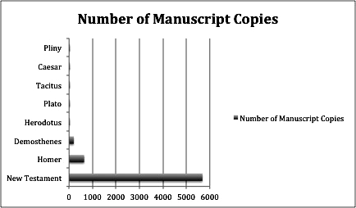
This number is for Greek manuscript copies

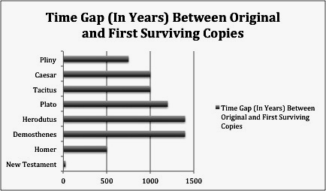

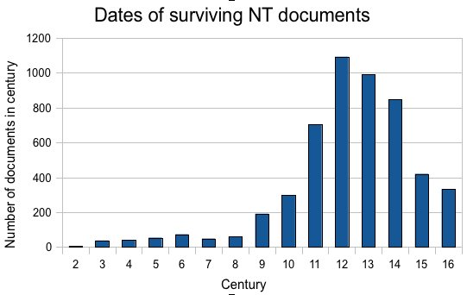

The internal evidence test

How able was the author to testify to facts by reason of geographical and time proximity to the people, facts and events in question?

- geographical proximity
- time proximity
- time of exposure to the evidence
- opportunities & intent to investigate
- claims and intent of the author(s) – consistent with reliability

Matthew, Mark, John, Paul, and Peter wrote primarily as eyewitnesses. Luke wrote as an eyewitness in much of Acts 16-28, as revealed by the use of ‘us’ and ‘we’. As for people and events when he was not an eyewitness, Luke wrote this about his aim and approach:

Luke 1:1-4
Inasmuch as many have undertaken to compile an account of the things accomplished among us, 2 just as they were handed down to us by those who from the beginning were eyewitnesses and servants of the word, 3 it seemed fitting for me as well, having investigated everything carefully from the beginning, to write it out for you in consecutive order, most excellent Theophilus; 4 so that you may know the exact truth about the things you have been taught.

John wrote this about the character of what he witnessed to in his writings:

1 John 1:1-4 (see also Revelation 1:1-8)
What was from the beginning, what we have heard, what we have seen with our eyes, what we have looked at and touched with our hands, concerning the Word of Life-- 2 and the life was manifested, and we have seen and testify and proclaim to you the eternal life, which was with the Father and was manifested to us-- 3 what we have seen and heard we proclaim to you also, so that you too may have fellowship with us; and indeed our fellowship is with the Father, and with His Son Jesus Christ. 4 These things we write, so that our joy may be made complete.

The external evidence test

How well does the testimony claimed in the historical document correspond to other facts from other historical sources?

- the quantity of evidence
- the quality of the evidence

The above tests are explicitly stated for historical documents. Parallel tests, questions and considerations are applied to archaeological material that is not literary in nature, such as building materials, pottery, glass, and household or industrial utensils. The tools of science are likewise used to assist in the assessment of the archaeological evidence.

As an example of the reliability of the New Testament documents, the names and titles of all of the prominent public figures named in the New Testament have been independently confirmed. Considering that there was no systematic way of giving titles in the Roman Empire, and that titles would sometimes change after a few years, this is extraordinary.

Where presuppositions come in

What is presumed before even assessing the evidence, based upon answers to questions such as these, will greatly impact the resulting conclusions:

- Do we disbelieve a document’s claims and content unless independently confirmed (minimalism), or do we believe it unless clearly proven wrong (maximalism)?
- Does a claim to miracles in a document categorically exclude its truth claims?

The discovery of historical documents, earlier New Testament documents, and archaeological discoveries, have tended to move the minimalists’ viewpoints closer to those of the maximalist over time.
For instance, it was once thought by minimalists that the gospel of John was written about 170-180 AD. But the discovery of a fragment of the gospel of John from Egypt (see below) dating to about 125 AD compelled minimalist scholars to reconsider. Additionally, if the fragment was found in Egypt, then the original document must have taken time to arrive in Egypt from Ephesus (most likely).

Similarly, it was once claimed by minimalist scholars that there were no synagogue buildings in the time of Christ, therefore the multiple references to synagogue buildings in the four gospels (especially Luke) and Acts were anachronisms. However, recent excavations at Magdala revealed that there were indeed synagogue buildings in Jesus’ time, as dated by coins in the synagogue floor (see below). This would also indicate that the basalt synagogue foundation in Capernaum (see below) was in use during Jesus’ time as the gospels record.
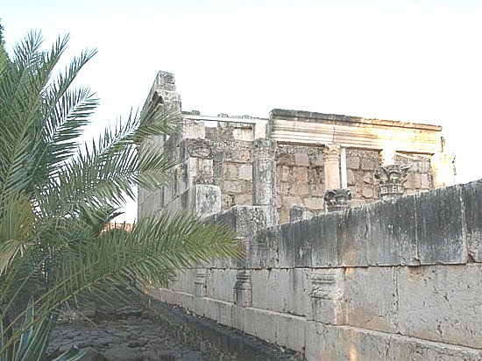
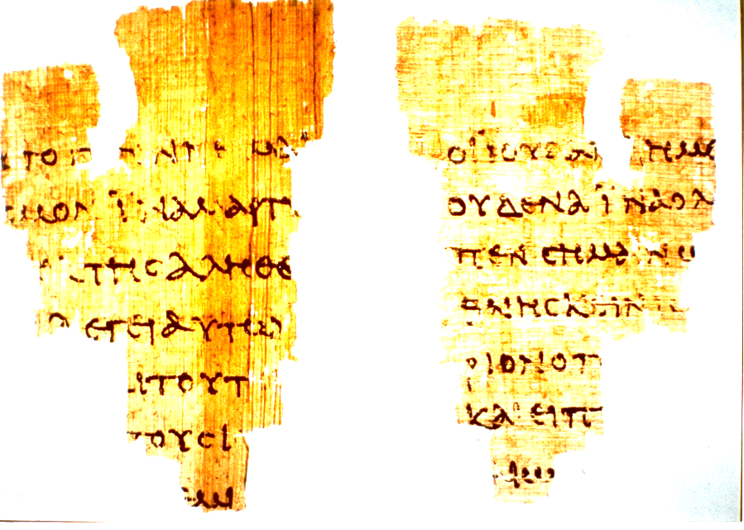
Capernaum

Magdala
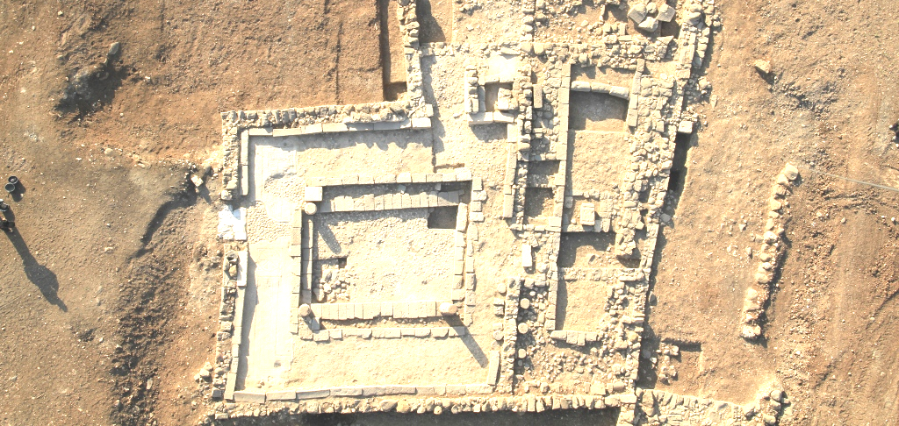

Isaiah 40-46; Psalm 47:6-9; Acts 17:22-31; Revelation 21:6; 22:13
Matthew 1:1-2:23; Luke 1:1-2:19; Galatians 4:4
John 1:45,46; Acts 3:18-26; 28:25-27; Hebrews 1:1,2; 2 Peter 1:21
For a secular discussion of these approaches to the history of western cultures, one may refer to Ernst Breisach, Historiography: Ancient, Medieval & Modern, 2nd edition, 1994.
Josh McDowell & Bill Wilson, He Walked Among Us, 1993, pages 112-118; Chauncey Sanders, An Introduction to Research in English Literary History, 1952, pages 142-161; Gary R. Habermas, The Historical Jesus, 1996, pages 259-274 (Appendix 1); J.P. Holding, Gospel Dates, Gospel Authors, Gospels Freedoms: http://www.tektonics.org/ntdocdef/gospdefhub.html
John D. Currid, Doing Archaeology in the Land of the Bible, 1999; Howard F. Vos, An Introduction to Bible Archaeology, 1983, pages 31-53
J.P. Holding, Calculated Contempt: Why Bible critics do not deserve the benefit of the doubt, http://www.tektonics.org/af/calcon.html; compare to the approach in US law: innocent until proven guilty.
John Warwick Montgomery, A Critique Of Certain Uncritical Assumptions In Modern Historiography, Global Journal of Classical Theology, Vol. 2, No. 1 (12/99) http://www.trinitysem.edu/journal/montgomerypap.html

