Archaeology & The Old Testament

On March 22nd, we presented History: How do we know what we know? – Part II, in which we presented the three tests of classical historiography, by which an historical document is verified as to its genuineness:

- Bibliographic test - where did this document come from?
- Internal evidence test - how self-consistent is a document?
- The external evidence test – how does a document check out with other historical documents that have proven genuine and reliable?

For now we’ll look to the external evidence test regarding archaeology.

The external evidence test

How well does the testimony claimed in the historical document correspond to facts from other historical sources?

- the quantity of evidence
- the quality of the evidence

The above tests are explicitly stated for historical documents. Parallel tests, questions and considerations are applied to archaeological material that is not literary in nature, such as building materials, pottery, glass, and household or industrial utensils. The tools of science are likewise used to assist in the assessment of the archaeological evidence.

As an example of the reliability of the New Testament documents, the names and titles of all of the prominent public figures named in the New Testament have been independently confirmed. Considering that there was no systematic way of giving titles in the Roman Empire, and that titles would sometimes change after a few years, this is extraordinary.

Where presuppositions come in

What is presumed before even assessing the evidence, based upon answers to questions such as these, will greatly impact the resulting conclusions:

- Do we disbelieve a document’s claims and content unless independently confirmed (minimalism), or do we believe it unless clearly proven wrong (maximalism)?
- Does a claim to miracles in a document categorically exclude its truth claims?

The discovery of historical documents, earlier New Testament documents, and archaeological discoveries, have tended to move the minimalists’ viewpoints closer to those of the maximalist over time.

For instance, it was once thought by minimalists that the gospel of John was written about 170-180 AD. But the discovery of a fragment of the gospel of John from Egypt (see below) dating to about 125 AD compelled minimalist scholars to reconsider. Additionally, if the fragment was found in Egypt, then the original document must have taken time to be copied and arrive in Egypt from Ephesus (most likely).

Similarly, it was once claimed by minimalist scholars that there were no synagogue buildings in the time of Christ, therefore the multiple references to synagogue buildings in the four gospels (especially Luke) and Acts were anachronisms. However, recent excavations at Magdala revealed that there were indeed synagogue buildings in Jesus’ time, as dated by coins in the synagogue floor (see below). This would also indicate that the basalt synagogue foundation in Capernaum (see below) was in use during Jesus’ time as the gospels record.
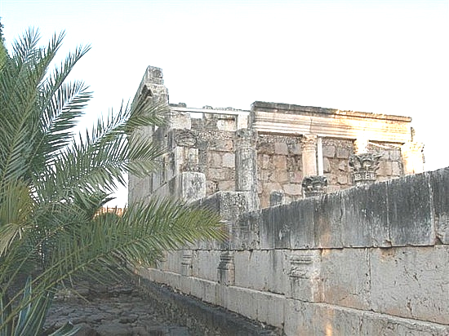
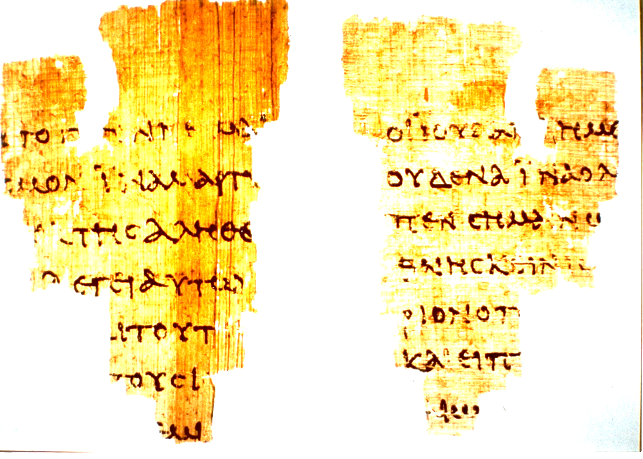
Capernaum

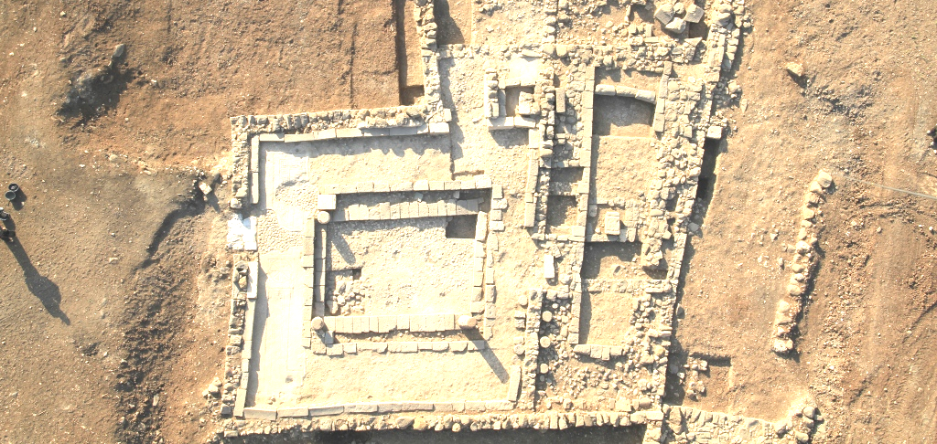
Magdala

50 Proofs for the Bible: Old Testament & New Testament

There have been a great number of archaeological finds over the decades that are relevant to the Old & New Testaments. We will be making reference to two quality pamphlets by Rose Publishing, titled, 50 Proofs of the Bible. There is one for the Old Testament and another for the New Testament. While both pamphlets are well-done, we would do well to ask a question: Is ‘Proofs’ the best choice of words? With archaeological evidence, can we have the same level of ‘proof’ that we might have in, say, a mathematical proof, or something that is repeatable and observable in the fields of operational science or engineering? No, we cannot. Archaeology is a valid field of science, but it is very interpretive. Further, archaeology often has to use presuppositions in order to operate. We cannot lay out 50 ‘proofs’ which will absolutely compel a scientifically-minded person to believe that the Bible is historically true and accurate. So while we will use these pamphlets and have no problem recommending them, a better word choice than ‘proofs’ might have been ‘points of confirmation’ or ‘points of verification’.

Example: The Tel Dan Stele

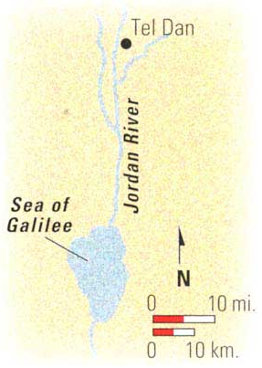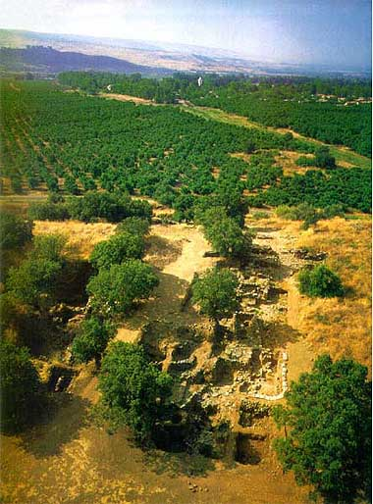
Tel Dan Excavation

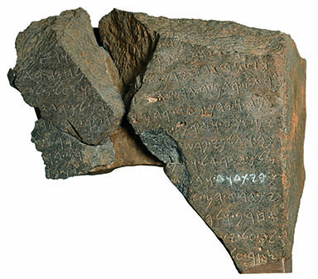
At Tel Dan in northern Israel, in 1993, there was discovered a piece of an inscription written in the 9th century making direct historical reference to ‘the house of David’ (whitened in the photo to the left). Two smaller pieces were found in subsequent excavation. It is the first direct historical reference to the ‘house of David’ outside of the Old and New Testaments. It is also likely the first historical reference to ‘the King of Israel’ outside of the Bible. The implication of the inscription is that the biblical accounts of the northern kingdom of Israel and the southern kingdom of Judah were at least generally as described in the Bible.

So those who regard Scripture as some degree of unreliable have fallen into two camps regarding this inscription:

1) Some have accepted the general validity of this inscription, and have embraced that the inscription is real, and that there is some actual historical basis for the house of David, and that David was truly a person. Additionally, the northern kingdom of Israel is more or less like what is described in the Bible (Examples: Yosef Garfinkel and Eilat Mazar, Hebrew University).

2) Others have said that David was a tribal chieftain, and/or have even called the Tel Dan inscription a fraud, and have spoken badly of its archaeologist/discoverer, Professor Avraham Biran (Examples: Israel Finkelstein and Neil Asher Silberman, Tel Aviv University), who first excavated at Tel Dan in 1966. The claims of archaeological fraud have all but gone away, as the find has held up to investigation over the years.

This is where presuppositions come into the science of archaeology. Extreme minimalists, such as those taking position 2) above, will find one or more reasons to set aside supportive data such as the Tel Dan inscription rather than accept it as confirming the historical content of Scripture. Some of this persuasion will even take to task those holding to position 1), verbally and/or in writing. This is why we say that archaeology, though a science, is very interpretive, by nature. And the interpretation of archaeology often begins with scientifically unverifiable presuppositions, springing from the worldview of the scientist – before consideration of the available evidence.

Other recommendable references:

Ten Top Biblical Archaeology Discoveries, by the Biblical Archaeology Society:
http://c795631.r31.cf2.rackcdn.com/ten_top_biblical_archaeology_discoveries.pdf
This material is not necessarily from a Bible-believing Christian perspective

Associates for Biblical Research:
http://www.biblearchaeology.org/
Associates for Biblical Research also has a quarterly publication: Bible & Spade

This is good if you’re more into photographs than text:
http://www.bibleplaces.com/

Good combination of graphics & text:
http://www.bible-history.com/

Archaeology and the Old Testament, Alfred Hoerth, 1999.

On The Reliability of the Old Testament, K.A. Kitchen, 2003

Archaeological Study Bible, NIV or KJV, 2005
Lots of good material, but the early chapters of Genesis are not as well supported in this Bible as one might hope.

The Historical Conquest, Murray D. Hiebert, 2004

100 Reasons to Trust Old Testament History, Murray D. Hiebert, 2005

Zondervan Illustrated Bible Backgrounds Commentary, Volumes 1-5, John H. Walton, General Editor, 2009
Lots of good material, but the early chapters of Genesis are not as well supported in the first volume of this set as one might hope.

John D. Currid, Doing Archaeology in the Land of the Bible, 1999; Howard F. Vos, An Introduction to Bible Archaeology, 1983, pages 31-53
J.P. Holding, Calculated Contempt: Why Bible critics do not deserve the benefit of the doubt, http://www.tektonics.org/af/calcon.html; compare to the approach in US law: innocent until proven guilty.
John Warwick Montgomery, A Critique Of Certain Uncritical Assumptions In Modern Historiography, Global Journal of Classical Theology, Vol. 2, No. 1 (12/99) http://www.trinitysem.edu/journal/montgomerypap.html
Israel Exploration Journal, Vol 43, 1993.

