Who is Bart D. Ehrman & why do we care?

Dr. Bart D. Ehrman is an American New Testament scholar, currently the James A. Gray Distinguished Professor of Religious Studies at the University of North Carolina at Chapel Hill. Born in 1955, he was educated at Moody Bible Institute, Wheaton College and Princeton Theological Seminary. He once claimed to be a Christian, but now calls himself an agnostic. It was a transition that began when he went to Princeton Theological Seminary. He is the prolific author of more than 25 books that are mostly directed at undermining the authenticity, historicity and integrity of the New Testament. The book titles include:

Misquoting Jesus: The Story Behind Who Changed the Bible and Why, 2007

Jesus, Interrupted: Revealing the Hidden Contradictions in the Bible (And Why We Don't Know About Them), 2010

Forged: Writing in the Name of God--Why the Bible's Authors Are Not
Who We Think They Are, 2012

How Jesus Became God: The Exaltation of a Jewish Preacher from Galilee, 2015

He has also appeared at a number of debates with Christian scholars, such as Daniel Wallace, James White, William Lane Craig, et al. Portions or all of those many debates can be found on www.youtube.com. But his critics are not just Bible-believing Christians. He has greatly offended those who claim that Jesus is entirely fictitious (mythicists), with the publication of
Did Jesus Exist?: The Historical Argument for Jesus of Nazareth, 2012

We will apply critical thinking to his writings, compare original source documents, and examine how his writings present the evidence. With the volume of material that Dr. Ehrman has written and spoken, we will take a preliminary look, present some general conclusions, and then point you to other resources.

He doesn’t always do his homework

While this is a generalization, on page 50 of Jesus Interrupted, Dr. Ehrman writes, “What did Jesus tell the high priest when questioned at his trial? My sense is that historically, this is something we could never know. Jesus was there, and the Jewish leaders were there, but there were no followers of Jesus there, taking notes for posterity.”

Contrary to Dr. Ehrman’s claim, both Peter and probably John were present at the trials before the high priests Annas and Caiaphas. It was John who had gotten them access. The apostle John seems to have some unique connections to the Sanhedrin and the priestly class. Only John mentions Nicodemus, one of the Sanhedrin, and also Joseph of Arimathea, also of the Council (John 3:1, 4, 9; 7:50-52; 19:39). Nicodemus is named when he comes to Jesus by night, when he attempts to defend Jesus before the Sanhedrin, and at Jesus’ burial after Christ was crucified. John also, not naming himself, but calling himself ‘another disciple’, ‘that disciple’ or ‘the other disciple’, was able to get Peter into the courtyard of the high priest, and he was known by the high priest (John 18:15, 16). Peter’s presence in the courtyard of the high priest is recorded in all four gospels.

Further, Dr. Leen Ritmeyer, among the world’s greatest authorities on the archaeology of the Temple Mount and vicinity, has shown exactly where he believes Peter was standing so as to see and hear the trial: http://www.ritmeyer.com/2012/08/28/the-palace-of-annas-the-high-priest/. Dr. Ritmeyer has other notes on that page that are worth reading.

Also note Luke’s account of the trial:

Luke 22:54-62
Having arrested Him, they led Him away and brought Him to the house of the high priest; but Peter was following at a distance. 55 After they had kindled a fire in the middle of the courtyard and had sat down together, Peter was sitting among them. 56 And a servant-girl, seeing him as he sat in the firelight and looking intently at him, said, "This man was with Him too." 57 But he denied it, saying, "Woman, I do not know Him." 58 A little later, another saw him and said, "You are one of them too!" But Peter said, "Man, I am not!" 59 After about an hour had passed, another man began to insist, saying, "Certainly this man also was with Him, for he is a Galilean too." 60 But Peter said, "Man, I do not know what you are talking about." Immediately, while he was still speaking, a rooster crowed. 61 The Lord turned and looked at Peter. And Peter remembered the word of the Lord, how He had told him, "Before a rooster crows today, you will deny Me three times." 62 And he went out and wept bitterly.

In addition to Peter, and likely John, we have these men who would have been able to report to the apostles regarding the events at the house of the high priest:

Matthew 27:57
When it was evening, there came a rich man from Arimathea, named Joseph, who himself had also become a disciple of Jesus.

Mark 15:43
Joseph of Arimathea came, a prominent member of the Council, who himself was waiting for the kingdom of God; and he gathered up courage and went in before Pilate, and asked for the body of Jesus.

Luke 23:51
[Joseph] (he had not consented to their plan and action), a man from Arimathea, a city of the Jews, who was waiting for the kingdom of God;

John 3:1, 4, 9
Now there was a man of the Pharisees, named Nicodemus, a ruler of the Jews... 4 Nicodemus said to Him, "How can a man be born when he is old? He cannot enter a second time into his mother's womb and be born, can he?"... 9 Nicodemus said to Him, "How can these things be?"

John 7:50
Nicodemus (he who came to Him before, being one of them) said to them,

John 19:38
After these things Joseph of Arimathea, being a disciple of Jesus, but a secret one for fear of the Jews, asked Pilate that he might take away the body of Jesus; and Pilate granted permission. So he came and took away His body.

John 19:39
Nicodemus, who had first come to Him by night, also came, bringing a mixture of myrrh and aloes, about a hundred pounds weight [this was EXPENSIVE - a royal burial].

Acts 6:7 Then, after Christ's ascension...
The word of God kept on spreading; and the number of the disciples continued to increase greatly in Jerusalem, and a great many of the priests were becoming obedient to the faith.

Perhaps now these priests were finding an answer as to why the temple veil was torn from top to bottom...

Matthew 27:51
And behold, the veil of the temple was torn in two from top to bottom...
Mark 15:38 (see also Luke 23:45)
And the veil of the temple was torn in two from top to bottom.
...and the veil of the temple was torn in two.

In Jesus Interrupted, Bart Ehrman wrote, “In Luke there is an empire wide census that requires everyone to return to their hometown. This would totally disrupt human life in the region, but it is not recorded anywhere else.”

That there were censuses ordered by Augustus Caesar in the Roman Empire before the birth of Christ and afterwards is recorded in:

A transcription and translation of Caesar Augustus’ funerary inscription can be viewed here: http://classics.mit.edu/Augustus/deeds.html.. A portion of it (#8 of 35 items) reads:

When I was consul the fifth time (29 B.C.E.), I increased the number of patricians by order of the people and senate. I read the roll of the senate three times, and in my sixth consulate (28 B.C.E.) I made a census of the people with Marcus Agrippa as my colleague. I conducted a lustrum, after a forty-one year gap, in which lustrum were counted 4,063,000 heads of Roman citizens. Then again, with consular imperium I conducted a lustrum alone when Gaius Censorinus and Gaius Asinius were consuls (8 B.C.E.), in which lustrum were counted 4,233,000 heads of Roman citizens. And the third time, with consular imperium, I conducted a lustrum with my son Tiberius Caesar as colleague, when Sextus Pompeius and Sextus Appuleius were consuls (14 A.C.E.), in which lustrum were counted 4,937,000 of the heads of Roman citizens. By new laws passed with my sponsorship, I restored many traditions of the ancestors, which were falling into disuse in our age, and myself I handed on precedents of many things to be imitated in later generations.

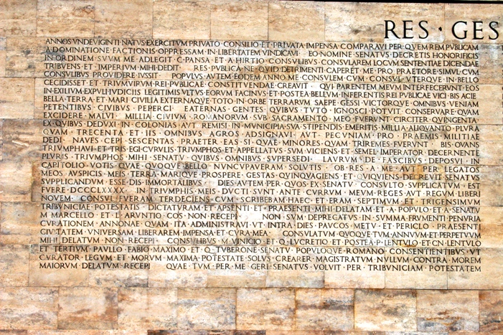

A portion of “The Deeds of the Divine Caesar” funerary inscription.
Caesar Augustus’ funerary inscription was a summary of his accomplishments written for Roman citizens and higher officials. The censuses that he wrote about, then, may have included those who were not citizens but those statistics are not included in his summary.
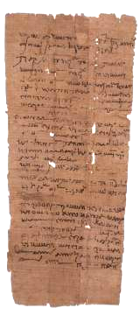
We also have available a number of individual census documents from the Roman Empire, and not just of those who were Roman citizens. As for the claim Dr. Ehrman makes about the census, there is ample evidence that the Romans required a periodic census, and the way that they did it was to rotate the locations and spread the requirement over time so that the disruption was not universal and simultaneous. See separate scan of pages from the book, “Archaeology of the New Testament – Blaiklock”. I also have a number of other scans of the census documents from this era. To the left is an example dated May 10, 91 AD (by our calendar system), which starts as follows:
“…From Peteuris, son of Horos, a resident of the village of Bacchias. There belongs to me in the village 3/4 of a house in which I dwell…”
Additionally, there are many census and other papyrus documents from Roman times in the possession of several universities in the US (in the tens of thousands), and elsewhere a great many of them have never been translated, even though they have been in the possession of the universities for many decades.
More on the census of Luke 2:1-5

On pages 32 and 33 of Jesus Interrupted Dr. Ehrman wrote:

“The historical problems with Luke are even more pronounced. For one thing, we have relatively good records for the reign of Caesar Augustus, and there is no mention anywhere in any of them of an empire-wide census for which everyone had to register by returning to their ancestral home. And how could such a thing even be imagined? Joseph returns to Bethlehem because his ancestor David was born there. But David lived a thousand years before Joseph. Are we to imagine that everyone in the Roman Empire was required to return to the homes of their ancestors from a thousand years earlier?… There is not a single reference to any such census in any ancient source, apart from Luke.”

Here is what Luke wrote about the census, with retranslation and explanatory notes:

Luke 2:1-5
Now in those days a decree went out from Caesar Augustus, that all the inhabited earth [The Greek word was commonly used to mean the Roman Empire] should be enrolled. 2 This was the first enrollment taken while Quirinius was governing Syria. 3 And everyone [in Israel and perhaps in some other Roman districts] was on his way to register for the enrollment, each to his own city. 4 Joseph also went up from Galilee, from the city of Nazareth, to Judea, to the city of David which is called Bethlehem, because he was of the house and family of David, 5 in order to register along with Mary, who was engaged to him, and was with child.

The huge problem that Dr. Ehrman describes is that Luke said that Caesar Augustus sent out an empire-wide decree that everyone must return to their ancestral home for the census or to be enrolled. But that is not what Luke wrote. Luke wrote that Caesar Augustus sent out a decree that the Roman empire should be enrolled. After referring to the local governing official, Quirinius, Luke then refers to returning to one’s own ancestral city with a specific impact on Joseph and Mary.

In the following pages we will show that:

- Caesar Augustus did, in fact, order multiple empire-wide enrollments or censuses during his reign, which ended in 14 AD, the year of His death.
- Census orders and results are rarely preserved in most of the Roman Empire.

- The implementation of those enrollments or censuses was delegated to regional officials, and was carried out with some local variation that included, in some cases, requiring a return to one’s homeland.
- That the Jews had laws and traditions that made enrollments and censuses by genealogical record a long-standing tradition such that going to the home city of an ancestor from a thousand years back was no challenge at all.

Caesar Augustus’ empire-wide enrollments and censuses
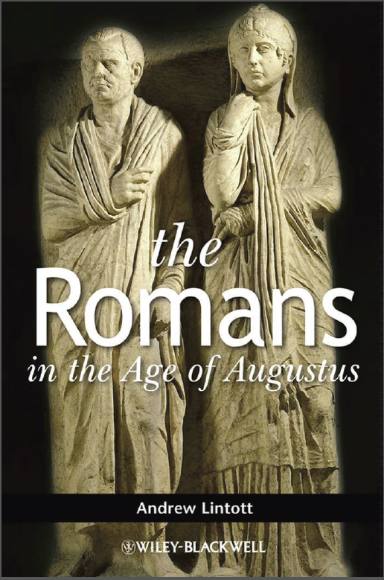
In The Romans in the Age of Augustus, page 84, we read:

Augustus conducted three formal censuses himself – in 28 BC, 8 BC, and 14 AD (RG 8.2 – 4) – and a further one was concluded by elected censors in 22 BC. However, we also see evidence of provision for continuous registration and assessment.

What Roman census data has survived – and where

Below is an objective summary of the available census data in the Greek and Roman era, written with no maximalist nor minimalist bias. On page 76 of A Companion to Families in the Greek and Roman Worlds , edited by Beryl Rawson, we find:

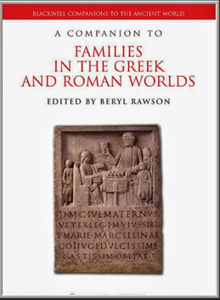
Unfortunately, census data did not survive for most parts of the ancient world, even though regular census surveys were conducted throughout the Hellenistic and Roman imperial periods. Only for the villages and towns of Middle and Upper Egypt has extraordinary documentation in the forms of tax lists and census returns survived in the dry desert sands…

In Roman Egypt the entire population was liable for filing declarations, and the household was normally the registration unit. Every 14 years the head of each household, normally the eldest male, had to file such a census return and had to declare his property, his house and the persons who lived in it (Bagnall and Frier (2006) 12-13, 22-25). Names, status, profession, age, physical descriptions, and relationships to the other members of the household are given in the most detailed returns. Meanwhile, we have nearly 400 extant census returns recording almost 1,500 individuals. These documents make detailed studies on household composition possible, allowing for a more complex analysis of the structure of the household than for any other region of the Greco-Roman world.

The paragraphs above present the reason that census returns are found in relatively great quantity in Middle and Upper Egypt, but are relatively rare in most other parts of the Roman Empire, including Israel. So the absence of Roman census records in Israel does not necessarily show that there was no census in Israel when and where Luke says there was, but rather that such documents were not preserved over the centuries. For more on the Egyptian papyrus records, see: http://www.athenapub.com/egypap1.htm.

Return to one’s homeland for the census - sometimes
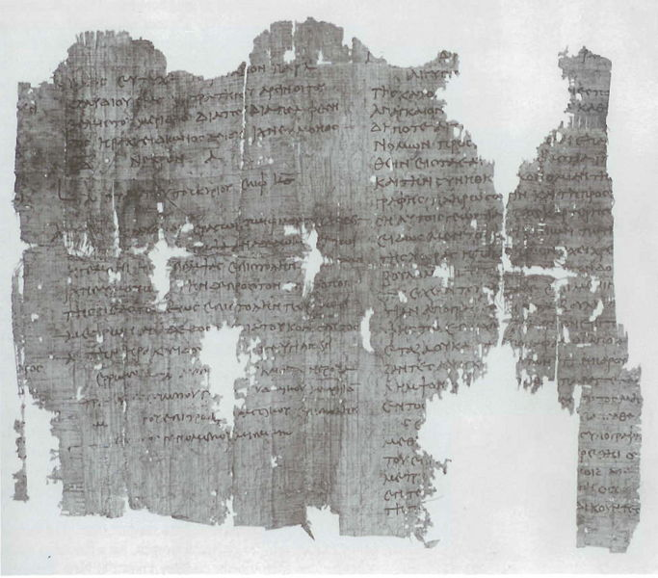
The census documents that we do have indicate that the way in which the census was carried out varied by location and by specific census, and that a return to one’s homeland was sometimes a census requirement.

The following is a record of a census taken in the year 104 A.D. with similar wording to that in the Gospel of Luke: (http://cojs.org/cojswiki/Papyrus_Census_Order,_104_CE):
"From the Prefect of Egypt, Gaius Vibius Maximus...”
"From the Prefect of Egypt, Gaius Vibius Maximus. Being that the time has come for the house to house census, it is mandatory that all men who are living outside of their districts return to their own homelands in order that the census may be carried out."

Another census was found from 48 AD which also records a return of the people to their native land for the census. It reads as follows:

"I Thermoutharion along with Apollonius, my guardian, pledge an oath to Tiberius Claudius Caesar that the preceding document gives an accurate account of those returning, who live in my household, and that there is no one else living with me, neither a foreigner, nor an Alexandrian, nor a freedman, nor a Roman citizen, nor an Egyptian. If I am telling the truth, may it be well with me, but if falsely, the reverse. In the ninth year of the reign of Tiberius Claudius Augustus Germanicus Emperor."

Census among the Jews

Further, unlike most other peoples in the Roman empire, the Jews had laws and traditions which required them to keep genealogical records, and to know where their ancestors were from, and to observe those laws and traditions:

- Levites serving in the temple had to be descended from Levi, within the tribe of Levi. And only those also descended from Aaron could serve as priests, and only those descended from Aaron through Zadok could serve as high priests (Exodus 38:21; Leviticus 7:31-34, 1 Chronicles 6; Nehemiah chapter 12; et al).

- Once David, descendent of Judah, served as King of Israel and was promised through Nathan that a descendent of his would sit on the throne, only a descendent of David could sit on the throne as King of Israel (1 Chronicles 17).

- The name ‘David’ was connected with Bethlehem in the Old Testament, starting in 1 Samuel 16, so there is no question where Joseph and Mary had to return.

- In the gospel of Luke, Anna is of the tribe of Asher, and Saul (later, Paul) is said to be of the tribe of Benjamin in Acts 13:21; Romans 11:1; Philippians 3:5. Jesus is of the tribe of Judah (Matthew 1:2; Luke 3:33; Hebrews 7:14; Revelation 5:5). The Jews knew or had access to their tribe, family, etc. until 70 AD when the records were destroyed.

- A census by genealogy was a Jewish tradition for several centuries before Christ’s birth (1 Chronicles 5:1-17; 9:1-44; Nehemiah chapter 7). A census among the Israelites was first mentioned in Exodus 30:12. See also Numbers 3:14-24.

- The Jewish laws of temple assembly and inheritance (Deuteronomy 23:2, 3; Numbers 27:1-11, et al) required the keeping of careful genealogical records.

- Nehemiah 10:34 (see also Nehemiah 13:31) set up an annual rotation among tribes and families within those tribes to cut wood for the temple fire, which was never allowed to go out (Leviticus 6:12, 13). This meant that Joseph would likely go regularly to the vicinity of Jerusalem and Bethlehem for his wood-cutting rotation, especially being a carpenter by trade. Josephus wrote, “Now the next day was the festival of Xylophory; upon which the custom was for every one to bring wood for the altar (that there might never be a want of fuel for that fire which was unquenchable and always burning). – Josephus, Wars of the Jews, Book 2.

- The Jews would make a pilgrimage to Jerusalem for the Mosaic feasts, typically several times a year, and Bethlehem is only about six miles away from Jerusalem.

- What the Jews would find infuriating was a census required by the Romans that was not respectful of Jewish culture, such as the 6 AD census which resulted in revolt: Acts 5:37.

A summary assessment

Dr. Thomas Howe, who is the head of the Ph.D. program at Southern Evangelical Seminary, wrote a 66 page review of Dr. Ehrman’s Misquoting Jesus, which he prefaced with:

To the individual with even rudimentary training in textual criticism, church history, philosophy, and logic, the multitude of problems with Dr. Ehrman’s book are easily identifiable. Rather, this book is difficult because virtually every assertion and every claim is so fully laden with exaggeration, misrepresentation, selective reporting, and outright falsehoods that almost every line requires a recasting in an accurate
light and involves a lengthy response to a series of misrepresentations and half-truths, each built upon the conclusions of the previous. Ehrman has woven a tight web of exaggeration, partial truths, falsehood, and misrepresentation that would take many more pages to unravel in order to set the record straight.

Other references

"A Response To Bart D. Ehrman’s Misquoting Jesus", By Thomas Howe, Ph.D.
http://www.confidentchristians.org/resources_other/A%20Response%20to%20Bart%20Ehrman.pdf

Misquoting Jesus critique by James F. Reed:
http://www.christianlifetools.org/clientimages/28178/bartehrman.pdf

How God Became Jesus, by Craig Evans, et al, 2014
http://smile.amazon.com/How-God-Became-Jesus-Nature---/dp/0310519594/ref=sr_1_15?ie=UTF8&qid=1432158182&sr=8-15&keywords=Bart+D.+Ehrman

William Lane Craig and Bart D. Ehrman Debate the Question
"Is There Historical Evidence for the Resurrection of Jesus?"
Held at College of the Holy Cross, Worcester, Massachusetts on March 28, 2006.
http://www.philvaz.com/apologetics/p96.htm

Debate: Is the Original New Testament Lost? Daniel Wallace vs. Bart Ehrman:
Date: February 1, 2012
Location: University of North Carolina, Chapel Hill
https://www.youtube.com/watch?v=Uk0bMzaIGas

The Greek text does not have the title ‘governor’, but the verb, so ‘governing’, or ‘ruling’, or a similar term. It does not say ‘the governor’ per Ehrman, pages 31, 33, 175.
This is Emperor Claudius, who ruled from 41 until 54 AD..

