Western Religions

Religion? What do you mean?
Religion: A personal or institutional set or system of beliefs and practices that is rooted in a view of human life in the physical world and its relationship with the spiritual realm or denial thereof. The major world religions, and most minor religions, have a definition of the spiritual realm that affirms its existence and defines a relationship of humans to that realm. Agnosticism is a set of beliefs that denies either the present knowledge or ability to know about the spiritual realm. Atheism is also a system of beliefs, but which by faith emphatically denies the existence of the spiritual realm or at least the existence of God.

Western & eastern religions: a basic difference
While we could detail a great many differences between eastern & western religions, one helpful approach is to see that western religions tend to view God as transcendent from His creation, revealing and involving Himself by personal and deliberate intent. Time is viewed as primarily progressive and linear. Eastern religions on the other hand, view God as fundamentally intermingled with and immanent with the physical realm, and any transcendence from the physical realm is secondary and ultimately temporary. Time is viewed as primarily circular.

Old time religion?
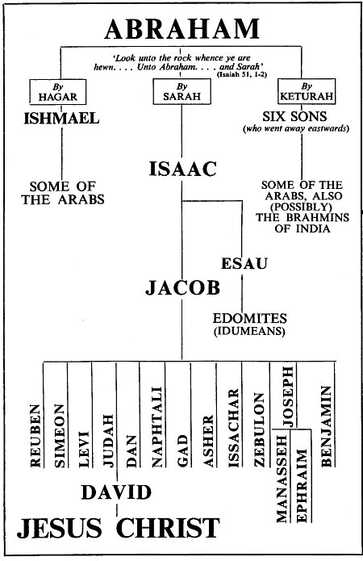
In earlier centuries, it was the custom and frequently the law, that the religion of the political leader was also the religion of the people. Often this set of beliefs and practices included viewing the political leader as a deity among deities. It has only been in recent centuries of world history that the political leadership of many modern nations has stood at a distance from religion, allowing personal choice of belief, with minimal personal consequence. But when we speak of religions, we must acknowledge that for many, their religious point of view is a cultural aspect of life that holds varying degrees of importance, rather than a deeply held belief and a consequent practice consistent with that belief.

Father Abraham had many sons
Interestingly, the three major western religions claim to have some root in Abraham, first introduced in the Bible (Jewish: TaNaCH) in Genesis 12 as Abram. Even today, Christian believers have a claim to relationship with Abraham by faith, as explained by Paul:

Galatians 3:7 (NASU)
Therefore, be sure that it is those who are of faith who are sons of Abraham.

Side by Side
We can compare and contrast the three major world religions in various aspects, some of which are shown in the chart below:

Christianity Judaism Islam

Founded 1st century AD 15th century BC 7th century AD

Founder Jesus Christ Moses Muhammad

Saved by faith (many: also by works) faith & works works

Heaven one (+crowns & rewards) three (vague) seven

Purgatory no, except Roman Catholic no yes (Barzakh)

Man’s nature sinful good & bad good

Double no, except some Calvinists no, except Essenes yes
Predestination

Messiah Yes, 2nd coming (some Orthodox (yes, 1st time) Isa to come
to come exceptions & variations) again, bow to
Muhammed, then die for the first time

Scriptures 66 Books of the Old & Tanach, primarily Torah Koran +
New Testament (plus the + written traditions Hadith
Apocrypha among some)

Then there’s the math: dividing & addition
Within each of the three major religions, there are, of course, a number of divisions of doctrine, organization, etc. These, if one will allow for the certain errors of simplification, can be summarized as follows:

Christianity Judaism Islam

Orthodox Orthodox Sunni
Roman Catholic Conservative Shiite
Protestant Reformed

Each of these divisions, to be certain, has many subdivisions within each group listed. In the middle centuries of Christianity, these divisions involved violent clashes among the groups and subgroups within Christianity, but rarely today. In Islam, violent clashes between groups, originating in Muhammad’s extended family, continue to this day.
Beyond the three primary western world religions, western cultures have a great number of other religions, the geographical distribution of which is quite complex. Some of these are listed below, and have their own subgroups and varying degrees of interconnection within those subgroups:

- Zoroastrianism
- Neo-Paganism, earth religions, including Wicca
- Animism, Voodoo (aka Vodun, Sevi Lwa), Santeria & tribal religions
- Rastafarianism
- Atheism & Humanism
- Scientology
- Satanism
- Egyptian religion (Isis, Ra, et al)

What do we say to these people?
There may be some value in knowing about the beliefs of the person you are speaking with, and we see that the authors of the New Testament did write with a knowledge of other religions (1 Corinthians, Colossians, 1 John 4:1-6, Revelation 2-3, et al). But what is ultimately most important is that these people be presented with God’s special revelations, each testifying of the other:

- Jesus Christ: God’s living Word
- The Bible: God’s written word

Acts 4:12 (NASU)
And there is salvation in no one else; for there is no other name under heaven that has been given among men by which we must be saved."

1 Corinthians 2:1-2 (NASU)
And when I came to you, brethren, I did not come with superiority of speech or of wisdom, proclaiming to you the testimony of God. 2 For I determined to know nothing among you except Jesus Christ, and Him crucified.

1 Corinthians 15:1-11 (NASU)
Now I make known to you, brethren, the gospel which I preached to you, which also you received, in which also you stand, 2 by which also you are saved… 3 For I delivered to you as of first importance what I also received, that Christ died for our sins according to the Scriptures, 4 and that He was buried, and that He was raised on the third day according to the Scriptures… 11 …so we preach and so you believed.

1 Timothy 2:3-7 (NASU)
This is good and acceptable in the sight of God our Savior, 4 who desires all men to be saved and to come to the knowledge of the truth. 5 For there is one God, and one mediator also between God and men, the man Christ Jesus, 6 who gave Himself as a ransom for all, the testimony given at the proper time. 7 For this I was appointed a preacher and an apostle (I am telling the truth, I am not lying) as a teacher of the Gentiles in faith and truth.

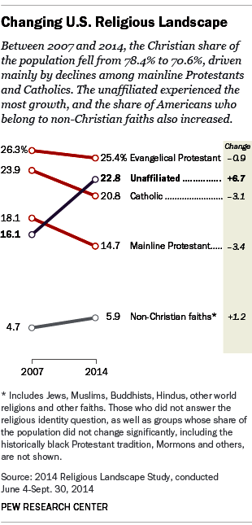
This article and chart show the changes in the US religious landscape between 2007 and 2014. The largest drops in affiliation were among the mainline protestant denominations and Catholics. The largest increase was among those who are unaffiliated with any religion.

