Roman Catholicism

The approach
This week we will compare the teachings and practices of the Roman Catholic Church with those of the Orthodox churches, with a primary focus upon the teachings and practices of the Roman Catholic Church. Next time we meet we will examine the Orthodox churches.

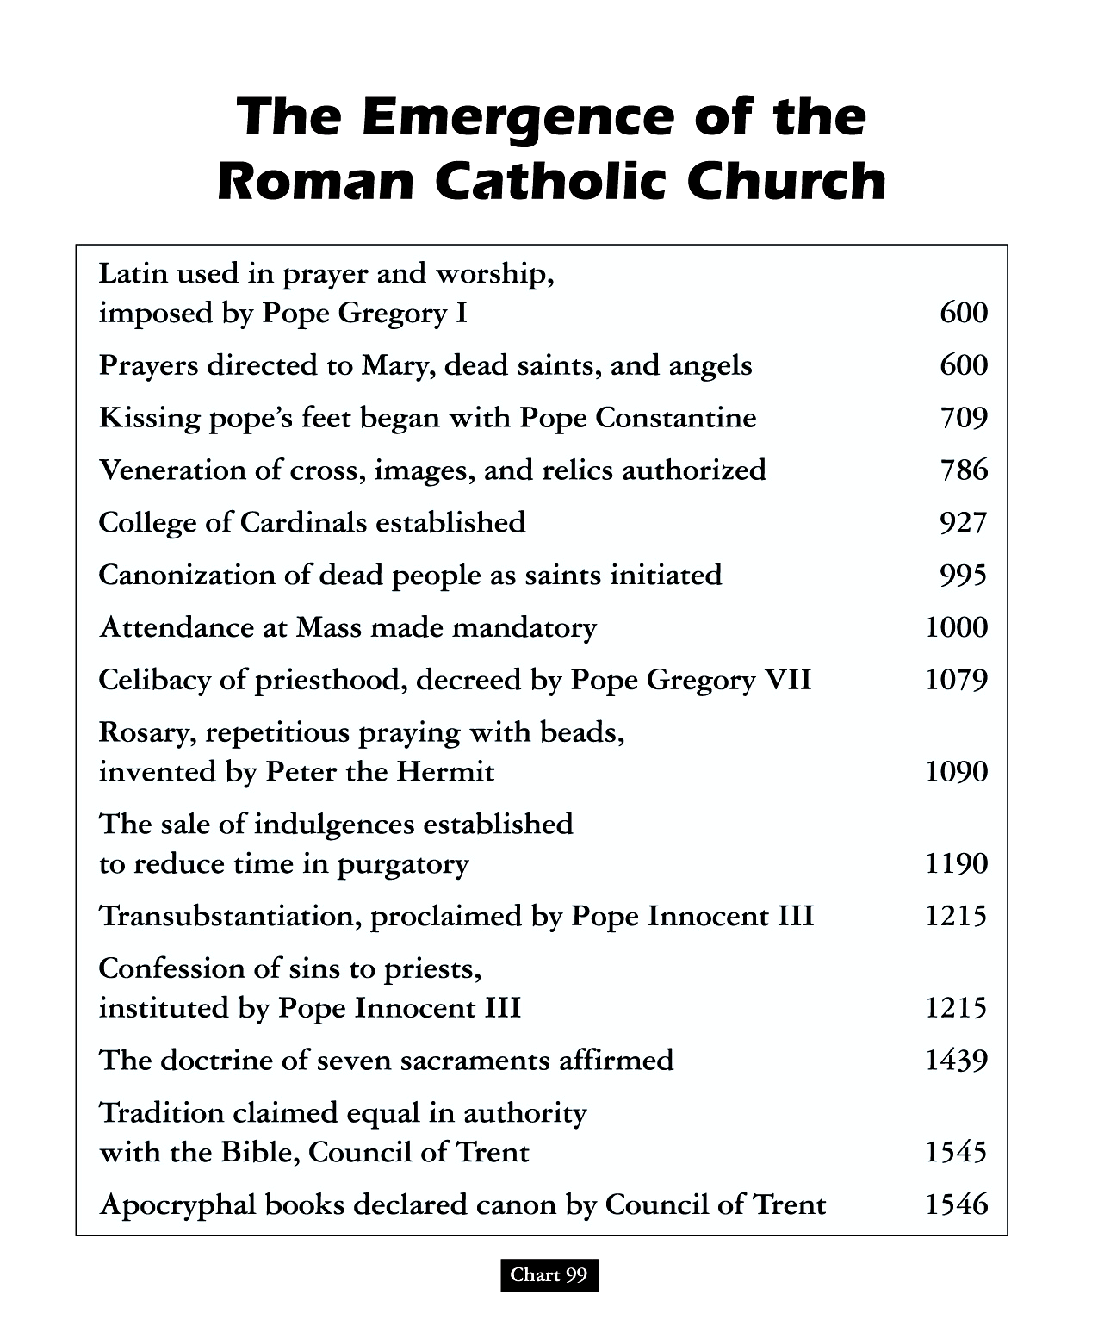
Once the Bishop of Rome began taking on the title and role of the Pope (about 600 AD), as singular head of the hierarchy of bishops, the Roman Catholic Church developed doctrines, religious perspectives, and practices which placed it farther apart from the confederation of bishops which continued to govern the Eastern Orthodox churches. Because the Roman Catholic Church had established a hierarchy and basis of authority that supplemented Scripture, the Roman Catholic Church added doctrines and practices over time that were not found in Scripture.
Charts of Ancient & Medieval Church History, John D. Hannah, 2001, chart 99
This plural basis of authority is not simply the claim of an external critic of the Roman Catholic Church. Paragraph 11 of the Roman Catholic Catechism says, “This catechism… Its principal sources are the Sacred Scriptures, the Fathers of the Church, the liturgy, and the Church's Magisterium.”

Where did many of the extrabiblical doctrines and practices come from? Roman Catholic Cardinal John Henry Newman, writing about the origin of many of the doctrines and practices, states:

We are told in various ways by Eusebius, that Constantine, in order to
recommend the new religion to the heathen, transferred into it the outward ornaments to which they had been accustomed in their own… The use of temples, and these dedicated to particular saints, and ornamented on occasions with branches of trees; incense, lamps, and candles; votive offerings on recovery from illness; holy water; asylums; holydays and seasons, use of calendars, processions, blessings on the fields; sacerdotal vestments, the tonsure, the ring in marriage, turning to the East, images at a later date, perhaps the ecclesiastical chant, and the Kyrie Eleison, are all of pagan origin, and sanctified by their adoption into the Church.

Since there was a similar basis of authority for both the Roman Catholic Church and the Orthodox churches, and significant commonality between them in earlier centuries, there remain a great number of aspects in common between the Roman Catholic Church and the Orthodox churches. The chart below reveals a number of points of contrast and similarity:

Roman Catholic Churches | Orthodox Churches
Leadership of singular pope over hierarchy | Leadership by confederation of bishops
Male celibate leadership to priests, nuns | Male leadership, celibate at highest level
Baptism & Eucharist as effective | Baptism & Eucharist as effective
Scripture: books, mainly through Latin | Scripture: books, mainly though Greek
Tradition of Roman Catholic Church | Tradition of Orthodox churches
Communication primarily in texts | Communication primarily in aesthetics
Venerations of statues & icons | Venerations of icons, but not statues
Emphasis upon definition & understanding | Emphasis upon continuing mystery
Mary as perpetual Virgin | Mary as perpetual Virgin
Adam’s sin brought universal guilt | Adam’s sin brought universal mortality
Roman Church is “our Mother” | Orthodox Church is “our Mother”

Introducing - and answering - an important question
Given that both the Roman Catholic Church and the Orthodox churches have developed doctrines and practices on the basis of authorities outside of Scripture, and that we will encounter this same basic issue with a number of institutions and groups in the weeks and months ahead, a very good question is:

Does Scripture itself claim that Scripture is our sole basis of authority?

Isaiah 8:20 (writing of the Scriptures revealed by his day)
To the law and to the testimony! If they do not speak according to this word, it is because they have no dawn.

Mark 7:7-9,13 (Jesus speaking to Pharisees and scribes; see Matthew 23:1-36)
'but in vain do they worship Me, teaching as doctrines the precepts of men.' 8 "Neglecting the commandment of God, you hold to the tradition of men." 9 He was also saying to them, "You are experts at setting aside the commandment of God in order to keep your tradition… 13 thus invalidating the word of God by your tradition which you have handed down; and you do many things such as that."

Acts 20:27-33 (Paul speaking to the elders from Ephesus for the last time)
"For I did not shrink from declaring to you the whole purpose of God. 28 "Be on guard for yourselves and for all the flock, among which the Holy Spirit has made you overseers, to shepherd the church of God which He purchased with His own blood. 29 "I know that after my departure savage wolves will come in among you, not sparing the flock; 30 and from among your own selves men will arise, speaking perverse things, to draw away the disciples after them. 31 "Therefore be on the alert, remembering that night and day for a period of three years I did not cease to admonish each one with tears. 32 "And now I commend you to God and to the word of His grace, which is able to build you up and to give you the inheritance among all those who are sanctified.

2 Timothy 2:2 (Paul writing to Timothy in his last letter, of which we have possession)
The things which you have heard from me in the presence of many witnesses, entrust these to faithful men who will be able to teach others also.

2 Timothy 3:16-17
All Scripture is inspired by God and profitable for teaching, for reproof, for correction, for training in righteousness; 17 so that the man of God may be adequate, equipped for every good work.

Jude 3
“…I felt the necessity to write to you appealing that you contend earnestly for the faith which was once for all handed down to the saints.”

And another question

May anyone interpret Scripture, or only the official hierarchy of the Church?

Roman Catholic Catechism, Paragraph 85

“…the task of interpretation has been entrusted to the bishops in communion with the successor of Peter, the Bishop of Rome.”

Acts 17:10-12
The brethren immediately sent Paul and Silas away by night to Berea, and when they arrived, they went into the synagogue of the Jews. 11 Now these were more noble-minded than those in Thessalonica, for they received the word with great eagerness, examining the Scriptures daily to see whether these things were so. 12 Therefore many of them believed, along with a number of prominent Greek women and men.

2 Peter 1:20-21
But know this first of all, that no prophecy of Scripture is a matter of one's own interpretation, 21 for no prophecy was ever made by an act of human will, but men moved by the Holy Spirit spoke from God.

And just how do they interpret Scripture?
Paragraph 492 of the Roman Catholic Catechism states:

‘The Father blessed Mary more than any other created person "in Christ with every spiritual blessing in the heavenly places" and chose her "in Christ before the foundation of the world, to be holy and blameless before him in love“’.

Ephesians 1:1-4
Paul, an apostle of Christ Jesus by the will of God, to the saints who are at Ephesus and who are faithful in Christ Jesus: 2 Grace to you and peace from God our Father and the Lord Jesus Christ. 3 Blessed be the God and Father of our Lord Jesus Christ, who has blessed us with every spiritual blessing in the heavenly places in Christ, 4 just as He chose us in Him before the foundation of the world, that we would be holy and blameless before Him.

Paragraph 969 of the Roman Catholic Catechism states:

Therefore the Blessed Virgin is invoked in the Church under the titles of Advocate, Helper, Benefactress, and Mediatrix.

1 John 2:1
My little children, I am writing these things to you so that you may not sin. And if anyone sins, we have an Advocate with the Father, Jesus Christ the righteous

1 Timothy 2:5
For there is one God, and one mediator also between God and men, the man Christ Jesus,

An Essay on the Development of Christian Doctrine, John Henry Newman, Digireads, 2004, p 248
“Salvation comes from God alone; but because we receive the life of faith through the Church, she is our mother: "We believe the Church as the mother of our new birth…”. Roman Catholic Catechism, paragraph 169. Jesus, in John 10:27-28 said, "My sheep hear My voice, and I know them, and they follow Me; and I give eternal life to them …”
The faith: the set of doctrines set down by the apostles (1 Corinthians 16:13; Ephesians 4:13; Philippians 1:27, 1 Timothy 4:1, 6, et al)
once for all - hapax: once given, perpetually valid.

