Orthodox Churches: Russian, Greek, Antiochene, et al

Let’s start at the beginning
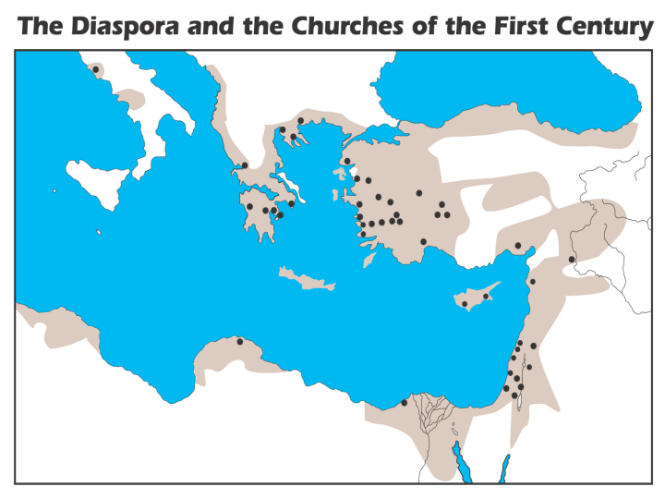
In the first century, under the ministry of the apostles, churches were founded first in Judea and Samaria, then established in other areas of the Roman Empire as shown on the map to the left. Other areas where churches were or may have been established which are outside the area of the map are not shown (Babylon in the Parthian empire, Madras, India, etc.). Other than the divisions within a church mentioned by the apostles (such as 1 Corinthians 1), the church was one body, which had elders among the believers in each city (Acts 14:23; 20:28; 1 Peter 5:1-4). From an examination of the New Testament, the apostles never intended to leave in place any higher human authority among the churches than a biblically qualified plurality of elders in each local church.

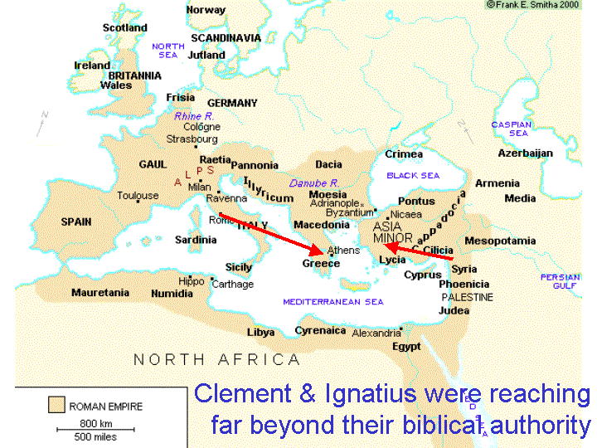
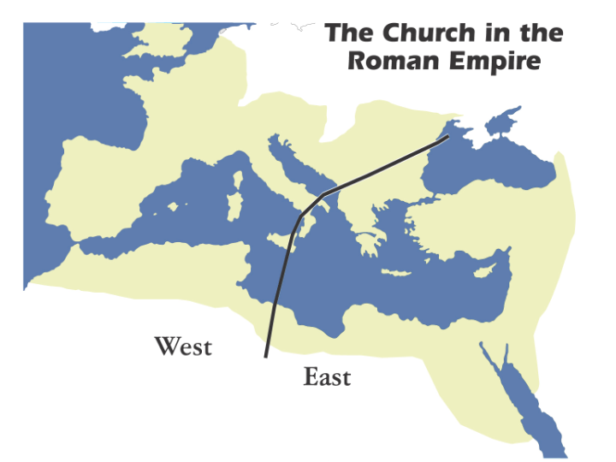
But as we pointed out last week, about 100 AD Clement of Rome and Ignatius of Antioch both began setting themselves up as individual bishops, as a position over other churches. This was an arrangement which has no basis whatsoever in Scripture. It appeared that this unbiblical arrangement was not challenged, so the concept of apostolic succession - a succession of individual bishops in a line founded by the apostles - was accepted by the churches throughout the empire. Along with this authority arrangement, the churches introduced a succession of new doctrines and practices not mentioned or taught in Scripture, or that were even contrary to Scripture. These added doctrines and practices were eventually fixed in place for the long term as “church traditions”.

Though there were a number of differences between churches in the western portion of the Roman Empire and those in the eastern portion of the Empire, the administrative division of the empire in 284 AD set the stage for eventually splitting up the churches as well.
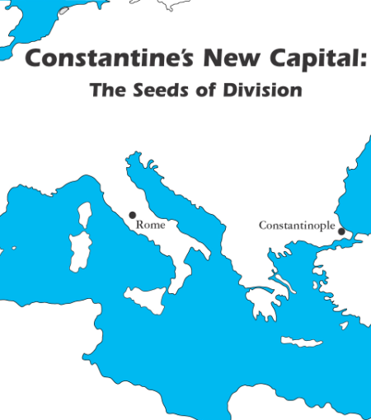
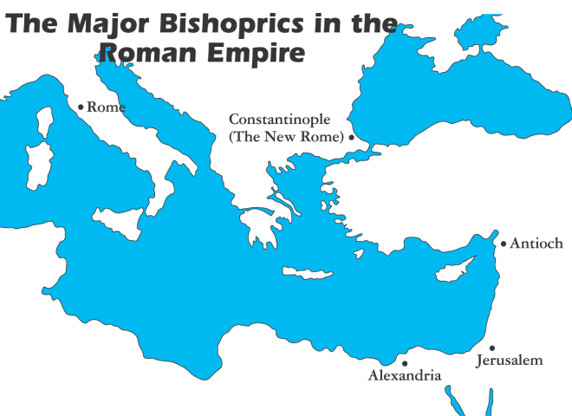
Emperor Constantine declared Christianity legal in 312 AD, calling upon the bishops in the churches to meet at Nicea in 325 AD, then set Constantinople (formerly called “Byzantium”) as the new eastern capital of the Roman Empire in 330 AD. By 395 AD, the political division of the empire had become total. Rome remained important to the western portion of the empire, and Constantinople was the eastern capital. Since the church, under Constantine, had been made the official religion of the empire, the political alliance between the Roman Empire and the church had set the churches up for division according to the political systems and capitals. The churches in both east and west, in spite of differences and initial political divisions, were still seen as one universal church. That one universal church was led by a confederation of bishops, with five of them having prominence, and Rome and Constantinople having the greater prominence among them. As the decline of the Roman Empire began to set in, the bishoprics (the places and regions headed by singular bishops) continued, and began to rise in importance. This pattern was especially evident in the three barbarian invasions of Rome in the 5th century, in which the Bishop of Rome negotiated with the barbarian leaders for leniency in their invasion of the now defenseless city.

THE SEVEN ECUMENICAL COUNCILS

PLACE AND DATE | DECISIONS/ACTIONS
Nicea I, 325 | The 1st part of the Nicene Creed, divinity of the Son of God.
Constantinople, 381 | The 2nd part of the Nicene Creed, divinity of the Holy Spirit.
Ephesus, 431 | Christ as the Incarnate Word of God & Mary as Theotokos
Chalcedon, 451 | Christ as Perfect God & Perfect Man in One Person
Constantinople II, 553 | Reconfirmed the doctrines of the Trinity & Christ
Constantinople III, 680 | Humanity of Jesus, the reality of His human will & action
Constantinople III, 692 | Finishing the work of the prior Councils (counted in III)
Nicea II, 787 | Propriety of icons as genuine expressions of the faith
The seven “Ecumenical Councils”, initiated at first by Emperor Constantine, were convened to resolve doctrinal questions and establish what the church saw as accepted doctrines. These began with a united Roman Empire, but ended with the empire having passed out of existence, and a sense of continuity having been maintained by the confederation of bishops. But there were events along the way that brought about the division of the Western (Latin background) churches from the Eastern (Greek background) churches.

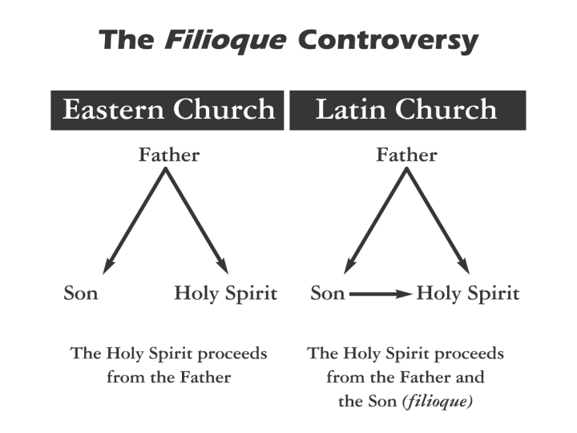
In 553, the Latin and Eastern churches were not able to resolve their differences over what was known as the “Filioque” doctrine. Essentially, the question that remained unresolved can be stated as, “Was the Holy Spirit sent by the Father (the Eastern churches’ view), or by the Father and the Son (the Latin churches’ view)?” See John 14:26, 15:26 and 16:7 to see what Scripture says about this question. This unresolved controversy led to an ongoing tension between the Eastern and Latin churches, that was heightened by other factors, summarized in today’s supplemental chart. This also leads us to the defining point of division between the Latin and Eastern churches: the time of 1054 when the bishop of Rome and the Bishop of Constantinople each excommunicated the other.

These points of history have been given, in part, to show that:

- Until the Great Schism of 1054, there was a great deal in common between what became the Roman Catholic Church, headed by the bishop of Rome, and the Eastern churches, known as the Orthodox churches, headed by a confederation of bishops, with a few bishops having higher honor among them, and the bishop of Constantinople having the highest honors among the Eastern churches (see “The Major Bishoprics in the Roman Empire”, on the prior page). But the Roman Catholic Church and the Orthodox churches have both common characteristics and differences today because of their course of history from those earliest centuries and into the most recent centuries.
- The above patterns, in combination with the varying and shifting pressures from Islam, beginning in the 7th century, contributed towards a more distributed authority and leadership structure. Ultimately, the confederation of bishops in the Eastern church changed into churches with (often) regional or ethnic names: Greek Orthodox, Russian Orthodox, Serbian Orthodox, Antiochene Orthodox, etc.
- The ability to add new traditions, thereby supplementing or even overriding the authority of Scripture in both the Latin church and the eastern churches, was and is mitigated by the maintenance of existing traditions, and a general reluctance to change. The direct meaning of Scripture was not and is not the basis of authority for either the Roman Catholic or Orthodox churches, but rather the traditions through which the Scripture is viewed and supplemented.
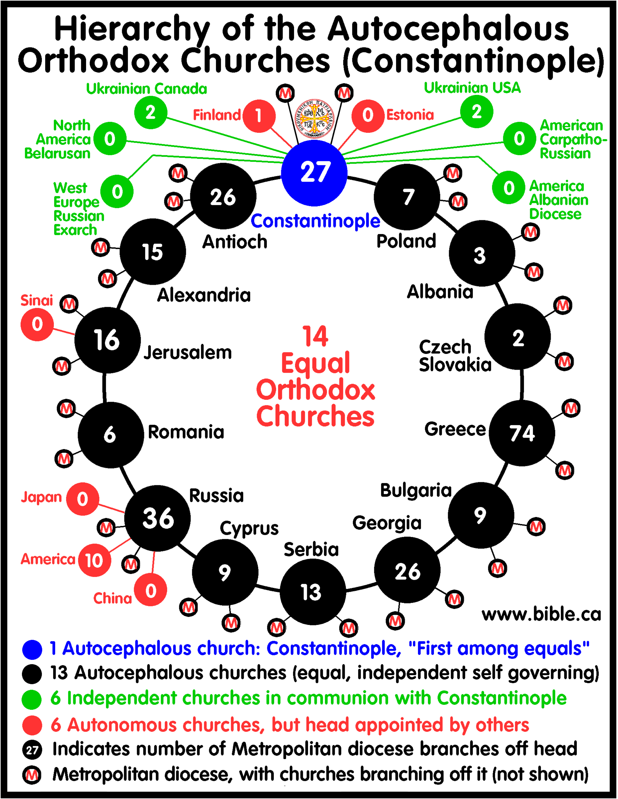
The organization and authority structure of the Orthodox churches is so complex that varying “numbers” of Orthodox churches can be presented. The chart at the left is one representation of the Orthodox churches. There are several other Orthodox churches, not shown, which do not recognize the bishop of Constantinople as the one deserving of highest honors, nor do they see themselves as being part of a confederation alongside other Orthodox churches.

Note: The 1st & 3rd through the 5th graphics in this handout are from the book, “Charts of Ancient & Medieval Church History”, by John D. Hannah, 2001, and are used in compliance with the publisher’s allowance for classroom use by teachers, but are not for general distribution for other purposes.

The chart presented is from www.bible.ca which has some good material, but should be viewed with a biblically discerning eye. Not all of it agrees with the doctrinal statement of Holly Hills Bible Church.

