Jehovah’s Witnesses

An offshoot of an offshoot of an offshoot of an offshoot of an…
Last Sunday we briefly summarized the history of the Seventh Day Adventists, who were an offshoot from the Baptists, who were an offshoot of the Reformed movement, who were an offshoot of the Lutherans, founded by Martin Luther, who wasn’t initially intending to be an offshoot from the Roman Catholic Church! The Jehovah’s Witnesses are the largest of several offshoots (7.8 million members as of 2014) of the Seventh Day Adventists (18.5 million members as of 2014). The split from the SDA was in 1879.

If you like change, you’ll love the Jehovah’s Witnesses!
The Jehovah’s Witnesses (JWs) are, historically, not that old, and they have published lots of material over the 136 years they have been in existence. One thing that this does is to document lots of change in lots of things.

The cross and crown were the symbol of the JWs (1891-1931), and even placed on founder Charles Taze Russell’s tombstone, then they decided that Jesus was actually impaled on a torture stake.
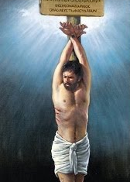
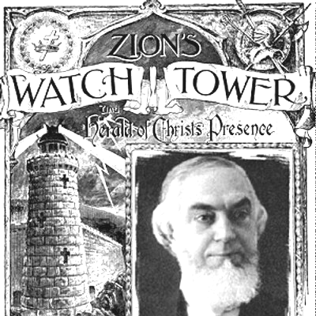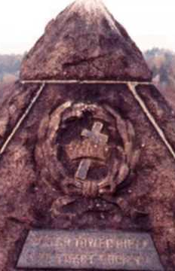

The JWs founder sold Christmas cards to raise money, and even the leadership of the JWs celebrated Christmas.

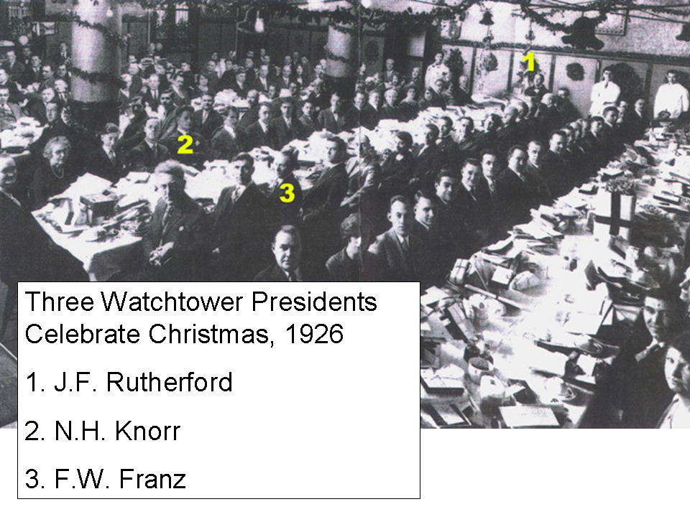
From an 1892 Watchtower advertisement:

CHRISTMAS CARDS (assorted, illuminated), .05 & .10

Nov 7, 1898 Watchtower: Last year about this time, through no fault of ours, many of our customers were greatly disappointed by delays—the publishers being unable to fill our orders. This year we have sought to guard against such a contingency by laying in a large supply: still we fear a dearth toward Christmas.
On January 7, 1906 Charles Taze Russell wrote:

Since, then, the majority of Christian people have become habituated to the celebration of December 25th as our Lord's birthday, we need make no protest, but join with all in celebrating that day with rejoicing of heart, giving gifts and remembrances one to another, thus copying divine favor, which gave to mankind the Son of God as a gift of mercy and love for our redemption.

But in 1928 observing Christmas was forbidden for JWs.

In Millennial Dawn, Vol. V, Chap. IV, page 366, Charles Taze Russell wrote that his niece had given him a birthday present. Charles Taze Russell encouraged JWs multiple times to buy his books to give as birthday presents (as well as Christmas presents). But in 1951 observing birthdays was forbidden for JWs.

The critical end time date went from 1874, to 1914, 1917, 1918, 1925, 1975 and 2000. According to Life Everlasting – In Freedom of the Sons of God, page 29:

According to this trustworthy Bible chronology six thousand years from man's creation will end in 1975, and the seventh period of a thousand years of human history will begin in the fall of 1975 C.E.

So six thousand years of man's existence on earth will soon be up, yes, within this generation.

AWAKE! 8 November 1986, page 78:

For the year 2000, I visualize a world transformed into a beautiful paradise! But I don't think that either the present world or its rulers will live to see that day. We are living in the last days of the system of things.

The generation born in 1914 ‘Will Not Pass Away’, until it did.

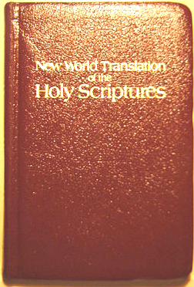
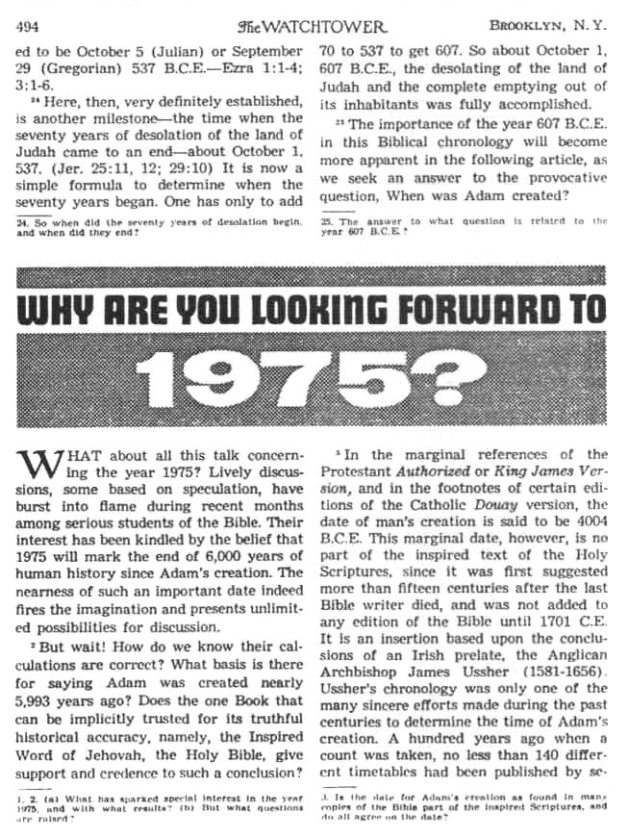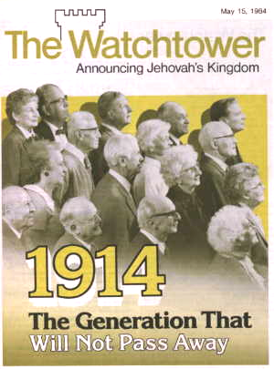
March 1, 1979

The Jehovah’s Witness organization generally used the King James Version, until they come up with the New World Translation (NWT). Though not always pivotal to the doctrinal positions of the JWs, in 1950 the JWs introduced the (NWT), consisting of the New Testament, and by 1961 the Old Testament and New Testament. The 1961 edition of the NWT has been revised a number of times. There are places where the NWT has some curious but inconsistent translations and mistranslations:

- The word ‘cross’ is replaced with ‘torture stake’, and ‘crucified’ is replaced with ‘impaled’. Though the pictures of Christ impaled on a torture stake show one nail in Christ’s hands, the NWT of John 20:25 has, “…his hands the print of the nails…the print of the nails”. That is a good translation but doesn’t fit with the rest of the NWT.
- Christ is not presented as Deity, but as ‘a god’ who is ‘at unity’ with the Father (John 1:1; 10:30).
- The Holy Spirit is sometimes presented as a force, but not a person:

John 14:16-17 (NWT)
And I will ask the Father and he will give you another helper to be with you forever, 17 the spirit of the truth, which the world cannot receive, because it neither sees it nor knows it. You know it, because it remains with you and is in you.

John 14:16-17 (NASU)
"I will ask the Father, and He will give you another Helper, that He may be with you forever; 17 that is the Spirit of truth, whom the world cannot receive, because it does not see Him or know Him, but you know Him because He abides with you and will be in you.

John 16:13, 14 (NWT)
However, when that one comes, the spirit of the truth, he will guide you into all the truth, for he will not speak of his own initiative, but what he hears he will speak, and he will declare to you the things to come. 14 That one will glorify me, because he will receive from what is mine and will declare it to you.

JWs could give blood and receive a transfusion, until it was forbidden in 1945. Taking in someone else’s blood or giving blood for someone else was determined to be unbiblical.

About voting
“these spiritual brothers… do not run for political office, or vote for political candidates.” WT, Dec. 15, 1973, p 741
“Do we today feel the same way as did these faithful servants of God in the past? When national law or community pressureseems to make it imperative that we … vote for political leaders or support nationalistic schemes, will we compromise and getdisqualified and sidetracked from the race for life?” WT, Aug. 15, 1975, p 496-7.
“They do not seek or offer compromises… To serve in the army, to vote...”
WT, Sept. 1, 1986, p 21.
“Those who reject an accurate knowledge of the truth often choose the pathway of expediency…Now they can even vote for one of the political parties of the ‘wild beast.’ (Rev. 13:1,7) Thus, as unsteady souls, some have been seduced and misled from the straight path of accurate knowledge by those who, while ‘promising them freedom, are themselves existing as slaves of corruption.’ – 2 Peter 2:15-19.” - WT, Dec. 1, 1989, p 13,14. The Oct. 15, 1970 WT carries an 8-page article detailing the suffering that Jehovah’s Witnesses in Cameroon, Africa, endured because of their refusal to vote.

But as of November 1, 1999

“…there appears to be no principle against the practice of voting itself.”
“As to whether they will personally vote for someone running in an election, each one of Jehovah’s Witnesses makes a decision based on his Bible-trained conscience and an understanding of his responsibility to God and to the State.”
“If someone decides to go to the polling booth, that is his decision. What he does in the polling booth is between him and his Creator.”
“If she obeys her husband and goes to the polling booth, that is her personal decision. No one should criticize her.
“…a Christian has to make his own decision”.
“…each Christian has to make his own decision before Jehovah God – Romans 14:12”.

What’s not all that different?
What does the Jehovah’s Witnesses group have in common with its parent (SDA) and/or similar religious cult groups?

- Salvation gained and sustained by keeping the laws adopted by the organization
- Loss of salvation has the eternal consequence of annihilation (or diminished standing)
- Salvation is only available through the one organization, rather than from God alone
- Interpretation of elements of prophecy is by the allegory adopted by the organization
- The organization has some exclusive role of interpreting Scripture, supplementing Scripture and/or dispensing rituals, that keeps the organization in some degree of control of its adherents.

Who’s in charge?
Though founded by Nelson Barbour and Charles Taze Russell, formerly of the Seventh Day Adventists, the Jehovah’s Witness organization – the Watchtower Society – the leadership of the organization has been passed along to a series of men as president, and increasingly to the Governing Body of Jehovah’s Witnesses, in recent decades.

Watchtower, July 1, 1973, page 402
Jehovah’s organization alone, in all the earth, is directed by God’s holy spirit or force (Zech,4:6) Only this organization functions for Jehovah’s purpose and to his praise. To it alone God’s Sacred Word, the Bible, is not a sealed book… How very much true Christians appreciate associating with the only organization on earth that understands the deep things of God! Direction by God’s spirit enables Jehovah’s servants to have divine light in a world of spiritual darkness.

Watchtower, November 15, 1981, page 21

“come to Jehovah’s organization for salvation”.

But what really matters is…
So just what kinds of things does the Jehovah’s Witnesses (JWs) teach?

Nearly identical to the 4th century Arian heresy, the JWs teach that only God the Father is God, whose name is Jehovah, Jesus Christ is Jehovah’s first created being, and the holy spirit is an impersonal invisible active force from Jehovah. The JWs teach that before Jesus Christ came to earth he was Michael the archangel, as do the SDA, though the SDA hold that Jesus is the second person of the Trinity and JWs do not.
Salvation in the JW teaching requires being baptized as a Jehovah’s Witness, followed by continuing “door to door work”. Salvation for the first 144,000 JWs filled the capacity of those who would actually go to heaven, these being “the anointed ones”. The remaining JWs to be saved, beyond the 144,000, will be on the earth (the “other sheep”, “Jonadab” or “great crowd” class). It is too late for them to be among “the anointed ones” in heaven. The souls of those who are not among the ones saved to heaven or earth will be annihilated – they will cease to exist. JWs cannot have assurance of eternal salvation, because their salvation depends upon continuous works all the way to the end. Charles Taze Russell referenced Revelation 3:5 as a threat of having ones name removed, rather than a comforting promise, which it is (see below).

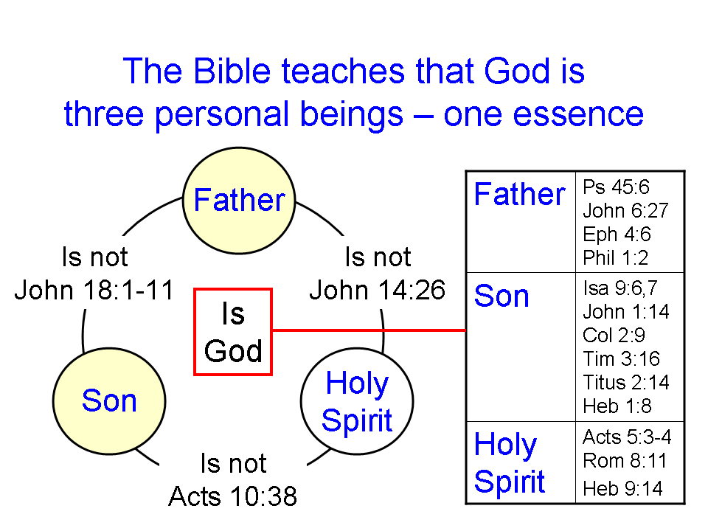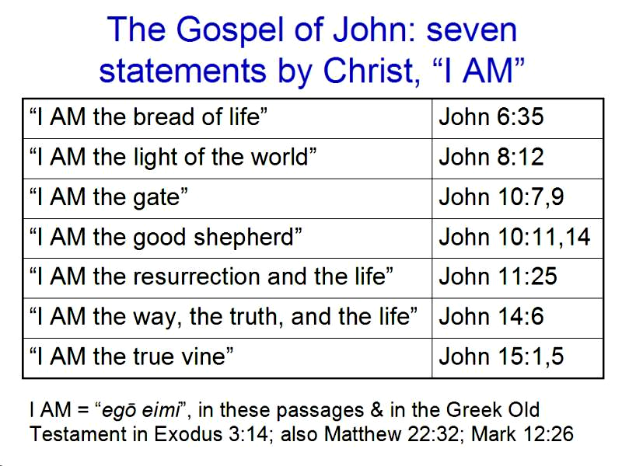

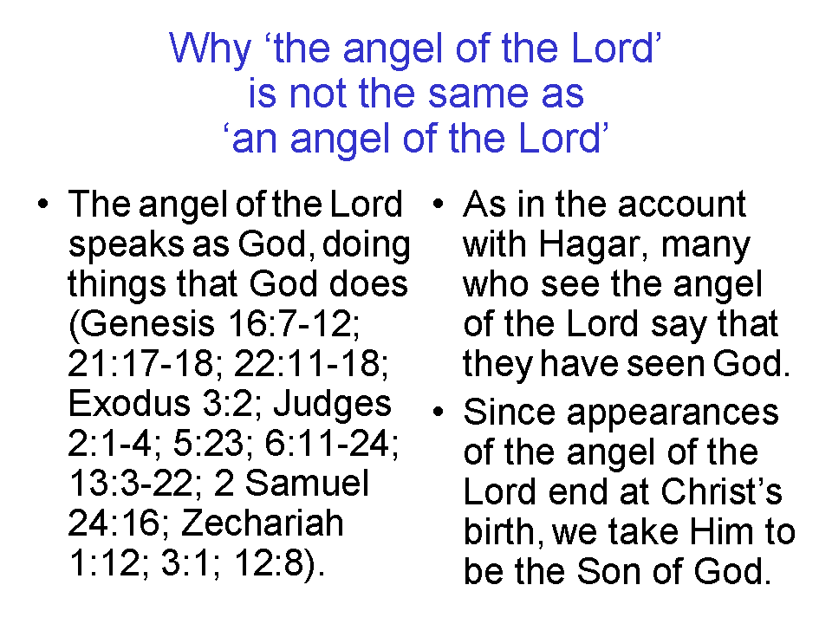
Jude 8-10
Yet in the same way these men, also by dreaming, defile the flesh, and reject authority, and revile angelic majesties. 9 But Michael the archangel, when he disputed with the devil and argued about the body of Moses, did not dare pronounce against him a railing judgment, but said, " The Lord rebuke you!" 10 But these men revile the things which they do not understand; and the things which they know by instinct, like unreasoning animals, by these things they are destroyed.

John 10:25-30
Jesus answered them, "I told you, and you do not believe; the works that I do in My Father's name, these testify of Me. 26 But you do not believe because you are not of My sheep. 27 My sheep hear My voice, and I know them, and they follow Me; 28 and I give eternal life to them, and they will never [ou me] perish [middle voice]; and no one will snatch them out of My hand. 29 My Father, who has given them to Me, is greater than all; and no one is able to snatch them out of the Father's hand. 30 I and the Father are one."

31 The Jews picked up stones again to stone Him. 32 Jesus answered them, "I showed you many good works from the Father; for which of them are you stoning Me?" 33 The Jews answered Him, "For a good work we do not stone You, but for blasphemy; and because You, being a man, make Yourself out to be God." 34 Jesus answered them, "Has it not been written in your Law, 'I said, you are gods'? 35 "If he called them gods, to whom the word of God came (and the Scripture cannot be broken), 36 do you say of Him, whom the Father sanctified and sent into the world, 'You are blaspheming,' because I said, ' I am the Son of God'? 37 " If I do not do the works of My Father, do not believe Me; 38 but if I do them, though you do not believe Me, believe the works, so that you may know and understand that the Father is in Me, and I in the Father."

Ephesians 2:8-9
For by grace you have been saved [perfect passive verb: a completed past action, with ongoing results into the future; passive indicates that it is God who does the saving] through faith; and that not of yourselves, it is the gift of God; 9 not as a result of works, so that no one may boast.

Revelation 3:5
He who overcomes will thus be clothed in white garments; and I will not [ou me²] erase his name from the book of life, and I will confess his name before My Father and before His angels.

Quoted from: http://www.quotes-watchtower.co.uk/. Not all content on this website is recommended.
ou me = ‘not not’, as in ‘Not the slightest chance’, or ‘Not even remotely possible’. It is emphatic denial of the possibility.
Middle voice with this verb, along with ou me means that it is not even remotely possible that His sheep will lose their salvation, so as to perish of their own doing.
Literally, “I and the Father are one essence” (Wuest). It does not just mean agreement or having the same purpose or objective.

