The Christian Circus
‘Televangelists’

‘There’s a sucker born very minute’ – likely said by David Hannum regarding the fake of a fake statue made by P.T. Barnum

Big Money!

If a person really wants to make money in the religion business, pursue becoming a ‘televangelist’. Benny Hinn has a net worth of about $42 million, and his ministry owns a private jet. Joyce Meyer has a net worth of about $25 million, and her ministry also owns a private jet. Her husband and their four grown children all have benefitted financially from her ministry. Joel Osteen has a net worth of $40 million, and recently bought a $10.5 million home. Compare these to what the word of God says:

Luke 12:15-16
Then He said to them, "Beware, and be on your guard against every form of greed; for not even when one has an abundance does his life consist of his possessions."

2 Corinthians 2:17
For we are not like many, peddling the word of God, but as from sincerity, but as from God, we speak in Christ in the sight of God.

1 Timothy 3:1, 3, 8
An overseer, then, must be… 3 …free from the love of money… 8 Deacons likewise must be men of dignity, not… fond of sordid gain

Hebrews 13:5
Make sure that your character is free from the love of money, being content with what you have; for He Himself has said, "I will never [ou me] desert you, nor [ou me⁵] will I ever forsake you,"

1 Peter 5:1-2
Therefore, I exhort the elders among you, as your fellow elder and witness of the sufferings of Christ, and a partaker also of the glory that is to be revealed, 2 shepherd the flock of God among you… not for sordid gain…

False Gospel & False Teaching!

Joel Osteen

In 2009, when Larry King asked Joel Osteen whether people of other faiths who don't believe in Christ would go to heaven, Osteen replied, "You know, I'm very careful about saying who would and wouldn't go to heaven. I don't know. . . . Well, I don't know if I believe they're wrong."

In that same interview, King asked Osteen if he believed all other faiths were going to hell such as Jews, Muslims, Buddhists, Hindus, etc. Osteen remarked that he went with his father one time to India and met some fine people and that no, he did not believe they were going to hell if they were sincere in their hearts.

John 8:21-24
Then He said again to them [the leaders of the Jews], "I go away, and you will seek Me, and will die in your sin; where I am going, you cannot come." 22 So the Jews were saying, "Surely He will not kill Himself, will He, since He says, ' Where I am going, you cannot come'?" 23 And He was saying to them, "You are from below, I am from above; you are of this world, I am not of this world. 24 "Therefore I said to you that you will die in your sins; for unless you believe that I AM⁷, you will die in your sins."

John 14:6
Jesus said to him, "I AM the way, and the truth, and the life; no one comes to the Father but through Me.

Joyce Meyer

"He could have helped himself up until the point where he said I commend my spirit into your hands, at that point he couldn’t do nothing [sic] for himself anymore. He had become sin, he was no longer the Son of God. He was sin."

Matthew 27:54
Now the centurion, and those who were with him keeping guard over Jesus, when they saw the earthquake and the things that were happening, became very frightened and said, "Truly this was the Son of God!"

Luke 22:70
And they all said, "Are You the Son of God, then?" And He said to them, "Yes, I AM ."
John 8:58
Jesus said to them, "Truly, truly, I say to you, before Abraham was born, I AM."

Colossians 1:15-17
He is the image of the invisible God, the firstborn of all creation. 16 For by Him all things were created, both in the heavens and on earth, visible and invisible, whether thrones or dominions or rulers or authorities-- all things have been created through Him and for Him. 17 He is before all things, and in Him all things hold together.

"The minute that blood sacrifice was accepted Jesus was the first human being that [sic] was ever born again."

However, only those who are in need of salvation are spoken of as being ‘born again’. Jesus didn’t need to be saved, and was therefore never born again.

John 3:3, 7
Jesus answered and said to him, "Truly, truly, I say to you, unless one is born again he cannot see the kingdom of God." … 7 "Do not be amazed that I said to you, 'You must be born again.'

1 Peter 1:3
Blessed be the God and Father of our Lord Jesus Christ, who according to His great mercy has caused us to be born again to a living hope through the resurrection of Jesus Christ from the dead… 23 for you have been born again not of seed which is perishable but imperishable, that is, through the living and enduring word of God.

"He became our sacrifice and died on the cross. He did not stay dead. He was in the grave three days. During that time he entered hell, where you and I deserve to go (legally) because of our sin. He paid the price there.”

John 19:30
Therefore when Jesus had received the sour wine, He said, "It is finished! [Tetelestai!; perfect tense verb for “It is paid”, completely and permanently]" And He bowed His head and gave up His spirit.

"His spirit went to hell because that is where we deserve to go . . . There is no hope of anyone going to heaven unless they believe this truth,"

Luke 23:42-46
And he was saying, "Jesus, remember me when You come in Your kingdom!" 43 And He said to him, "Truly I say to you, today you shall be with Me in Paradise."
44 It was now about the sixth hour, and darkness fell over the whole land until the ninth hour, 45 because the sun was obscured; and the veil of the temple was torn in two. 46 And Jesus, crying out with a loud voice, said, "Father, into Your hands I commit my spirit." Having said this, He breathed His last.

Benny Hinn

Popular faith healer Benny Hinn explains the Trinity: "There's nine of 'em."

This slide, however, summarizes what the Bible actually teaches:

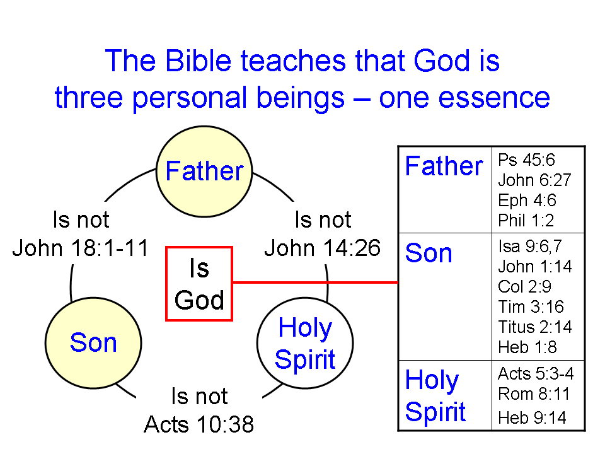

A Caution on Parachurch Ministries

The New Testament provides quite a bit of guidance on how churches are to be led, including the character qualifications, ministries, and operating guidelines for elders (Greek: presbuteros) = shepherds (Greek: poimen; from the Latin: pastors) = overseers (Greek: episcopos; middle English: bishops). Similar character qualifications apply to deacons. See the document on ‘Elders, Deacons & the Church Board’ on the HHBC website:

http://hollyhillsbiblechurch.org/wp-content/Files/EldersDeaconstheChurchBoard.pdf
One characteristic of the elders in the New Testament is that they are plural, and elders are not found to be high profile. The one exception was the church in Jerusalem, in which the apostles acted as elders initially, and James, Jesus’ half-brother, was an elder (Acts 15:13-35).

While churches can and often do operate slightly to widely outside of what has been revealed in the New Testament, parachurch ministries are often not set up as churches but as non-profit corporations having a tax-exempt status. The following has been observed among ‘televangelist’ parachurch ministries:

Tax-exempt status is often used to accumulate substantial net worth for the high-profile leader and sometimes the extended family of the high-profile leader. See examples on page 1.

While the elders = shepherds = overseers are generally anonymous in the New Testament, and are supposed to be plural in number, the televangelists are selling their ‘brand’, and are typically presented as a single person, or as a couple.

While 1 Timothy 2:11-14 calls for women not to teach or have authority over a man in the church context, this is frequently set aside in some regard among ‘televangelists’ (Joyce Meyer, Marilyn Hickey, etc.; Joel Osteen was appointed as pastor of Lakewood Church by his mother, on the death of his father, etc.).

Since the high-profile leader of the ministry is often in the position of substantial organizational power, there is generally no objective accountability regarding morals, ethics, doctrine, etc. Those who fail in one or more of these areas are often retained in their place with little or no correction, recourse, consequences, restoration process, etc.

3 John 9
I wrote something to the church; but Diotrephes, who loves to be first among them, does not accept what we say.

Like groups within Christendom which have some channel of additional revelation and/or authority outside of Scripture, or authority over the interpretation of Scripture, televangelists will often also have some basis of revelation and authority outside of Scripture and/or over Scripture, and that authority is typically placed in one or two people – the high profile one or ones whose personal brand is being ‘marketed’.

Conclusion

We could say far more about the ‘televangelists’ on various points, but the key points are clear:

Believers are to evaluate everything by means of Scripture, and that requires that we know how to understand Scripture. Believers ought also to set aside anything that bypasses the authority of Scripture, or sets aside the need to understand Scripture.

Though other suggestions have been made regarding who said this first, and there are some close variants of these specific words.
http://www.factsuniversity.com/religion/45-list-of-world-s-richest-pastors-2015.html
http://allchristiannews.com/the-irs-wants-to-know-why-this-pastor-owns-five-houses-but-pays-no-taxes/
http://www.celebritynetworth.com/richest-celebrities/joel-osteen-net-worth/
The Greek words ‘ou me’ literally mean ‘not not’, and convey the idea, “it is not even remotely possible” or “there is not the slightest chance”.
http://www.thebiblicalworldview.org/is-joel-osteen-a-false-prophet/
‘I AM’ is translated from egō eimi, the same as Exodus 3:14 and Isaiah 46:9, et al, in the Greek Old Testament.
http://storage.carm.org/joycemeyer/joyce-meyer-Jesus-became-sin-stopped-being-son-of-God.mp3
See footnote 7.
See footnote 7.
http://www.youtube.com/watch?v=neKsa_74w7k&feature=related
The Most Important Decision You'll Ever Make by Joyce Meyer, second printing, May, 1993, page 35
Ibid., page 37
http://www.faith-theology.com/2010/02/theology-fail-benny-hinn-on-trinity.html; https://www.youtube.com/watch?v=beiSK3kxh4U

