Christian Liberalism

In the beginning…

Christian liberalism rose to prominence in the 19th and early 20th centuries, largely in the mainline Christian denominations and their seminaries. It is based upon a worldview, a view of Scripture, and therefore a hermeneutical approach – a method of interpretation of Scripture. The worldview of Christian liberalism sets the knowledge obtained by science – including the social sciences – as of highest value and priority. The Bible is viewed through the eyes of secular cultural anthropology, as ancient literature that contains legend, myth, and other evolved written forms of human origin.

The doctrinal statement of Christian Liberalism compared to Scripture

The Bible: The Bible is basically man-originated, expressing thoughts about man, the world, God and the spiritual realm. It is not inspired by God, but may in places, and, varying from one person to another, be inspiring. Though the genre of the Bible may vary, its content is in the realm of myth, legend, etc. which is unenlightened by findings of modern science.

Response:

John 17:17
Sanctify them in the truth; Your word is truth.

1 Corinthians 4:1
Let a man regard us in this manner, as servants of Christ and stewards of the mysteries of God.

2 Timothy 2:15
Be diligent to present yourself approved to God as a workman who does not need to be ashamed, accurately handling the word of truth.

Hebrews 4:12
For the word of God is living and active and sharper than any two-edged sword, and piercing as far as the division of soul and spirit, of both joints and marrow, and able to judge the thoughts and intentions of the heart.

The virgin birth: The virgin birth is derives from the realm of myth. There is no scientific basis for such a belief.

Response:

Isaiah 7:14
"Therefore the Lord Himself will give you a sign: Behold, a virgin will be with child and bear a son, and she will call His name Immanuel."
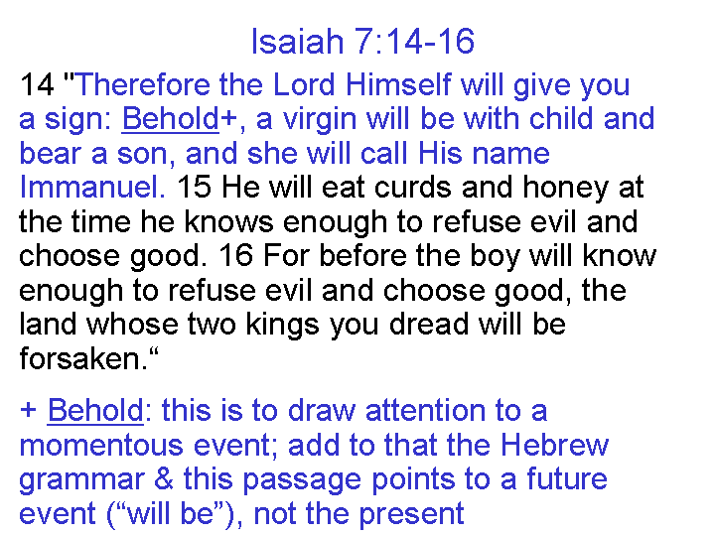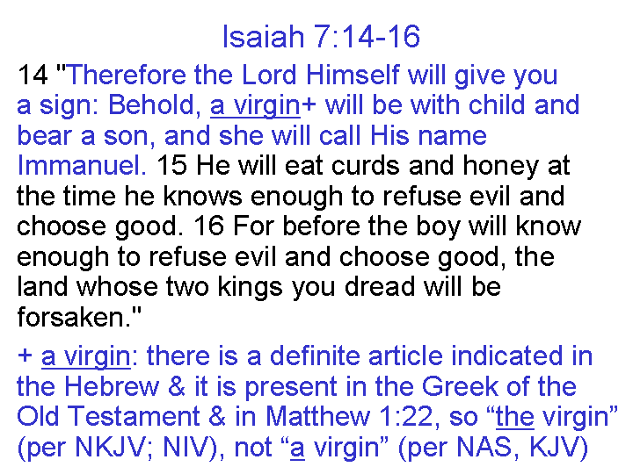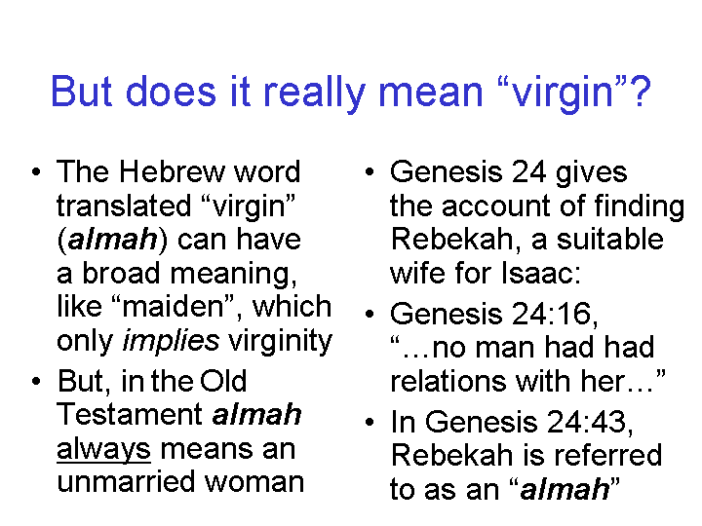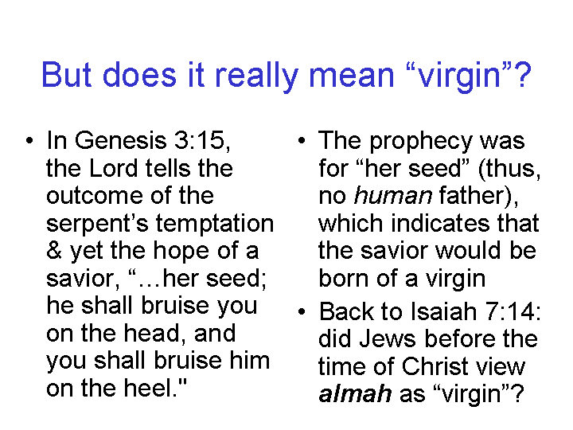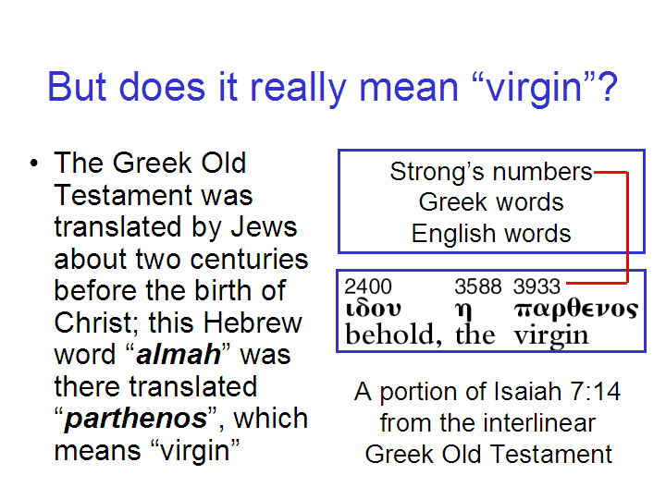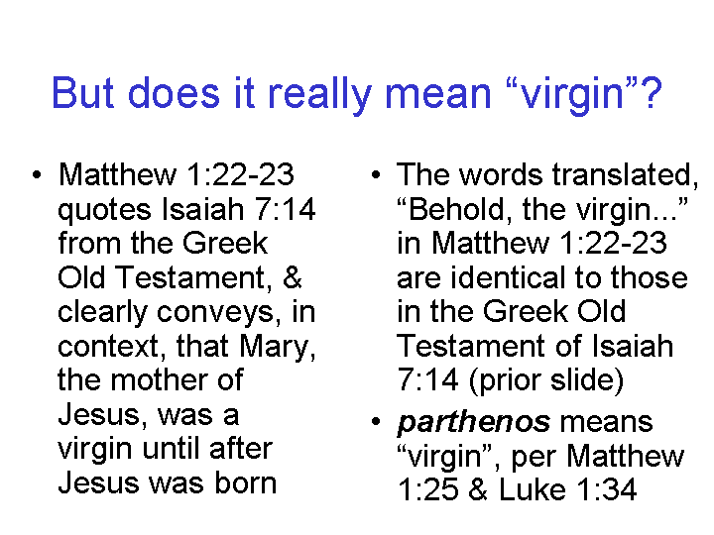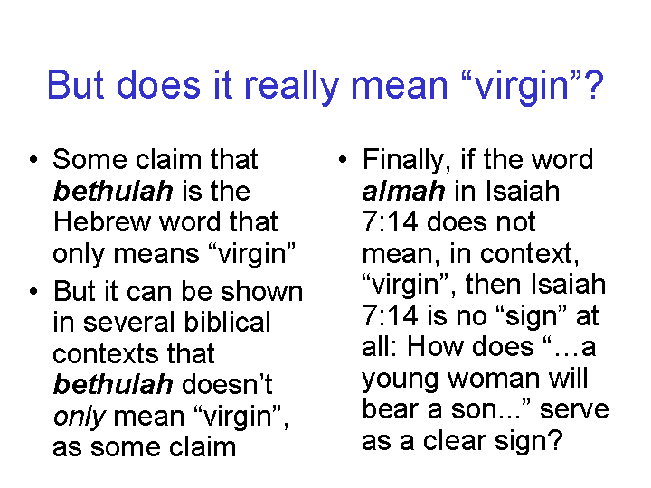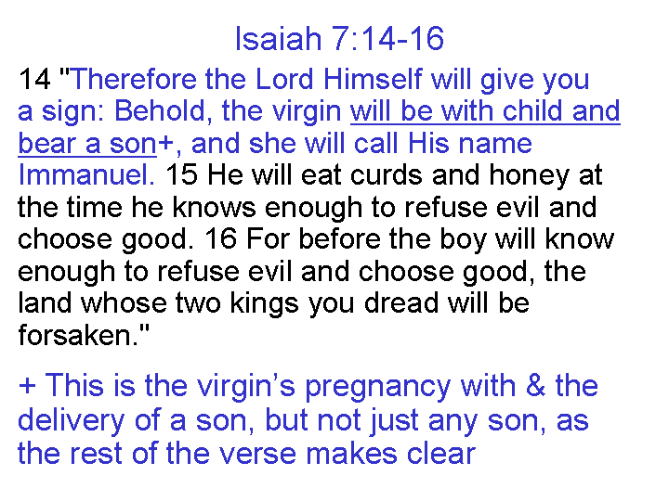
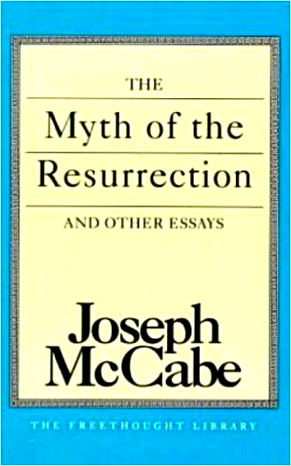
Christ’s resurrection: The resurrection of Christ is simply a myth that goes along with other ancient myths about resurrection of gods, cultural heroes, etc. This viewpoint has been expressed in books like the one shown to the left.

Response:

See the table on the next page for a summary of the resurrection accounts in the New Testament. Lessons 21 and 22 (May 31 and Jun 7) addressed the evidence for the resurrection in more detail. Lessons 15 and 16 (Apr 19 and 26) addressed the question of whether the gospel narratives can or should be considered mythology. In lessons 12 and 13 (Mar 29 and Apr 5) we addressed how we got the New Testament documents, including the four Gospel narratives. See also the response below.

Christ’s life and character: Christ was a good moral teacher, but his followers took liberties as they conveyed the stories of his life, embellishing the accounts with miracles, claims to deity, and the like. These ‘accounts’, actually written much later and not by the ‘apostles’, became mythology, rather than true historical or eyewitness accounts, but the original moral teachings can be gleaned from the New Testament writings.

Response:

Many of the same points can be made about the gospel accounts in general that were referenced in the response given above to the denial of the resurrection of Christ. Briefly, however, we will point out that:

1) The apostles were aware of myths, fables and tales, and specifically warned against them and denied such things (1 Timothy 1:4; 4:7; 2 Timothy 4:4; Titus 1:14; 2 Peter 1:16).

2) The apostles were persecuted, as recorded in the book of Acts and in some letters of the New Testament. So far as we have record, all died as martyrs, except John, in proclaiming what they had witnessed.

3) The apostles did not expect Jesus to perform all the miracles that He did, nor did they expect that He would be crucified, buried and resurrected. Jesus’ brothers did not believe in Him until after His resurrection (John 7:5; Acts 1:14), yet James gave his life for his belief in Christ, as recorded by Josephus.

4) The Jewish culture of New Testament times was, in contrast to the surrounding cultures, sharply resistant to the confusion of humanity and deity, yet the Jewish culture was the only environment for the growth of the Christian message for about a decade.
The Resurrection of Christ – A Summary of the Passages

The Empty Tomb
Day | Subject/Other Features | Scriptures
Sunday | The Tomb visited by the women: Mary  Magdalene, Mary the mother of James, Salome | Matthew 28:1; Mark 16:1
Sunday | The stone rolled away, allowing witnesses to  See the empty tomb | Matthew 28:2-4
Sunday | The tomb found empty by the women, at about  The time of sunrise | Matthew 28:5-8; Mark 16:2-8;  Luke 24:1-8; John 20:1
Sunday | The tomb found empty by Peter & John’ grave  Clothes arranged consistent with resurrection | Luke 24:9-11, 12; John 20:2-10
Post-Resurrection Appearances
Day | Appearance To Whom & Summary Info | Scriptures
Sunday | Mary Magdalene; Jesus predicts His ascension | Mark 16:9-11; John 20:11-18
Sunday | The other women; instruction to meet in Galilee | Matthew 28:9-10
Sunday | Report of the soldiers to the Jewish authorities;  Sanhedrin’s absurd explanation | Matthew 28:11-15
Sunday | The two disciples traveling to Emmaus who  didn’t believe the report about the empty tomb | Mark 16:12-13; Luke 24:13-32
Sunday | Report of the two disciples to the rest, including  an appearance to Peter; Paul also reported  another appearance to Peter | Luke 24:33-35; 1 Corinthians 15:5a
Sunday | Ten disciples, revealing characteristics of Jesus’ resurrected body | Mark 16:14; Luke 24:36-43;  John 20:19-25
Sunday, a  week later | The eleven disciples, in which Thomas’ doubt  is removed | John 20:26-31  1 Corinthians 15:5b
Some time later | Seven disciples fishing in Galilee; peter told to  feed & care for His sheep | John 21:1-25
Still later | The eleven in Galilee, then to the 500+; Great  Commission to large number of followers | Matthew 28:16-20; Mark  16:15-18; 1 Corinthians 15:6
Still later | James, Jesus’ brother, who becomes a believer | 1 Corinthians 15:7; John 7:1-5
40 Days after resurrection | The disciples in Jerusalem who are told to wait  for the coming of the Spirit | Luke 24:44-59; Acts 1:3-8
After His ascension | To Stephen, Saul, later called Paul, & to John | Acts 7:55-56; 9:3-6; 20:24;  22:17-21; 23:11; 26:17; Gal.  1:12, 17; Rev. 1:12-20

To summarize: there were several recorded testimonies to the empty tomb, including multiple instances of simultaneous witnesses, and at least eleven recorded instances of witnessing Christ’s resurrected body in the 40 days after the resurrection, with witnesses numbering from one to over five hundred, and three witnesses to Christ’s resurrection after His ascension. To these we can add the persistent public testimonies to the resurrection, often spoken among other witnesses in the very same locality (Acts 2:24, 32; 3:26; 4:10; 5:30-32; 10:39-42, et al), and the personal testimony of Peter in writing (1 Peter 1:21), who saw the empty tomb right after Christ was resurrected, and saw and spoke to Him in His resurrected body multiple times, up to the day of Christ’s ascension.
Hell and the lake of fire: These are mythological places and not real places. So Christ did not have to die to save anyone from hell or the lake of fire. Along the same lines, human beings are not born in sin, but just need good moral teaching, like Christ actually taught. People ought to live out Christ’s good moral teachings.

Response:

The Bible, instead, teaches about hell and heaven. Christ is recorded to have said more about hell, hades and the lake of fire than all of the apostles wrote in their letters, combined. For example, read Matthew 23:29-33 and Luke 16:19-31. In the book of Revelation, the apostle John wrote a little bit about hell and the lake of fire, but about 150 verses on the heavenly scene.

The Bible’s authors: Most of the Bible’s authors were not who they claimed to be. Rather, editors compiled the Bible, usually at much later times, pretending to write as the supposed historical figures Moses, Isaiah, Daniel, etc. in the Old Testament, and as Matthew, Mark, Luke, etc. in the New Testament. There is no such thing as predictive prophecy, so the books that contain such ‘prophecy’ must have been written after the ‘fulfillment’ of these events.

Response:

In lessons 18, 19 and 20 we addressed the findings of archaeology regarding the Old and New Testaments (May 10, 17 and 24), as well as the views of Bart Ehrman who represents a view of the development of the Bible much the same as that of the Christian liberals. Bart Ehrman went to school from Moody Bible Institute to Wheaton to Princeton (once a conservative Presbyterian institution), where he went from Christian to agnostic.

Jewish and Christian archaeologists, historians and scholars have rebutted the liberal and skeptical viewpoint about the origins and authorship of Scripture numerous times over the decades. The evidence that has surfaced in recent decades keeps moving the line of allowable interpretation of the evidence in the direction of conservative Jewish and Christian scholarship.

Christian morals and ethics: The end result is that Christian liberalism promotes a social gospel of Christian concerns for other people and society, motivated by the love and empathy which Jesus, the great moral teacher, actually taught.

Response:

Jesus and the apostles taught in specifics a great deal more than just broad outlines of love and empathy. Jesus taught only in Israel confirming the Law of Moses, but rejecting the additions to the Law of Moses imposed by the Sadducees and the Pharisees. The apostles taught that those in the church were under grace, and not under the Law of Moses. Such distinctions are lost on liberal Christianity.
Christian liberalism has been brought into a number of especially mainline denominations, such as the Presbyterian, Lutheran, Methodist, etc. We will use the example of the Presbyterian denomination to show the reaction to Christian liberalism by some within the Presbyterian denominations. Note that Orthodox, Bible and Evangelical Presbyterian Churches are more conservative offshoots of the Presbyterian denominations, rejecting the liberalism.

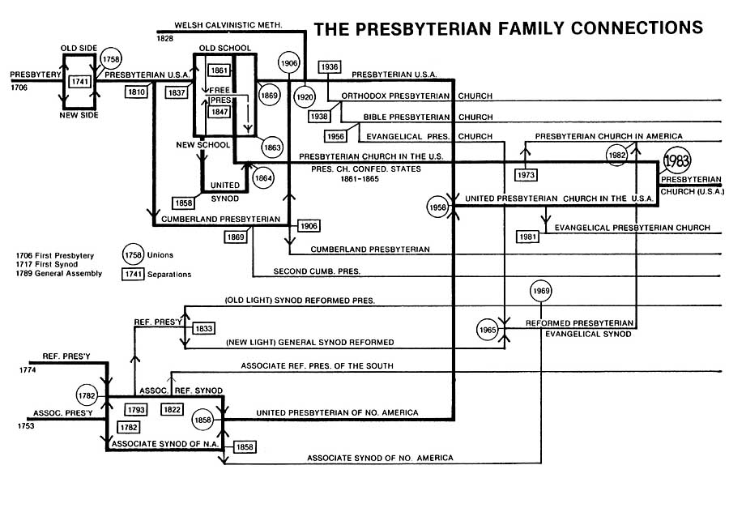

2 Timothy 2:1-2
You therefore, my son, be strong in the grace that is in Christ Jesus. 2 The things which you have heard from me in the presence of many witnesses, entrust these to faithful men who will be able to teach others also.

