Christian Existentialism & Mysticism

OK, so just what are we talking about here?

Christian existentialism (as well as secular existentialism) has been "credited" to Danish philosopher Soren Kierkegaard (sketch to the left; 1813-1855). At the risk of being accused of oversimplification, we'll summarize that portion of his thesis which is relevant to our purposes here in a brief couple of points:

- God is transcendent and wholly other than man, so that God's revelations of Himself, beyond any rationalistic human approach to knowing and understanding Him, require of human beings a "leap of faith".
- The leap of faith. Keirkegaard said, was the sole means of making true contact with God, verified on the human side by an experience, beyond those kinds of typical and mundane experiences that all humans have within the physical realm.

Mysticism on the other hand, has a much longer history within Christendom, though it shares some characteristics of subjectivity in common with existentialism. Mysticism was expressed and, in its unbiblical forms, opposed by the apostles in the pages of the New Testament, from the book of Acts to the book of Revelation. Nonetheless, mysticism seeks to make contact with God apart from the propositional truths of Scripture or perhaps using Scripture loosely as a springboard for that divine contact. The history of mysticism goes back to New Testament era heresies, and is expressed in the monasteries that have existed over the centuries, and by both individuals and entire movements.

Existentialism & Mysticism we’ve already addressed
In lesson 38 we took a look at Spiritual Formation / Contemplative Spirituality, which is a form of mysticism, in that it bypasses Scripture in order to supposedly have contact with God. It is also a form of existentialism in that it looks to feelings and experiences from essentially eastern and Roman Catholic meditation to ‘confirm the truth’ of that approach to God. Also, a number of the televangelists employ mystical (bypassing Scripture) and existentialist (appeal to feelings and experiences) approaches in their version of Christianity (see lesson 42 The Christian Circus).

Not so long ago, in a hemisphere not so far away…
The historical confluence of Greek and Egyptian mysticism, mystical philosophy and religion carried from Asia along with Silk Road trade, had their influence in Christianity from its inception. The roots of gnosticism were (and continue to be, in a more developed form) part of the mysticism that was both within and outside of Christendom. Here are some of the apostolic responses to such mysticism and the asceticism often associated with it:
Colossians 2:6-8, 20-23
Therefore as you have received Christ Jesus the Lord, so walk in Him, 7 having been firmly rooted and now being built up in Him and established in your faith, just as you were instructed, and overflowing with gratitude. 8 See to it that no one takes you captive through philosophy and empty deception, according to the tradition of men, according to the elementary principles of the world, rather than according to Christ….20 If you have died with Christ to the elementary principles of the world, why, as if you were living in the world, do you submit yourself to decrees, such as, 21 "Do not handle, do not taste, do not touch!" 22 (which all refer to things destined to perish with use)--in accordance with the commandments and teachings of men? 23 These are matters which have, to be sure, the appearance of wisdom in self-made religion and self-abasement and severe treatment of the body, but are of no value against fleshly indulgence.

1 Timothy 4:1-5
But the Spirit explicitly says that in later times some will fall away from the faith, paying attention to deceitful spirits and doctrines of demons, 2 by means of the hypocrisy of liars seared in their own conscience as with a branding iron, 3 men who forbid marriage and advocate abstaining from foods which God has created to be gratefully shared in by those who believe and know the truth. 4 For everything created by God is good, and nothing is to be rejected if it is received with gratitude; 5 for it is sanctified by means of the word of God and prayer.
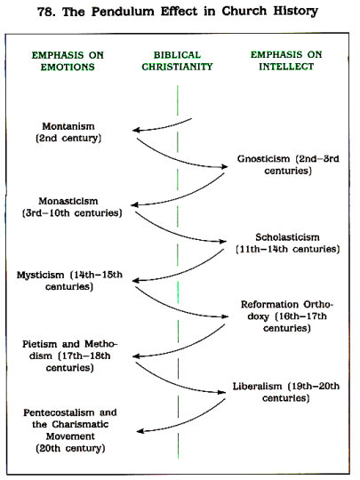
Nonetheless mysticism has continued throughout the centuries of Christendom, and prevailed for centuries at a time (see chart at left, used by permission of H. W. House). As was included in lesson 38, it has been expressed in our own era in Christian circles by such authors as Richard Foster, Dallas Willard and through the Quakers (aka Friends), and through the Renovare organization (www.renovare.org) as well as others that have sponsored their message. Proponents of Christian mysticism will often speak in terms of "spiritual formation" rather than the more biblically founded terms "spiritual growth" or "spiritual maturity".

Christian existentialism has had a voice in the last century through what is known as Neo-orthodoxy and by such names as Karl Barth (1886-1968), Paul Tillich (1886-1965) and others. Such proponents have spoken or will speak of Scripture as being a testimony to the truth or being subjectively inspiring, but not objectively inspired nor historically grounded. A number of seminaries have been conveying this view of Scripture for many decades, as the philosophy has worked its way into denominational structures and local church leadership. The approach to Scripture among many Christian existentialists of this persuasion (and many Christian mystics as well) is often to speak of Scripture as being spiritually true, but not necessarily historically true, or sometimes having no substantial connection to history whatsoever.

Another Christian expression that deals in existentialism and mysticism is the charismatic movement, which has a variety of expressions. Historically, the charismatic movement in modern times developed in this way:

Pentecostalism  (after 1900) | Charismatic  (about 1960) | Hypercharismatic  (about 1980)
Tongues is the evidence of the baptism of the Holy Spirit | Various apostolic era gifts are manifested | Various manifestations that are not found in Scripture

These deal in existentialism in that feelings and experiences are often looked upon as confirming or establishing what is true. These also deal in mysticism, in that Scripture is either bypassed entirely, or Scripture is just the starting point for a departure from biblical doctrine, guided by feelings and experiences.

Then there are those who are not in any of these movements or churches, but still operate in their lives by existential and/or mystical assumptions. Theophostic prayer for deep-seated hurts, for example, is existential and mystical, though it was developed in recent decades by a Baptist minister. Theophostic prayer does not consistently use Scripture to impact the believer deeply (Hebrews 4:12), but looks for a mystical encounter with Christ in words, a vision or impression to heal deep hurts. As another example, Christian music, which is to be teaching and admonishing and a result of being filled with Christ by means of the Spirit (Ephesians 5:1`9; Colossians 3:16), and therefore must be biblical in content and message. However, the worthiness of a piece of Christian music is evaluated by some on the basis of ‘confirming feelings’ and subjective experience rather than by Scripture.

So what should a Christian think about all this?
The Holy Spirit is personally and essentially involved in the writing of Scripture so as to bring truth to the pages of Scripture:

2 Timothy 3:16-17
All Scripture is inspired by God [theopneustos: God-breathed] and profitable for teaching, for reproof, for correction, for training in righteousness; 17 so that the man of God may be adequate, equipped for every good work.

2 Peter 1:20-21
But know this first of all, that no prophecy of Scripture is a matter of one's own interpretation [i.e., not subjectively validated as the basis of truth], 21 for no prophecy was ever made by an act of human will, but men moved by the Holy Spirit spoke from God [so is intended as objective revelation from God to be applied subjectively].

As we brought up earlier in this elective (lessons 12 & 13 The Bible: How did we get it - Parts I & II), God is involved through the Holy Spirit in the writing, transmission, and preservation of Scripture. The words of Scripture send a resounding message regarding the specific content of Scripture that God has deliberately revealed for our benefit and His glory:

- In the three relatively short books known as the pastoral epistles (1 & 2 Timothy, Titus) there are over 50 references to doctrine, teaching, instruction, etc. The doctrine, teaching and instruction are not to be pursued just for the sake of academic and intellectual development, but are intended by God as the essentials for every believer's spiritual growth and maturity.
- In the New Testament historical book of Acts, on into the epistles we find repeated reference to "the faith", as a specific set of apostolic teachings, such as: Acts 6:7; 13:8; 14:22; 16:5; 1 Corinthians 16:13; 2 Corinthians 13:5; Galatians 1:23; 6:10; Ephesians 4:5,13; Philippians 1:27; Colossians 1:23; 2:7; 1 Timothy 1:2; 3:9; 4:1,6; 5:8; 6:10,21; 2 Timothy 3:8; 4:7; Titus 1:13; Jude 3 & Revelation 2:13.
- In Ephesians chapter 3 Paul makes clear that it has been given to him to reveal certain truths of Scripture that have not been revealed before. In doing so, Paul makes use of a number of words and phrases that are identical to those found in the Greek Old Testament version of Daniel chapter 2, where Daniel says that God is the One who deliberately reveals. In both of the messages from Daniel and from Paul, the truths revealed were intended as a propositional, objective message to be applied personally.

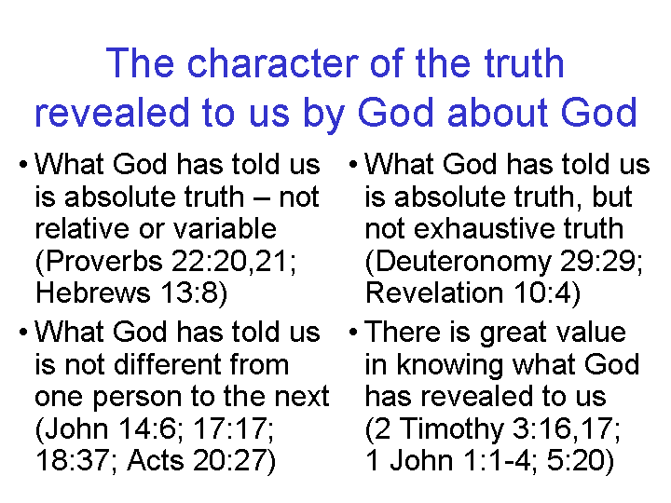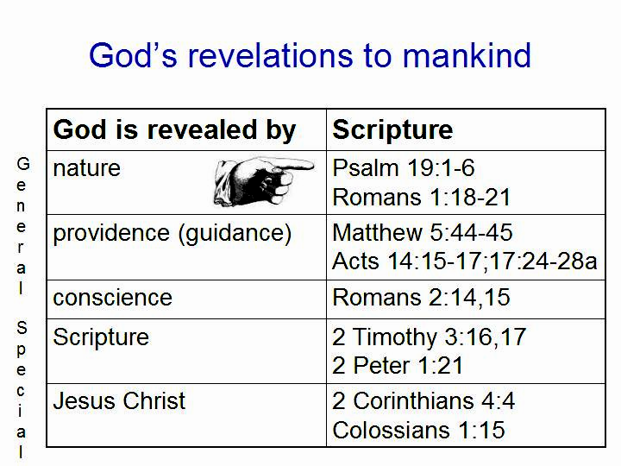

Further, the Holy Spirit, who indwells every believer, is involved in bringing us to the understanding of the truth of Scripture, as a key aspect of His role in our lives:

John 16:13 (explicitly said to the soon-to-be apostles)
"But when He, the Spirit of truth, comes, He will guide you into all the truth; for He will not speak on His own initiative, but whatever He hears, He will speak; and He will disclose to you what is to come."

John 16:14-15, Romans 8:14 and 1 Corinthians 2:15 also speak to this point as well, though not quite as directly. Christians have been given, through Scripture, the God-revealed spiritual facts, and our proper response to those revealed spiritual facts is faith in them (e.g., Romans 6:1-11). It is no "leap of faith", and in fact, Scripture keeps referring to having a solid foundation in those revealed facts (1 Corinthians 3:10-15; Ephesians 2:19-22), and not in any blind leap of faith. The point that is very relevant to the present topic is that Scripture is God's specific, deliberate revelation of truth content that is God's designated point of contact for the knowledge of God and for spiritual growth and maturity, both individually and as a church body:

2 Corinthians 3:18
But we all, with unveiled face, beholding as in a mirror the glory of the Lord, are being transformed into the same image from glory to glory, just as from the Lord, the Spirit.

Ephesians 4:11-16
And He gave some as apostles, and some as prophets, and some as evangelists, and some as pastors and teachers, 12 for the equipping of the saints for the work of service, to the building up of the body of Christ; 13 until we all attain to the unity of the faith, and of the knowledge of the Son of God, to a mature man, to the measure of the stature which belongs to the fullness of Christ. 14 As a result, we are no longer to be children, tossed here and there by waves and carried about by every wind of doctrine, by the trickery of men, by craftiness in deceitful scheming; 15 but speaking the truth in love, we are to grow up in all aspects into Him who is the head, even Christ, 16 from whom the whole body, being fitted and held together by what every joint supplies, according to the proper working of each individual part, causes the growth of the body for the building up of itself in love.

Colossians 1:28
We proclaim Him, admonishing every man and teaching every man with all wisdom, so that we may present every man complete [i.e., mature] in Christ.

1 Timothy 4:6
In pointing out these things to the brethren, you will be a good servant of Christ Jesus, constantly nourished on the words of the faith and of the sound doctrine which you have been following.

1 Peter 2:1-3
Therefore, putting aside all malice and all deceit and hypocrisy and envy and all slander, 2 like newborn babies, long for the pure milk of the word, so that by it you may grow in respect to salvation, 3 if you have tasted the kindness of the Lord.

Walk, but neither leap nor drift
The approach of Christian existentialism and mysticism is to either bypass the spiritual function of Scripture that Scripture reveals of itself by God's intent, or to (mis)use Scripture as a point of departure from which to go onto other mystical experiences. Either way, God's deliberate revelation through Scripture is not or does not remain in its God-intended role. Spiritual growth, then, becomes humanly centered, lacking the necessary explicit scriptural definitions. Human experience, rather than God's action in and through us, as revealed in and accomplished by means of the incomparable truth of Scripture, becomes the focal point. True biblical spiritual growth and maturity, being set aside as misguided, actually guarantees spiritual immaturity for those true Christians who take the paths of Christian existentialism and mysticism. For those who attempt to find salvation in these paths, the outcome is eternally far worse. How much better to meet the Lord at the meeting place of His word, and enjoy genuine and solidly founded fellowship with Him:

2 Peter 3:14-18
Therefore, beloved, since you look for these things, be diligent to be found by Him in peace, spotless and blameless, 15 and regard the patience of our Lord as salvation; just as also our beloved brother Paul, according to the wisdom given him, wrote to you, 16 as also in all his letters, speaking in them of these things, in which are some things hard to understand, which the untaught and unstable distort, as they do also the rest of the Scriptures, to their own destruction. 17 You therefore, beloved, knowing this beforehand, be on your guard so that you are not carried away by the error of unprincipled men and fall from your own steadfastness, 18 but grow in the grace and knowledge of our Lord and Savior Jesus Christ. To Him be the glory, both now and to the day of eternity. Amen.

Hebrews 2:1-4
For this reason we must pay much closer attention to what we have heard [from the apostles], so that we do not drift away from it. 2 For if the word spoken through angels [the Mosaic Law] proved unalterable, and every transgression and disobedience received a just penalty, 3 how will we escape if we neglect so great a salvation? After it was at the first spoken through the Lord [Jesus Christ], it was confirmed to us by those who heard [the apostles], 4 God also testifying with them, both by signs and wonders and by various miracles and by gifts of the Holy Spirit [2 Corinthians 12:12] according to His own will.

Though fully developed gnosticism was not evident until the 2nd century AD, after the New Testament era (Pre-Christian Gnosticism, Edwin M. Yamauchi, 1973, 1983).
Which is the word of God (1 Corinthians 13:12, James 1:23).
This is the same Greek word as is used in 1 Peter 2:2 (see above), where spiritual growth and God's word are also tied together in the same context.

