Introduction to the Complete Word Study New Testament

For lessons 06 through 11 of How to Study the Bible III we will be offering an alternate to the originally planned Greek series. Then we will rejoin the rest of the class for the remainder of the year.

The Complete Word Study New Testament is in the usual book sequence (Matthew, Mark, Luke, etc.) and chapter and verse markings. What is different is that the words are followed with Strong’s numbers in red and grammar codes in green. It is not necessary to learn or know Greek, but insights from the Greek text of the New Testament can still be gained.

To look up the grammar codes, use the accompanying Complete Word Study New Testament. We’ll take up how to look up the meaning of the grammar in a later lesson.

To look up the meaning of a word you look up the Strong’s number listed in red after the word in the Complete Word Study New Testament Dictionary. As is often the case in Bible study, once you gain an insight at one place, you can use that in many places. Let’s take an example to illustrate this point. Below is the Complete Word Study New Testament for Galatians 1:6-9:

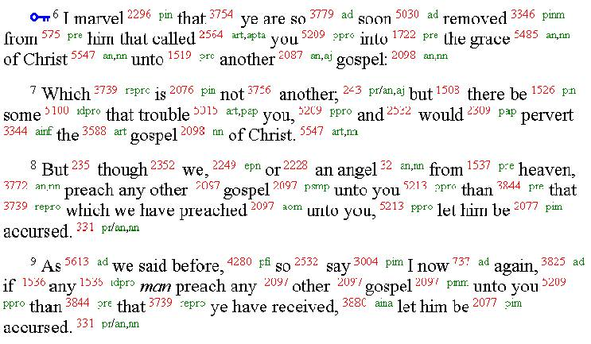

Notice that ‘another’ in verse 6 has a different Strong’s number than ‘another’ in verse 7 (2087 versus 243). When we look those up in the Complete Word Study Dictionary we find that there are two Greek words which are often translated “another”, but which have a distinct point of opposition:

243 – allos = another of the same kind

2087 – heteros = another of a different kind

Just being able to observe this one distinction provides much better insight into a number of New Testament passages. For example:

Matthew 2:11-12
11 After coming into the house they saw the Child with Mary His mother; and they fell to the ground and worshiped Him. Then, opening their treasures, they presented to Him gifts of gold, frankincense, and myrrh.
12 And having been warned by God in a dream not to return to Herod, the magi left for their own country by another ²⁴³ way.

John 14:16-17
16 "I will ask the Father, and He will give you another ²⁴³ Helper, that He may be with you forever;
17 that is the Spirit of truth, whom the world cannot receive, because it does not see Him or know Him, but you know Him because He abides with you and will be in you.

Luke 9:57-61
57 As they were going along the road, someone said to Him, "I will follow You wherever You go."
58 And Jesus said to him, "The foxes have holes and the birds of the air have nests, but the Son of Man has nowhere to lay His head."
59 And He said to another ²⁰⁸⁷, "Follow Me." But he said, "Lord, permit me first to go and bury my father."
60 But He said to him, "Allow the dead to bury their own dead; but as for you, go and proclaim everywhere the kingdom of God."
61 Another ²⁰⁸⁷ also said, "I will follow You, Lord; but first permit me to say good-bye to those at home."

Acts 7:17-19
17 "But as the time of the promise was approaching which God had assured to Abraham, the people increased and multiplied in Egypt, 18 until there arose another ²⁰⁸⁷ king over Egypt who knew nothing about Joseph. 19 It was he who took shrewd advantage of our race and mistreated our fathers so that they would expose their infants and they would not survive."

Acts 17:5-8
5 But the Jews, becoming jealous and taking along some wicked men from the market place, formed a mob and set the city in an uproar; and attacking the house of Jason, they were seeking to bring them out to the people. 6 When they did not find them, they began dragging Jason and some brethren before the city authorities, shouting, "These men who have upset the world have come here also; 7 and Jason has welcomed them, and they all act contrary to the decrees of Caesar, saying that there is another ²⁰⁸⁷ king, Jesus." 8 They stirred up the crowd and the city authorities who heard these things.

Hebrews 7:11-15
11 Now if perfection was through the Levitical priesthood (for on the basis of it the people received the Law), what further need was there for another ²⁰⁸⁷ priest to arise according to the order of Melchizedek, and not be designated according to the order of Aaron? 12 For when the priesthood is changed, of necessity there takes place a change of law also. 13 For the one concerning whom these things are spoken belongs to another ²⁰⁸⁷ tribe, from which no one has officiated at the altar. 14 For it is evident that our Lord was descended from Judah, a tribe with reference to which Moses spoke nothing concerning priests. 15 And this is clearer still, if another ²⁰⁸⁷ priest arises according to the likeness of Melchizedek…

Mark 16:12
12 After that, He appeared in a different ²⁰⁸⁷ form to two of them while they were walking along on their way to the country.

Luke 9:29
29 And while He was praying, the appearance of His face became different ²⁰⁸⁷, and His clothing became white and gleaming.

Romans 7:23
23 but I see a different ²⁰⁸⁷ law in the members of my body, waging war against the law of my mind and making me a prisoner of the law of sin which is in my members.

Philippians 3:15
15 Let us therefore, as many as are perfect, have this attitude; and if in anything you have a different ²⁰⁸⁷ attitude, God will reveal that also to you;

1 Timothy 6:3
3 If anyone advocates a different ²⁰⁸⁷ doctrine and does not agree with sound words, those of our Lord Jesus Christ, and with the doctrine conforming to godliness,

As another example of gaining multiple insights from the discovery of just one repeated understanding of word meanings, we have the pair of two letter words ‘ou me’ (pronounced ‘oo-may’). Literally, these words mean ‘not-not’. But the meaning of these Greek words together (Strong’s number 3364) is ‘by no means’. Some examples of the use of Strong’s number 3364 include:

John 10:22-30
At that time the Feast of the Dedication took place at Jerusalem; 23 it was winter, and Jesus was walking in the temple in the portico of Solomon. 24 The Jews then gathered around Him, and were saying to Him, "How long will You keep us in suspense? If You are the Christ, tell us plainly." 25 Jesus answered them, "I told you, and you do not believe; the works that I do in My Father's name, these testify of Me. 26 "But you do not believe because you are not of My sheep. 27 "My sheep hear My voice, and I know them, and they follow Me; 28 and I give eternal life to them, and they will never ³³⁶⁴ perish; and no one will snatch them out of My hand. 29 " My Father, who has given them to Me, is greater than all; and no one is able to snatch them out of the Father's hand. 30 "I and the Father are one."

Hebrews 13:5
5 Make sure that your character is free from the love of money, being content with what you have; for He Himself has said, "I will never ³³⁶⁴ desert you, nor will I ever ³³⁶⁴ forsake you,"

Luke 21:33
33 "Heaven and earth will pass away, but My words will not ³³⁶⁴ pass away."

Revelation 3:5-6
He who overcomes will thus be clothed in white garments; and I will not ³³⁶⁴ erase his name from the book of life, and I will confess his name before My Father and before His angels. 6' He who has an ear, let him hear what the Spirit says to the churches.'

In the gospel of John, in Revelation, and other places we’ll be looking at later on, the word pair that is usually translated ‘I am’ is the Strong’s numbers together

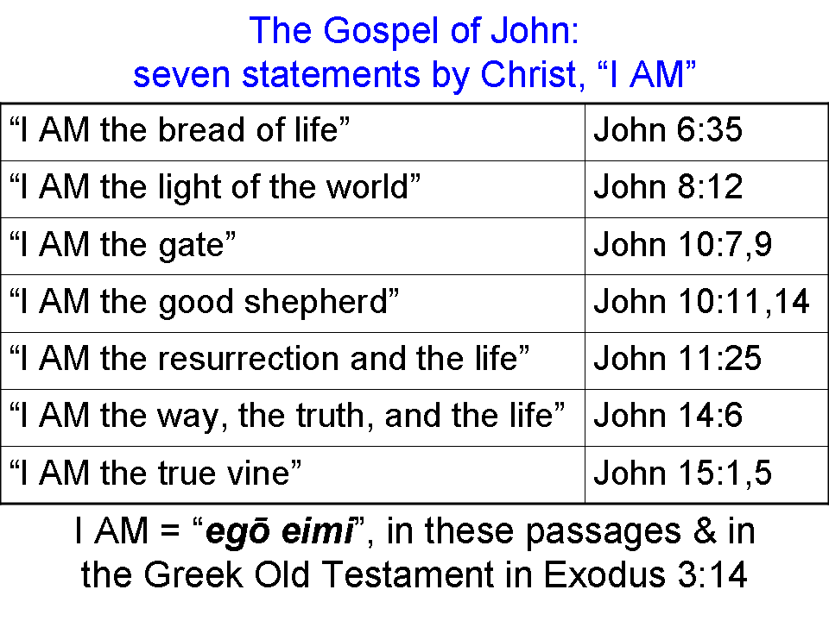
John 6:35
35 Jesus said to them,
"I am ¹⁴⁷³ ¹⁵¹⁰ the bread of life; he who comes to Me will not hunger, and he who believes in Me will never thirst.

John 6:48
"I am ¹⁴⁷³ ¹⁵¹⁰ the bread of life.

