Introduction I: Why Are We Doing This?

The God of Scripture is a God who intentionally reveals Himself
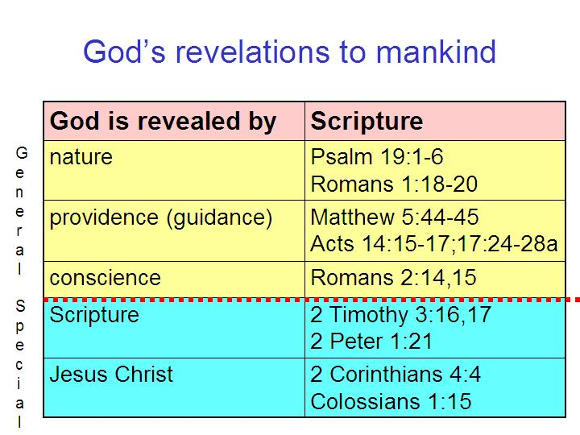
Scripture spends little ink on whether there is a God – His existence is simply a given. Scripture also makes abundantly clear that God intentionally reveals Himself in multiple ways, each of which is also revealed in Scripture (see chart to the left). And from the earliest pages of Scripture we see that God is a personal being, with a specific character, Who from the beginning of Scripture to the very end has an intense interest in relating to humankind, and a great concern for the character of that relationship.

Since God was so intentional -what did God intend?

There is at least a handful of interpretations offered for just about every passage of Scripture, and for some passages, even more than a handful. Then there is the plethora of ‘personal opinions’ and ‘personal impressions’. But did God intend that there be a range of interpretations for every passage? Did God have in mind that we remain uncertain about what the Bible says? Does God want us to simply embrace the diversity of opinions and be united anyway – agree to disagree? Paul gave his apostolic insights into those questions to the deeply divided church at Corinth:

1 Corinthians 1:10 (NASU)
Now I exhort you, brethren, by the name of our Lord Jesus Christ, that you all agree [literally, ‘say the same thing’] and that there be no divisions among you, but that you be made complete [katartizō: a word used for mending nets and setting broken bones] in the same mind and in the same judgment.

Paul also wrote to Titus, his personal delegate on tough assignment to the island of Crete:

Titus 1:5,9 (NASU)
For this reason I left you in Crete, that you would set in order what remains and appoint elders in every city as I directed you… 9 holding fast the faithful word which is in accordance with the teaching, so that he will be able both to exhort in sound doctrine and to refute those who contradict. [See also 2 Timothy 2:15 on, literally, “accurately handling the word of the truth.”]
There are also the many New Testament passages that refer to “the faith”, as a singular set of doctrines, and “the truth” referring to the one body of truth. Those passages include:

• Acts 6:7; 13:8; 14:22; 16:5 • Colossians 1:23; 2:7

• 1 Corinthians 16:13 • 1 Timothy 1:2; 3:9; 4:1,6; 5:8; 6:10,21

• 2 Corinthians 13:5 • 2 Timothy 3:8; 4:7

• Galatians 1:23; 6:10 • Titus 1:13
• Ephesians 4:5,13 (“the unity of the faith.”) • Jude 3
• Philippians 1:27 • Revelation 2:13

The apostle John also wrote about the certainty that we are to have about what he wrote and about the resulting certainty of the knowledge of the Son of God and that we are in Him:

1 John 5:13, 20 (NASU)
These things I have written to you who believe in the name of the Son of God, so that you may know that you have eternal life… And we know that the Son of God has come, and has given us understanding so that we may know Him who is true; and we are in Him who is true, in His Son Jesus Christ. This is the true God and eternal life.

What do these passages, among many others, tell us? God intended to convey a singular, unifying body of truth, and to have us clearly understand what is true and what is false, and to have that singular body of truth culminate in a true and intimate personal knowledge of Jesus Christ, the Son of God. Scripture is God’s written word (message) of God and Jesus Christ is the Living Word (message) of God.

Key Portions of the Holly Hills Bible Church Doctrinal Statement

The Bible - We believe that all the authors of the entire Old and New Testaments wrote by the guidance of the Holy Spirit (i.e., verbal inspiration). Those books are completely inerrant and infallible in the original writings. They are the final authority for faith and practice, and the means through which believers behold Christ (2 Timothy 3:16-17; 1 Peter 1:10-12; 2 Peter 1:20-21; 2 Corinthians 3:18; Galatians 1:11-17; 1 Thessalonians 2:13).

The Holy Spirit - We believe in the deity and personality of the Holy Spirit. Certain ministries have been committed to Him in this age. He convicts the world of sin, of righteousness, and of judgment. He is responsible for the regeneration, indwelling, enlightening, sealing unto the day of redemption, He baptizes each believer into the one body of Christ (the Church) and into the person and work of Christ (His death, burial, and resurrection). He transforms each believer into the image of Christ as the believer beholds Christ in the word of God. (John 3:6, 16:7-11; Romans 6:1-6, 8:9, 29; 1 Corinthians 12:13; 2 Corinthians 3:18; Ephesians 4:30, 5:18; 2 Thessalonians 2:7; 1 John 2:20-27).

Dispensational Interpretation - We believe that Scripture is to be interpreted according to its grammatical and historical context, including that God, Who does not change, deals in a different manner with the Gentile nations, the people of Israel, and the God-created body of heavenly saints called “the Church”. We believe that all who are saved of all time are saved entirely by faith in Christ, either looking forward or back to the cross. (John 14:6; Acts 4:12; Romans 11:1, 2; 1 Corinthians 9:17, 10:32; Ephesians 1:10, 2:11-22, 3:2; Colossians 1:25)
.
We will discuss more in detail about why this approach to Scripture makes good consistent sense (versus other approaches to interpretation), and why the authors of Scripture intended their message to be understood in this way. We will also present that the key to understanding the term ‘Dispensation’ is to observe and understand the many and various stewardships in the Bible.

The Life and Walk of Believers - We believe that every believer possesses the life of Christ and grows in the grace and knowledge of Christ through the Holy Spirit, Who fills the believer with the things of Christ. This occurs as the believer beholds Christ in the word of God, as he walks by faith, moment by moment abiding in Christ. The believer is to walk and rest in the eternally established identity that he possesses by virtue of his faith in the crucified, buried, resurrected, ascended and seated person of Christ (his position) and his identification with Him in these things. Christ’s life is then lived in the believer, which is evident to those who do not know Christ and to those who share Christ’s life. (John 14:1-5, 17:22; 1 Corinthians 16:20; 2 Corinthians 3:18, 9:7; Galatians 2:19, 20; Ephesians 5:17-18; Colossians 2:6-7, 3:1-4, 16; Hebrews 11:6; 2 Peter 3:18).

This paragraph is critical to understanding why we are approaching Scripture in this way. We are not doing it to be quirky, nitpicky, narrow-minded or oddly particular about how we do things. We are approaching Scripture in this way because we see that, as revealed in Scripture, God intends, desires, and planned before creation that we in the body of Christ would have relationship with Him, fellowship with Him and grow in intimacy with Christ until the day we see Him face to face.

1 Peter 2:1-3
Therefore, putting aside all malice and all deceit and hypocrisy and envy and all slander, 2 like newborn babies, long for the pure milk of the word, so that by it you may grow in respect to salvation, 3 if you have tasted the kindness of the Lord.

2 Peter 3:17-18
You therefore, beloved, knowing this beforehand, be on your guard so that you are not carried away by the error of unprincipled men and fall from your own steadfastness, 18 but grow in the grace and knowledge of our Lord and Savior Jesus Christ. To Him be the glory, both now and to the day of eternity. Amen.

The approach to this elective, in broad outline will be defined by this process in understanding, applying and appropriating God’s word:

Observation > Interpretation > Application > Appropriation

So as outlined in the Schedule on the next page (for January through June 2016) we will have two weeks of introduction, then from January 17 through June 26 and beyond we will present tools of observation. Then we will present principles of interpretation, principles of application and appropriation. Towards the end of the year we will have practice in observation, interpretation and
Schedule for How to Study the Bible III
(January through June 2016)

Jan No Subject Teacher

3 01 Introduction I – Why are we doing this? VP 10 02 Introduction II – How are we doing this? VP
17 03 Introductory New Testament Greek I CK
24 04 Introductory New Testament Greek II CK
31 05 Introductory New Testament Greek III CK

Feb No Subject Teacher

7 06 Introductory New Testament Greek IV CK
14 07 Introductory New Testament Greek V CK
21 08 Introductory New Testament Greek VI CK
28 09 Introductory New Testament Greek VII CK

Mar No Subject Teacher

6 10 Introductory New Testament Greek VIII CK
13 11 Introductory New Testament Greek IX CK
20 12 Greek Old & New Testaments I VP
27 13 Greek Old & New Testaments II VP

Apr No Subject Teacher

3 14 Greek Old & New Testaments III JD
10 15 Word Meanings: Old Testament VP
17 16 Word Meanings: New Testament CK
24 17 Figures of Speech I VP

May No Subject Teacher

1 18 Figures of Speech II JD
8 19 Rhetorical Writing VP
15 20 Hebrew Poetry Patterns VP
22 21 Poetic Forms & Sentence Diagramming CK
29 22 Chiasms VP

Jun No Subject Teacher

5 23 Old Testament History VP
12 24 Between the Old & New Testaments CK
19 25 New Testament History JD
26 26 Old Testament Cultures VP

katartizō: used of the disciples mending nets on the shores of Galilee in Matthew 4:21. 2 Corinthians 13:11, “Finally, brethren, rejoice, be made complete (katartizō), be comforted, be like-minded, live in peace; and the God of love and peace will be with you.” Galatians 6:1abc, “Brethren, even if anyone is caught in any trespass, you who are spiritual, restore (katartizō) such a one in a spirit of gentleness…”
nous, singular. In 1 Corinthians 2:16, Paul wrote, “…But we have the mind (nous, singular) of Christ.”.

