The Greek Old & New Testaments III
The deity of Christ

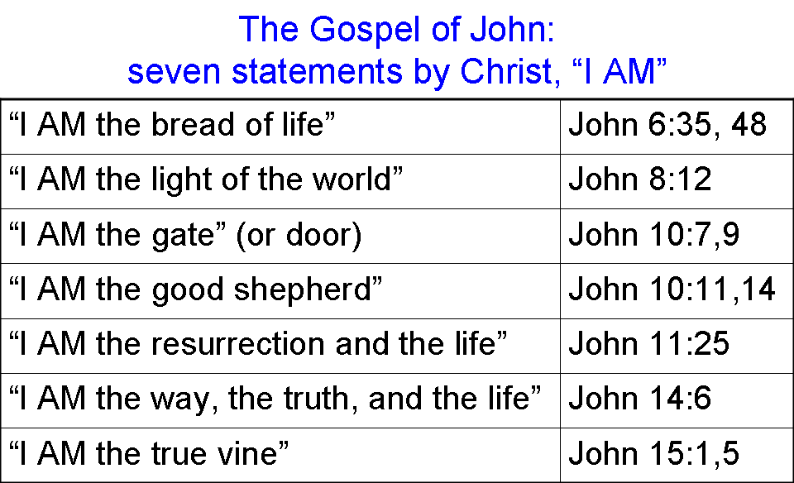
Both in the gospel of John and in the book of Revelation, also written by John, there is a pattern of sevens. For instance, in the gospel of John there are seven metaphorical statements of ‘I AM’ by Christ, and with multiple statements of the same claim. These seven metaphorical statements are shown in the table to the right. These seven metaphorical statements of ‘I AM’ are translated in every case from the Greek egō eimi [Strong’s numbers 1474 & 1510]. Most of these statements were made to the disciples, but those in John chapters 8 & 10 are said to skeptical and unbelieving Jews.

John 8:24
"Therefore I said to you that you will die in your sins; for unless you believe that I AM [egō eimi; Strong’s numbers 1474 & 1510] He, you will die in your sins."

John 8:56-59
"Your father Abraham rejoiced to see My day, and he saw it and was glad." 57 So the Jews said to Him, "You are not yet fifty years old, and have You seen Abraham?" 58 Jesus said to them, "Truly, truly, I say to you, before Abraham was born, I AM [egō eimi; Strong’s numbers 1474 & 1510]." 59 Therefore they picked up stones to throw at Him, but Jesus hid Himself and went out of the temple.

The claim to deity is clear, and the Jews’ reaction reflects that. Just two chapters later (in John 10), after Jesus made double statements, “I AM the door” and “I AM the good shepherd”, as listed above, Jesus responds to the Jews’ request to speak plainly:

John 10:24-30
If You are the Christ, tell us plainly. "25 Jesus answered them, " I told you, and you do not believe; the works that I do in My Father's name, these testify of Me. 26 "But you do not believe because you are not of My sheep. 27 "My sheep hear My voice, and I know them, and they follow Me; 28 and I give eternal life to them, and they will never perish; and no one will snatch them out of My hand. 29 "My Father, who has given them to Me, is greater than all; and no one is able to snatch them out of the Father's hand."

Some key points to bring up about the above passage:

- ‘the Christ’, as we pointed out last Sunday, refers to ‘the Messiah’, especially in a Jewish context. An open claim to be the Messiah might spark the ire of the Romans, who put down multiple uprisings led by ‘Messiahs’.

- The Sadducees did not believe in a Messiah at all, and the Pharisees believed in the Messiah, as the descendent of David, but not as deity.

- The Jews considered Jews calling God ‘Our Father’ to be acceptable, but calling God ‘My Father’ implied a special and unique relationship with the Father.

- Effectively, the Jews asked for Jesus to tell them plainly that He was the Messiah. Jesus’ answer goes at least one better than that – He tells them that He is deity!

Then Jesus told them, in a more literal Greek translation:

John 10:30
“I and the Father are one essence.”

John 10:36
“I said Son of the God am”

John 10:38
“…the Father is in Me, and I in the Father.”

With these words, the Jews were picking up stones and trying to seize Him. Jesus’ statements of ‘I AM’ [egō eimi; Strong’s numbers 1474 & 1510] began this series of statements which come across as a clear claim to deity. John also has Jesus saying I AM, in a couple of other important contexts.

John 13:19
"From now on I am telling you before it comes to pass, so that when it does occur, you may believe that I AM [egō eimi; Strong’s numbers 1474 & 1510] He.

John 18:1-9 (egō eimi and Strong’s numbers 1474 & 1510 represented by I AM)
When Jesus had spoken these words, He went forth with His disciples over the ravine of the Kidron, where there was a garden, in which He entered with His disciples. 2 Now Judas also, who was betraying Him, knew the place, for Jesus had often met there with His disciples. 3 Judas then, having received the Roman cohort and officers from the chief priests and the Pharisees, came there with lanterns and torches and weapons. 4 So Jesus, knowing all the things that were coming upon Him, went forth and said to them, " Whom do you seek?" 5 They answered Him, "Jesus the Nazarene." He said to them, "I AM He." And Judas also, who was betraying Him, was standing with them. 6 So when He said to them, "I AM He," they drew back and fell to the ground. 7 Therefore He again asked them, " Whom do you seek?" And they said, "Jesus the Nazarene." 8 Jesus answered, "I told you that I AM He; so if you seek Me, let these go their way," 9 to fulfill the word which He spoke, " Of those whom You have given Me I lost not one."
Then in Revelation, the apostle John continues his declarations of Christ as deity:

Revelation 1:8-11, 17-20
"I AM the Alpha and the Omega," says the Lord God, "who is and who was and who is to come, the Almighty."

9 I, John, your brother and fellow partaker in the tribulation and kingdom and perseverance which are in Jesus, was on the island called Patmos because of the word of God and the testimony of Jesus. 10 I was in the Spirit on the Lord's day, and I heard behind me a loud voice like the sound of a trumpet, 11 saying, "Write in a book what you see, and send it to the seven churches: to Ephesus and to Smyrna and to Pergamum and to Thyatira and to Sardis and to Philadelphia and to Laodicea."…

17 When I saw Him, I fell at His feet like a dead man. And He placed His right hand on me, saying, "Do not be afraid; I AM the first and the last, 18 and the living One; and I was dead, and behold, I am alive forevermore, and I have the keys of death and of Hades. 19 Therefore write the things which you have seen, and the things which are, and the things which will take place after these things. 20 As for the mystery of the seven stars which you saw in My right hand, and the seven golden lampstands: the seven stars are the angels of the seven churches, and the seven lampstands are the seven churches."

Revelation 22:12-13, 16
"Behold, I am coming quickly, and My reward is with Me, to render to every man according to what he has done. 13 I am the Alpha and the Omega, the first and the last, the beginning and the end."…

16 "I, Jesus, have sent My angel to testify to you these things for the churches. I AM the root and the descendant of David, the bright morning star."

Now let’s look at the Greek Old Testament interlinear for Isaiah 43:10:

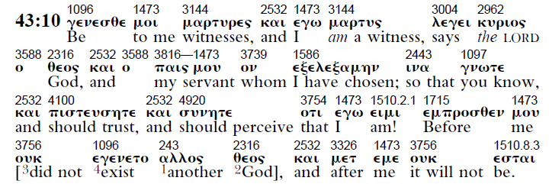
And Isaiah 43:25 in the Greek Old Testament interlinear:

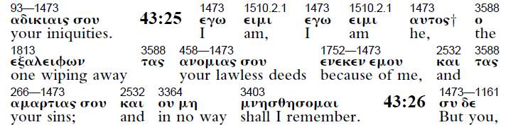

In these Isaiah passages, egō eimi [Strong’s numbers 1474 & 1510] are present in all three verses in the Greek Old Testament, Revelation 1:17 and 22:13 seem to reflect John’s direct translation of the Hebrew for these passages rather than drawing from the Greek Old Testament, aka LXX or Septuagint.

Isaiah 41:4
"Who has performed and accomplished it,
Calling forth the generations from the beginning?
'I, the Lord, am the first, and with the last. I AM He.'"

Isaiah 44:6
"Thus says the Lord, the King of Israel and his Redeemer, the Lord of hosts:
'I AM the first and I am the last,
And there is no God besides Me.

Isaiah 48:12
"Listen to Me, O Jacob, even Israel whom I called;
I AM He, I am the first, I am also the last.”

And then when we look at Exodus 3:6 in the Greek Old Testament we realize why Matthew 22:32, Mark 12:26 and Acts 7:32 all quote God as saying in Exodus 3:6, “I AM [egō eimi; Strong’s numbers 1474 & 1510] the God of…”

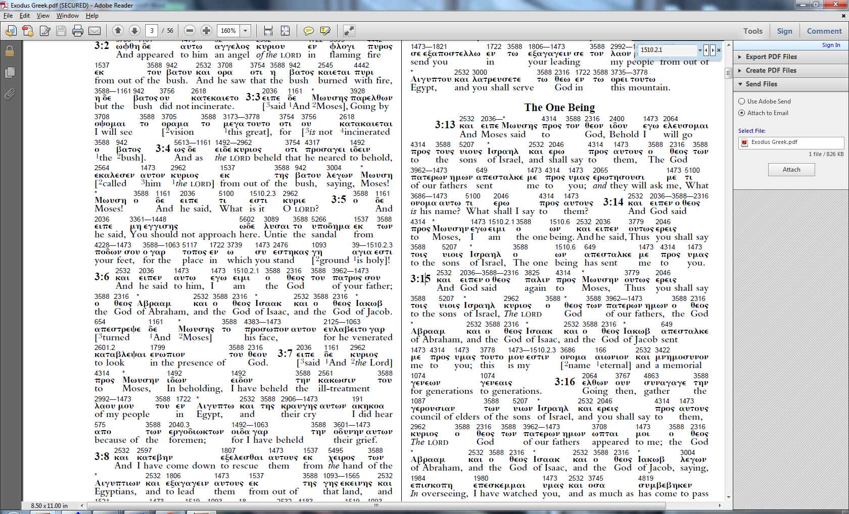

Then, in Exodus 3:14 of the Greek Old Testament we see that the Lord is continuing to talk to Moses out of the burning bush:

_____________________________________

This is not an exhaustive study of either occurrences of egō eimi [Strong’s numbers 1474 & 1510] in the Greek Old and New Testaments, or of the deity of Christ.

