Figures of Speech I

Try on these sentences that have various kinds of figures of speech:

“I have insomnia but I am not going to lose any sleep over it.”

“I would give my right arm to be ambidextrous.”

“‘So I see,’ said the blind carpenter as he picked up his hammer and saw,”

“‘We just struck oil!’, Tom gushed.”

“If I agreed with you, we'd both be wrong.”

“War does not determine who is right - only who is left.”

“‘We’ll have to rehearse that,’ said the undertaker as the coffin fell out of the car.”

Figures of speech used in the Bible are sometimes culturally specific and sometimes not.

Some of the figures of speech in the Bible – even words of Christ – can be pretty intense!

Matthew 5:29-30 (NASU)
"If your right eye makes you stumble, tear it out and throw it from you; for it is better for you to lose one of the parts of your body, than for your whole body to be thrown into hell. 30 If your right hand makes you stumble, cut it off and throw it from you; for it is better for you to lose one of the parts of your body, than for your whole body to go into hell.

Matthew 7:3-6
"Why do you look at the speck that is in your brother's eye, but do not notice the log that is in your own eye? 4 Or how can you say to your brother, 'Let me take the speck out of your eye,' and behold, the log is in your own eye? 5 You hypocrite, first take the log out of your own eye, and then you will see clearly to take the speck out of your brother's eye.

6 Do not give what is holy to dogs, and do not throw your pearls before swine, or they will trample them under their feet, and turn and tear you to pieces."

Luke 14:25-27
Now large crowds were going along with Him; and He turned and said to them, 26 "If anyone comes to Me, and does not hate his own father and mother and wife and children and brothers and sisters, yes, and even his own life, he cannot be My disciple.

27 Whoever does not carry his own cross and come after Me cannot be My disciple."

What if we were to take the figures of speech in the Song of Solomon literally?
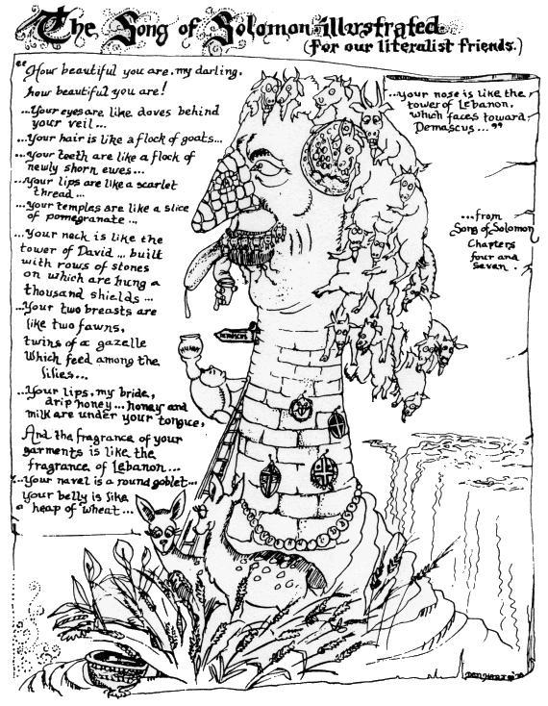
Used by permission from: http://www.growingchristians.org, originally located at:
http://www.growingchristians.org/cfgc/herm/HermenueticsSG.pdf, page 109.
The world’s best resource on figures of speech in the Bible

The world’s best resource on figures of speech in the Bible is free! You can download it here:

http://www.biblicalresearchjournal.org/brj-pages_pdf/001ewb_figures_of_speech.pdf

The book is Figures of Speech Used In The Bible, by E.W. Bullinger, which was first published in 1899. It is also available in print. It is 979 pages long, and it is probably exhaustive. Just a listing of all of the figures of speech from that book is seven pages long. But we do not wish to make anyone exhausted, so we will not study all of it.

Some figures of speech will be easy to recognize, but some not

Some figures of speech can be fairly easily recognized in our English translations. And in some cases we have the exact same figure of speech in the English language. The passage below has a series of similies, in which similiarity is seen by the use of ‘like’ or ‘as’.

Revelation 1:12-16
Then I turned to see the voice that was speaking with me. And having turned I saw seven golden lampstands; 13 and in the middle of the lampstands I saw one like a son of man, clothed in a robe reaching to the feet, and girded across His chest with a golden sash. 14 His head and His hair were white like white wool, like snow; and His eyes were like a flame of fire. 15 His feet were like burnished bronze, when it has been made to glow in a furnace, and His voice was like the sound of many waters. 16 In His right hand He held seven stars, and out of His mouth came a sharp two-edged sword; and His face was like the sun shining in its strength.

We can also see that there are figures of speech within a symbol.

But other figures of speech will require insights into the original language and / or the culture to properly recognize them or interpret them.

Philippians 3:1-2
Finally, my brethren, rejoice in the Lord. To write the same things again is no trouble to me, and it is a safeguard for you.

2 Beware of the dogs, beware of the evil workers, beware of the false circumcision;

This is a triple warning against the Jews, who will try to put the Christians under the Law of Moses, along with all of the corruptions of Pharisees. These are sometimes called the Judaizers. The language in English is pretty intense as it is. But what is not seen in English is that all of the words in verse 2 have an intensity that comes out more clearly in the Greek text behind the English

- Each noun in verse 2 is preceded by a definite article, so Paul is saying the dogs, the evil workers, the mutilators, as is brought across in many of the translations.
- The nouns in each case start with a ‘k’ sound: kuon, kakos ergates, katatome

If we were to carry this over into English in some equivalent way we might say something like:

- Beware the killing canines!
- Beware the cruel craftsmen!
- Beware the clandestine clumsy cutters!

In other instances, the figure of speech may be unique to the culture in or to which it was written. One figure of speech pattern that is used in both the Old and New Testaments is this:

• The work of God in the physical realm (such as in creation) is often spoken of as being done by God's hands or is called the work of His hands:

Job 10:8a
Your hands fashioned and made me altogether…

Psalm 19:1
The heavens are telling of the glory of God;
And their expanse is declaring the work of His hands.

See also Psalm 92:4; 95:5 and Hebrews 1:10; 2:7
.

• When God does something in the spiritual realm it is spoken of as "not made with hands“, "made without hands" or similar terms:

Hebrews 9:11
But when Christ appeared as a high priest of the good things to come, He entered through the greater and more perfect tabernacle, not made with hands, that is to say, not of this creation…

See also Daniel 2:34, 45; 2 Corinthians 5:1 and Colossians 2:11.

Other figures of speech may be more commonly or even uniquely used by one specific author. Dr. Luke, for example, wrote with a fairly unique figure of speech known as litotes, writing that something was “no small…’ or “ no little…” to indicate that it was big or large:
Acts 12:18 (NASU)
Now when day came, there was no small disturbance among the soldiers as to what could have become of Peter.

Acts 19:23, 24 (NASU)
About that time there occurred no small disturbance concerning the Way. 24 For a man named Demetrius, a silversmith, who made silver shrines of Artemis, was bringing no little business to the craftsmen;

Acts 27:20 (NASU)
Since neither sun nor stars appeared for many days, and no small storm was assailing us, from then on all hope of our being saved was gradually abandoned.

Paul often wrote with a figure of speech that is known as ellipsis, though many of our English translations do not reveal his figure of speech. An example of Paul’s use of ellipsis from the book of Philippians would be:

Philippians 4:8-9 (NASU) written in poetic form:

Finally, brethren,

whatever is true,
whatever [is] honorable,
whatever [is] right,
whatever [is] pure,
whatever [is] lovely,
whatever [is] of good repute,

if there is any excellence and
if anything worthy of praise,

dwell on these things.

So Paul left out the verb, the Greek equivalent of ‘is’, five times in a row! Why would Paul write in this way? His use of ellipsis in passages such as this creates a literary ‘pause
‘ which places a dramatic emphasis on the word or words that follow each literary ‘pause’.

There are many other figures of speech in Scripture, and recognizing those will provide a great number of insights – sometimes profound – in our understanding of God’s intended message through His written word.

