Chiasms

It is common in our own culture to outline documents and books of various kinds, and one can find such outlines, in varying levels of detail, in a number of Bible dictionaries, commentaries, and similar resources. The outlines are helpful in seeing what are the main subjects addressed along with the line of thought the author has taken. But the Bible contains other kinds of ‘structure’ on varying scales. Recognizing these other structures can be helpful in our understanding of what the authors of Scripture were seeking to convey. One kind of structure that is found commonly in both the Old and New Testaments is what is known as chiasm, or chiasmus. The basic pattern of chiasm is a literary ‘mirror image’. It is important to note that these chiasms can be found on varying scales:

- Within a verse or two
- Within a passage, even up to several chapters
- An entire book of the Bible may be a chiasm

Here are some examples of one or two verses of chiasm in Scripture:

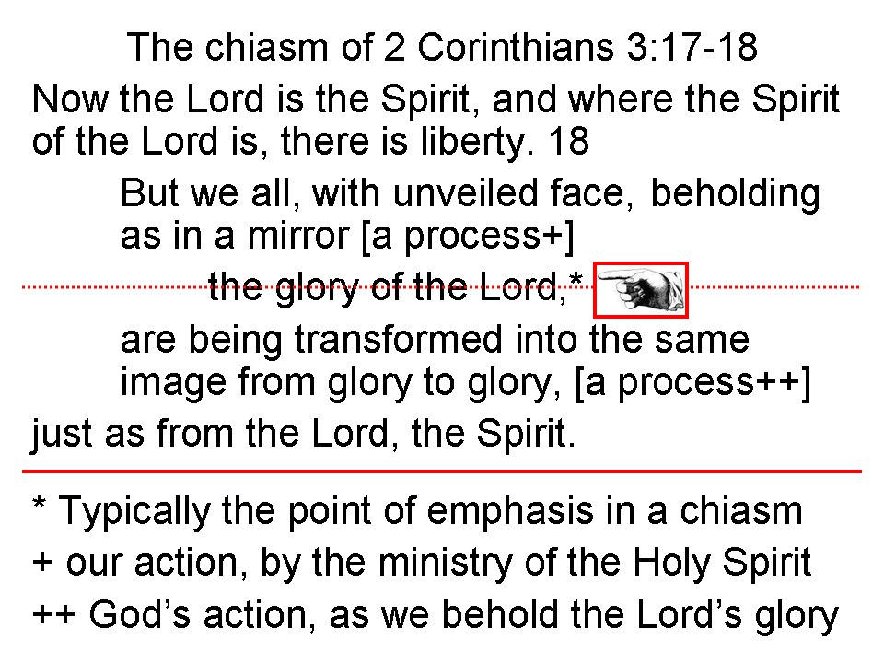

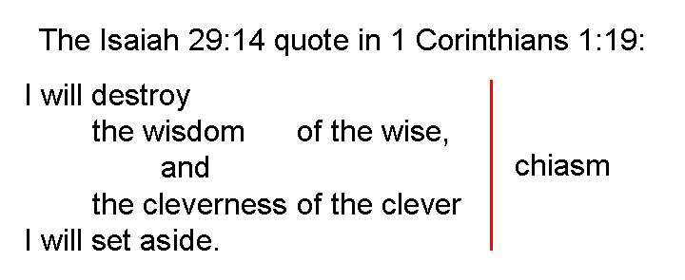
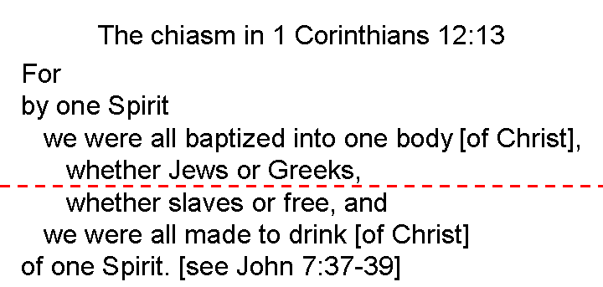

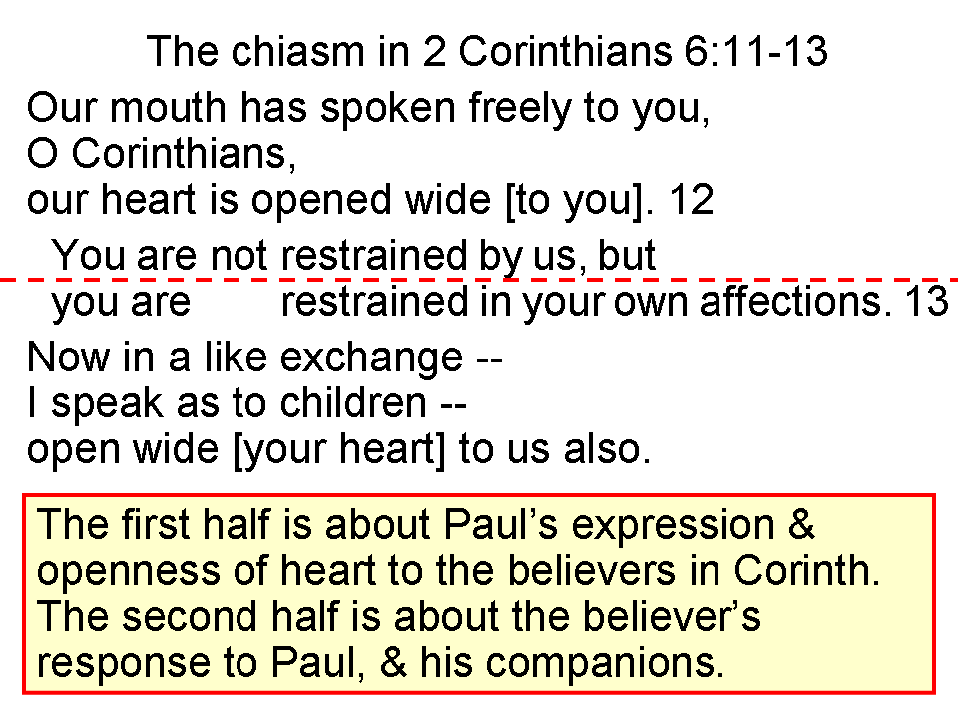

The chiasm in 1 John 3:9
A Whoever has been born of God
B does not sin
C for His seed remains in him
B’ and he cannot sin
A’ because he has been born of God

Chiasms, within a passage, even up to several chapters

Chiasm in Genesis 3:9-22

A The Lord God said & interactions (3:9-11)
B Adam to God about Eve (3:12)
C Eve to God about the serpent (3:13)
D God judges the serpent & promises a Savior (3:14-15)
C’ God judges Eve (3:16)
B’ God judges Adam (3:17-19)
A’ The Lord God said & interactions (3:20-22)

The chiasm in Isaiah 60:1-22

A The Lord, the light of Zion (1-5)
B The nations accepted by the Lord (6-7)
C World expectations met by the Lord (8-9)
D The nations serve Zion (10-11)
E Zion, the key to world destiny (12)
D’ The nations recognize Zion (13-14)
C’ Zion’s needs met by the Lord (15-16)
B’ Zion transformed by the Lord (17-18b)
A’ The Lord, the light of Zion (18c-22)

This literary chiasm in Genesis contains a number chiasm as well: 7-7-40-150  150-40-7- 7.

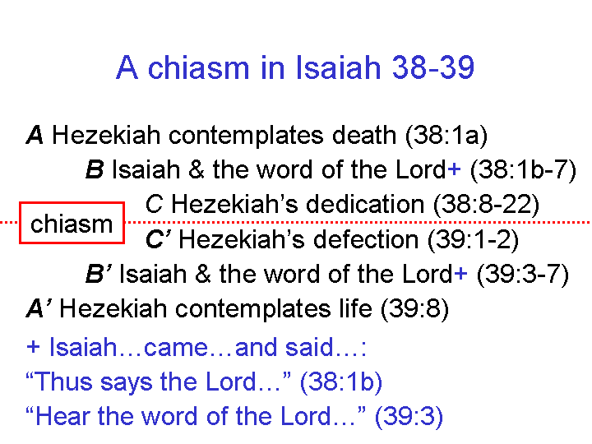

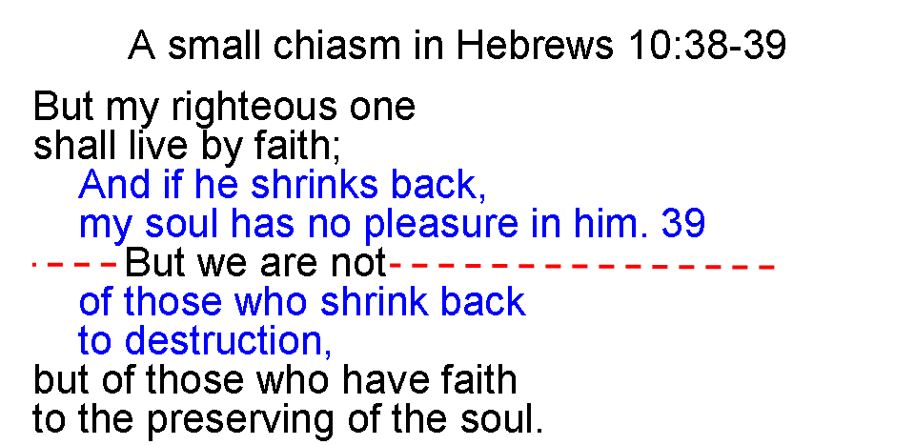

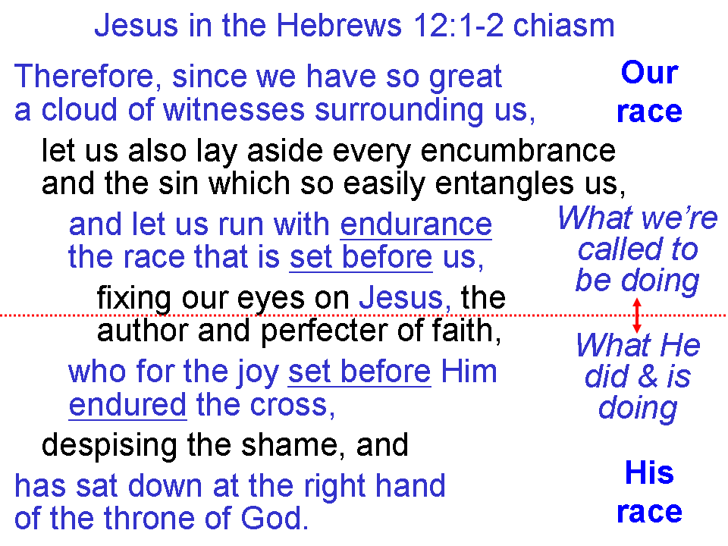
Sometimes an entire book of the Bible may be in the form of a chiasm.

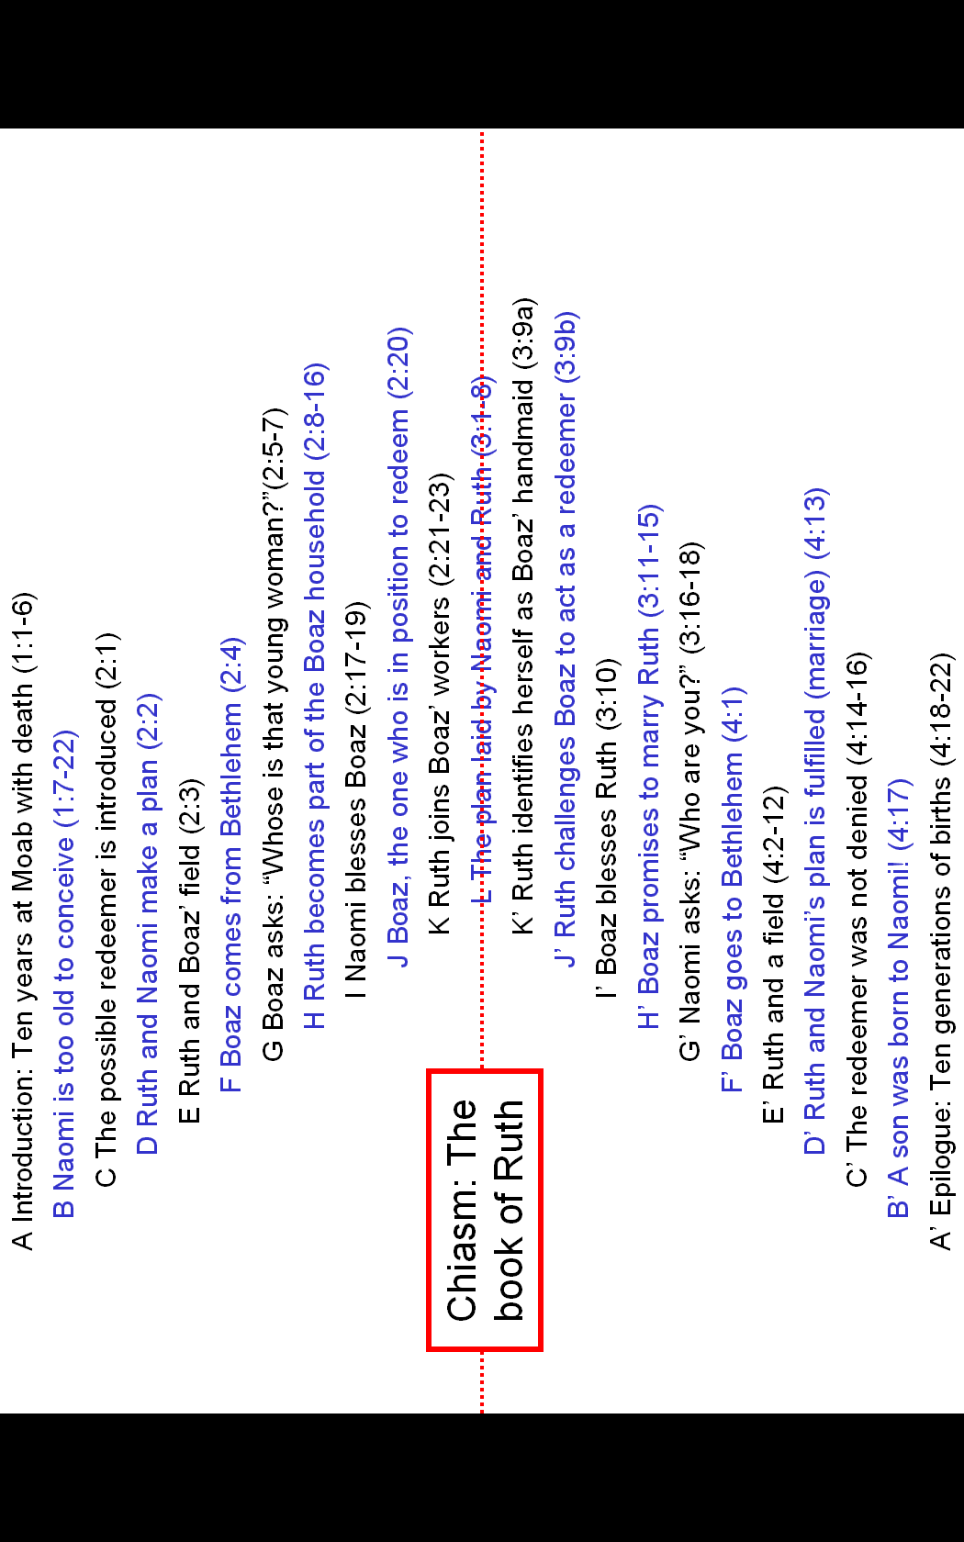
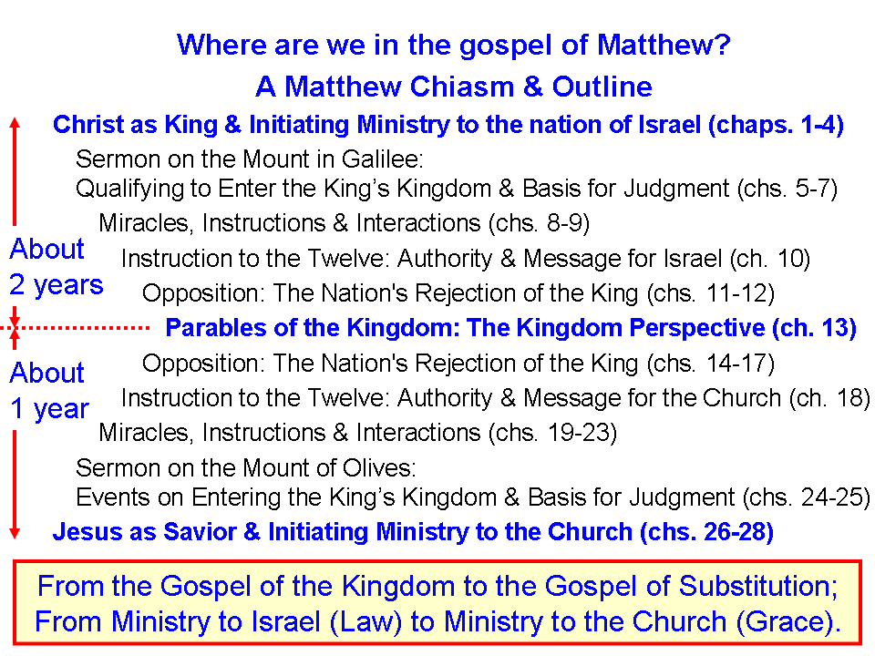
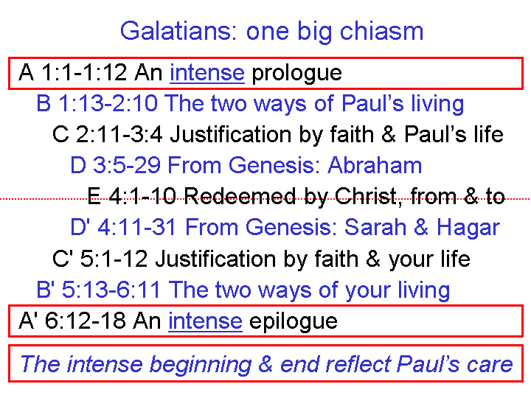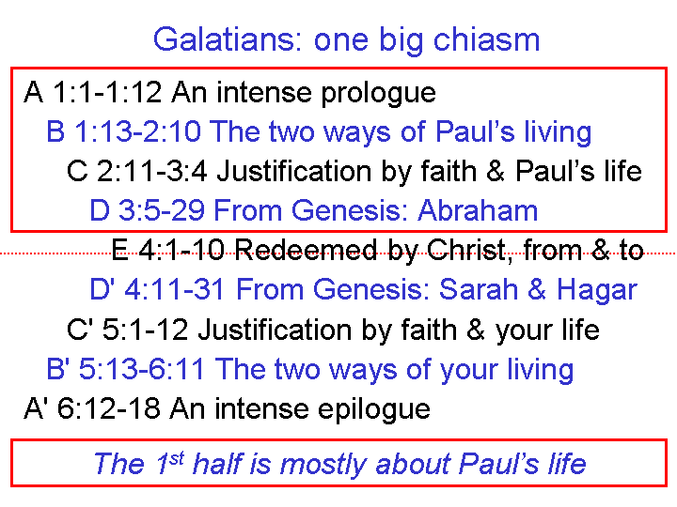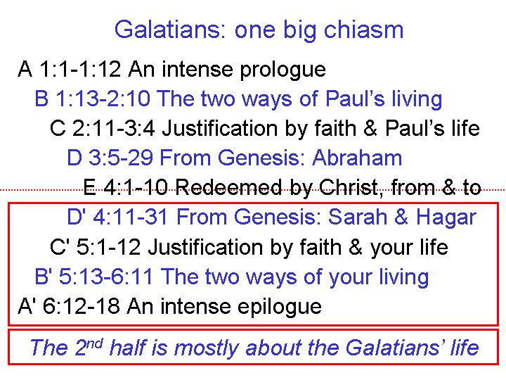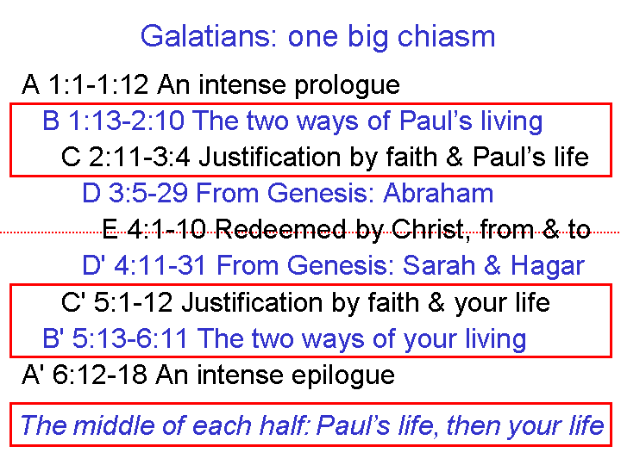

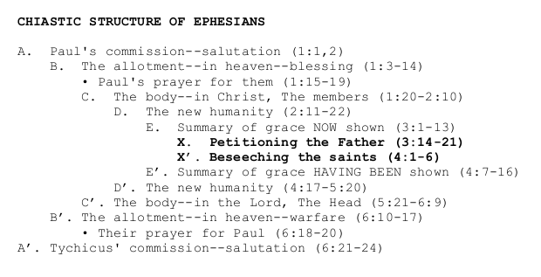
The chiasm in the book of Jude

A Assurance for the Christian (vv. 1,2)
B The believer & the faith (v. 3)
C Apostates described (v. 4)
D Apostasy in Old Testament history (vv. 5-8)
E Apostasy in the supernatural realm (vv. 9,10)
F An ancient trio of apostates (v. 11)
E’ Apostasy in the natural realm (vv. 12,13)
D’ Apostasy on Old Testament prophecy (vv. 14-16)
C’ Apostates described (vv. 17-19)
B’ The believe r & the faith (vv. 20-23)
A’ Assurance for the Christian (vv. 24,25)

As one can see, we can find numerous chiasms in Scripture, from one verse long to whole books. But why are there so many chiasms? How can they help us study God’s word?

- Chiasms emphasize by repetition and by the pivot or center of the passage.
- Chiasms can also emphasize by contrasting the first half with the last half.
- Chiasms made for a memory tool and a cross-check for copying by hand.
- Chiasms made for an orderly presentation.
- Chiasms serve to help us check our understanding of each part of a passage.
________________________________________________________________________

Some additional recommended resources for Hebrew Poetry Patterns, Poetic Forms & Chiasm:

Hebrew Poetry: What’s It All About? By Dennis Hinks:
http://www.journal33.org/bible/html/hebpoet.htm

Chiasmus, by Brad McCoy:
http://chafer.nextmeta.com/files/v9n2_2chiasmus.pdf

