Principles Of Interpretation I: From Facts To Meaning

Building upon where we started

Back when we began our study, we looked at a couple of overview sheets. The second overview sheet, with the heading “Overview Sheet II” provides some perspectives for our study of God’s word that are essential to understanding the meaning that God intended. We will reintroduce those points here, along with other passages and principles.

The Bible is God’s inspired word

It is essential that we see the Bible for what it is: God’s written word.

1 Corinthians 4:1 (NASU: see also 1 Corinthians 14:37)
Let a man regard us in this manner, as servants of Christ and stewards of the mysteries of God.

2 Timothy 3:16-17 (NASU)
All Scripture is inspired by God and profitable for teaching, for reproof, for correction, for training in righteousness; 17 so that the man of God may be adequate, equipped for every good work.

The Bible is necessary for spiritual growth and understanding

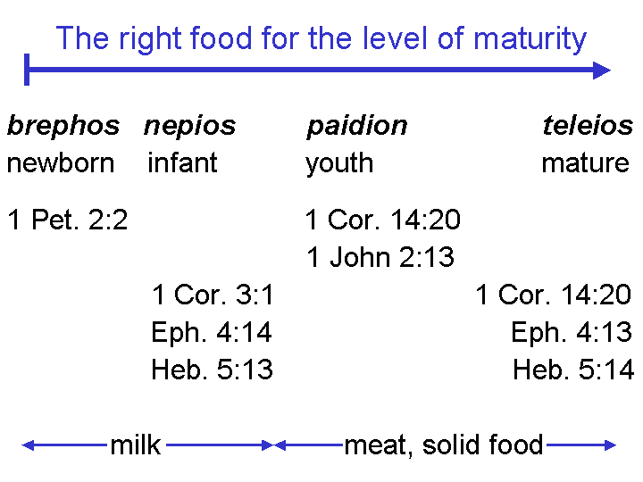
While the 1 Peter 2:2 passage in the chart to left is actually in reference to longing for the “milk of the word”, the point is that there is still a fitting comparison between milk and meat as necessary for growth at various spiritual stages. The depth of the truth being sought and taught is comparable to the food fitting physical growth at each stage of life. As we study god’s word, it is essential that we understand why we are studying, and growth from God’s word is central to the purpose for study.

1 Peter 2:2 (NASU)
…like newborn babies, long [imperative] for the pure milk of the word, so that by it you may grow in respect to salvation…

2 Peter 3:18 (NASU)
but grow [imperative] in the grace and knowledge of our Lord and Savior Jesus Christ. To Him be the glory, both now and to the day of eternity. Amen.

2 Corinthians 3:18 (NASU)
But we all, with unveiled face, beholding as in a mirror the glory of the Lord, are being transformed into the same image from glory to glory, just as from the Lord, the Spirit.

The unbeliever and the out of fellowship or immature believer have limited understanding

1 Corinthians 2:14-16 (NASU)
But a natural man does not accept the things of the Spirit of God, for they are foolishness to him; and he cannot understand them, because they are spiritually appraised. 15 But he who is spiritual appraises all things, yet he himself is appraised by no one.

1 Corinthians 3:1-4 (NASU)
And I, brethren, could not speak to you as to spiritual men, but as to men of flesh, as to infants in Christ. 2 I gave you milk to drink, not solid food; for you were not yet able to receive it. Indeed, even now you are not yet able, 3 for you are still fleshly. For since there is jealousy and strife among you, are you not fleshly, and are you not walking like mere men? 4 For when one says, "I am of Paul," and another, "I am of Apollos," are you not mere men?

Our approach must be with diligence

2 Timothy 2:15
Be diligent to present yourself approved to God as a workman who does not need to be ashamed, accurately handling the word of truth.

We start with objective observations

We examine a passage of God-given Scripture for objective facts regarding the elements of language, history and culture that fit the passage in question. In order to have confidence that those observations will provide the basis for the one singular meaning that God intended (the one correct interpretation) of the passage, our observations will fulfill the following criteria:

- The observations are complete - there is no missing information.
- The observations do not include any misinformation (mistaken ‘observations’).
- The observations do not include any from outside the context of language, history and culture.

When we have a sufficiently complete set of objective observations, we will be able to use those observations to logically arrive at the one interpretation that was the original intended meaning.

Christ, for example, proved the Sadducees quite wrong with a verb tense (Matthew 22:23-46):

Matthew 22:29-32 (NASU)
But Jesus answered and said to them, "You are mistaken, not understanding the Scriptures nor the power of God. 30 For in the resurrection they neither marry nor are given in marriage, but are like angels in heaven. 31 But regarding the resurrection of the dead, have you not read what was spoken to you by God: 32' I AM [gnomic present tense] the God of Abraham, and the God of Isaac, and the God of Jacob'? He is not the God of the dead but of the living."
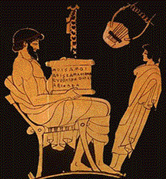

Paul appealed to the clear historical sequence of Law and Grace to convey that we live under the principle of Grace, and are no longer under the principle of Law, using the culturally understood word picture of a slave who acted as a child-training tutor (a paidagōgos – see the Greek pottery illustration of paidagōgos to the right):

Galatians 3:24-25 (NASU)

Therefore the Law has become our tutor [paidagōgos] to lead us to Christ, so that we may be justified by faith. 25 But now that faith has come, we are no longer under a tutor [paidagōgos].

We proceed, by logic, to the one correct interpretation of those objective observations

From a complete set of accurate observations, free of extraneous non-biblical observations, we can then logically draw out the one correct interpretation of the passage, which was the author’s intended meaning for the passage, and is God’s intended message. We are then able to respond to Paul’s urging that we “say the same thing” and mend, heal and restore any doctrinal differences among ourselves (1 Corinthians 1:10) – or even better, to head off any doctrinal differences altogether, and to preserve the unity of the Spirit (Ephesians 4:1-6). The unity of the Spirit does not come from allowing variation within our teachings, but centers on ‘one faith’.
Just as the observation of the facts regarding Scripture are to be objective and repeatable, so the process of interpretation is to be open, verifiable, and consistent:

2 Peter 1:20 (NASU)
But know this first of all, that no prophecy of Scripture is a matter of one's own interpretation…

Interpreting Scripture is not a veiled nor private process, nor is it to be controlled by one individual or a group. Certainly there are principles that guide the interpretation which are not enumerated here. But the key point is that God intended to convey a clear message through the approximately 40 human authors of Scripture, who were inspired by God (2 Timothy 3:16,17) and moved by the Holy Spirit (2 Peter 1:20-21). It is because God is eternally consistent (Hebrews 13:8) and The Truth (John 14:6), that we can count upon His consistency throughout the pages of Scripture. That God-intended message is singular for each passage, and consistent, when properly understood, throughout the whole of Scripture. If we are still having more than one understood message for each passage of Scripture, then we are not done with the objective observation and logical interpretation process. As Paul wrote to the church in Rome:

Romans 15:4-6 (NASU)
For whatever was written in earlier times was written for our instruction, so that through perseverance and the encouragement of the Scriptures we might have hope. 5 Now may the God who gives perseverance and encouragement grant you to be of the same mind with one another according to Christ Jesus, 6 so that with one accord you may with one voice glorify the God and Father of our Lord Jesus Christ.

Singular. These are identical words to 2 Corinthians 13:11, referenced in footnote 1, which is also singular.
homothumadon; the same word is used repeatedly of the unity of the apostles and disciples in Acts 1:14; 2:46; 4:24; 5:12; 7:57; 8:6; 12:20, 25; 18:12 & 19:29. See also Philippians 2:2.
Literally, ‘one mouth”, so it is a graphic way of conveying that the believers should ‘say the same thing’.

