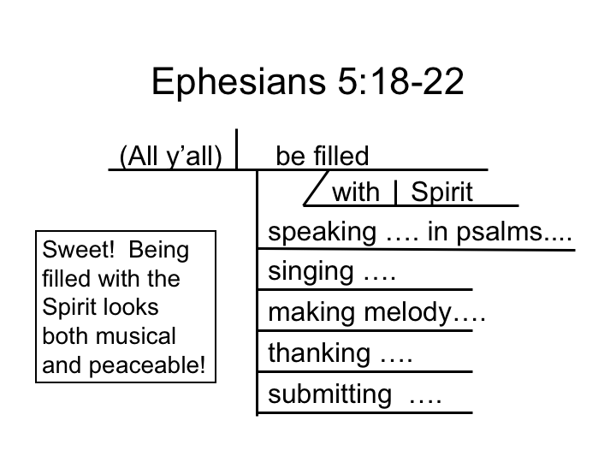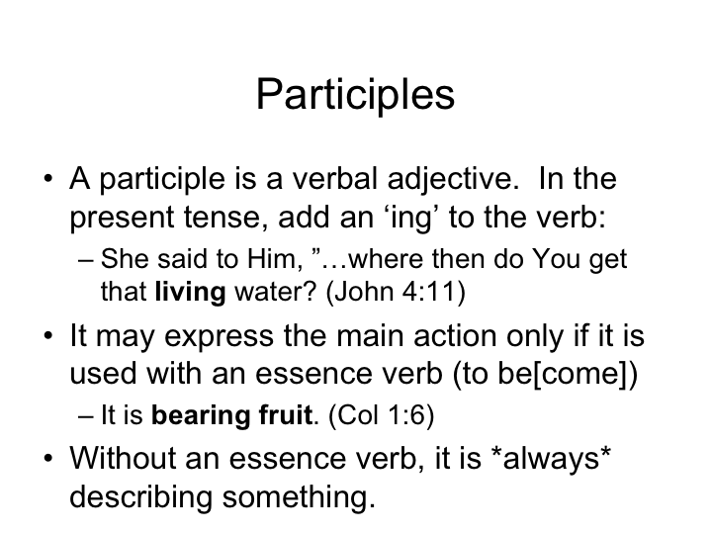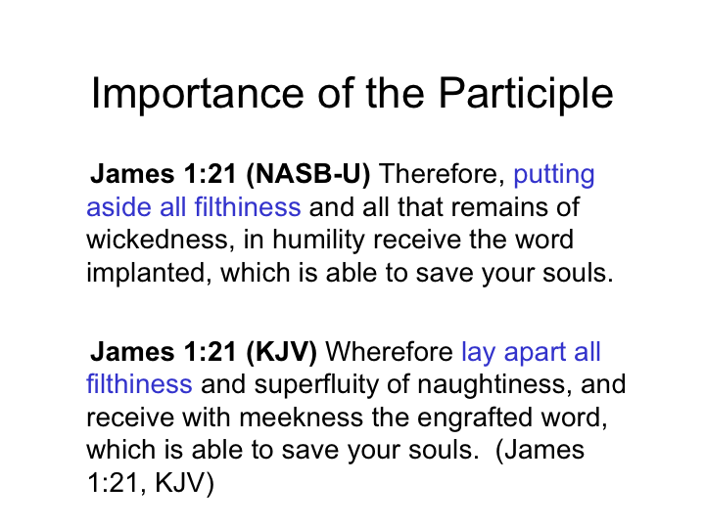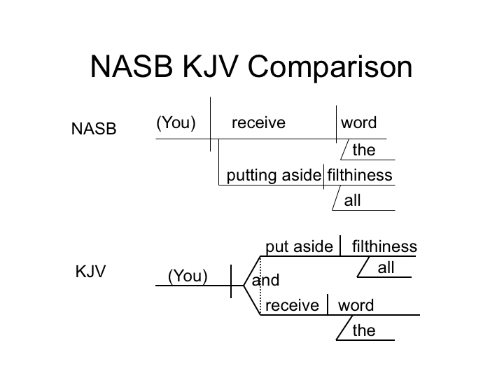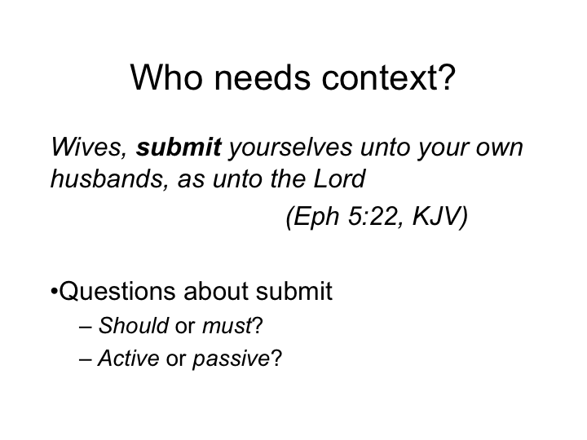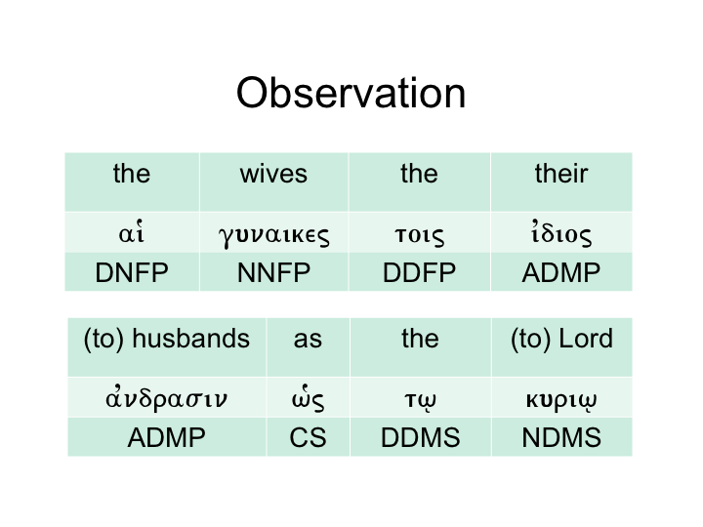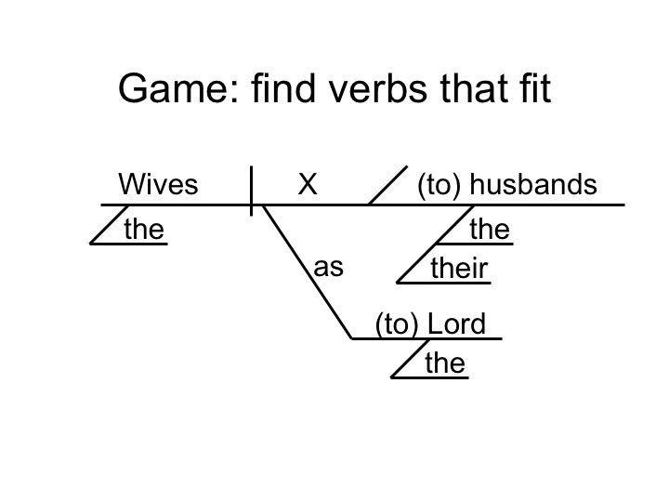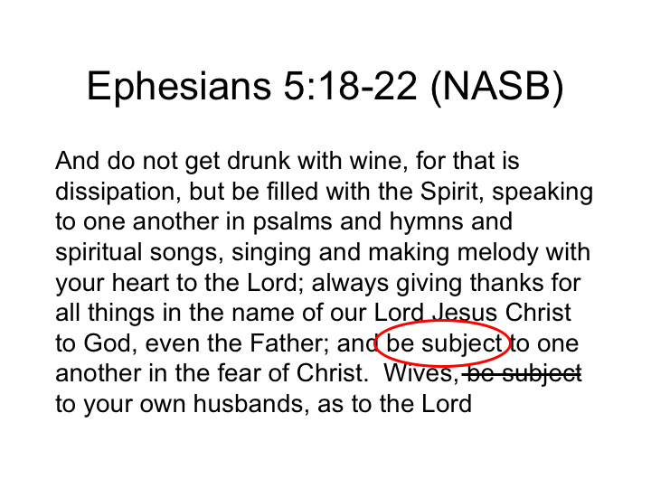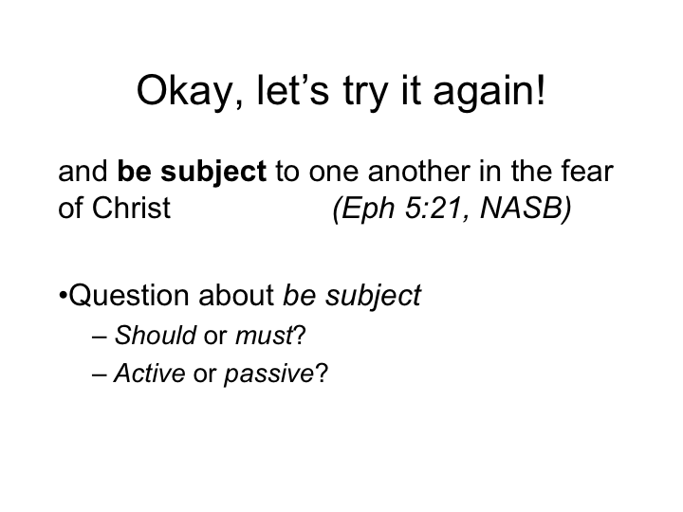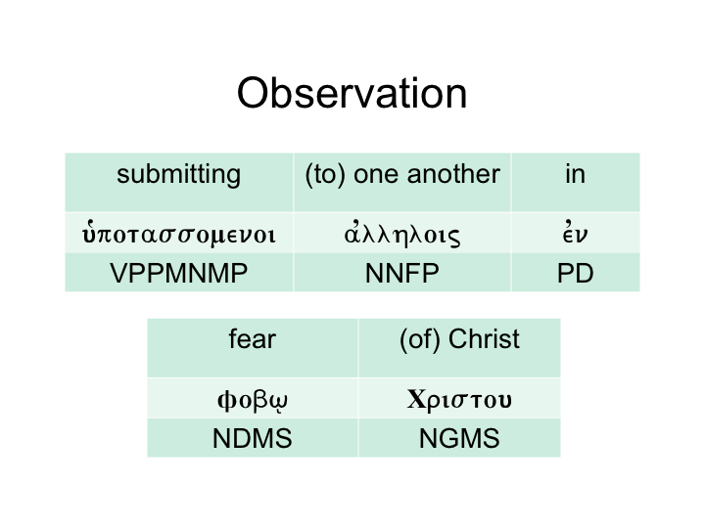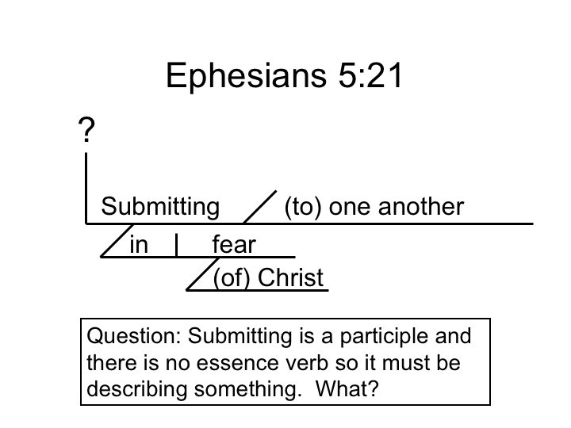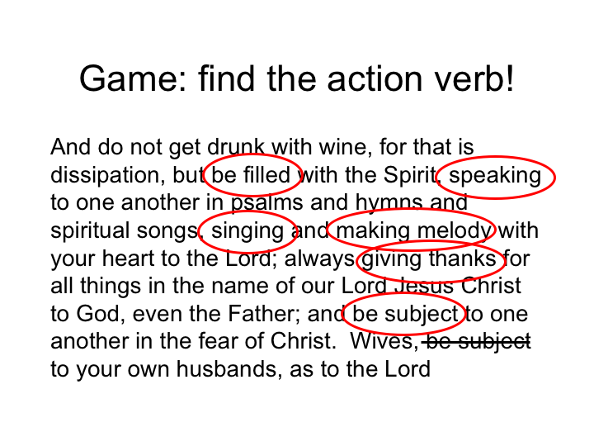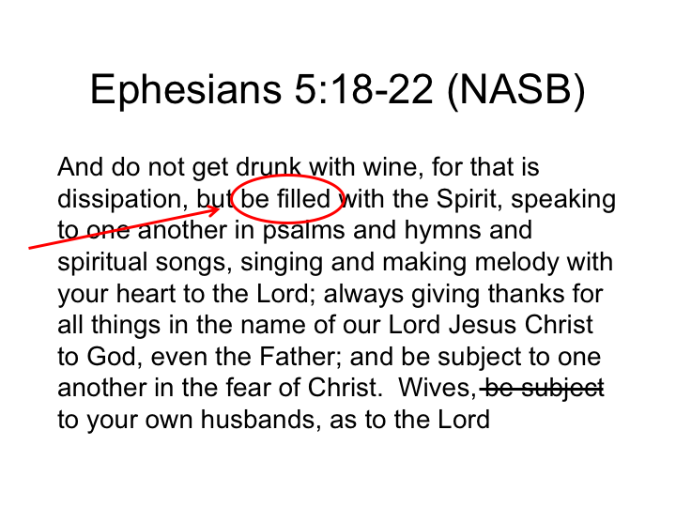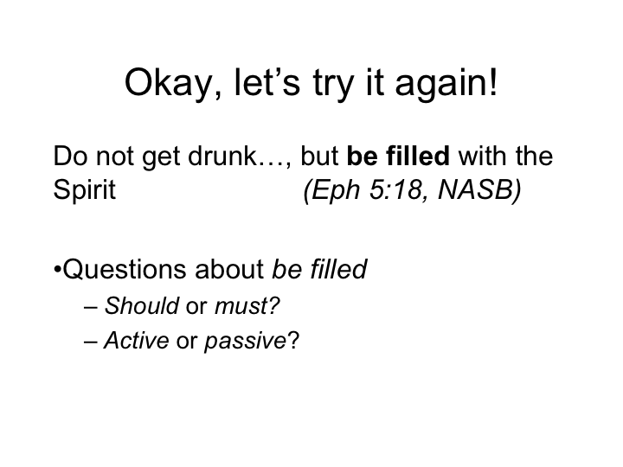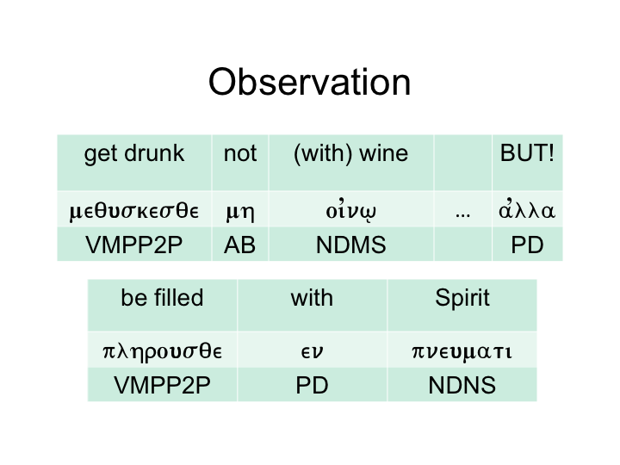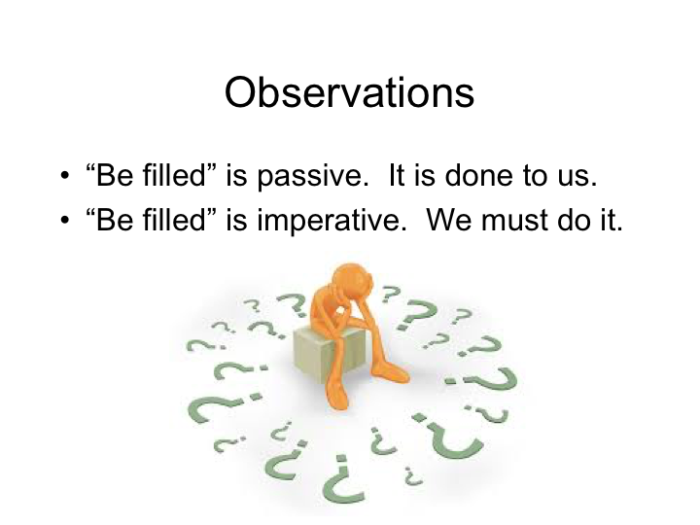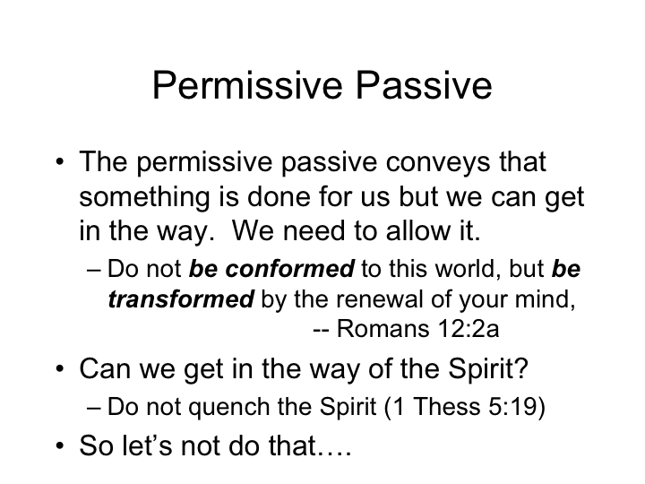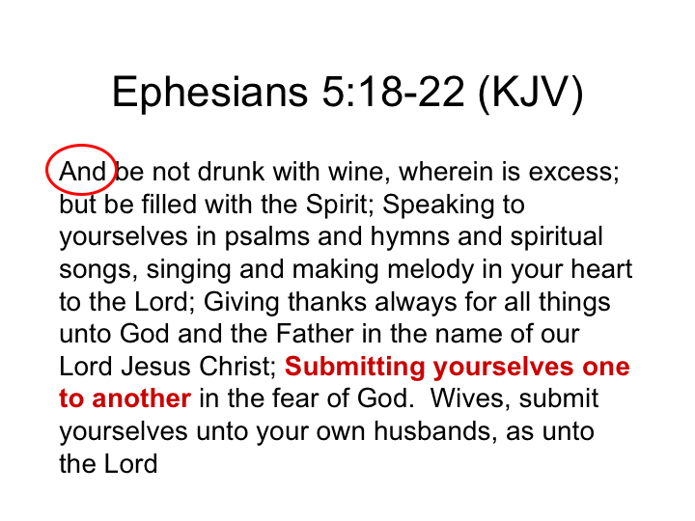
Ephesians 5:15-6:9

Walk! | Therefore be careful how you walk, not as unwise men but as wise, making the most of your time, because the days are evil. So then do not be foolish, but understand what the will of the Lord is. And do not get drunk with wine, for that is dissipation, but be filled with the Spirit,
Walk!  → Filled w/ Spirit | speaking to one another in psalms and hymns and spiritual songs, singing and making melody with your heart to the Lord; always giving thanks for all things in the name of our Lord Jesus Christ to God, even the Father; and be subject to one another in the fear of Christ.
Walk!  → Filled w/ Spirit  → being subject  Example | Wives, be subject to your own husbands, as to the Lord. For the husband is the head of the wife, as Christ also is the head of the church, He Himself being the Savior of the body. But as the church is subject to Christ, so also the wives ought to be to their husbands in everything.
Should husbands take advantage? | Husbands, love your wives, just as Christ also loved the church and gave Himself up for her, so that He might sanctify her, having cleansed her by the washing of water with the word, that He might present to Himself the church in all her glory, having no spot or wrinkle or any such thing; but that she would be holy and blameless. So husbands ought also to love their own wives as their own bodies. He who loves his own wife loves himself; for no one ever hated his own flesh, but nourishes and cherishes it, just as Christ also does the church, because we are members of His body. For this reason a man shall leave his father and mother and shall be joined to his wife, and the two shall become one flesh. This mystery is great; but I am speaking with reference to Christ and the church. Nevertheless, each individual among you also is to love his own wife even as himself, and the wife must see to it that she respects her husband.
Walk!  → Filled w/ Spirit  → being subject  Example | Children, obey your parents in the Lord, for this is right. Honor your father and mother (which is the first commandment with a promise), so that it may be well with you, and that you may live long on the earth.
Should fathers take advantage? | Fathers, do not provoke your children to anger, but bring them up in the discipline and instruction of the Lord
Walk!  → Filled w/ Spirit  → being subject  Example | Slaves, be obedient to those who are your masters according to the flesh, with fear and trembling, in the sincerity of your heart, as to Christ; not by way of eyeservice, as men-pleasers, but as slaves of Christ, doing the will of God from the heart. With good will render service, as to the Lord, and not to men, knowing that whatever good thing each one does, this he will receive back from the Lord, whether slave or free.
Should masters take advantage? | And masters, do the same things to them, and give up threatening, knowing that both their Master and yours is in heaven, and there is no partiality with Him.

