Interpreting the Book of Revelation

The book of Revelation is a wonderful, and precious book, being the one Bible book that comes with a promise of blessing for those who read it (Revelation 1:3). Revelation also uniquely describes Christ – and us! - in the heavenlies in narrative form (compare to Ephesians 1:3 and 2:6).

Author: John the apostle, who also wrote the gospel of John, as well as the three epistles (letters) of John. So far as we know, John was the last living apostle at this time.

Date and place of writing: about 95 AD, from the island of Patmos.

But there is a variety of teachings on the book of Revelation, and there are even those who have deliberately shied away from teaching or commenting on Revelation because of a supposed difficulty in understanding the book.

There is, however, no good reason for all the variations in understanding, nor for there to be confusion: Here is how were will avoid the confusion…

1) We will interpret the book of Revelation literally:

If the plain, literal sense makes sense – seek no other sense

- When the over 100 prophecies of Christ’s first coming were given in the Old Testament, they were given and fulfilled literally.

- Though Christ spoke repeatedly against the teachings of the Pharisees, he never rebuked them or argued over their literal interpretation of prophecy.

- Orthodox Jews today, based on the Old Testament alone (and about 70% of Revelation is straight out of the Old Testament), believe that:

- There will come upon the earth a terrible time of Tribulation
- The tribulation will last 7 Jewish years (of 360 days each)
- The antichrist (Armilus) will come to deceive and destroy
- At the end of the 7 year Tribulation, the Messiah will come, defeat His enemies and rule the earth from Jerusalem for a long time

How did and how does the Orthodox Jew arrive at an interpretation of the Old Testament Scriptures that lines up so closely with the outline of future events that is taught in Holly Hills Bible Church? Like most of the Jews of the time of Christ – and Orthodox Jews through today, they interpret prophecy literally, as did Christ. We will do the same here, but we will have full regard for the New Testament Scriptures, and gain insights from the New Testament that the Orthodox Jews do not.
Here are some additional principles for “interpreting literally”:

2) When John uses the word like or as – as he does over 100 times – we take that to be a simile, a comparison with the thing he uses as a comparison:
(Rev 1:16), “His face was like the sun shining in its strength.” or
(Rev 8:10) “a great star fell from heaven, burning like a torch”

3) When the text explains a symbol right in the text, we simply take John’s explanation:
(Rev 1:20) “As for the mystery of the seven stars which you saw in My right hand, and the seven golden lampstands: the seven stars are the angels of the seven churches, and the seven lampstands are the seven churches”.

4) We will examine carefully the word usage, grammar and verb tenses that John uses.

- We will examine everything in context.

- We will interpret according to history and the culture in which John wrote.
If you were to look at me with exhaustion and tell me, “I’m out of gas”, I would understand exactly what you mean in the context of our culture. John says things that similarly have to be understood in terms of his culture – as a Jewish fisherman turned apostle who had been living for over 30 years in a culture influenced by the Greeks and Romans.

The symbolism in the book of Revelation is Jewish, rather than Greek. The Greek cultural perspective looks at John’s symbolism, and asks, “What does that look like?”. The Jewish cultural perspective looks at the symbolism in Revelation and asks, “What does it mean?”. See Revelation 1:9-20, for multiple examples of Jewish symbolism.

7) We will take advantage of the fact that 70% of the book of Revelation is straight out of the Old Testament. All of those Old Testament contexts are available to us to provide insight into the meaning of passages in Revelation.

8) We will read Israel as Israel and the church as the church, and we will differentiate between the saints of the church age and the saints of the Tribulation.

9) We will take full advantage of John’s amazing consistency, such as:

- Christ is called “the Lamb” 30 times (similar to John 1:29, 36 – no other New Testament author calls Christ “the Lamb”).

- Christ is said to have a “sword in His mouth” five times, and in each case John uses the Greek word for a barbarian’s long sword (ramphaia).

- The phrase “loud voice” occurs 19 times, and the loud voice never comes from someone on the earth.

10) We will recognize that there are some things that are clearly spelled out, but will not be understood clearly as to their application until the time in which they are fulfilled. Daniel did not know the fulfillment of all the prophecies that he wrote, but those of later centuries did:

- We don’t know the time when the Lord will come to take us home, but those who become believers during the coming seven years of Tribulation will indeed understand when that time occurred.

- Some in our time may struggle to guess at the identity of the antichrist, but those believers living during the Tribulation will come to a place of certainty when the right time has come to pass.

- Sometimes the right time must come for a truth to be fully understood.

About these things we must exhibit humility – and not feel forced to understand what it is not yet time to understand.

Here are some things that we will not do as we go through the book of Revelation:

- We will not try to force everything we read to fit into current events:
This is done to hype up the passages and the people.

- We will not abuse John’s clear communication in Revelation by allegorizing his language: every major conflicting interpretation of Revelation and of prophecy in general is based on allegorizing.

- We will not set dates for the Lord’s return.

Acts 1:6-7
So when they had come together, they were asking Him, saying, "Lord, is it at this time You are restoring the kingdom to Israel?" He said to them, "It is not for you to know times or epochs which the Father has fixed by His own authority;

The original date setters were the ones Paul had to correct – when He wrote the books of I and II Thessalonians – somebody was telling the church that Christ had already come – just as some do today (they are called Preterists).

By approaching the Scriptures as God intended, we will find that the book of Revelation will be very straightforward and understandable. A number of folks have been stunned to hear us tell them: Understanding the book of Revelation is a “piece of cake”.

In The Book of Revelation, Christ Appears Mostly in Heaven

We will see the scene shifting back and forth between heaven and earth as we proceed through Revelation. Keeping this in mind will help clarify the entire message of the book, and to stay oriented as the scene shifts alternately through this book.

Scene: Revelation Passage

Heaven 1:10-20 4:1-6:1 7:1-7:17 10:1-11 11:15-12:12 15:1-8 19:1-16 20:11-22:21

Earth 1:1-1:9 2:1-3:22 6:2-17 8:1-9:21 11:1-14 12:13-14:20 16:1-18:24 19:17-20:10

Notes: ______________________________________________________________________________________ ________________________________________________________________________________________________________________________________________________________________________________________
____________________________________________________________________________________________
____________________________________________________________________________________________
____________________________________________________________________________________________
____________________________________________________________________________________________
____________________________________________________________________________________________
____________________________________________________________________________________________
____________________________________________________________________________________________

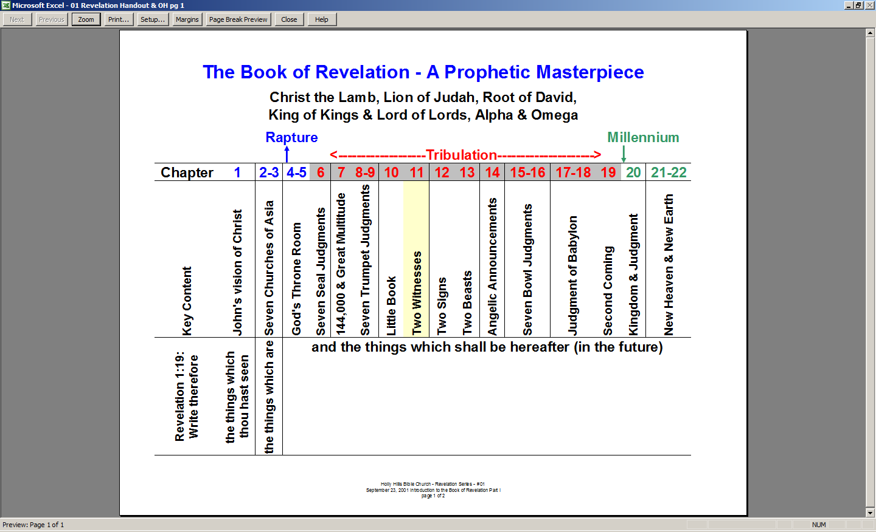

http://www.pre-trib.org/data/pdf/Ice-TheDateoftheBookofRe.pdf

