How to Study the Bible Finale

As of today we have spent 49 Sundays focusing on How to Study the Bible. Why would we do that? There are several reasons, given in Scripture itself:

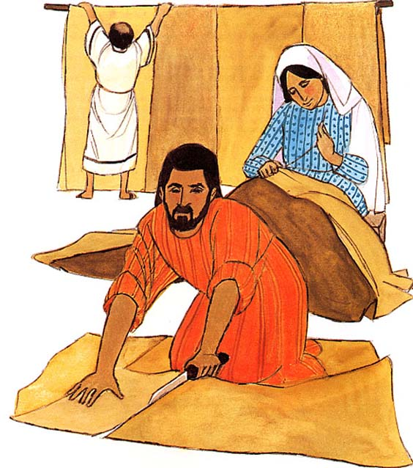
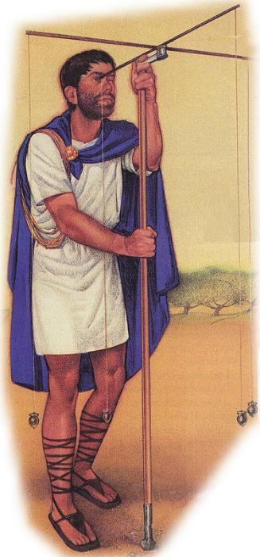
2 Timothy 2:15
Be diligent to present yourself approved to God as a workman who does not need to be ashamed, accurately handling [orthotomeo: see practical illustrations with Roman roadway engineer, and Paul with Aquila and Priscilla, making tents, to the left] the word of truth.

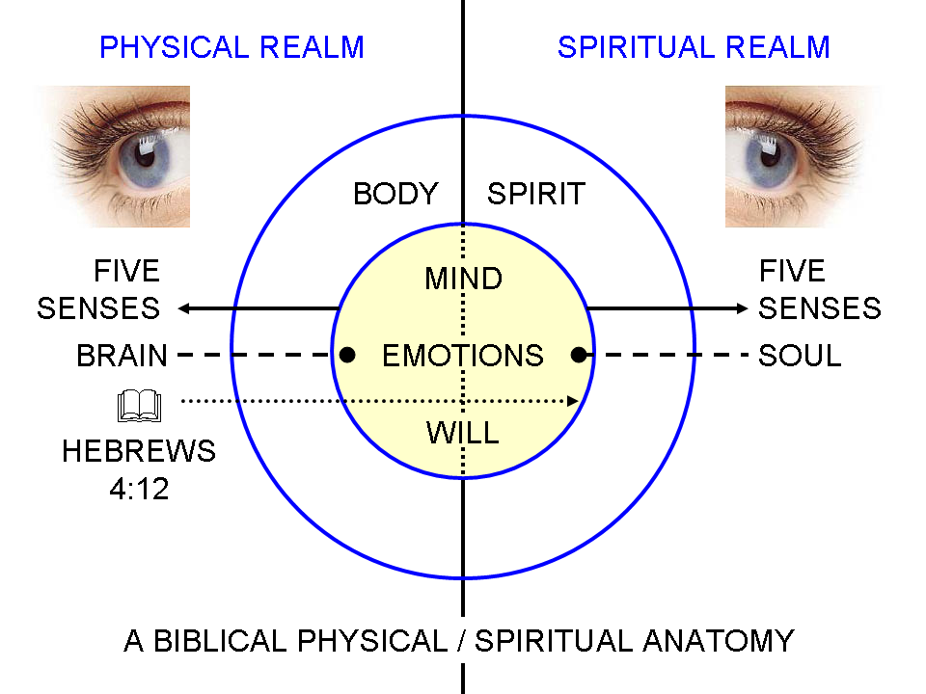
Hebrews 4:12
For the word of God is living and active and sharper than any two-edged sword, and piercing as far as the division of soul and spirit, of both joints and marrow, and able to judge the thoughts and intentions of the heart.

John 17:17 (Jesus, praying to the Father, regarding His disciples)
"Sanctify them in the truth; Your word is truth."

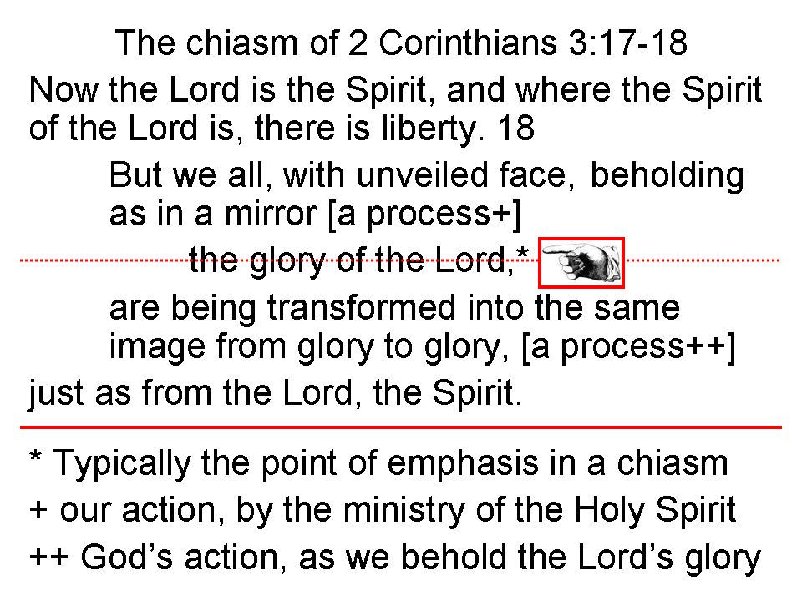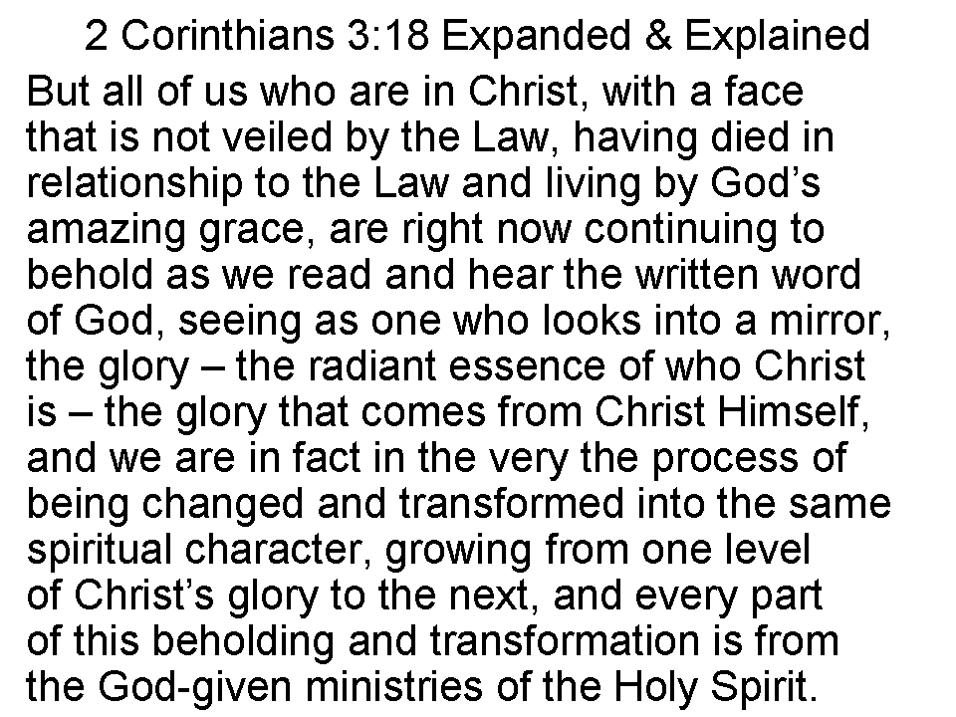

2 Timothy 3:16-17
All Scripture is inspired by God and profitable for teaching, for reproof, for correction, for training in the righteousness; 17 so that the man of the God may be adequate, equipped for every good work.

Early on, we said that the outline and sequence of studying the Bible looks like this:

Observation > Interpretation > Application > Appropriation

Over the course of the first six months of this elective we introduced principles and techniques of observation, addressing elements of language, history and culture. Then we also said that those observations need to be true and complete, before we begin to interpret.

At the beginning of the second half of this elective we introduced principles of interpretation. The central truth in these principles was literal interpretation, and even went so far as to say that if we employ consistent literal interpretation, that we don’t need any of the ‘isms’ of Christianity.

Application is written and/or spoken statements of how properly observed and interpreted Scripture applies to individual believers and their relationships, marriage and families, and to individual church bodies and relationships between church bodies. We have said that though there is one correct interpretation of a passage, there may be many applications.

Appropriation of those applications is the implementation of the applications in the life of the believer, among believers, within marriages and families, and in and among us in the body of Christ.

Once having spent about six months introducing the principles and techniques of observation, then principles of interpretation, we spent the rest of the elective time providing detailed examples of applying all of these principles and techniques of observation, as well as principles of observation to specific passages and topics or study, so that we had numerous and varying examples. The final Schedule for How to Study the Bible III, which accompanies this handout, outlines our course of study for 49 Sundays.

