Gates

We’ll find that the Bible, mostly in the Old Testament, has a few hundred references to a gate or to gates. In Biblical times – especially in the Old Testament – the gates of a city were important in several respects, and references to gates will have a significance way beyond just hardware. For example:

- To ‘possess the gate’ of a city was to possess the city entirely (Genesis 24:60).
- Many cities did not have a designated marketplace within the city, but instead had their marketplace around the gates (2 Kings 7:1).
- Official transactions were often done at city gates (Genesis 23:3 and following; Ruth 4:1 and following).
- Kings and royalty often addressed people of varying rank and status at the city gates (2 Samuel 19:8; 1 Kings 22:1; Jeremiah 17:9).
- Legal cases and judgments were often brought before officials and elders at the city gates (Deuteronomy 22:15; 25:7).
- Judgments were commonly carried out at the city gates (Deuteronomy 17:5; 22:24).
- Some larger cities had temporary prisons at the gates only to hold someone until the officials or elders could hear the case. Judgment did not include more time in the temporary prison.
- To ‘sit at the city gate’ meant to be honored (Job 29:7-8; Proverbs 31:23).
- And to enter the city gates often meant citizenship (Genesis 23:10,18).
- To ‘lift up the heads of the gates’ was an expression for opening the gates in rejoicing and welcome of someone (Psalm 24:7,9).
- Conversely, gates that sink are an expression of hopelessness, despair, and the defeat of a city (Lamentations 1:4; 2:9).
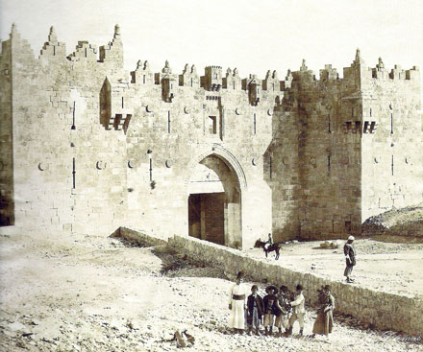
Damascus Gate, Jerusalem, 1870
So when we read about a gate or gates in Scripture, especially in the Old Testament, it may be important to read the passage and its context to determine if the mention of a gate or gates has more significance than just hardware. The context will typically be the best guide for which of the above meanings is intended.

Though this lesson is about the Old Testament, the ‘gates’ mentioned in the Gospel of Matthew and in the book of Revelation have more significance than mere hardware.

