The aorist tense in New Testament Greek

For over a century, good students of the word have been teaching things about the aorist tense in New Testament Greek such as:

- The aorist tense is the once-for-all tense
- The aorist tense conveys a past action or standing
- The aorist tense presents a past point in time
- The aorist tense presents a single discrete action
- The aorist tense states a fact

In Major Bible Themes, Chapter 19 – page 118 and Chapter 40 – page 275, for example, Romans 12:1, present is given as ‘once-for-all’. Here is a brief history of who has which of the two views on whether the aorist tense means ‘once-for-all’:

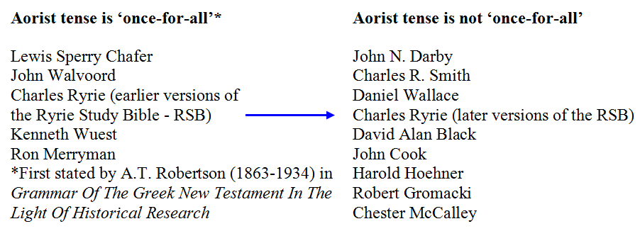

But rather than get involved in a century long technical argument, let’s instead look at a series of passages where we can rather easily see whether the aorist tense means ‘once-for-all, past tense or point in time, a single discrete action, etc.

- Matthew 22:15-22; the aorist tense is reflected in ‘render’ in verse 21
- Matthew 22:23-28; the aorist tense is reflected in ‘had’ in verse 28
- John 2:13-22; the aorist tense is reflected in ‘build’ in verse 20
- John 4:15-19; the aorist tense is reflected in ‘have had’ in verse 18
- 1 Corinthians 6:19-20; the aorist tense is reflected in ‘glorify’ in verse 20
- Ephesians 4:1-3; the aorist tense is reflected in ‘walk’ in verse 1
- Revelation 1:9-20; the aorist tense is reflected in ‘write’ in verse 19

What does the aorist tense convey in the New Testament? Simply stated, the aorist tense only refers to the past in the indicative and participle moods, but otherwise the reference to time is to be found elsewhere in the context, rather than in the aorist tense verb.

