Introduction to 1 Corinthians

Dates and Authorship
Written by the apostle Paul in 54AD on his third missionary journey from Ephesus (see: 1 Corinthians 16:8).

Paul’s Contact with Corinth
Paul visited Corinth on his 2^{nd [Acts 18:1]} and 3rd [1 Corinthians 16:1-7; 2 Corinthians 13:1-2] missionary journeys as well as at least one other time. We know that he wrote at least 4 letters to the church in Corinth. We believe we have the 2^{nd [1 Corinthians 5:9]} and 4th letters.

- Acts 18:1 - Visits Corinth after leaving Athens (c. AD 51)
- Writes the "previous letter", Sometimes calls “Corinthians A” by scholars (c. AD 53-54). See 1 Cor. 5:9
- Receives a letter from the Corinthians. See: 1 Corithians 7:1
- Writes 1 Corinthians, Sometimes called “Corinthians B” by scholars (c. AD 54-55)
- Deploys Timothy to Corinth with the second letter. AKA: 1 Corinthians
- The "painful visit" (Second visit, see 2nd Corinthians 2:1)
- The "severe letter", a third letter sometimes called “Corinthians C” by scholars (2nd 2:4)
- Writes "2 Corinthians", sometimes called “Corinthians D” by scholars (c. AD 56), evidenced by the text of 2 Corinthians that it was after “Corinthians C”
Visits Corinth a third time (see 2 Corinthians 12:14, 13:1)

History and Culture of Corinth
Corinth had been established as a Roman colony in 44BC after being mostly destroyed by war in an earlier war in 146BC. By the time Paul visited it is estimated that about 200,000 people lived there.
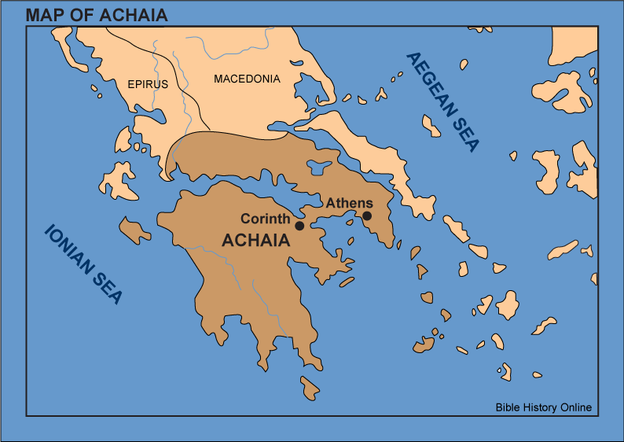

Because of Corinth’s geographical location the city was a critical commercial and trading center for Rome. A road came down through the Isthmus of Corinth and another stone paved road went from the Saronic gulf and the Gulf of Corinth. That road would have been used to have slaves haul ships or their cargo across the Isthmus.

Social Standing was a key element to Corinthian culture. There was a vast disparity between the richest members of the city and the poorest members of the city. The richest enjoyed the wealthy lifestyle that the crossroads brought into the city, and the poorest were living a subsistence living. Interactions between various groups to maintain or develop social standing included a few common behaviors:

- seeking human wisdom to be smarter than everyone else, this would have often come with oratory to show you’re superior
- public displays of generosity to show you’re superior
- lawsuits to show you’re superior
- Putting down the poor to imply that you’re superior

Ethnicity would have been critical as well given that Rome was the dominant political power and their establishment of citizens there as a colony would have made Roman citizens as powerful. Due to the Greek history both Latin and Greek were spoken. In addition there were a strong and established group of Jewish citizens (see 1 Cor. 10:1-4). These Jews were more than likely of the Pharisees given that the Pharisees were more evangelistic.

Pagan idolatry would also have been critical to the culture due to the both Roman mystery cults, myths and Greek mythical system as well as the various world religions such as Egyption mythology that would have passed through the trading crossroads. The crumbling temple to Aphrodite, the goddess of love, was located in Corinth and temple prostitution (See 1 Corinthians 11:1-10) would have been common as well in the area temples to Apollo, Hermes, Venus, Isis, and Demeter.

Sexual immorality was not limited to temple prostitution and all sorts of perversity was common in the city. Paul’s letters are not shy in addressing these things (See: 1 Corinthians 5:1-13, 6:9-11, 7:8-16). Sexual deviance crept into the church and brought negative attention and outsiders questioned the validity of the church because the things preached and the things practiced were inconsistent (1 Corinthians 5:1-8).

Key Arguments
1 Corinthians (and 2 Corinthians) are focused on addressing questions and issues that the church had raised or that Timothy had raised or passed along. The letter alternates topics from sources, but answers issues that Paul wants to address. It is focused on practical living of the Christian life in the face of a culture that was raunchy, deceitful, political, and radically divided. Paul reminds the believers of identification truths and that they were placed in Christ (1:1-3), leading with the establishing of the outcome of their faith and then correcting the error and answering questions.

Paul focuses on the critical nature of the crucifixion of Christ in the gospel message (1:13, 1:23, 2:2) as well as the resurrection (15) and addresses the whole nature of his relationship with them based on his delivery of that message. While he is an apostle, his focus is on salvation and the sanctification that comes after that. He does not focus on his role as his authority alone, which would have been counter-culture for the Corinthian readers.

Paul also addresses wisdom from God (2:6-13) vs. human wisdom (3:18-20). If acquiring human wisdom was a priority in the Corinthian culture Paul puts forth a critical analysis of its roots and does not suffer the very foundation of secular thinking that would have been a building block for social standing.

The letter hits on gender roles (ex. 1 Corinthians 6:9-11, 11:1-18) and sexual deviance that were intertwined within the culture. He seeks to draw the believers to a proper understanding of their intimate relationships with one another based on biblical principles as well as responding to the secular thinking at the time and those coming out of sexual sins.

Arrogance (4:7, 18-21), division (1:10-11) and social standing (12:12-31) are hit upon to draw out the value of Godliness through the Spirit over carnality and pride.

Outline
- Salutation (1:1-9)
  - Greetings (1:1-3)
  - Thanksgiving (1:4-9)
- Divisions in the Church (1:10–4:21)
  - The Fact of Divisions (1:10-17)
  - The Causes of Division (1:18–4:13)
    - Faulty View of the Christian Message (1:18–3:4)
    - Faulty View of Christian Ministry, Ministers and Sanctification (3:5–4:5)
    - Faulty View of the Christian’s Blessings (4:6-13)
  - The Cure for Divisions (4:14-21)
    - Imitation of Paul (4:14-17)
    - Rebuke of Arrogance (4:18-21)
- Disorders in the Church (5:1–6:20)
  - Failure to Discipline an Immoral Brother (5:1-13)
  - Failure to Resolve Personal Disputes (6:1-11)
  - Failure to Exercise Sexual Purity (6:12-21)
- Difficulties in the Church (7:1–14:40)
  - Concerning Marriage (7:1-40)
    - Conjugal Duties and Celibacy (7:1-9)
    - Divorce (7:10-24)
    - Marriage and Ministry (7:25-38)
  - Concerning Christian Liberty (8:1–11:1)
    - Eating Meat Offered to Idols (8:1-13)
    - Paul’s Personal Example: Restricting his Rights (9:1-27)
    - Israel’s Failure as an Example to Believers (10:1-13)
    - Eating Meat in Pagan Temples (10:14-22)
    - The Principles Applied (10:23–11:1)
  - Concerning Order in the Church (11:2–14:40)
    - Gender Roles & Women leaving temple prostitution (11:2-16)
    - Carnality at the Lord’s Table (11:17-34)
    - Diversity in Worship Roles because of Spiritual Gifts (12:1–14:40)
      - The Necessity of Diversity of Gifts (12:1-31a)
      - The Priority of Love over the Gifts (12:31b–13:13)
      - The Priority of Prophecy over Tongues (14:1-40)
- Doctrinal Correction of the Church Regarding the Resurrection (15:1-58)
  - The Evidence for Christ’s Resurrection (15:1-11)
  - The Necessity of Christ’s Resurrection (15:12-28)
  - The Proof of Believers’ Resurrection (15:29-34)
  - The Nature of the Resurrection Body (15:35-49)
  - The Assurance of Resurrection (15:50-58)
- Conclusion (16:1-24)
  - Instructions on Giving (16:1-4)
  - The Travel Plans of Paul and Timothy (16:5-11)
  - News about Apollos (16:12)
  - Final Exhortations (16:13-18)
  - Final Greetings (16:19-24)

Closing Thought
Much of what the church at Corinth was facing is alive and well in the American church and culture. Our society and churches are divided, chasing class standing, financial resources have caused all sorts of divisions due to successful trade, sexual immorality is rampant, genders are confused, and we don’t understand the practical application of love and order. This book is very relevant to us as we seek to live the Christian life.

Modified from the outline from https://bible.org/seriespage/7-1-corinthians-introduction-argument-and-outline#_ftn20

