Introduction to knowing & growing

Over this next year, should our Lord not come for us first, we will be covering three subjects:

- Knowing the Lord, from January through March
- What God is doing in the life of the believer, from April through September
- What God is doing in the life of the church body, from October through December

So, the title ‘knowing and growing’ is about how we know the Lord, both when we first come to believe, and throughout the rest of our lives. And the ‘growing’ part is both about the various processes God intends in individual believers, and about the growth of the church body. Everything we will be exploring in this elective will be focused what the word of God says on these very important subjects.

Knowing the Lord

In ‘knowing the Lord’ we will start with the gospel of salvation, talking about the content of the gospel, and that salvation is by grace through faith. Once we believe the gospel God implements a number of radical spiritual changes in the believer.

After our introduction to the Lord upon believing the gospel, God not only brings about a number of radical spiritual changes, but He also brings about a number of ways for us to know Him progressively – more and more. In our exploration of how we get to know the Lord more and more we will be investigating what these passages reveal about our continuing to know the Lord more and more:

John 14:16-17; 17:1-5 | “…the Spirit of truth…you know Him…”  "This is eternal life, that they may know You…”
Philippians 3:7-11 | “…that I may know Him…”
John 15:1-9 | “Abide in Me…”
1 Corinthians 1:4-9 | “…you were called into fellowship with His Son…”
2 Corinthians 3:12-18 | “…beholding as in a mirror the glory of the Lord…”
Galatians 2:19-21 | “…I live by faith in the Son of God…”
Galatians 5:16-26 | “…walk by the Spirit…” “walk by the Spirit”
Ephesians 4:11-16 | “…the knowledge of the Son of God…”
2 Peter 1:1-3; 3:17-18 | “…in the knowledge of God and of Jesus our Lord”  “…but grow in the grace and knowledge of our Lord and Savior, Jesus Christ…”
1 John 5:20 | “…so that we may know Him who is true…”

We will find that all of these passages are describing different aspects of the same thing: our ongoing fellowship with and dependence upon and intimacy with the Lord. In these things, we are progressively coming to know the Lord more and more.

So, is there a termination point where we know the Lord in an absolute and final sense, and in which we are no longer getting to know the Lord more and more? The short answer is, “No.” But there are a few different ways in which we can arrive at that answer:

1) The apostle Paul, who wrote many of the passages we’ll be examining, put it this way when he wrote to the church at Philippi:

Philippians 3:10
…that I may know Him and the power of His resurrection and the fellowship of His sufferings…

Since Paul looked upon knowing Christ as something still in progress after about 25 years of being a believer, and having the Lord meet with him personally, it is clear that Paul did not see knowing the Lord as an accomplishment or having already been completed.

2) Once this life is over, and we have passed into eternity, God will show us His multiple massive magnitudes of grace on into the rolling ages to come.

Ephesians 2:4-7
But God, being rich in mercy, because of His great love with which He loved us, 5 even when we were dead in our transgressions, made us alive together with Christ (by grace you have been saved), 6 and raised us up with Him, and seated us with Him in the heavenly places in Christ Jesus, 7 so that in the ages to come He might show the surpassing riches of His grace in kindness toward us in Christ Jesus.

One does not get the impression that His showing us His grace will come to be monotonous!

3) God is an infinite God, so that while what He has revealed to us is indeed true, and we can experience His truth as we live life in fellowship with the Lord, we can never exhaust coming to know Him, the infinite God of love and grace.

What God is doing in the life of the believer

In April, we will examine what the Bible says about the spiritual anatomy of a believer compared to an unbeliever. See an example of the spiritual anatomy of a believer on the top of the next page. One reason for doing this first is to understand what has been changed from the unbeliever to the believer, and the other reason for examining the believer’s spiritual anatomy is to understand what is not changing and to understand what God’s processes are changing. In understanding our spiritual anatomy we will see what
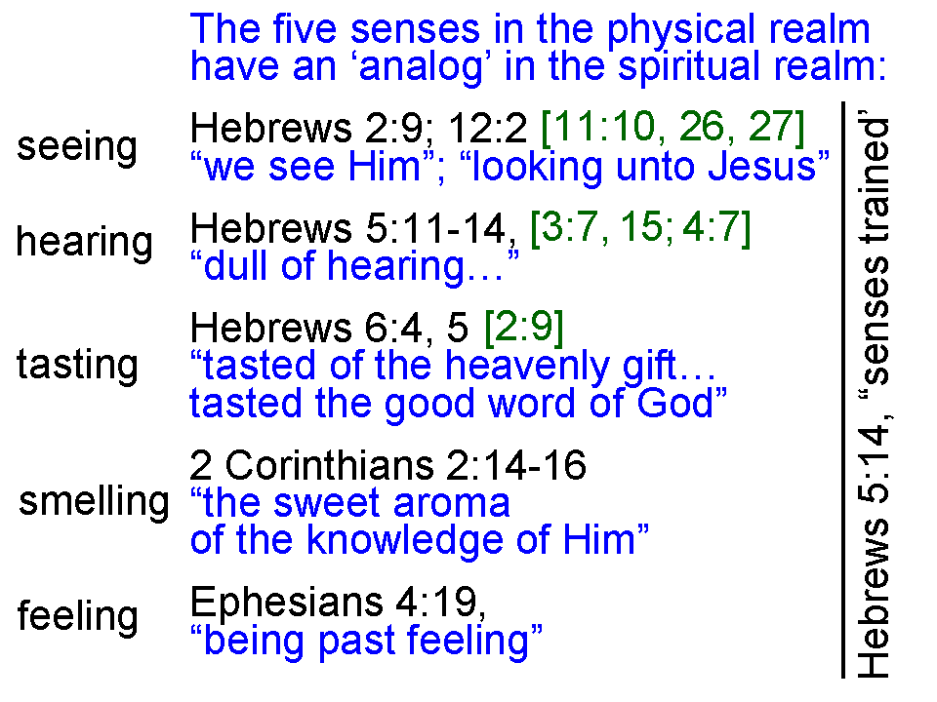
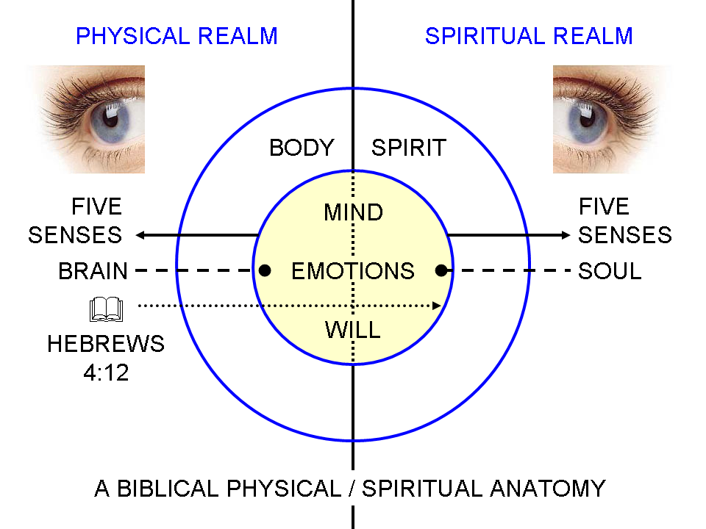

the Bible says about our having been in Adam and our now being in Christ, and what part of us is saved, and what parts are not saved.

From May through September we will examine carefully the processes God intends for the believer through the course of life:

- Being conformed (Romans 8:28, 29)
- Being transformed (2 Corinthians 3:18)
- Growing (1 Peter 2:2; 2 Peter 3:18)
- Sanctification (Hebrews 10:14)
- Discipleship (John 15:1-9; Ephesians 4:20-24)

The general pattern we will use in each of these is to take this approach;

1) Introduce each process
2) Explain God’s part
3) Explain the believer’s part
4) Bring each of those together

We will find that there is some crossover between the ‘knowing the Lord’ part of the elective and the what God is doing in the life of the believer part. We will discover why as we proceed. As we examine all that is involved in knowing the Lord and the processes that God has in place, we will come to discover that God does not waste anything. Everything that is going on and all of God’s intended inputs into the believer’s life are designed to prepare us for ministry and to prepare us for eternity.

What God is doing in the life of the church body

With all of what God has done and is doing so that each believer is knowing the Lord progressively, and being conformed and transformed into the image of Christ, and growing, and being sanctified and discipled, it is amazing that God has an intent for the church which includes each individual, but also the entire church body. This has special aspects, ministries, gifts, etc. that include but go beyond what God has in mind for each individual believer. Some of the topics for this part of the elective will include:

- The Universal Church & the Local Church
- The Purpose of the Church
- Baptism & The Lord’s Table
- Elders & Deacons
- Spiritual Gifts
- Church Discipline
- Biblical Worship
- Christian Education
- Selecting a Church, Why Stay at a Church, & When to Leave It

There are multiple things about the local gathering of the body of Christ which go well beyond what God intends for each individual within the body of Christ. We will explore what God intends for the body of Christ.

