John 14:16-17 & 17:1-5

John chapters 13 and 14 contain truths from Christ to prepare His disciples for their coming ministry as apostles, in the establishing and growth of the church, and for the authoring and sponsoring of Scripture. John chapters 15 and 16 are also truths from Christ to prepare His disciples for their coming ministry as apostles, and these chapters contain words given while Christ was on the way to the Garden of Gethsemane or possibly already having arrived there. But in chapter 17, Christ’s prayer to the Father while Christ was in the Garden of Gethsemane. Jesus prayed for Himself, and for His disciples, soon to be apostles, and for us, who would believe because of the message of the apostles. Let’s take a look at these two passages to see what Christ has to tell us about ‘knowing the Lord’.

In the Upper Room at the Last Supper

John 14:16-17
"I will ask the Father, and He will give you another Helper, that He may be with you forever; 17 that is the Spirit of the truth, whom the world cannot receive, because it does not see Him or know Him, but you know Him because He abides with you and will be in you.

So by what means will the Helper come here to minister to the apostles and the church?

John 14:26
"But the Helper, the Holy Spirit, whom the Father will send [future active indicative] in My name…

John 15:26
"When the Helper comes, whom I will send [future active indicative] to you from the Father, that is the Spirit of truth who proceeds [present middle indicative] from the Father…

John 16:7
"But I tell you the truth, it is to your advantage that I go away; for if I do not go away, the Helper will not come [future middle indicative] to you; but if I go, I will send [future active indicative] Him to you.

Which person of the Trinity has the final say in the Holy Spirit’s coming? Are the three persons of the Trinity of differing opinions on the Holy Spirit’s coming? Is the Holy Spirit going to come reluctantly? What names of the Holy Spirit are given in John chapters 14, 15 and 16?

John 15:26
"When the Helper comes, whom I will send to you from the Father, that is the Spirit of the truth who proceeds from the Father, He will testify about Me,…

John 16:13
"But when He, the Spirit of the truth, comes, He will guide you into all the truth; for He will not speak on His own initiative, but whatever He hears, He will speak; and He will disclose to you what is to come.
Drawing from all of theses passages, what are the things that the Holy Spirit will do when He comes, which we now know was on the day of Pentecost (May 24, 33 AD)? Are there other things that the Holy Spirit will do in and among church age believers that are not included in these quotes, but are in the passages from which these quotes are taken? Are there still yet more things that the Holy Spirit does that are not in these passages?

Going back to John 14:16-17, what is meant by ‘see Him’?

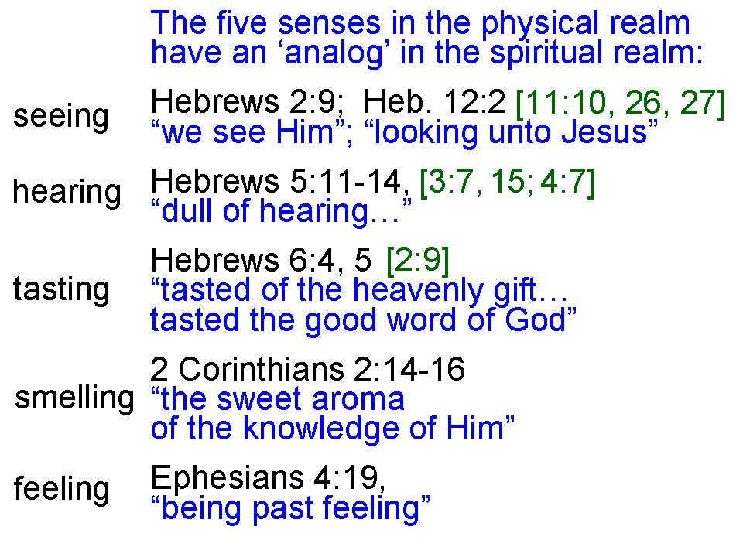
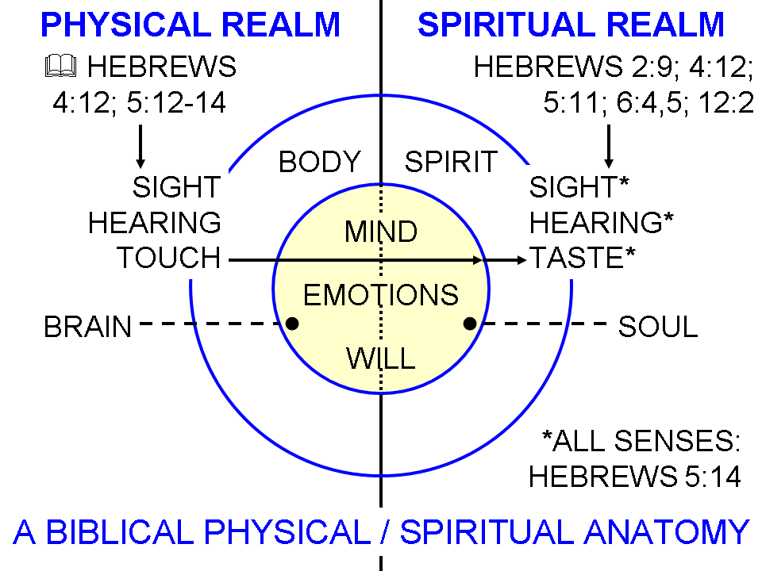

And what is meant by ‘know Him’[the Holy Spirit; John 14:17]? Can we know the Holy Spirit independent of and without knowing God the Father and God the Son? Is knowing the Holy Spirit exactly the same as knowing God the Father and God the Son?

What did Jesus mean by “…you know Him because He abides [present tense] with you and will be [future tense] in you?”

Jesus’ High Priestly Prayer in the Garden

As we said earlier, in John chapter 17, Christ’s prayer to the Father while Christ was in the garden of Gethsemane. Jesus prayed for Himself, and for His disciples, soon to be apostles, and for us, who would believe because of the message of the apostles.

John 17:1-5
Jesus spoke these things; and lifting up His eyes to heaven, He said, "Father, the hour has come; glorify Your Son, that the Son may glorify You, 2 even as You gave Him authority over all flesh, that to all whom You have given Him, He may give eternal life. 3 "This is eternal life, that they may know You, the only true God, and Jesus Christ whom You have sent. 4 I glorified You on the earth, having accomplished the work which You have given Me to do. 5 "Now, Father, glorify Me together with Yourself, with the glory which I had with You before the world was."

Jesus tells the Father ‘the hour has come’. In Matthew 26:18; John 2:4; 7:6 & 8 Jesus had said that His time or hour had not yet come. But now, it has. This is the time or hour in which the fulfillment of the eternal covenant will come about (Hebrews 13:20).
So what did Jesus mean by, ‘…glorify Your Son, that the Son may glorify You…’?

Likewise, what did Christ mean by (paraphrasing), ‘All whom the Father had given Christ, Christ may in turn give eternal life’?

‘This is eternal life, that they may know You, the only true God, and Jesus s Christ, whom you have sent’.

Who is ‘You, the only true God’?

‘And Jesus Christ, whom You have sent.’ Between John 14:16, 17 and John 17:1-5, are we to know all three person of the Trinity? Is that a ‘once for all knowing, finished at the outset’, or is it ‘progressive throughout the believer’s life’?

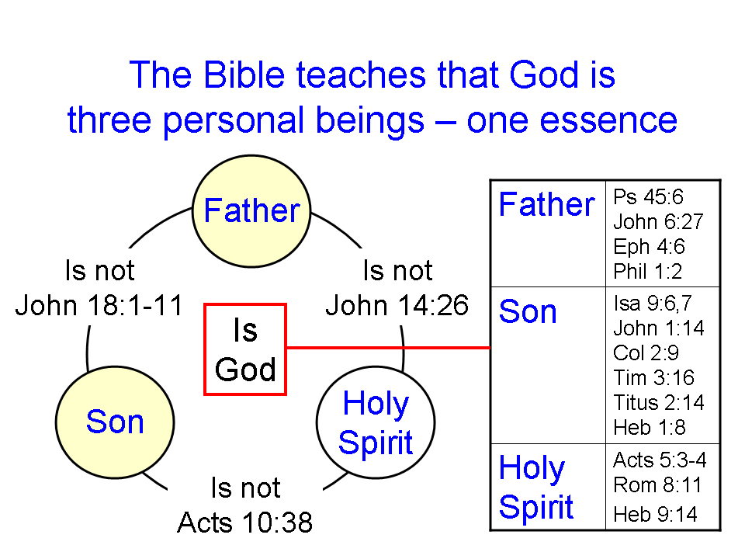

Does the glory and glorifying that Jesus prayed about in verses 1, 4 and 5 have anything to do with knowing the Father and the Son?

