Galatians 5:16-26 & Context

In the mini-series we’re calling ‘Knowing the Lord’, which extends from January through March of this year, we’ve included selected passages from the New Testament. In this mini-series, we will include passages that address our individually knowing the Lord, as well as passages that address our knowing the Lord corporately – together as a church body. Both dimensions and magnitudes of growth have an introductory and positional aspect, first impacting those who believe in order to be saved, as well as ongoing and progressive growth that is designed and intended throughout the Christian life. For that, and relevant to this passage, we will quote Galatians 5:13-6:1, but focus primarily on Galatians 5:16-18, and 5:22-26. We will include, but not focus upon the works of the flesh. This passage talks about the living out of our knowing the Lord, both individually, and together as a church body. Tucked within it are some ‘best kept secrets’ about knowing the Lord and what that looks like as the Christian’s life is lived out.

Galatians 5:13-15 (NASU, with notes & adjustments)
For you were called to freedom, brethren; only do not [imperative] turn your freedom into an opportunity for the flesh, but through love serve [imperative] one another. 14 For the [requirements of the] whole Law [regarding relationships with others] is fulfilled in one word [that is, one message], in the statement, "You shall love your neighbor as yourself." 15 But [alla; in sharp contrast] if you bite and devour one another [assumed to be true], take care [imperative] that you are not consumed by one another.

The apostle Paul had been addressing this church body with strong warnings about a false gospel, the unity of the apostles and others in authority, the basis for Paul’s teaching, and multiple strong warnings about putting themselves under the Law of Moses. The outcome of putting themselves under a false gospel and the Law of Moses was to ‘bite and devour one another’, as we see in Galatians 5:15.

The righteousness of ‘the whole law regarding our relationships with others’ is summed up in “You shall love your neighbor as yourself”, which is from Leviticus 19:17, 18. That verse is quoted or made reference to in Matthew 5:43; 19:19; 22:39; Mark 12:31, 33; Luke 10:25-37, Romans 13:8, 9, 10; 15:2; 1 Corinthians 10:24; Galatians 5:14, Ephesians 4:25; James 2:8 and 4:12. The whole quote as referenced in Mark 12:31 is:

Deuteronomy 6:4-5 (regarding one’s relationship with God)
"Hear, O Israel! The Lord is our God, the Lord is one! 5 You shall love the Lord your God with all your heart and with all your soul and with all your might."

Leviticus 19:17-18 (regarding one’s relationship with other people)
'You shall not hate your fellow countryman in your heart; you may surely reprove your neighbor, but shall not incur sin because of him. 18 You shall not take vengeance, nor bear any grudge against the sons of your people, but you shall love your neighbor as yourself; I am the Lord.'

So that brings us to the focal points of our passage, which are Galatians 5:16-18 and 5:22-26. These passages take us to the living out of our knowing the Lord, both individually and together as a church body.

Galatians 5:16-18 (NASU, with notes & adjustments)
Then I say, by Spirit walk [imperative], and you will not carry out the desire of the flesh [sarx; the sin nature as it operates through the body]. 17 For the flesh sets its desire [epithumeo] against the Spirit, and the Spirit [implied epithumeo] against the flesh; for these are in opposition to one another, so that you may not do [live out] the things that you please [will]. 18 But if you are led by the Spirit [assumed to be true], you are not under Law.

The believer must individually walk, step by step, by the divine character and full set of ministries of the Holy Spirit, and in so doing will not carry out the desire of the flesh – the sin nature as it works through the human body, using the human body as its military instrument (Romans 6:13). It is 100%, and not 50 – 50 or any mixture of one or the other. It is not a ‘grayscale’ matter at all. There will be absolutely no compromise, nor getting along, nor negotiation, nor truce between the Holy Spirit and the flesh – the sin nature as it operates in the body of the believer. There will be absolutely no ‘fixing up the flesh’ so that it is more compatible with the Holy Spirit.

The last part of Galatians 5:17 is among the best-kept secrets in all of Christendom! You, as a believer, are never – not ever - in a place of simply willing to do the right thing and willing not to do the wrong thing! Romans 7:15-21 says the exact same thing, using the exact same word for ‘will’, and the Law does not help at all – not even one of them, and not even one of the ten commandments! Why? Because the primary and essential first decision on the part of the believer is to will which spiritual entity is in charge. Any other understanding of the place of the will of the believer is total foolishness!

If a believer is led by the Spirit, and that is assumed to be true (see Romans 8:14), then neither the Law of Moses nor any principle of law has anything to do with his walk and can make no contribution to it. Not even one law nor even a little bit of law will help! The believer is not under the Law (Romans 5:14, 15).

Galatians 5:19-21 (NASU, with notes & adjustments)
19 Now the deeds of the flesh are evident, which are: immorality, impurity, sensuality, 20 idolatry, sorcery, enmities, strife, jealousy, outbursts of anger, disputes, dissensions, factions, 21 envying, drunkenness, carousing, and things like these, of which I forewarn you, just as I have forewarned you, that those who practice such things will not inherit the kingdom of God.

While a closer look at the works of the flesh can be and is very insightful, for our purposes today we will not focus on them. Our intent today is to focus on the living out of the knowing of the Lord, and the works of the flesh are definitely not that living out of the knowing of the Lord.

Galatians 5:22-24 (NASU, with notes & adjustments)
But the fruit of the Spirit is love, joy, peace, patience, kindness, goodness, faithfulness, 23 gentleness, self-control; against such things there is no law. 24 Now those who belong to Christ Jesus have crucified the flesh with its passions and desires.

The fruit is the heart and life product of the harmonious multiple ministries of the Holy Spirit in the believer, as the believer walks, that is, ordering one’s life step by step according to a set of spiritual principles, that is, by means of the Holy Spirit. That is where the “…love, joy, peace, patience, kindness, goodness, faithfulness, gentleness, self-control…” come from. And about these heart and life qualities neither the Law of Moses nor any principle of law can contribute anything, nor gain any traction. We can learn from the Law, but we are not in the tiniest bit ‘under the law’.

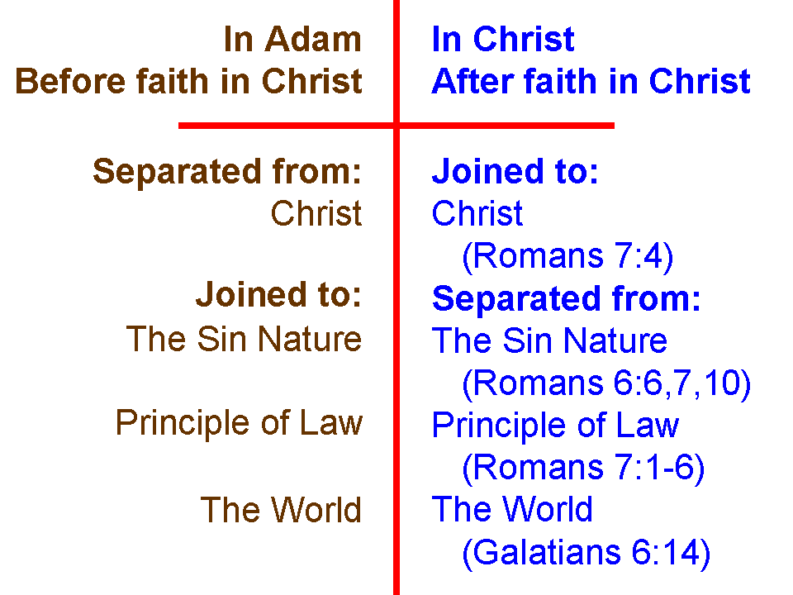
As we studied through Romans 5-8 we summarized our being ‘joined to’ and ‘separated from’ by what is shown in the inset on the left. That is a summary illustration of what it means to have ‘crucified the flesh’, and to be ‘In Adam’ and ‘In Christ’. Having crucified the flesh does not mean that the flesh is dead and gone! Having crucified the flesh means that we are dead in relationship to the flesh, such that the flesh (the sin nature, as it uses the humans body as its instrument) is not a reigning monarch.

Galatians 5:25-26 (NASU, with notes & adjustments)
If we live by the Spirit, let us also walk by the Spirit. 26 Let us not become boastful, challenging one another, envying one another.

Galatians 5:25 is often understood as simply a restatement of what Paul had already written in Galatians 5:16 – but it is not! So we’ll show them side by side, expanded, so that we can better understand what Paul wrote:

Galatians 5:16ab (NASU, with notes & adjustments)
Then I say, by Spirit walk [peripateo]…

Galatians 5:25ab (NASU, with notes & adjustments)
If we live by the Spirit, let us also walk [stoicheo] by the Spirit.

Galatians 5:16 is about the individual walking – ordering of one’s life, step by step, individually, each person ‘walking’ according to a spiritual principle or set of principles. But Galatians 5:25 uses a different word for ‘walk’, which is a word for Roman soldiers marching together in unison. Take note of Paul’s use of ‘we’ and ‘us’ in Galatians 5:25. If each one of us individually walks with the Lord, then together we will walk in harmony and in unison as a church body.
So what about the case where a believer is not walking, either individually with the Lord or together in unison with other believers – what then? Paul addresses exactly that case:

Galatians 6:1 (NASU, with notes & adjustments)
Brethren, even if anyone is caught in any trespass, you who are spiritual, restore such a one in a spirit of gentleness; each one looking to yourself, so that you too will not be tempted.

So we’ll expand this verse to express the full meaning of the text:

Galatians 6:1 (expanded & explained)
Brethren in Christ, even if anyone in the church body is caught in any single trespass, so as to have fallen off of the path of fellowship with God and other believers, you who are spiritual, that is, walking individually by the Spirit, restore and mend back to fellowship such a one in a spirit of gentleness; each one looking to yourself first and along the way, so that you too will not be tempted, and therefore also fall off the path of fellowship.

The biblical guidance, then, is for those who are walking individually by the Spirit, and in unison with other believers by the Spirit, should gently restore and mend the believer who has fallen off the path of fellowship back to a place of fellowship, so that the believer so restored and mended is back in fellowship with the Lord and with the rest of the church body. These acts of restoration and mending should not be left to be dealt with after much time has passed, nor should the acts of restoration wait until multiple issues have accumulated.

