Ephesians 4:11-16

In this series. ‘Knowing and Growing’, the first quarter has focused on ‘Knowing the Lord’. Initially, we talked about New Testament passages that speak of each believer knowing the Lord individually. Last week, in examining Galatians 5:13-6:1, we saw that Galatians 5:16 starts out with our individual walk with the Lord, but Galatians 5:25 takes that to a walk together with the Lord. This morning we’ll turn to Ephesians 4:11-16, which looks at our knowing the Lord corporately, that is, together as a church body.

In this passage, we will also see something new: spiritual gifts are commonly thought of, and rightfully so, as gifts from the Holy Spirit to individual members of the church body for the benefit of the rest of the church body. That is the message of 1 Corinthians chapter 12. But in this passage, we’re going to see that these specific spiritual gifts are Christ’s gift to the church body!

We will also see some (perhaps) surprising things in this passage, including:

- Two of the five gifts are temporary, and the other three endure until the rapture
- This passage contains a ‘triple definition’ of ‘knowing the Lord’
- God intends something to happen in a church that simply cannot happen in a classical seminary or Bible college environment
- Spiritual immaturity is defined as three different kinds of ‘vulnerability’
- Knowledge and knowing the Lord are tied closely to its working out and application in the body of Christ

Here is the whole passage we will examine in more detail, one verse at a time:

Ephesians 4:11-16 (NASU)
And He gave some as apostles, and some as prophets, and some as evangelists, and some as pastors and teachers, 12 for the equipping of the saints for the work of service, to the building up of the body of Christ; 13 until we all attain to the unity of the faith, and of the knowledge of the Son of God, to a mature man, to the measure of the stature which belongs to the fullness of Christ. 14 As a result, we are no longer to be children, tossed here and there by waves and carried about by every wind of doctrine, by the trickery of men, by craftiness in deceitful scheming; 15 but speaking the truth in love, we are to grow up in all aspects into Him who is the head, even Christ, 16 from whom the whole body, being fitted and held together by what every joint supplies, according to the proper working of each individual part, causes the growth of the body for the building up of itself in love.

Taking it one verse at a time…

Ephesians 4:11 (NASU; emphasis added)
And He [Christ] gave some as apostles, and some as prophets, and some as evangelists, and some as pastors and teachers…

‘Apostles and prophets’ is referenced as a pair of gifts or roles in the church three times in the book of Ephesians, in the same word order each time:

Ephesians 2:20
…having been built on the foundation of the apostles and prophets, Christ Jesus Himself being the corner stone…

Ephesians 3:5
…which in other generations was not made known to the sons of men, as it has now been revealed to His holy apostles and prophets in the Spirit…

Ephesians 4:11
And He [Christ] gave some as apostles, and some as prophets, and some as evangelists, and some as pastors and teachers…

See the last page (page 6) for a comprehensive chart on the spiritual gifts. The apostles (literally, ‘special messengers’), had a ‘supergift’. The ‘supergift’ of apostle was a collection of all of the other spiritual gifts, given to and expressed in each apostle. That began with the 12 on the day of Pentecost, May 24, 33 AD, until the last living apostle, John, who was called home in 96 AD, about a year after he wrote the book of Revelation.

Apostles and prophets were given to author the New Testament Scriptures, as well as to reveal guidance and truth to the churches of the first century that did not yet have the completed New Testament. That is why they were foundational (Ephesians 2:20).

And Christ gave some as evangelists, gifted to present the gospel to unbelievers, such that the unbelievers will believe and be saved. This gift is given so that the churches have people added to them by means of the evangelists, so that the gospel is presented, and the church also has continuity from one generation to the next. An evangelist is not necessarily someone who evangelizes large groups of people at once, though that may be the case among some or in some instances.

Finally, Christ gifted the church with pastors (shepherds, aka overseers, or elders) and teachers. There are a few points to clarify regarding pastors and teachers.

- A pastor (a shepherd) = overseer = elder may or may not also have the gift of evangelism
- A pastor is also a teacher, but a teacher may not be a pastor
- A believer who teaches in the secular realm may not also have the gift of teaching
- There are cultural definitions of a pastor and what he does and how he works that do not fit the biblical role of the pastor

The ministry of elders is spelled out in a variety of Scriptures, but can be summarized as follows:

- Shepherd the flock (Acts 20:28; 1 Peter 5:2), which will entail (speaking figuratively) protecting, guiding, leading, seeking out pastures and waters, selecting paths, correcting the path of some, rescuing, mending wounds and illnesses, etc. This will involve teaching, counseling, correction, consolation, training, spiritual discernment, and the like. I Peter 5:4 makes clear that this shepherding role of the elders is one of “undershepherd”, since Christ is the Chief Shepherd.
- Be an overseer (Acts 20:28; Philippians 1:1; 1 Timothy 3:1,2; Titus 1:7; 1 Peter 5:2), which will involve overlooking the character and condition of the church, taking both proactive and responsive measures to keep the church under his care in such a way as to produce a spiritually healthy and growing “flock”.
- Be on guard (and alert) for themselves and for the flock (Acts 20:28, 31)
- Be ready to take on the spiritual “wolves” who will attack the flock (Acts 20:29, 30)
- Teach, standing on and being able to discern and convey sound doctrine (Ephesians 4:11; 1 Timothy 3:2; 5:17; Titus 1:9).
- Refute doctrine that conflicts with “the faith” (Titus 1:9).
- Rule (lead, superintend) well (1 Timothy 5:17)
- Work hard (Acts 20:35)
- Help the weak (Acts 20:35)
- Other tasks which have become associated with being an elder, but can be performed by others, are conducting weddings, funerals, and memorial services, leading services, baptisms, and the Lord’s table.

So someone may have the gift of teaching that does not include much of the above-listed aspects of the role of pastor. But in both cases the content of teaching is to be based in Scripture. Here is what these people who are gifts to the church are to do:

Ephesians 4:12 (NASU)
…for the equipping of the saints for the work of service, to the building up of the body of Christ;

So the work of the service is not the pastor’s or pastors’ job, but that of the saints in the church body. Seeing it otherwise is a prelude to pastoral or pastoral family ‘burnout’.

Ephesians 4:13 (NASU; plus added emphasis and added notes)
…until we all attain to the unity of the faith, and of the (full, precise & correct) knowledge of the Son of God, to a mature man, to the measure of the stature which belongs to the fullness of (i.e., that belongs to) Christ.

Now we’re going to come to some insights that will answer questions like:

- Should I become a part of this church body?
- Or even, should I leave this church body?
- Why do we have such a thing as ‘a church’?
- How can we tell if we are doing the things a church ought to be doing?
- Are the elders being effective toward what God has assigned them?
Ephesians 4:13 (NASU; plus added emphasis and added notes)
…until we all attain to
the unity of the faith, and of
the (full, precise & correct) knowledge of the Son of God,
to a mature man, to the measure of the stature which belongs to the fullness of (i.e., that belongs to) Christ.

The words ‘…until we all attain to…’ indicates direction and goal, rather than accomplishment. Those words include ‘we all’, which says the entire church body - all the believers – are included in this direction and goal (see also ‘every person’ in Colossians 1:28). There is not some special group within the church for whom the direction and goal is to be sought, excluding others. And there are three aspects to this direction and goal for ‘we all’:

- the unity of the faith (the set of teachings of the apostles, from Acts 6 on), and of
- the (full, precise & correct) knowledge of the Son of God (complete, accurate personal knowledge of the Son of God, the second Person of the Trinity),
- to a mature man, to the measure of the stature which belongs to the fullness of (i.e., that belongs to) Christ, such that the church body together is growing toward maturity.

Ephesians 4:14 (NASU; plus added emphasis and added notes)
As a result, we are no longer to be (immature – opposite of mature) children, tossed here and there (back & forth) by waves and carried (around and around) about by every wind of doctrine (picture a ship aimlessly wandering and seasick occupants), by the trickery (cubeia – loaded dice-playing) of men, by craftiness (ready to do anything) in deceitful scheming (tending to a system of intentional errors);

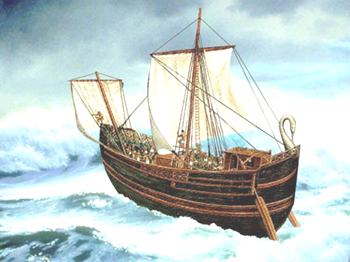
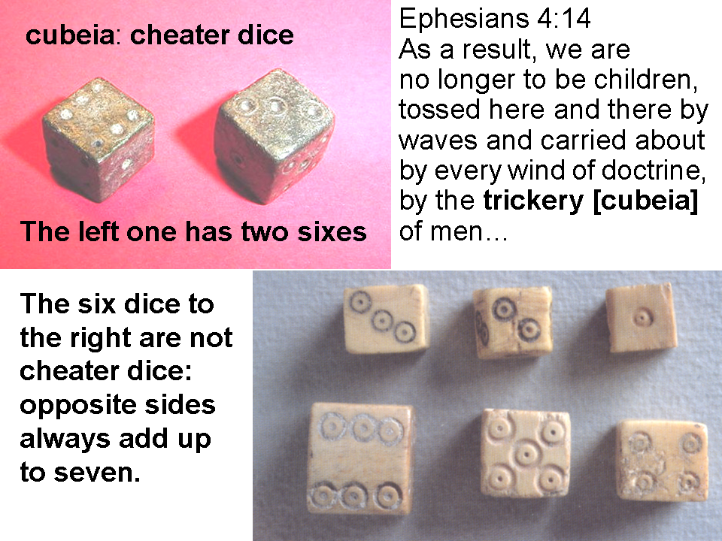

This immaturity, having a character of vulnerability, is what we are to be growing away from. Each of the three characteristics of immaturity in verse 14 are in opposing correspondence with the three directions or goals for maturity in verse 13 (doctrinal unity and stability versus doctrinal instability and doctrinal diversity, truth versus falsehood, Christ, who is the truth, who graciously gives versus deceptive men who take away).

Ephesians 4:15 (NASU; plus added emphasis and added notes)
…but (in contrast to vs. 14) speaking the truth in (agape) love (literally, “truthing in love”), we are to grow up (!!!) in all aspects into Him who is the head, even Christ…

So by ‘truthing in love’ we all are together to be growing up in all aspects – in every regard – into Christ the head of the church body. Love and truth are not at odds, with one to be chosen over the other, but love and truth are harmoniously consistent.

Ephesians 4:16 (NASU)
…from whom the whole body, being fitted and held together by what every joint supplies, according to the proper working of each individual part, causes the growth of the body for the building up of itself in love.

We can see in this verse that individual function within the church body is not at odds with the function of the whole church body, but is consistent with the rest of the body, and each part contributes to and supports the health and growth of the whole body. Though it is presented in a different way in Ephesians 4:11-16 than we saw in Galatians 5:13-6:1, we see that each individual in the church body knowing the Lord, when brought together, contributes to the church body harmoniously knowing the Lord, together and corporately. Knowing the Lord, which ought to be the focus of each individual believer, is also to be the focus of the church body as a whole, including those who shepherd and teach them.


