Introduction – What God is Doing in the Life of the Believer

Here is the anticipated schedule for this elective from April through September of this year. These topics are going to be addressed on this schedule unless unexpected events arise.

Apr No Subject

2 13 Introduction to God’s ongoing processes in the believer
9 14 Who were we - Who are we - Who are we becoming - Part I
16 -- No elective
23 15 Who were we - Who are we - Who are we becoming - Part II
30 16 Who were we - Who are we - Who are we becoming - Part III

May No Subject

7 17 Who were we - Who are we - Who are we becoming – Part IV
14 18 Being conformed - what is that process?
21 19 Being conformed – what is God doing?
28 20 Being conformed – what is the believer’s part?

Jun No Subject Teacher

4 21 Being conformed – not conformed to this world
11 22 Being transformed – what is that process?
18 23 Being transformed – what is God doing?
25 24 Being transformed – what is the believer’s part?

Jul No Subject

2 25 Being transformed – not conformed to this world
9 26 Growing – what is that process?
16 27 Growing – what is God doing?
23 28 Growing – what is the believer’s part?
30 29 Growing – conformed, transformed, & maturing

Aug No Subject

6 30 Sanctified - what is that process?
13 -- No electives
20 31 Sanctified - what is God doing?
27 32 Sanctified - what is the believer’s part?

Sep No Subject

3 33 Discipled by Christ - what is that process?
10 34 Discipled by Christ - what is God doing?
17 35 Discipled by Christ - what is the believer’s part?
24 36 God’s processes revisited

After today’s introduction, this will be the general pattern through the end of September:

For four Sundays we will talk about the ‘spiritual anatomy’ of the unbeliever, the one who believes when he first believes, and what God is changing and what God is not changing in the believer. These are titled, “Who were we - Who are we - Who are we becoming”, in four parts (Parts I-IV). Examples of what we mean by ‘spiritual anatomy’ would be:

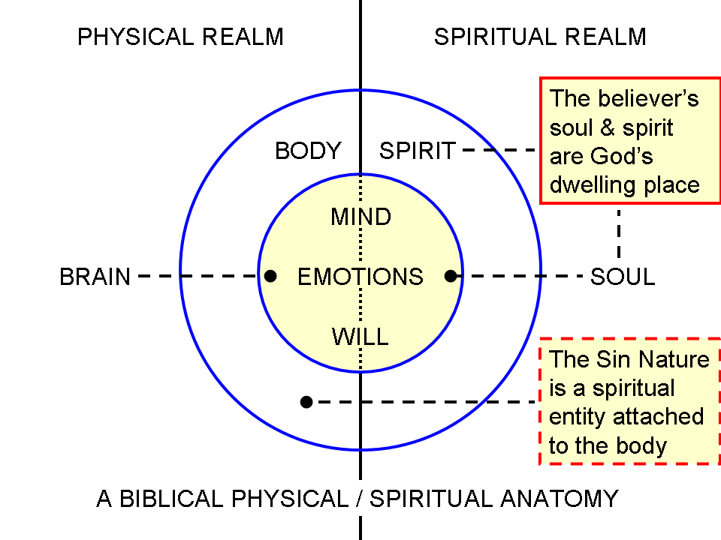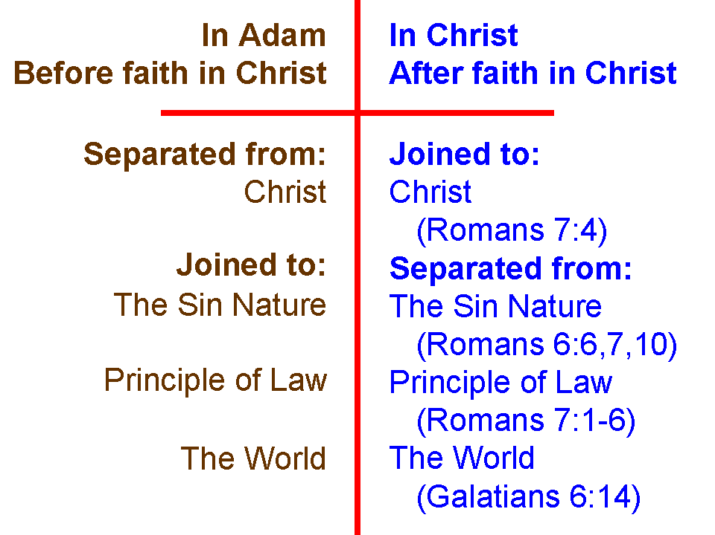

For three or four Sundays each, we will address these processes that God intends in the believer, in this order:

- Conformed
- Transformed
- Growing
- Sanctified
- Discipled

Within each of these topics, this will be the general pattern on sequential Sundays:

- What is the process?
- What is God doing?
- What is the believer’s part?

After each of these, there may be a fourth Sunday which further addresses the process or explains how the presented process interrelates with the previous process. There may also be some explanation of biblical cautions about the world’s processes, which are not intended to replace God’s processes. The reason for starting with ‘What is the process’ is to start with a clear understanding of what the biblical process is. Then, we address what God’s word says is God’s part in the process.

Next, we describe what is the believer’s part in the process. The reason for talking about the believer’s part in the process thirdly is that we want to clearly understand what the biblical process is, and is not, and then understand what God’s part is, which is most important. If God did not do His part first there would be no process at all. Only when we understand these things clearly can we respond biblically with our part in the process. The hazard, if we do not correctly understand that the process is, as biblically revealed, is to misinterpret what is happening, possibly in various ways. If we do not understand what God’s part is, then the inclination is often for the believer either to try to do all or some of God’s part (what He is already doing), or to leave to God what is the believer’s part (which God will not do). All of these things are revealed clearly in Scripture, so none of the above hazards, confusions, misinterpretations, or unwise actions or inactions for the believer are necessary at all. Also, none of this is revealed as applying to the unbeliever, who has an entirely different ministry of the Holy Spirit in his life than the believer, and God has an entirely different set of purposes for what He allows and constrains in the unbeliever’s life than He does for the believer (John 16:5-11; Acts 17:22-31).

So our purpose in this section of this elective (‘Knowing and Growing’) is to have a clear understanding of what God is doing in the life of the believer (the processes), starting with a basic understanding of his unchangeable position in Christ, and knowing what is changing through the process, and where that change is headed or directed. Once a person is saved by faith, believing that Christ died for his sins, was buried, and rose again, that person is new in kind, and has an eternal position in Christ that is untouchable, unchangeable and fixed in the heavenlies. That believer can look forward to an eternity with Christ, in a new body like Christ’s, free of pain, sorrow, or mourning. But between the time that the believer is saved by faith and the time that believer goes to be with the Lord, we could ask some questions:

- Why does the Lord have the believer still remain on the earth – why not take everyone home as soon as they become saved?

- What is God doing in the life of the believer between the time the believer is saved and the time the Lord takes that believer home?

- What part does God have in those processes and what part does the believer have?

- What part of the believer has changed in comparison to the unbeliever?

- What part of the believer does not change once the believer is saved?

- What part of the believer does change once the believer is saved, and how and why?

- What is the character and direction of the changes that take place in the life of the believer?

- Is it possible for a believer to change in ways that are not what God intends?

- Does a believer have any part in or influence upon whether or not a he or she changes in ways that God does not intend?

- Can we thwart or corrupt what God has predestined, either temporarily or permanently?

- Does how the changes take place or the degree to which they take place in the life of the believer have any impact upon that believer’s present life, and if so, what is that impact?

- Does how the changes take place or the degree to which they take place in the life of the believer have any impact upon that believer’s eternity, and if so, what is that impact?

- Is there a difference between spiritual relationship and spiritual fellowship?

- Does God care about how we live, behave, think or feel? Which of these matter the most?

- What part do circumstances have in what God is doing in the life of the believer?

- What part does God’s word have in what God is doing in the life of the believer?

- What are the words that God’s word uses for what God is doing in the life of the believer?

- How do those words differ and how are they similar?

- Does what happens on earth impact anything in eternity, and if so, what is impacted?

- What are God’s ongoing actions, ministries and provisions for us and through us, once we are saved?

In the October through December timeframe, the elective will move to ‘What God is doing in the life of the church body’. The schedule for that will be developed later on, but will be along the lines of the elective, “God’s Intent for the Church”, which was offered over a decade ago at HHBC.

