Where have we been – where are we going?

For the last four Sundays we have been exploring what God’s word says about us as spiritual beings, and particularly as we are now as believers in the body of Christ, the Church. That focus has brought us to have an understanding of:

- The physical and spiritual aspects of human beings, including the brain as a part of the physical body of a person, and the soul as a part of spiritual being of a person, and the five senses in both the physical realm and the spiritual realm, and the mind, emotions and will each as parts of both the brain and the soul

- The image and likeness of God as human beings are originally created, that image marred but still present, and our being conformed and transformed into the image of Christ rather than being made into ‘Adam again’

- The Identification Truths in regard to the above: dead to, alive to, joined to and separated from for both the unbeliever and the believer

- In Adam, the Old Man, the Old (Sin) Nature, and in Christ the New Man, the New Nature, and the Continuity of Person or Continuing Person – the part of each believer that God is changing over time

Having these valuable insights, from here forward, and for the next five months, we will proceed with exploring what God’s word says about the processes that God is using in the believer’s life. For the next four weeks, the topic schedule looks like this:

May No. Passage / Topic

14 18 Being conformed - what is that process?
21 19 Being conformed – what is God doing?
28 20 Being conformed – what is the believer’s part?

Jun No. Passage / Topic

4 21 Being conformed – not conformed to this world

Our objective, of course, is to have greater insight into the processes God is using in our lives, what God’s part is and what our part is in those processes, and what God intends those processes to result in. As we have been saying in recent weeks and months at Holly Hills, this earth is a ‘getting ready’ kind of place. That is what life is all about. So knowing how we are getting ready and what we’re getting ready for helps immensely – we have understanding and insight into what God is doing and how He is doing it and why, as well as what our part is in those processes along the way. Let’s begin with the process called ‘being conformed’.

Being conformed - what is that process?

While we will certainly make reference to other verses and passages, the central passage providing insight into this spiritual process of being conformed is Romans 8:28-30, particularly verses 28 and 29:

Romans 8:28-30 (NASU; all Scripture references are NASU unless stated otherwise)
And we know that God causes all things to work together for good to those who love God, to those who are called according to His purpose. 29 For those whom He foreknew, He also predestined to become conformed to the image of His Son, so that He would be the firstborn among many brethren; 30 and these whom He predestined, He also called; and these whom He called, He also justified; and these whom He justified, He also glorified.

We know

The ‘we know’ term shows up more than two dozen times in the New Testament, almost entirely in the writings of Paul and John, as knowledge that is or ought to be common knowledge among Christian believers. These are things that were taught and ought to be taught among believers in the body of Christ. We can say a few things about ‘we know’:

- Knowing as common knowledge among believers implies that it is not only possible to know spiritual truth with certainty and clarity, but that believers ought to be taught so as to know these things in common and with uniformity among believers. This biblical viewpoint stands in sharp contrast to the postmodern and similar worldviews that tell us that we cannot know anything with certainty. More than once the expected common knowledge among believers involves the identification truths ('in Christ', 'baptized into Christ', etc.).

- At times the New Testament author would write, “we know”, and at other times he would write, “knowing this” or “knowing that”. In some contexts, “knowing this” or “knowing that” is in a grammatical form that means “because you know…”, as in Romans 6:6 and 6:9.

- At times this same truth was stated in the New Testament (Romans four times, 1 Corinthians ten times, James once) with a question having an implied answer. “Do you [plural] not know [as common knowledge]?” was used not to imply doubt but to underscore the truth known in common, and to have the believers respond in their thought processes with a resounding “Yes, we know”. The question was often used to draw logical spiritual conclusions as part of an exhortation.

- Knowing these spiritual basics allows us to build upon those truths, and that is how Paul and James used the statement form (‘we know’) or question form (‘Do you not know?’) of Christian common knowledge to draw further spiritual and moral and ethical conclusions. In Romans 6, for example, Paul used, “Do you not know?” in verse 3, and the “because you know” form in verses 6 and 9. That is why in verse 11 he says that they must draw a conclusion from the things that they most certainly know in common: Romans 6:11-12a, “Even so consider yourselves to be dead to sin, but alive to God in Christ Jesus. 12 Therefore…”

So that is the way that Paul starts this pivotal passage in Romans 8:28-30, “And we know…”.
God causes

The Romans 8:28-30 passage starts with, “And we know that God causes all things to work together for good…”. We‘ve addressed the “And we know…” part of the verse, and the part that we know with certainty, in common with all other believers, is the truth that ‘God causes…’. God is certainly the Originator and Creator of all things in this physical and spiritual universe, but He did not stop there and leave things to work out in whatever way that they happened to work out. The Bible does not teach Deism (God was involved in the creation of the world, but not after things were first created). God is still continuing to cause things to happen – He is still intimately involved in His creation. He still cares about and is actively involved in the details that we see, and the details that we don’t see – both! And the immensity of the universe does not dilute or overwhelm His ability to be doing this in your individual life as a believer.

But the Bible does not teach that God’s sovereignty means that He controls every finite detail such that our choices are merely our subjective perception, that God makes every choice for us and for the entire universe. God’s continuing causation in the physical and spiritual universe is that He, “….causes all things to work together for good…”. Whether things happen by natural law, that is, by natural principles and processes in the physical universe and the spiritual universe, or whether God works in ways that are miraculous and by His deliberate intervention, “God causes all things to work together”. Even what appears to us to be great catastrophe and massive destruction are things that God causes “to work together”.

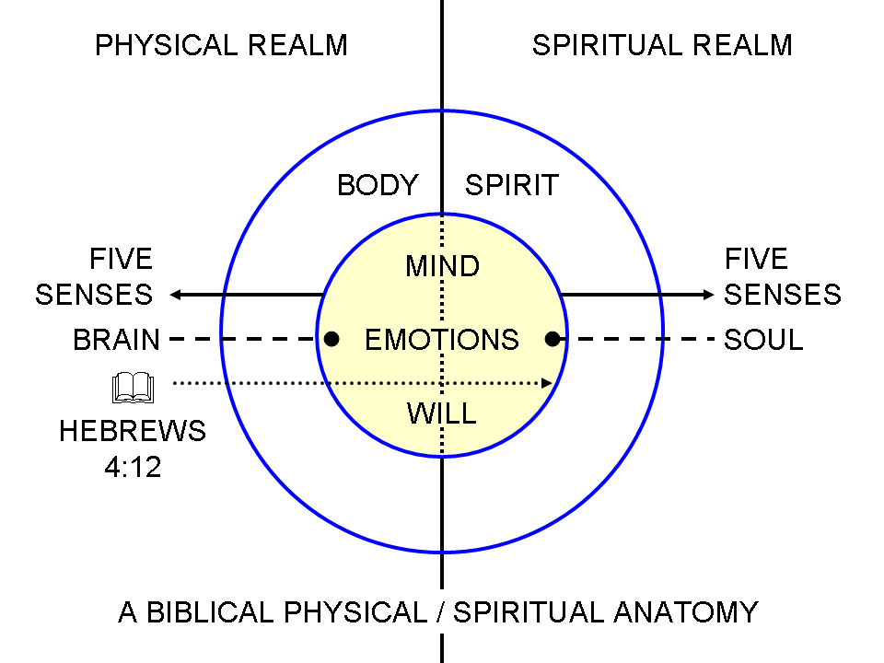
This diagram that was included in an earlier lesson in this elective series provides for us another important understanding and insight into what is meant by “God causes all things”. The “all things” refers to both things that are physical and things that are spiritual. God is not simply working in one realm or the other to fulfill His purposeful causation. He is working on both sides at once.

So God has caused there to be ongoing realities in the physical realm and ongoing realities in the spiritual realm in order to ‘pull this off’. He is also causing specific physical and spiritual events to come about for this same purpose – events both near to us and far from us, and of various kinds and magnitudes. Some things are fixed in place for this purpose, unchanging (such as out position in Christ), while others are worked together more dynamically (physical and spiritual circumstances outside of our being, as well as situations in our physical and spiritual being). But what is abundantly clear is that God is not ‘hands off’ about our spirituality – He is most definitely involved.

Oh, good!

What this passage also makes clear is that God is working in a specific direction as He works all things together: for good. Now this does not mean that everything that happens in our lives and the lives of other believers can be called ‘good’. Sometimes some really awful things happen in believers’ lives. So when really awful things do happen, it does not mean that God has failed in working all things together for good. We are not justified in being mad at or disappointed in God, or downgrading our concept of the power or intent or goodness of God. What it does mean is that God does in fact work all things to the good end that we are conformed through those things to the image of Jesus Christ, His Son. Being conformed to the image of His Son is ‘good’, even if the things that happen along the way are simply ‘not good’.

Being conformed

This particular word in the original language means ‘together formed’. Our ongoing formation into the likeness of Christ in character is not superficial nor does it take place at some distance from Christ, having only an approximate correspondence to and relationship with Him. It is a deep conformity with Him as the pattern about which we are ‘together formed’ to be like Him so as to express His character outwardly from a likeness to Him that comes from the depth of who we are, having been made to be like Him in character, as an ongoing process.

In the image of His Son

So we are being together formed into the image of Christ, the Son of God. This process is to make us like Him, but not to simply be absolutely identical copies of Him. As the passage says, He is to be the first of many brethren – not Christ clones. Though we will be like Him, we will not be made into a ‘deity duplicate’, nor will we share His history in every detail.

Catching up with our history

As we have been made to be ‘in Christ’, and so to share His history (died, buried, raised, ascended, seated), the processes that God has in place through His making all things work together for good is to catch us up with our new history in Him – to make us more like Him every day, until that day when we see Him face to face and we shall be like Him (1 John 3:2).

