Sanctified – what is that process?

To sanctify means ‘to be set apart for a holy purpose’. The Greek words that are translated ‘holy’, ‘sanctify’, and ‘saints’, in their various forms, are all related words. Let’s examine some passages that shed light on what it means to be ‘sanctified’.

John 17:13-18 (NASU; all references are NASU, unless stated otherwise)
"But now I come to You; and these things I speak in the world so that they may have My joy made full in themselves. 14 "I have given them Your word; and the world has hated them, because they are not of the world, even as I am not of the world. 15 I do not ask You to take them out of the world, but to keep them from the evil one. 16 They are not of the world, even as I am not of the world. 17 Sanctify them in the truth; Your word is truth."

This verse is referring to the ongoing process of being sanctified – set apart for a holy purpose. And the instrument that sanctifies is the word of God. At the time Jesus spoke this, it referred to the what we now call the Old Testament, but as the apostles would learn greater and greater truth, ‘Your word’ has come to mean the entire Bible, what we have come to call the Old and New Testaments.

1 Corinthians 1:2
To the church of God which is at Corinth, to those who have been sanctified [perfect tense, a completed past action with ongoing results on into the future, implying permanence] in Christ Jesus, saints by calling, with all who in every place call on the name of our Lord Jesus Christ, their Lord and ours:

Though Paul writes to a church body with lots and lots of spiritual and moral problems, he still begins his letter to them by telling them that they are sanctified, in the perfect tense. By that he means that they have been sanctified already completely and entirely by Gods’ own doing, in their eternal position, which is ‘in Christ’ (1 Corinthians 1:30). Having been sanctified in their position, they are saints – holy ones – even if they are walking fleshly (1 Corinthians 3:1ff), and still need to recognize Paul’s writings as being from a steward of God (1 Corinthians 4:1ff), etc. As far as their position of being sanctified (what God has done), these saints are totally and completely in Christ, but as far as the process of being sanctified (what God is doing), they have a long, long way to go.

1 Corinthians 6:11
Such were some of you; but you were washed, but you were sanctified, but you were justified in the name of the Lord Jesus Christ and in the Spirit of our God.

In this passage, which follows a listing of some of the deeply sinful lifestyles which characterized the Corinthians before they believed, Paul writes, “Such were some of you…”. But these believers, because they believe, have been spiritually and washed, and have been spiritually and morally sanctified – set apart for a holy purpose. Paul puts together two ideas in this verse that are also put together elsewhere. In Ephesians 5:25-27 he writes, “Husbands, love your wives, just as Christ also loved the church and gave Himself up for her, 26 so that He might sanctify her, having cleansed her by the washing of water with the word, 27 that He might present to Himself the church in all her glory, having no spot or wrinkle or any such thing; but that she would be holy and blameless.”

Being sanctified, for those who were once unholy, means being washed and cleansed and purified so as to become holy and sanctified and set apart for God’s holy purpose in their lives. That’s the process God has in mind.

1 Thessalonians 5:23-24 Expanded & Explained
Now may the God of peace Himself sanctify you entirely; and may the spirit and the soul and the body of you be wholly whole, without blame at the coming of our Lord Jesus Christ, may you be kept. 24 Faithful is the One who calls you, and He also will do it.

For the believer there is sanctification of position, sanctification as a process, and sanctification completed, when we will have our new bodies. In body, soul and spirit, when we pass through heaven’s gates, we will be sanctified. God will be the one who does these things.

Hebrews 10:10-14
By this will we have been sanctified [perfect tense, a completed past action with ongoing results on into the future, implying permanence] through the offering of the body of Jesus Christ once for all [once given, perpetually valid and effective]. 11 Every priest stands daily ministering and offering time after time the same sacrifices, which can never take away sins; 12 but He, having offered one sacrifice for sins for all time, sat down at the right hand of God, 13 waiting from that time onward until His enemies be made a footstool for His feet. 14 For by one offering He has perfected [perfect tense, a completed past action with ongoing results on into the future, implying permanence] for all time those who are [being progressively] sanctified.

In the book of Hebrews the author has been comparing the sacrificial system of the Temple in Jerusalem, with its ongoing and endless sacrifices, to the once for all sacrifice of Christ on the cross. In doing so, verse 10 tells of believers being totally and completely sanctified, from the moment they believed. Then in verse 14 the author tells of both having been perfected once and for all (position), and then the ongoing process of being sanctified.

So, are we already completely sanctified or is there a process – which is it? Is the author of Hebrews using ‘double-speak’, and talking in contradictions, or is there a critical insight that we should have that makes sense of these seemingly conflicted truths?

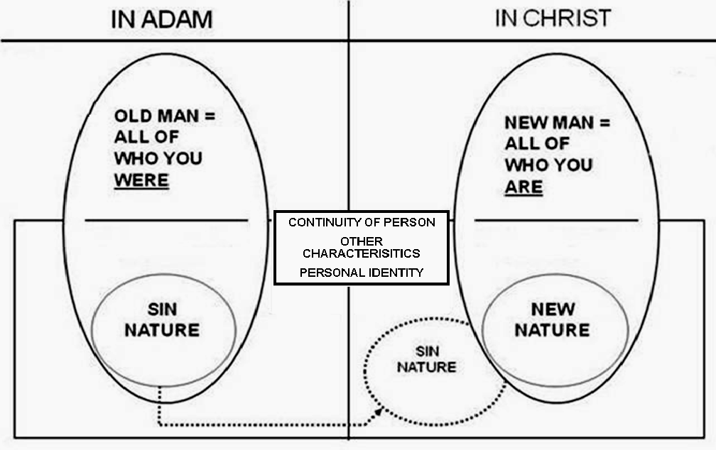
As we return to the diagram that we have referred to in recent months, we can now resolve what appears to be a conflict. The New Man, who is all of who we are in Christ, including the New Nature, and our new history, are entirely and permanently sanctified – once and for all. But it is the Continuity of Person or Continuing Person who is in need of the ongoing process of being sanctified. See also Lesson 23 Knowing & growing – June 18, 2017, Supplement: The Inner Man - The Continuing Person in the Believer. The Continuing Person is the part of who we were and still are that must ‘catch up’ with who we already are in our position - the process of being sanctified. Paul explains this process in a practical way to the young believers in Thessalonica:

1 Thessalonians 4:3-7
For this is the will of God, your sanctification; that is, that you abstain from sexual immorality; 4 that each of you know how to possess his own vessel in sanctification and honor, 5 not in lustful passion, like the Gentiles who do not know God; 6 and that no man transgress and defraud his brother in the matter because the Lord is the avenger in all these things, just as we also told you before and solemnly warned you. 7 For God has not called us for the purpose of impurity, but in sanctification.

So the apostle Paul is expressing the practical process of sanctification – being sanctified – set apart for a holy purpose. We have been sanctified in our position from the moment we believed. We are also continually being sanctified, as a process, in our Continuing Person (aka ‘inner person’ of the believer), which works itself out in our present human bodies. And our eternal position and ongoing process of sanctification will be complete when we will one day have new bodies like Christ’s own body.

