Christ’s Disciple – what is that process?

The History Of The Greek Word For ‘Disciple’ Relevant To The New Testament

Stated briefly, there were four stages of use of the Greek word for ‘disciple’ (mathetés) relevant to the New Testament use of the word, and related words:

Stage 1) Mathetés (learner) derived from manthano (learn) about 500 BC, and applied first to trainees in the Greek pagan religions, then to trainees under the Greek philosophers. Matheteuo (make disciples) was then derived from mathetés. The Koine Greek language was spread throughout the eastern Mediterranean by military action and enforcement under Alexander the Great, reaching Israel in 332 BC. Alexander the Great asked many Jews to move to Alexandria (about April, 331 BC).

Stage 2) As the Jews began developing traditions regarding a rabbi and his disciples, they generally continued to call them rabbi (‘great one’, a euphemism for ‘teacher’) and talmidim (‘disciples’), the Hebrew terms. They understood, however, that the Greek word for a talmid was mathetés. The traditions regarding a rabbi and his disciples, focused on the Torah, were still developing by the time that Jesus began His earthly ministry in summer/fall of 29 AD. He shortly thereafter began calling His disciples. Jesus followed some portions of the rabbinical traditions, and also broke radically from those traditions in other respects.

Stage 3) In the days before His crucifixion, and in preparing the disciples to head up the church, the body of Christ, Jesus told His disciples that they were not to be called ‘rabbi’ (Matthew 23:8). But He did tell them that they would show that they were His disciples by loving one another and being fruitful by abiding (John 13:35; 15:8) – not focused on the Law of Moses. Just before He ascended, He told His disciples, soon to be apostles, to ‘make disciples’ (matheteuo; Matthew 28:19).

In the time that followed the establishment of the church (Acts 2), believers were immediately called disciples (mathetés) as soon as they believed, and regardless of being younger or older in the Lord, male or female, Jew or Gentile, from Acts 6:1-21:16. The word was never used again in Acts or the rest of the New Testament, likely resulting from the meeting between Paul and James along with the other Jerusalem elders (Acts 21:18).

Stage 4) This stage overlaps the end of Stage 3), and will continue on until the day of the rapture. All of the disciple-making activities of the apostles, as recorded in the letters from the apostles and their associates (teaching, being an example, following an example, etc.) were ultimately directed towards making disciples so as to be Christ’s disciple (mathetés; John 15:1-9, written about 85 AD, after Paul wrote), and to learn Him (mathetés; Ephesians 4:20-24, written about 60 AD, after Paul reached Rome), directly, intimately, personally, and to find our life and blessings in the heavenlies, in Christ, and to set our minds there (Colossians 3:1-4; Ephesians 1:3, about 60 AD). It is this 4th stage that we will focus on in this elective, and today we will pursue, ‘What does it mean to be Christ’s disciple?

If anyone desires more detail on these four stages, please consult ‘Holly Hills Bible Church – 03 Knowing & Growing – January 22, 2017’. Our focus from here forward will be on stage 4).
Stage 4), from Acts 2 to the rapture
This 4th stage overlaps the end of stage 3), and will continue on until the day of the rapture. There is no discussion of when Jesus’ command to make disciples (matheteuo) ended, because there was no end time or end point given by Christ to the church, nor decided by the apostles regarding the church.

Matthew 28:19-20
"Go therefore and make disciples [imperative] of all the nations, baptizing them in the name of the Father and the Son and the Holy Spirit, 20 teaching them to observe all that I commanded you; and lo, I am with you always, even to the end of the age."

While making disciples begins with evangelism, the elements of making disciples continued during the book of Acts and afterwards, even in the letters of Paul:

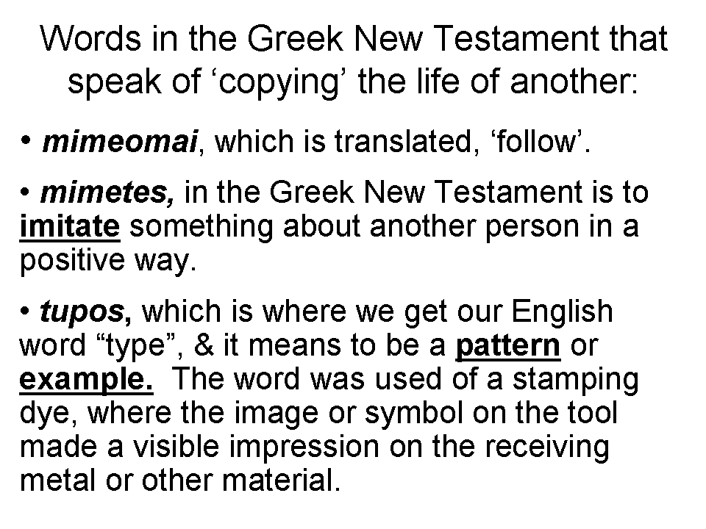
1 Corinthians 4:14-17
I do not write these things to shame you, but to admonish you as my beloved children. 15 For if you were to have countless tutors in Christ, yet you would not have many fathers, for in Christ Jesus I became your father through the gospel. 16 Therefore I exhort you, be imitators of me.

1 Corinthians 11:1
Be imitators of me, just as I also am of Christ.

1 Thessalonians 1:6-7
You also became imitators of us and of the Lord, having received the word in much tribulation with the joy of the Holy Spirit, 7 so that you became an example to all the believers in Macedonia and in Achaia.

2 Thessalonians 3:7-9
For you yourselves know how you ought to follow our example, because we did not act in an undisciplined manner among you, 8 nor did we eat anyone's bread without paying for it, but with labor and hardship we kept working night and day so that we would not be a burden to any of you; 9 not because we do not have the right to this, but in order to offer ourselves as a model for you, so that you would follow our example.

Philippians 3:17-18, 4:9 (‘actively’ added based on the active voice)
Brethren, join in following my example, and observe those who walk according to the pattern you have in us… 4:9 The things you have actively learned and actively received and actively heard and actively seen in me, practice these things, and the God of peace will be with you.

2 Timothy 2:2
The things which you have heard from me in the presence of many witnesses, entrust these to faithful men who will be able to teach others also.
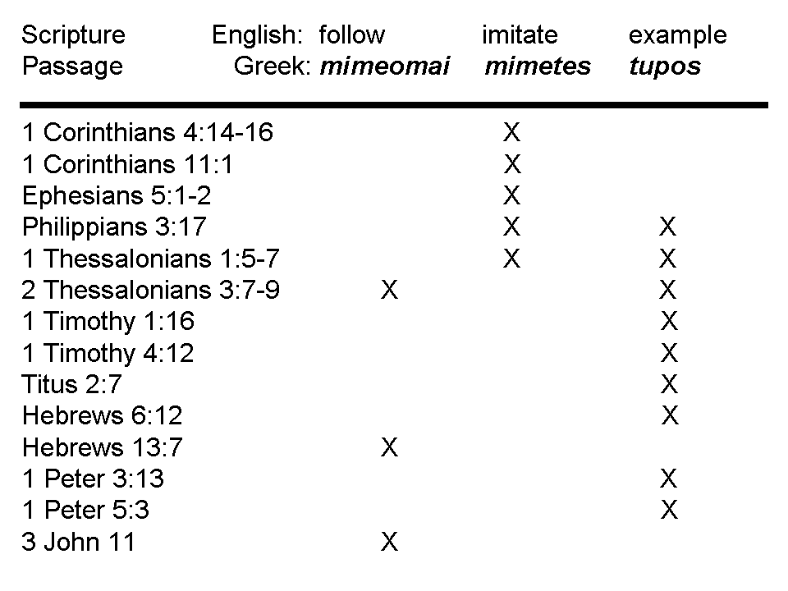
The ‘model’ used throughout Acts and the epistles was for the apostles and those they trained to use the full range of training approaches, once the people had become believers: teaching, counseling, being examples, etc. with those they were training, including having them follow, imitate, hear, see, etc.

Paul’s unique teachings such as identification, indwelling and intimacy with Christ were not truths that displaced earlier teachings, but were additive truths and truths in parallel. All of the apostles, including Paul, were always making disciples (matheteuo), to the ends of each of their lives, and they taught and trained others to do the same.

But the disciple-making activities of the apostles were ultimately directed towards making disciples so as to be Christ’s disciple (mathetés; John 15:1-9, written about 85 AD, after Paul wrote), and to learn Him (manthanō; Ephesians 4:20-24, written about 60 AD, after Paul reaches Rome), directly, intimately, personally, and to find our life and blessings in the heavenlies, in Christ, and to set our minds there (Colossians 3:1-4; Ephesians 1:3, about 60 AD). These passages are quoted below.

John 15:1-9 (NASU; with added capitalization)
"I AM the true vine, and My Father is the vinedresser. 2 Every branch in Me that does not bear fruit, He takes away; and every branch that bears fruit, He prunes it so that it may bear more fruit. 3 You are already clean because of the word which I have spoken to you.

4 Abide in Me, and I in you. As the branch cannot bear fruit of itself unless it abides in the vine, so neither can you unless you abide in Me. 5 I AM the vine, you are the branches; he who abides in Me and I in him, he bears much fruit, for apart from Me you can do nothing. 6 If anyone does not abide in Me, he is thrown away as a branch and dries up; and they gather them, and cast them into the fire and they are burned. 7 If you abide in Me, and My words abide in you, ask whatever you wish, and it will be done for you. 8 My Father is glorified by this, that you bear much fruit, and so prove to be My disciples (mathetés). 9 Just as the Father has loved Me, I have also loved you; abide in My love."

Ephesians 1:3 (NASU)
Blessed be the God and Father of our Lord Jesus Christ, who has blessed us with every spiritual blessing in the heavenly places in Christ,…
Ephesians 4:17-24 (Darby Translation; [with added brief comments in brackets])
17 This I say therefore, and testify in Lord, that ye should no longer walk as the nations [NASU: Gentiles] walk in vanity of their mind, 18 being darkened in understanding, estranged from the life of God by reason of the ignorance which is in them, by reason of the hardness of their hearts, 19 who having cast off all feeling, have given themselves up to lasciviousness, to work all uncleanness with greedy unsatisfied lust. 20 But ye have not thus learnt [manthano; Constable: ‘learned as a disciple’] the Christ [the Messiah], 21 if ye have heard him and been instructed in him according as truth is in Jesus; 22 your having put off according to the former conversation the old man which corrupts itself according to the deceitful lusts; 23 and being renewed in the spirit of your mind; 24 and having put on the new man, which according to God is created in truthful righteousness and holiness.

Colossians 3:1-4 (NASU)
Therefore if you have been raised up with Christ, keep seeking the things above, where Christ is, seated at the right hand of God. 2 Set your mind on the things above, not on the things that are on earth. 3 For you have died and your life is hidden with Christ in God. 4 When Christ, who is our life, is revealed, then you also will be revealed with Him in glory.

