Christ’s Disciple – what is the believer’s part?

Earlier, we saw that the word ‘disciple’ was used in the pagan world. It was later used among the Jews, who had traditions for rabbis and the rabbi’s disciples. During Christ’s earthly ministry, He had the twelve disciples, plus other disciples, and even taught women as disciples. But the definition of ‘disciples’ in the book of Acts (chapters 6 through 21) and as given by Christ for the church in John 13:35 and 15:8 is distinct from the use of the word ‘disciples’ among the pagans, among the Jews, and even among Jesus and the disciples in His earthly ministry. We who are believers in Christ are His disciples, personally, intimately, spiritually – knowing Him.

We also defined what the process of being a disciple means for believers in the body of Christ. We said the aspects of the process of being a disciple are:
1) becoming a believer, and
2) the involvement of both the individual and the church body as a whole
3) toward the end that each believer abides in Christ in dependence upon and intimacy with Christ, and loves others in the body of Christ based on abiding in Christ (John 13:35 and 15:8).

Next, centering on John 15:1-9, we then looked at God’s part in the disciple-making process. John 15:1-9 has Christ as the vine, the Father as the vinedresser, and we who believe as the branches. It is on the basis of who Christ is, and who the Father is, and what they each do, that the branches are pruned, lifted up and managed toward fruitfulness. As the vine, Christ is the exclusive means of drawing nutrients from the soil and through the roots, which feed life to the branches. We saw that John 15:1-9 implied that the believer was, in his position ‘in Christ’. So we briefly introduced what are often referred to as ‘the identification truths’. We also observed that it is by God’s doing that the believer is ‘in Christ’ (1 Corinthians 1:30).

‘Make disciples’

There is no discussion of when Jesus’ command to make disciples (matheteuo) ended, because there was no end time or end point given by Christ to the church, nor decided by the apostles regarding the church. We are called to make disciples even to the end of the age.

Matthew 28:19-20
"Go therefore and make disciples [imperative] of all the nations, baptizing them in the name of the Father and the Son and the Holy Spirit, 20 teaching them to observe all that I commanded you; and lo, I am with you always, even to the end of the age."

‘Making disciples’ begins with evangelism

Jesus command to ‘make disciples’ begins with evangelism, which is why baptism follows immediately in the above-given command, sometimes referred to as the ‘Great Commission’. There were those gifted with evangelism, which would include the apostles (Ephesians 4:11).

‘Making disciples’ continues after evangelism

While making disciples begins with evangelism, the elements of making disciples continued during the book of Acts and afterwards, even in the letters of Paul:

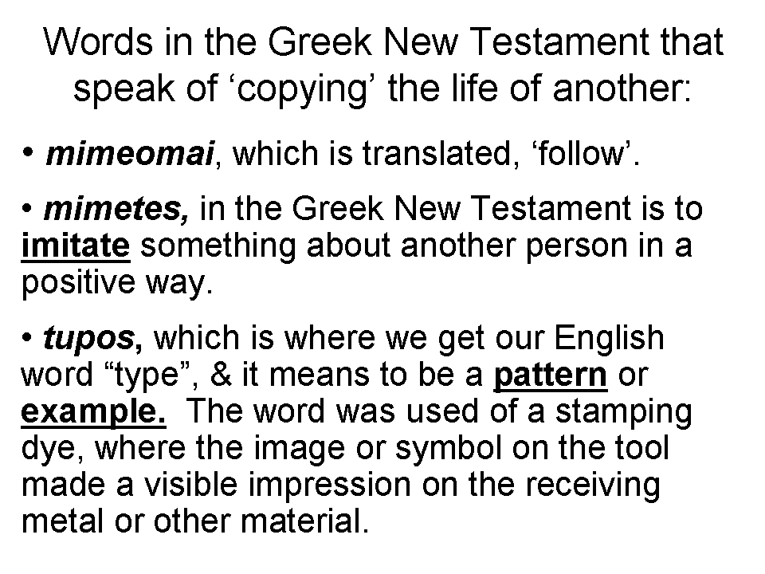
1 Corinthians 4:14-17
I do not write these things to shame you, but to admonish you as my beloved children. 15 For if you were to have countless tutors in Christ, yet you would not have many fathers, for in Christ Jesus I became your father through the gospel. 16 Therefore I exhort you, be imitators of me.

1 Corinthians 11:1
Be imitators of me, just as I also am of Christ.

1 Thessalonians 1:6-7
You also became imitators of us and of the Lord, having received the word in much tribulation with the joy of the Holy Spirit, 7 so that you became an example to all the believers in Macedonia and in Achaia.

2 Thessalonians 3:7-9
For you yourselves know how you ought to follow our example, because we did not act in an undisciplined manner among you, 8 nor did we eat anyone's bread without paying for it, but with labor and hardship we kept working night and day so that we would not be a burden to any of you; 9 not because we do not have the right to this, but in order to offer ourselves as a model for you, so that you would follow our example.
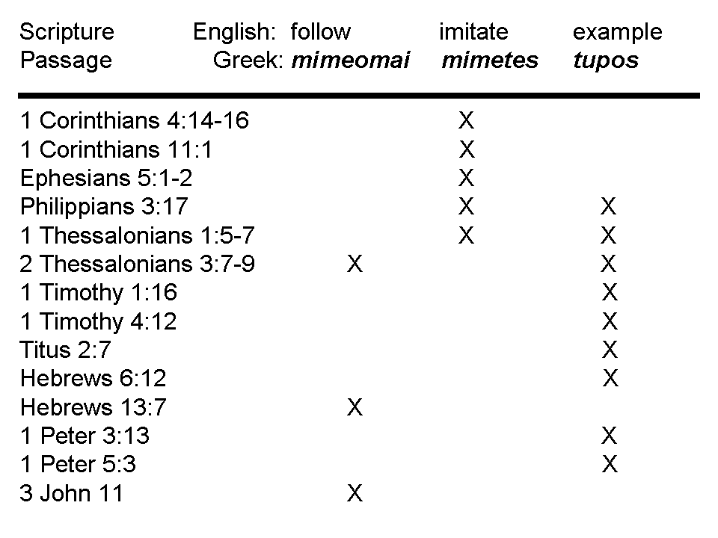
Philippians 3:17-18, 4:9 (‘actively’ added based on the active voice)
Brethren, join in following my example, and observe those who walk according to the pattern you have in us… 4:9 The things you have actively learned and actively received and actively heard and actively seen in me, practice these things, and the God of peace will be with you.

2 Timothy 2:2
The things which you have heard from me in the presence of many witnesses, entrust these to faithful men who will be able to teach others also.

The ‘model’ used throughout Acts and the epistles was for the apostles and those they trained to use the full range of training approaches, once the people had become believers:

- teaching, training
- counseling, urging them to see and hear
- being examples, instructing them to follow

Paul’s unique teachings such as identification, indwelling and intimacy with Christ were not truths that displaced earlier teachings, but were additive truths and truths in parallel. All of the apostles, including Paul, were always making disciples (matheteuo), to the ends of each of their lives, and they taught and trained others to do the same.

The disciple-making activities of the apostles and their associates were ultimately directed towards making disciples who were Christ’s disciples (mathetés; John 15:1-9, written about 85 AD, after Paul wrote). Disciples are to learn Him (manthanō; Ephesians 4:20-24, written about 60 AD, after Paul reaches Rome), directly, intimately, personally, and to find life and blessings in the heavenlies, in Christ. And Christ’s disciples are to set minds there in the heavenlies (Colossians 3:1-4; Ephesians 1:3, about 60 AD). These passages are quoted below.

John 15:1-9 (NASU; with added capitalization)
"I AM the true vine, and My Father is the vinedresser. 2 Every branch in Me that does not bear fruit, He takes away; and every branch that bears fruit, He prunes it so that it may bear more fruit. 3 You are already clean because of the word which I have spoken to you.

4 Abide in Me, and I in you. As the branch cannot bear fruit of itself unless it abides in the vine, so neither can you unless you abide in Me. 5 I AM the vine, you are the branches; he who abides in Me and I in him, he bears much fruit, for apart from Me you can do nothing. 6 If anyone does not abide in Me, he is thrown away as a branch and dries up; and they gather them, and cast them into the fire and they are burned. 7 If you abide in Me, and My words abide in you, ask whatever you wish, and it will be done for you. 8 My Father is glorified by this, that you bear much fruit, and so prove to be My disciples (mathetés). 9 Just as the Father has loved Me, I have also loved you; abide in My love."

Ephesians 4:17-24 (Darby Translation; [with added brief comments in brackets])
17 This I say therefore, and testify in Lord, that ye should no longer walk as the nations [NASU: Gentiles] walk in vanity of their mind, 18 being darkened in understanding, estranged from the life of God by reason of the ignorance which is in them, by reason of the hardness of their hearts, 19 who having cast off all feeling, have given themselves up to lasciviousness, to work all uncleanness with greedy unsatisfied lust. 20 But ye have not thus learnt [manthano; Constable: ‘learned as a disciple’] the Christ [the Messiah], 21 if ye have heard him and been instructed in him according as truth is in Jesus; 22 your having put off according to the former conversation the old man which corrupts itself according to the deceitful lusts; 23 and being renewed in the spirit of your mind; 24 and having put on the new man, which according to God is created in truthful righteousness and holiness.

Colossians 3:1-4 (NASU)
Therefore if you have been raised up with Christ, keep seeking the things above, where Christ is, seated at the right hand of God. 2 Set your mind on the things above, not on the things that are on earth. 3 For you have died and your life is hidden with Christ in God. 4 When Christ, who is our life, is revealed, then you also will be revealed with Him in glory.

