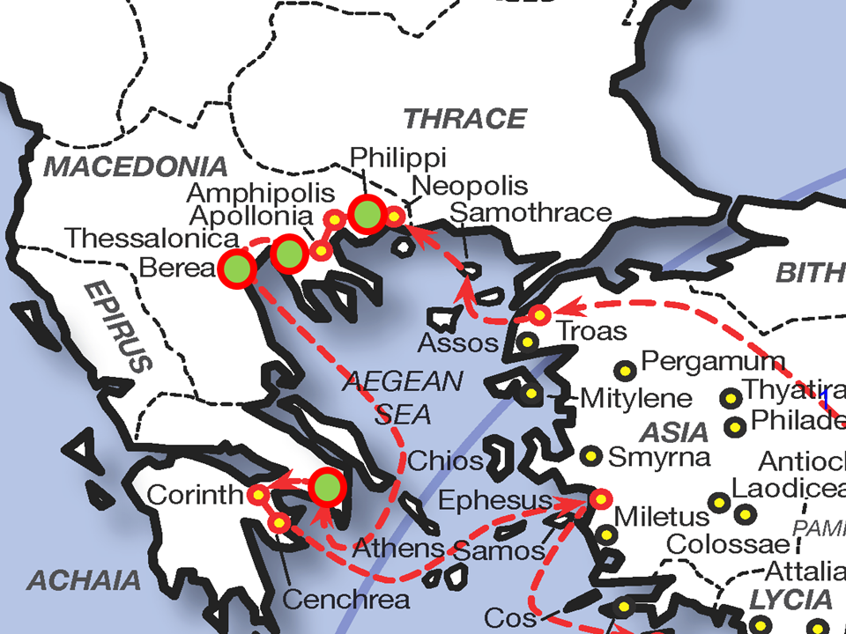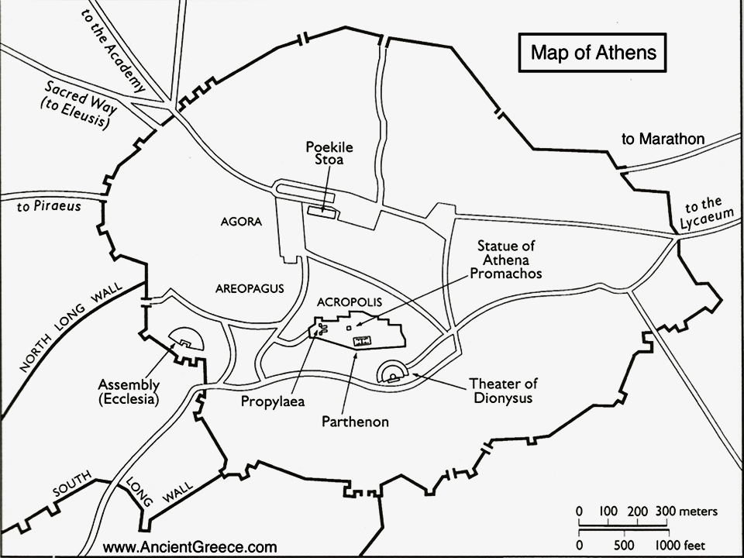

Paul’s Dependence on the Old (& New) Testament at the Areopagus
Statement (Acts chapter 17) | Old (or New) Testament Reference
God made the world and everything in it (Acts 17:24) | Genesis chapters 1-2; Isaiah 42:5, Jeremiah 10:12, 16
Lord of heaven and earth (Acts 17:24) | Exodus 20:11, Isaiah 42:5; (Matthew 11:25)
God does not live in temples built by hands (Acts 17:24) | 1 Kings 8:27 (1 Corinthians 3:16; 6:19; 2 Corinthians 5:1)
God does not need anything from the people he has created (Acts 17:25) | 1 Chronicles 29:14; Psalm 50:7-15
God as the source of “breath” (Acts 17:25) | Genesis 1, 2; 2:7; Isaiah 42:5
God appointed the eras for the successive nations (Acts 17:26) | Deuteronomy 32:8; Daniel 2:36-45 (Luke 21:24; Ephesians 1:9,10; 2:4-7)
God established national boundaries (Acts 17:26) | Deuteronomy 32:8; Psalm 74:17
God desires that people would seek him (Acts 17:27) | Psalm 14:2; Proverbs 8:17; Isaiah 55:6; 65:1; Jeremiah 29:13
God is not far away (Acts 17:27) | Psalm 145:18; Jeremiah 23:23-24
God is not like an image made out of gold, silver, or stone (Acts 17:29) | Deuteronomy. 5:8; Psalm 115:2-8; Isaiah 37:19; 44:9-20
God has overlooked such ignorance (Acts 17:30) | (Romans 3:25)
God calls men now to repent (Acts 17:30) | Isaiah 59:20; Jeremiah 15:19; Ezekiel 14:6; 18:30, 32 (Matthew 3:2; 4:17; Acts 2:38, 3:19; 1 Thessalonians 1:9)
God will judge the world (Acts 17:31) | Psalm 9:8; 96:13; 98:9; Isaiah 66:16; Jeremiah 25:31 (Matthew 11:22, 24; 12:36)
God has appointed a man who will judge (Acts 17:31) | (John 5:22, 27, 25-30)
Having furnished Proof to all men by raising Him from the dead (Acts 17:31) | Isaiah 53:12 (1 Corinthians 15:1-11)

