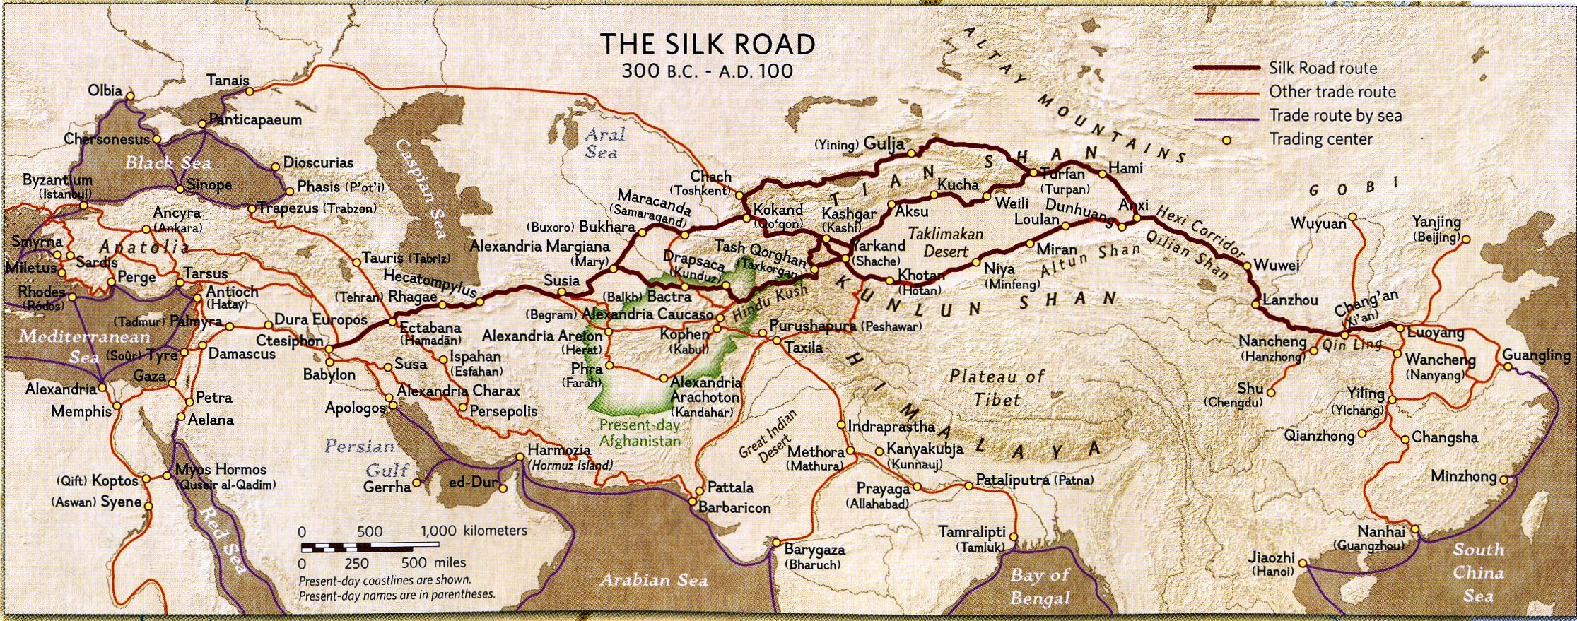
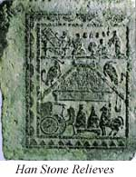
The ‘Silk Road’ trade was actually a network of roads by which goods were traded and transported between the Orient and the civilizations in the Middle East, North Africa, and Europe – including the Roman Empire. The impact on the study of the New Testament was that not only were goods exchanged between these areas, but also ideas, concepts and philosophies. A number of the cities named in the Book of Acts and the rest of the New Testament were on or near a major route within the Silk Road network. In the Book of Acts, Damascus and Antioch were among the major cities in the eastern Roman Empire where Silk Road trade was prominent. The Magi who came seeking the King of Jews (Matthew chapter 2), also known as the ‘wise men’, came, at least in part, along Silk Road trade routes, bearing gifts that were traded along the Silk Road trade routes (gold, frankincense and myrrh). Not only was the Silk Road trade a means of bringing eastern ideas, concepts and philosophies into the Roman Empire, but the Christian gospel and teachings appear to have reached into the Orient before the end of the first century, possibly along the Silk Road trade routes. According to Chinese professor Wang Weifan, Bible stories – even New Testament Bible stories - have been found on Eastern Han Dynasty tombstones dating from as early as 86 AD (see example to the right, which shows a Nativity scene in relief).

HHBC – 29 the Book of Acts – August 6, 2017 – Supplement: The Silk Road – Page 1 of 1

