The Identification Truths: The Front Door - Part II

And now… the really, really good news

Our identification with Christ, mentioned before, is expressed in several different ways. One of the frequent ways in which that truth is conveyed is that the believer is “in Christ’ as opposed to remaining “in Adam”. That truth is conveyed primarily in the letters of Paul, such as we find in his letter to the believers in Ephesus 36 times in six chapters, including these references:

- In Christ (1:3,7, 10)
- In Him (1:4, 9, 10, 13)
- In the Beloved (1:6)
- In Whom (2:21,22; 3:12)

So the one who has placed his faith in Christ for salvation is ‘in Christ’, meaning that the believer has been placed by God entirely in Christ (1 Corinthians 1:30), spiritually speaking, so as to share an identity with Him, and so as to share a history with Him in each of these aspects in which he has been identified. There is not the slightest indication from Scripture that this placement ‘in Christ’ is something that varies over time, or that it is ever undone or reversed or that such a reversal or undoing of the identification is even threatened. Every indication from Scripture is that once we have been made to be “in Christ” (and all the equivalent expressions, as listed in the bullets on the first page) by God’s doing, that placement ‘in Christ’ is eternally fixed and unchanging and irreversible.

With, together with and united

These terms tell of how we were identified with Christ in His death, burial, resurrection, ascension and seating in the heavenlies, as a number of verses testify:

Romans 6:4-6ab
Therefore we have been buried with Him through baptism into death, so that as Christ was raised from the dead through the glory of the Father, so we too might walk in newness of life. 5 For if we have become united with Him in the likeness of His death, certainly we shall also be [united with Him] in the likeness of His resurrection, 6 knowing this, that our old self was crucified with Him…

Galatians 2:20
I have been crucified with Christ; and it is no longer I who live, but Christ lives in me; and the life which I now live in the flesh I live by faith in the Son of God, who loved me and gave Himself up for me.

Ephesians 2:4-6
But God, being rich in mercy, because of His great love with which He loved us, 5 even when we were dead in our transgressions, made us alive together with Christ (by grace you have been saved), 6 and raised us up with Him, and seated us with Him in the heavenly places in Christ Jesus;
The consequences of identification

From here forward, we will address the consequences of our having been identified with Christ. All the facts of identification are known by revelation – not by personal memory or experience. Our faith, then, is in the revealed spiritual facts. These facts are absolutely true of us (our eternal position), and totally practical, for now (our condition) until the day we walk through heaven’s gates.

Crucified

Several New Testament passages say that we were identified with Christ in His death (such as Romans 6:1-10; Galatians 2:20; Colossians 2:20). Though the Romans soldiers that drove the nails, and the crowd that surrounded Christ were not aware of it, ever believer from the day of Pentecost to the day of the rapture was crucified with Christ:

- The sins of the entire world for all time – everyone on the planet - from Adam to the last one born on this present earth, were placed upon Christ (John 3:16; 1 John 2:2).
- Every person who has believed or will believe, from Acts 2 to the Rapture was there with Christ at His crucifixion, being crucified with Him. The Old Man (all of whom we were in Adam) of each one of us who believe was crucified there that day (Romans 6:1-10; Galatians 2:20).
- The Law was crucified there – nailed to the cross as well, along with the debt note that went with it (Ephesians 2:14-16; Colossians 2:14).

Yes, each of us who believes was with Christ being crucified with Him on that hill called Golgotha.

There are three summary outcomes to the identification with Christ’s crucifixion that God caused to take place that day. They are all three in the form of ‘died to’, that is, died in relationship to, which expresses the spiritual separation that took place on the cross. These three summary outcomes are:

- The believer died in relationship to ‘the sin’, which means that the believer is no longer an absolute slave to ‘the sin’ (Romans 6:1-10). The flesh is the expression of ‘the sin’ through the earthly body.

- The believer died in relationship to the Law of Moses, and any principle of law (Romans 7:4; Galatians 2:19). This means that no part of the Law of Moses is applicable as Law to the believer who is part of the body of Christ.

- The believer died in relationship to the world and its basic principles (Galatians 6:14; Colossians 2:20). The world has its pressures (Romans 12:2), ways and systems (Ephesians 2:1-3), and these no longer have a claim on the believer.

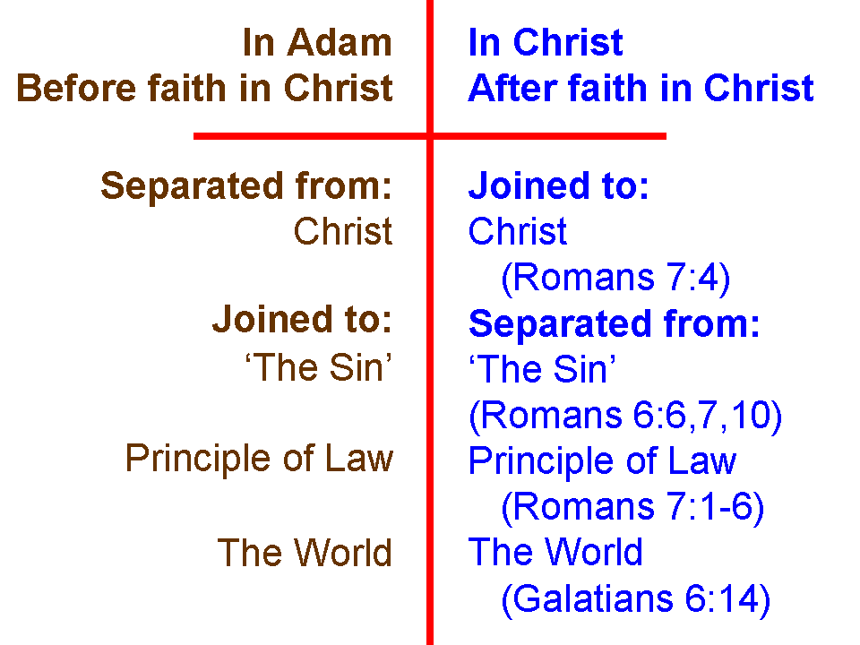
In each case it is important to see that our death with Christ on the cross does not terminate or annihilate ‘the sin’, the Law or the world. Each of these are still present here on earth. Our death with Christ on the cross, however, causes us to have died in relationship to each of these. It is a death of separation, rather than annihilation, termination, or cessation – or even inability.

Buried

Being buried with Christ (Romans 6:4; Colossians 2:12) is the assurance that the death actually took place. This was no fainting, swooning or coma phenomenon. The body of Christ was wrapped in accordance with traditional Jewish practices on the same day in which He was crucified, placed in a tomb, with a stone over the opening of the tomb. The tomb was sealed with the seal of Rome, and a team of Roman guards set in place to prevent the breaking of the seal. But inside the tomb, because we who believe, of the body of Christ, were there with Him as His wrapped body lay dead in the tomb. Being dead in relationship to ‘the sin’, the Law and the world are not hypothetical or nearly true. These are true.

Raised

Being raised with him (Ephesians 2:6; Colossians 2:12; 3:1) means that when Christ was raised to new life, every single one of us who believes was raised with Him! Being raised with Him has some momentous and critically important truths for us to live by. Being raised with Him means that our new life is derived from His new life. We are not only dead in relationship to ‘the sin’, the Law and the world, but we are alive, in a new kind of life, to God and to righteousness (Romans 6:1-10; 1 Peter 2:24). And while being made alive was a one time occurrence, being alive is from then on until forever.

But there is also an important aspect of that new kind of life that we share with Christ that should not be overlooked – we need to be spiritually calibrated for the massive and unparalleled magnitude of that resurrection life:

Ephesians 1:18-23
I pray that the eyes of your heart may be enlightened [literally, ‘having been enlightened’], so that you will know what is the hope of His calling, what are the riches of the glory of His inheritance in the saints, 19 and what is the surpassing greatness of His power toward [Greek: eis = into] us who believe. These are in accordance with the working of the strength of His might 20 which He brought about in Christ, when He raised Him from the dead and seated Him at His right hand in the heavenly places, 21 far above all rule and authority and power and dominion, and every name that is named, not only in this age but also in the one to come. 22 And He put all things in subjection under His feet, and gave Him as head over all things to the church, 23 which is His body, the fullness of Him who fills all in all.

The surpassing greatness of the power of Christ’s resurrection is the measure of the magnitude of that new life that was not just enacted at that past point in time, but is being right now directed into the life of each believer – right now! Which is also a marvelous truth that is not at all just hypothetical, but intended to be real life now: We who believe are not intended to do the living here on this planet – He is! (Galatians 2:20).

Next: We are ascended and seated with Christ!

See also 1 Peter 5:14.

