Every spiritual blessing in the heavenly places in Christ

When the apostle Paul wrote the book of Ephesians:
- He had been in Ephesus on both his 2nd and 3rd missionary journeys
- He was in Rome, under house arrest writing about fall of 60 AD
- He wrote to a church where the believers were as much as eight years old in the Lord

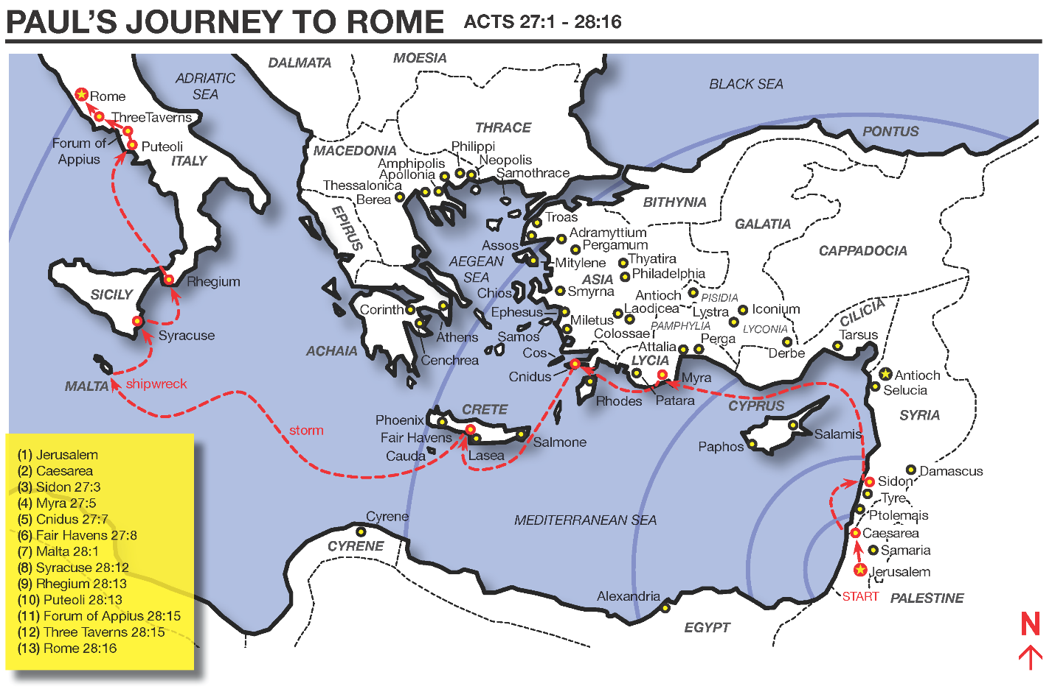
Copyright Mark Barry - used by permission

Ephesians 1:3 (NASU)

Blessed be the God and Father of our Lord Jesus Christ, who has blessed us with every spiritual blessing in the heavenly places in Christ…

The Greek word that is translated ‘Blessed’ is used eight times in the New Testament, and every time it is in reference to God – never to human beings. And ‘Blessed be the God and Father…’ is not a wish, but a declaration.

‘The God and Father’ refers to ‘God who is the Father’ and speaks of the Father’s eternal relationship to our Lord Jesus Christ, who is the Son of God. The words ‘of our Lord Jesus Christ’ tell us about four things:

- The personal relationship of the believer to Christ (‘our Lord’)
- The name of Jesus – His name, which means ‘Savior’
- The Lordship of Christ (‘our Lord’)
- The title of ‘Christ’, who is the Anointed One

God the Father is credited for a series of spiritual blessings for the believer, and He is referred to as ‘who’, ‘He, ‘His’, and similar words on down through the passage. The things that the Father is credited with include a number of accomplishments and actions and expressions of His eternal character.

Unlike with the nation of Israel, who was blessed conditionally – if they obeyed the Law of Moses (Deuteronomy 28:1-14), and were blessed in earthly ways, these Ephesian believers – and us – have been unconditionally blessed with every spiritual (rather than earthly) blessing in the heavenly places (see also Ephesians 1:20; 2:6; 3:10; 6:12).

From here on in much of the book of Ephesians, and certainly in the passage that follows, Paul begins to spell out in sequence the spiritual blessings with which the Father has blessed us. Those blessings are things that are true of our eternal position (where we are), as well as our eternal spiritual possessions (what we have). Paul will summarize these in Ephesians 3:8, which begins with:

For this reason I, Paul, the prisoner of Christ Jesus for the sake of you Gentiles-- 2 if indeed you have heard of the stewardship of God's grace which was given to me for you; 3 that by revelation there was made known to me the mystery, as I wrote before in brief. 4 By referring to this, when you read you can understand my insight into the mystery of Christ, 5 which in other generations was not made known to the sons of men, as it has now been revealed to His holy apostles and prophets in the Spirit; 6 to be specific, that the Gentiles are fellow heirs and fellow members of the body, and fellow partakers of the promise in Christ Jesus through the gospel, 7 of which I was made a minister, according to the gift of God's grace which was given to me according to the working of His power. 8 To me, the very least of all saints, this grace was given, to preach to the Gentiles the unfathomable riches of Christ…

There are two aspects of the location of our spiritual blessings that are important for us to recognize:

- The location of all of those spiritual blessings is heavenly – they are in the heavenly places. They are where no human being or human activity or human influence can reach them.
- The location of all those spiritual blessings is not just heavenly – a place – but they are personal – in Christ.

The book of Ephesians speaks of ‘in Christ’ or equivalent terms (in Him, in Whom, in the Beloved, etc.) 36 times. With a few related expressions, the total comes to 39 times. How did the believers come to be ‘in Christ’?

Ephesians 1:13-14

In Him, you also, after listening to the message of truth, the gospel of your salvation--having also believed, you were sealed in Him with the Holy Spirit of promise, 14 who is given as a pledge of our inheritance, with a view to the redemption of God's own possession, to the praise of His glory.

