In Christ, redeemed and forgiven, so as to be justified

Introduction

In the very first lesson in this elective, we pointed out that various authors have sought to bring together those great truths:

- Lewis Sperry Chafer, Systematic Theology Vol. III, Soteriology, pages 234-266 (a copy is attached as a supplement to this lesson)
- Hampton Keathley III, The Unfathomable Riches of Christ, compiled from Lewis Sperry Chafer’s material by Keathley, & edited with permission, by Nancy Peterman
- Robert Thieme, 40 Things God Provides Every Believer At Salvation, also compiled from Lewis Sperry Chafer’s material
- Arnold Fruchtenbaum, Thirty Three Things: A Study of Positional Truth
- George Zeller, 215 Things that Are True of Me Now That I Am Saved

While very good things could be said about each of these author’s presentations of our unfathomable riches in Christ (Ephesians 3:1-8), Scripture brings out some essential and momentous insights into our unfathomable riches that are best reflected in these two principles:

- An understanding of the identification truths is essential to grasping the meaning of our unfathomable riches in Christ. This principle is so critical that the apostle Paul stated this summary and all-inclusive truth as the introduction to his letter to the church at Ephesus:

Ephesians 1:3 (NASU)
Blessed be the God and Father of our Lord Jesus Christ, who has blessed us with every spiritual blessing in the heavenly places in Christ…

- Through what the Bible tells us about our identification in Christ, and the words that describe our unfathomable blessings in Christ, we can begin to see the relationships between the words and terms that the Bible uses to name and describe those unfathomable riches. We will begin to provide specific examples of the relationships between words that describe our unfathomable riches in Christ by exploring the connections between justification, redemption and forgiveness.

In Christ, redeemed and forgiven, so as to be justified

In the writings of the apostle Paul, justified and the related words (justify, justification) are used prominently and thematically in Romans chapters 3, 4 and 5, and in Galatians chapters 2 and 3. The words are also used in other chapters and books, though less often. Further, the apostle Paul uses the word ‘justified’ and its related words to mean ‘justified before God’, rather than James’ ‘justified before other people’.

In brief definition, the Greek word that is translated ‘justified’ means ‘declared righteous’. While that definition is fine as a starting point, we’re going to see that the brief definition, though a good start, is not an adequate definition in the context of Scripture. Let’s take a walk through the relevant passages which will give us a full biblical understanding of these words as they convey essential aspects of our unfathomable riches in Christ.

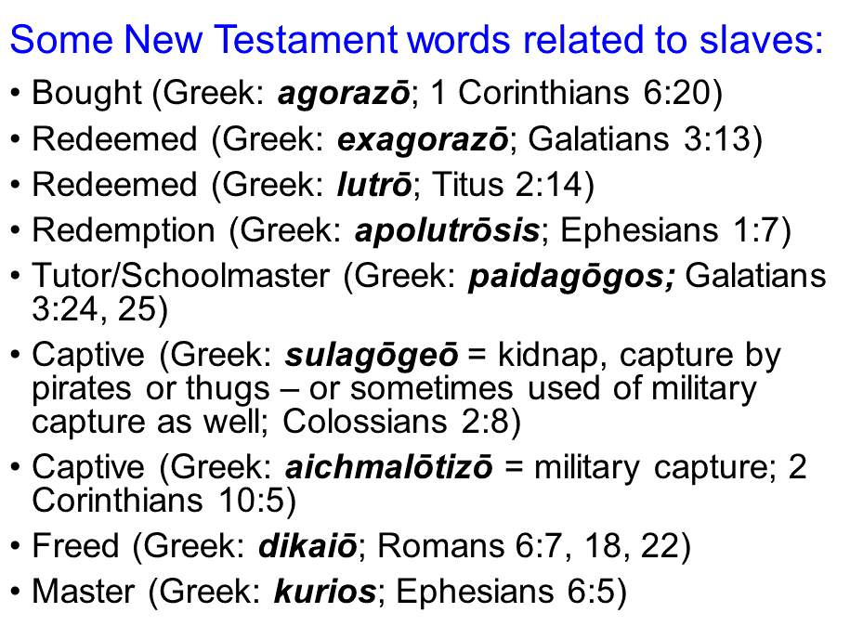
Romans 3:21-26 (NASU)
But now apart from the Law the righteousness of God has been manifested, being witnessed by the Law and the Prophets, 22 even the righteousness of God through faith in Jesus Christ for all those who believe; for there is no distinction; 23 for all have sinned and fall short of the glory of God, 24 being justified as a gift by His grace through the redemption [apolutrosis: fully redeemed from] which is in Christ Jesus; 25 whom God displayed publicly as a propitiation in His blood through faith. This was to demonstrate His righteousness, because in the forbearance of God He passed over the sins previously committed; 26 for the demonstration, I say, of His righteousness at the present time, so that He would be just and the justifier of the one who has faith in Jesus.

Ephesians 1:7-8
In Him we have [the] redemption [apolutrosis: fully redeemed from] through His blood, the forgiveness of our trespasses [the trespasses of us], according to the riches of His grace 8 which He lavished on us. In all wisdom and insight…

Colossians 1:13-14
For He rescued us from the domain of darkness, and transferred us to the kingdom of His beloved Son, 14 in whom we have [the] redemption [apolutrosis: fully redeemed from], the forgiveness of sins.

Colossians 2:13-14
When you were dead in your transgressions and the uncircumcision of your flesh, He made you alive together with Him, having forgiven us all our transgressions, 14 having canceled out the certificate of debt consisting of decrees against us, which was hostile to us; and He has taken it out of the way, having nailed it to the cross.

To bring these truths together, the believer, on the basis of faith, is placed in Christ. Being in Christ, the believer is forgiven of the debt of sins by Christ’s payment for them. Being in Christ, the believer is redeemed, fully bought out from slavery to sin. On the basis of those things, which come from being in Christ, God can and does declare the believer righteous.

